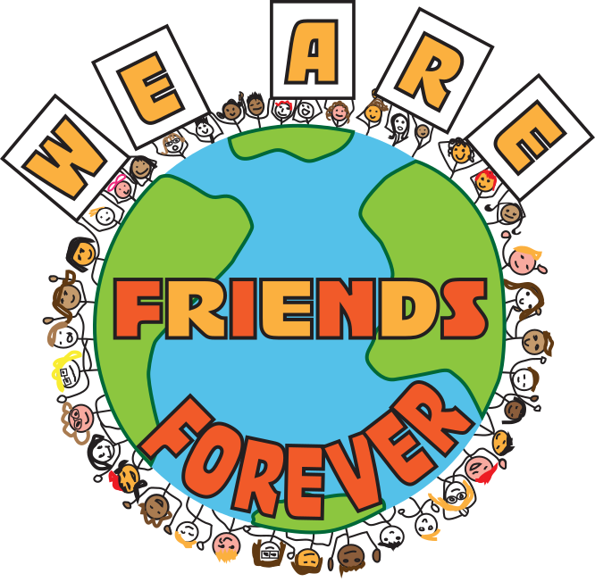

Friends Forever
Manual

Table of Contents
Section 1 – The Friends Forever Movement 3
Program Guide/Defined 4-5
Vision Letter 6
Successful Chapters 7
Where We Started and Where We’re Going 11
Section 2 – School Year Chapter Checklist 13
Section 3 – Chapter Requirements 16
The Role of the Instructional Staff 17
The Role of Sixth Grade Students 18-19
Logistics 20
Section 4 – Publicity and Recruitment 21
Publicizing Your Chapter 22
Friends Forever Key Messages 23
Presentation Tips 24
Relevant Documents 25
FAQs 26
Parent Involvement 28
Using the Friends Forever Logo & T-Shirt Ordering 29
Section 5 – Buddy Identification 31
Section 6 – Making the Matches & Spreadsheet 33
Section 7 – Mentor Training 36
Section 8 – Meetings 38
Section 9 – Monitoring Participants 41
Monitoring the Friendships 42
Monitoring Staff 43
Section 10 – Session Activities 44
Section 11 – Optional Fundraising to Build Community 47
Section 12 – Expanding Your Chapter 49
Section 13 – Appendix and Supporting Documents 51

Section 1

The Friends Forever Movement

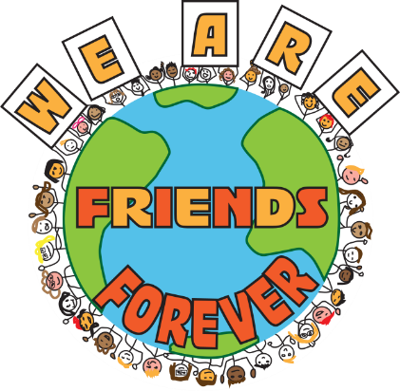The Friends Forever Movement

The Big Picture
Friends Forever (FF) seeks to set a foundation for students to impact positive change in their school community. It develops students as leaders and role models. FF teaches empathy and places focus on the common good for all members of the community. We promote inclusion, embrace diversity, and provide a space for all students to be themselves. Students develop these intrinsic values within a fun, joyful atmosphere. Instilling these values in elementary school has a lasting impact on students’ futures as leaders and influential community members.

Building Community
A goal of the FF Program is to build our school community. As we use inclusive practices, we heterogeneously group students across grade levels, across social groups, and across academic ability. Within our community, FF breaks artificial barriers and distinctions between students that would otherwise “label” and pigeonhole them. Students build unexpected friendships and collaborate with individuals they usually would not have the opportunity to work with. They use their individual strengths to bridge gaps between themselves and others. Students take pride in their participation and success in this school community activity.

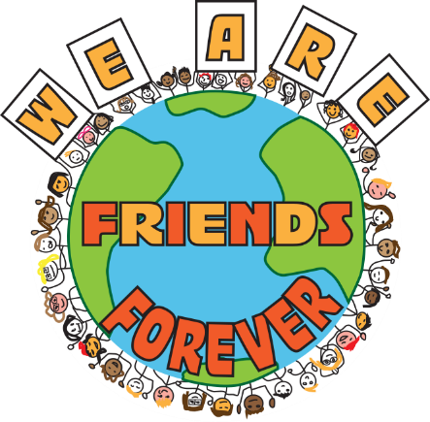Program Guide

What is Friends Forever?
Friends Forever is a mentor program that is run by members of the Special Education team and students of upper grade levels to offer unique opportunities for students with special needs and general education students.

How does it benefit children?
The Friends Forever program benefits all student participants in numerous ways. The club is presented as a leadership opportunity and a way to make our communities better.
    - Students are involved in creating the curriculum with support from special education teachers.
    - Students learn the value and importance of accepting all students into our school and community.
    - Students grow to see how the role of helping others benefits everyone.
    - Students develop empathy.
    - Students have the opportunity to develop leadership skills and move into the mentor or a coordinator role as appropriate.
    - Students feel accepted and are more an integral part of the community.
    - Students look forward to participating weekly
    - Students change the culture by accepting all students at our schools

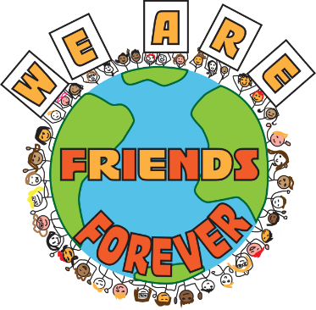Vision Letter
Dear Future Friends Forever Program Manager,
You are ready to embark on a new journey in your career as an educator. As a FF Program Manager, you will see the true beauty in children and the leadership role they will embrace when you give them this opportunity to lead on behalf of others. You will see children from all classrooms and intellectual abilities and handicaps and strengths and weaknesses all supporting each other. You will see the difference that children can make in our world and in the culture of your school.
Each day your children meet, you will be able to witness the power of compassion and empathy that children will embrace when given this opportunity. You can stand back and watch it all from afar with pride because the children will be doing the planning, creating, facilitating, laughing, bonding, and respecting. Your job is to set it up and then beam with pride. I couldn’t think of a better way to start each of my Friday mornings. Friends Forever, once in place, runs like a perfectly oiled machine: all the parts need each other to work.
Don’t be afraid that it’s too much work. Start small. I started with 16 students. You just need one other teacher to pilot the program with you. An important piece to remember as an educator is that all of our children do better because of this program. Students who feel isolated develop friends and feel included. All students develop empathy and see the perspective of other students. Students have the time to be creative. All students develop leadership skills and little buddies become mentors as they get older. It’s really a win-win situation here.
As you embark on this journey of compassion and inclusion, know that it is our children who are going to make this world a beautiful place to live where all people can live in harmony and nobody has to feel excluded. Thank you for joining me in this mission. Together we will empower our children to make this world a place where everyone fits.
Sincerely,

Deborah A. Alsado

Successful Chapters
“This is our 5th year running the “Friends Forever” program at Floris Elementary School in Herndon, Virginia. We started the program with about 20 buddy pairs meeting once a month. We are now up to 40 buddy pairs and meet every other week. I love watching our 6th graders take complete ownership of the program; from planning activities, to setting up, to running the morning sessions. We put much thought into matching our 6th grade role models with the younger students. And, the relationships that they develop with their younger buddies transfer to other parts of the building and to other parents of their academic day. I see younger buddies run to give their 6th grade buddy hugs at recess and 6th graders going out of their way to give a high five to their buddies in the hall. The younger buddies are practicing pro-social skills in a safe environment, while our 6th graders are becoming young leaders. We are so happy to have this program at our school!”
- Sarah DeKramer, (School Counselor, Floris Elementary, Herndon, VA)

Past Member Testimonials
“Over ten years ago as a fifth grader at Westbriar Elementary School, Ms. Alsado’s Friday Friends (now Friends Forever) program made a lasting impact on my life. I was asked to participate as a student mentor. As a student mentor I was paired with a student in the special education department and we met once a week to complete some fun activities. This program provides amazing opportunities to engage students with special needs in appropriate peer relationships. However, the reverse is just as important! It teaches the student mentors, from a young age, that interacting with their peers with special needs is normal. The skills I learned serving as a student mentor positively transformed the way I relate to people with disabilities. My involvement in the program led me to continue to seek out opportunities to serve my peers with special needs. In middle school I aided in a special education classroom, in high school I participated in Best Buddies and in college I am working with Young Life Capernaum. I believe I would not have pursued these programs if it were not for my initial involvement in Friday Friends. As a participant in Friday Friends I did not even realize I was learning how to properly interact with my peers with special needs and cultivating a desire to continue to impact the lives of people with special needs.”
- Wade Fritzeen (Former FF mentor)

“My name is Katie Kenny, and I am a senior and the President of the Best Buddies Chapter at George C. Marshall. I attended Westbriar and participated in Friday Friends. Some of my best memories of elementary school are the mornings we had Friday Friends meetings: playing games, talking and laughing, eating breakfast, making crafts, and running around outside. Oftentimes, students with intellectual and developmental disabilities do not learn in the same classrooms during the day as students without IDD, so I got to see my friends that I did not have classes with during Friday Friends, like my friend Skye. I met new people, as well as made stronger and closer friendships with other students at the school.
After moving onto high school, I began participating in Best Buddies. Throughout my experience with Best Buddies and running a high school chapter, I often talk with students who forego joining the club because they have not had experience interacting with people with IDD. Sometimes students express fear at saying or doing the wrong thing or not knowing how to talk to people with IDD. Even when I explain to students that talking to people with IDD is the same as talking to all of your other friends, when students have not actually spent time with students different from them, they sometimes still express discomfort.
Friday Friends allowed me to spend time with more students at my school, members of the community who other students and activities often don’t include. Elementary school is an integral time for all people to learn social skills, both people with and without IDD. Friday Friends supports all students to interact with more people and gain opportunities to make friendships that are not always available because of separation during the school day. Students with IDD gain opportunities to meet more people and make more friends, the value of which is immeasurable. Likewise, students without IDD also get the opportunity to make more friends, as well as interact with people with disabilities. The more experiences people have with those who are different them, the more tolerant and accepting they are likely to be. This ultimately results in a more tolerant and unified community, where differences are celebrated and do not act as barriers. Friday Friends programs truly improve the lives of everyone involved.
I got to do Friday Friends with Skye, who I have known since I was five years old. Skye and I worked together as coordinators of Friday Friends, planning and running our weekly meetings along with a few other students and teachers. One of the main goals of the Best Buddies organization is create leadership opportunities for people with IDD, a goal which Friday Friends also accomplishes. Without a doubt, every single school and every single student in the state of Virginia would greatly benefit from participating in Friday Friends.”
- Katie Kenny (Former FF Coordinator and Mentor)

“I am writing today to tell you about the Friends Forever club. The club is really fun and I think everyone should do it. My favorite memories from being in the club were going outside and crazy hair day. I had a buddy named Jeremy, and we had a blast. Friends Forever helped me make a lot of good friends. Outside we played with water balloons and played knockout. I also use to like being in the club because of the activities we use to do. We use to do crazy hair day, and I remember I made my hair blue with spikes.
In kindergarten I met Katie when I was little. We grew up together. Both of us used to be coordinators at Friends Forever and we have a lot of good memories together. Katie was always a good friend to me. We both liked to swim in my pool together in the backyard. We had playdates in her house and used to play Wii games and sometimes baked cookies. I haven't seen Katie in the long time. I really miss Katie so much. Katie was one of my best friends and I will never forget her. We all loved her at Westbriar Elementary. We had good times there.
My role as a coordinator was to make sure that everyone is having fun and was happy with their buddies. It made me happy seeing everyone having fun. Coordinators use to have lunch on Fridays in Ms. Alsado’s room, and we use to come up with ideas for buddies to do. Some ideas we did were karaoke and play freeze tag outside. My job as a coordinator was to make Friends Forever more fun. I wish everyone was a part of Friends Forever because it is a good experience and is a lot of fun.”

- Skye Marsili (Former FF Buddy)

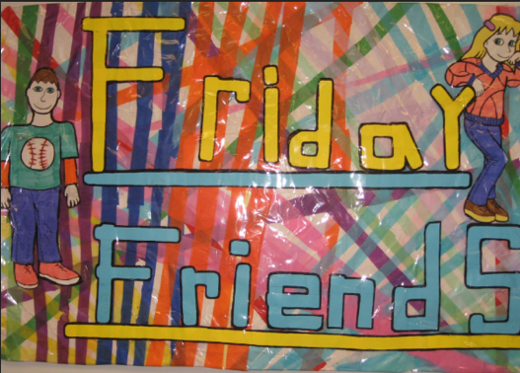
Where We Started and Where We’re Going
Twelve years ago I had an idea: I wanted to find a way for all students at our school to feel included. I wanted kids to embrace the differences of others despite gender, handicap, intellectual level, race or other otherwise. I knew our students would share my vision of one community, if I could just find a time and day to build a peer to peer mentoring program.
I chose Friday because it’s such a happy day at schools anyway. The faculty and students come with smiles on their faces anticipating a restful weekend after a hard week at school. Our students look forward to Fridays for this special program. This is how the program Friday Friends Forever was born. A student surprised me with the logo/banner and we adopted it as our first logo.
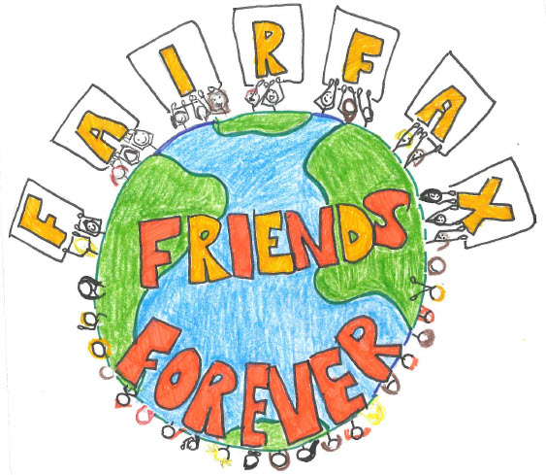
After a few years, other schools in our school district heard about Friday Friends and they wanted to start a program too. As I went to share the program, it occurred to me that we are not just friends on Fridays. Indeed, the goal is we are friends always, every day, and in every location. Also, maybe schools would want to meet on another day of the week. In order to expand more in Fairfax County Public Schools, I chose the name Fairfax Friends Forever. In this way, I was keeping the acronym FFF and keeping Friends Forever.
I had a student contest that year to design our new logo, and the logo with the earth was created. Everyone loved how the children were holding up the letters. This embraced the collaboration that is at the heart of our program. We took the same logo but removed Fairfax, added diversity to the children around the Earth, and kept Friends Forever again.

I found myself in the same position this year when we received the VDOE grant: contemplating and evaluating our logo and name. I questioned myself again, “Why would Fairfax Friends Forever only be in Fairfax?” I didn’t want to change the whole name again but felt the need to make the title one that could be not just on Fridays, not just in Fairfax, but any day and anywhere. Again, I wanted to keep whatever part of the original name that I could, so I kept Friends Forever. In this way, we are still Fairfax Friends Forever and another school can be Friends Forever, too.
I have always had the goal to spread the program with one name. In this way, it becomes a program that everyone is familiar with and has a chance of longevity. Otherwise, it would keep changing names and as the faculty members who started it retired or left, so would the program. I am committed to keeping Friends Forever and hope you will embrace the name and logo for your school, too.

Section 2

School Year Chapter Checklist

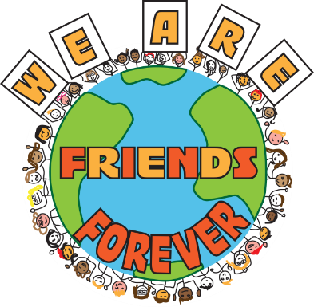School Year Chapter Checklist

Use this checklist as a guideline for running your Friends Forever Chapter.

**REMEMBER: Meetings with coordinators to plan the sessions happen each week, along with the weekly FF sessions!**

Before School Begins
- Staff recruitment; organize staff that will be supporting program (special education teachers, specialists, 6th grade teachers)
- Determine locations for FF meetings and activities; determine location for students who choose to not participate
- Share information with K-5 teachers about FF during staff development days
- Share information with community (at Open House, Back to School Night, etc.)

First two weeks of school
- FF slide presentation to launch program and inform student volunteers and drum up enthusiasm; one week for students to return forms

Weeks 3 and 4
- Student Volunteer Application turn-in (one week after they were distributed)
- Gathering names from teachers for buddy recommendations (ask LSC and specialists, too); if applicable, check over buddy continuation from previous year
- Coordinators are selected by Program Manager
- If a student applied to be a coordinator but did not receive the position, Program Manager lets these students know individually; then, Program Manager tells coordinators they have been chosen for the position
- K-5 teachers send home parent permission form for buddies, including t-shirt size selection

Week 5
- Program Manager discusses with committee (consisting of specialists, special educators, etc.) help pair mentors with buddies, considering “best fit” for grade level pairings
- Create spreadsheet to maintain record of buddy/mentor pairings, student roles, and students not participating and the pick-up and session locations

Week 6
- Coordinators plan buddy reveal

Week 7
- Buddy reveal - coordinators share with mentors who their buddies are (mentors get necessary information - buddy name and classroom)
- Mentors meet buddies (classroom visit and introduction; small craft from mentor to buddy in K-3)

Week 8
- First FF session

Throughout the year
- Potential school-wide activity: school sing-a-long
- Continue communication with community and other school staff
- Hold 5K/1 Mile Fun Walk fundraiser
- Last sessions of FF are held at the end of April due to state test preparation; use school discretion

Last month of school
- Honor participants at end-of-year award ceremony; coordinators receive plaques
- Pick a buddy pair from each grade that embody the vision of Friends Forever; these students also receive plaques

Section 3

Chapter Requirements

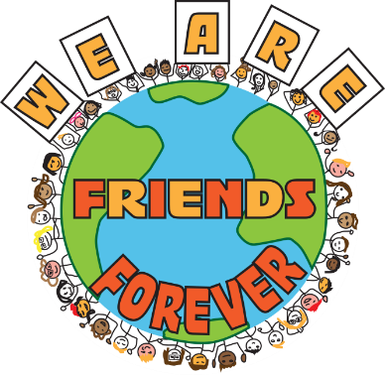The Role of the Instructional Staff

Program Manager
- Presenting the program at the start of each year to grade 6 students.
- Selecting members each year with the coordination of the general education and special education teachers.
- Lunch/planning meeting once a week with coordinators.
- Monitoring/helping run sessions.
- Check in on each of the different sessions, particularly if coordinators or teachers have indicated a mentor needs support in some way.
- Troubleshooting with students.
- Recruiting support staff.

Grade level teachers (6th grade)
- Help generate excitement and buy-in from grade level students.
- Assist with creating buddy/mentor pairings and determining coordinators.
- In our program, it is ideal that they do not permanently supervise a grade-level group so they can provide as-needed assistance (such as serving as substitute for special education teacher to monitor a grade-level room).
- Report to Program Manager if there are concerns about any participants in the program.

Special Education Teachers and Instructional Assistants
- Assist with suggesting students and pairings.
- Monitor each grade-level room, but allow coordinators and mentors to lead and facilitate activities. Provide assistance to coordinators upon request.
- Provide support to special education students, as needed.
- Report to Program Manager if there are concerns about any participants in the program.

Additional staff and faculty
  - K-5 teachers decide which students would benefit from the FF program and nominate them for the program.
  - Help generate excitement and buy-in from K-5 students.
  - Inform parents about FF program and send home/receive parent permission forms for buddies.

Role of 6th Grade Students
In this program, we make an effort to ensure that some of the Coordinators are students who have previously been Buddies in Friends Forever. We also make an effort to include students with special needs as Coordinators.
“Considerations” Disclaimer: In our inclusion program, no students are excluded or unqualified for participation. However, there are some roles that better suited for some students than others. We assign roles with the understanding that students will rise to meet high expectations if they are given the opportunity to lead.
Typically, SCA officers do not participate in this program to spread out leadership opportunities across the grade level.

Coordinators
Description:
- Grade 6 students who volunteer and are selected to lead and run the club.
Considerations:
- Responsible students, students who can benefit from a leadership opportunity.
Responsibilities:
- Meeting once per week with the program manager for the coordinator luncheon planning session.
- Make a list of needed materials in advance to give ample time for collection.
- Arrive 15-20 minutes early the morning of the session to set-up the room.
- Explain and run the session each week.
- Evaluate and troubleshoot as needed.

Mentors
Description:
- Grade 6 students who volunteer and are selected to participate in the club for one academic year
Considerations:
- Friendly, responsible, kind and patient
Responsibilities:
- Acting as a role model for inclusive practice in the school in all environments.
- Coming each week to the morning session with their buddy.
- Picking up/dropping off buddy for weekly sessions.
- Attending periodic mentor meetings with coordinators/facilitators.
- Supporting their buddy.

Bulletin Board Crew
Description:
- Two to four grade 6 students who are in charge of taking pictures at FF sessions.
- Maintaining a bulletin board for the entirety of the academic year for the club.
Considerations:
- Creative and responsible students who enjoy utilizing their talents to put together informative and eye catching bulletin boards to inform and share information with the school community pertaining to Friends Forever.
Responsibilities:
  - Sharing their idea each month with the program manager.
  - Preparing all materials to put up the board.
  - Changing the bulletin board each month.

Tech Crew
Description:
- Grade 6 students who volunteer and are selected take pictures each week.
Considerations:
- Responsible students who are familiar with different technological platforms to share pictures and other information with other program leaders, trustworthy with technology
Responsibilities:
- Upload pictures to computer
- Share pictures with the bulletin board members
- Prepares power points as needed

Logistics
On Friends Forever session days, one space per grade level is required to hold sessions. Spaces could include classrooms, the gym, the cafeteria, or outdoor activities. (Fewer rooms may be needed if grade-level groups are smaller.) A space will also need to be designated for students who do not participate in the program. An activity wall is needed to communicate weekly activities with FF members. Finally, FF utilizes a school bulletin board to communicate information about the program to the school community.

Materials required will vary from week to week, depending on Coordinators’ planned activities. These may include PE equipment or art supplies, for which Coordinators should submit a written request to borrow from the respective teacher. Board games are another popular activity. Use of the school-wide intercom is required directly preceding a session for Coordinators to communicate session areas for each grade-level group.

Section 4

Publicity and Recruitment

Publicizing Your Chapter

When to Start:
- Follow calendar outlined in section 2

How to do it:
- New teacher mentor program: lead mentor shares information about FF to new teachers in the building and establishes that this is part of the school community
- Back-to-School staff meeting: Program Manager presents information about FF to school faculty about what the program is, what to “look for” in students who are potential buddies; recruit faculty members interested in participating
- Back-to-School Night or Open House: share information with community about the program; potentially share video; inform parents about benefits of having their child participate as a buddy or a mentor
- Foster relationship with PTA: discuss with them at end or beginning of year (whenever they create their budget)
- T-shirt: Participating students and teachers can wear the T-shirt to cultivate conversations about the program.

Bulletin Board in Lobby
- Provides information to community about the program
- Shares images, facts, quotes, activities

Friends Forever Key Messages

We need children to stand up as leaders to make a difference.

What does it mean to be a leader to help others? What does it mean to change a child’s life? How can a high five in a hallway or just a smile make a child’s day? How do we make our world a more tolerant loving place where each child knows they are not alone? A place where no child has to sit alone in the lunchroom or feels like they are different or don’t quite fit a mold.
Friends Forever is that program where all children can rise as leaders. Our children can create that culture that is more loving, more caring, and more empathetic. We as educators can give them this opportunity. It’s not just another lesson plan or item on our list. Our children are the lesson plan makers. Our children are the mentors. Our children are the leaders. We, as educators, simply need to inspire them and believe in them. Only then can children rise to their full potential emotionally and academically.
- Inclusive school culture: It’s cool to help other kids! It is everyone’s job to try to make the world better; give kids the opportunity to do this. Allow them to lead, allow them to collaborate, allow them to take ownership; if you let them be leaders, they will rise to the challenge!
- Student-run program: All student participants become leaders throughout participation in the program, whether they are mentors and coordinators who lead their buddies, or buddies who eventually become leaders in the program! Students make sessions fun and engaging.

Presentation Tips
When presenting FF to sixth graders to garner interest, include the following:
- Friendship song; image of buddies
- We balance leadership opportunities, so if a student is are already a leader in a program like SCA, they may have to yield this opportunity to other students
- Acknowledge that students who have been part of FF as buddies in younger grades are now ready to be mentors and lead the program themselves
- Share program packets and volunteer forms following an explanation of all roles

Relevant Documents

See appendix for the following documents:
Student Volunteer Application Example
Student Volunteer Application Template
Buddy Permission Slip Example
Buddy Permission Slip Template
Buddy Continuation Notification Example
Buddy Continuation Notification Template
Friends Forever Presentation Example

Frequently Asked Questions
Why should we have this at our school?
This program should become part of a school community as it creates, fosters, and sustains an inclusive culture. It helps to educate the “whole child,” going beyond academic instruction and creating opportunities to develop latent interpersonal skills. For younger students, they look forward to working with their mentor and having the opportunity to meet new, older friends and participate in fun activities. They are recognized by their mentors around the school and receive encouragement throughout the year. This program often surprises educators, as they see new leaders emerge and take opportunities to unexpected heights.

Our 6th graders often seem “checked out.” How do you get them committed to this program?
Your program launch is a huge part of recruiting student participation. It is imperative that you convey they are the leaders of the program and its success depends on them! Explain that helping others is a vital skill in middle and high school, in college, and in life.

Your program is so big! How can we even begin to tackle this?
Start small. Begin with your highest grade level (5th or 6th) and a handful of classroom teachers and special educators. You may even choose just one 5th or 6th grade classroom to pilot the program, and then plan to extend to the full grade level in coming years. In this classroom, present the program and recruit committed student volunteers to serve as mentors and coordinators. Work with interested primary teachers to identify potential buddies; this could be limited to just one grade level or could span several grades depending on teacher interest.

How do I get teachers on board to start this program?
Ask for volunteers! Don’t try to recruit people who are not yet convinced; buy-in may come with time as your program becomes more successful.

What was your biggest challenge when starting this program?
Time! The time will pay off, but we also know that time is limited during the day so it may be difficult to convince others that this is worth it. Be creative in the window you choose; find a time that works best for your school, but avoid lunch and recess to ensure maximum participation by mentors.
How can I encourage my administrators to make this a priority?
It is proven that early intervention is effective for student success. Without labeling or formal evaluation, this program allows teachers to identify students who have needs that go beyond academic intervention. The school community provides support in a fun, safe environment. It provides the opportunity for special education teachers to meet more students and begin to address these emotional needs. Younger students can build a relationship with special education teachers, viewing these adults as resources without any negative stigma.

How can we make time for this without sacrificing instructional time?
One of the best parts of this program is that it doesn't require a lot of time or money to implement. Students are at the forefront of the planning and engaging one another. Our program takes place every Friday morning for a jam packed 20 minute session of fun to positively start a child’s day. The development of collaborative, social and leadership skills are irreplaceable in preparing 21st century learners for the future. It’s a small amount of time, but the benefits outweigh any detriments of what is missed. It’s a small investment of time that pays off with great results.

What do we do with students who choose not to participate?
It is possible that these students are part of other service learning opportunities or school volunteer work. If not, offer them other community service opportunities (reading to younger classes, cleaning up school grounds, etc.).

Parent Involvement
Parents are vital members of the community and their support of the program is crucial. Parents must approve of their child’s participation in Friends Forever as a buddy. Parents must also approve of their 6th grade child volunteering as a mentor, coordinator, or member of Tech or Bulletin Board Crews. Parents do not participate in weekly activities or 6th grade work throughout the week.

Using the Friends Forever Logo & T-shirt Ordering
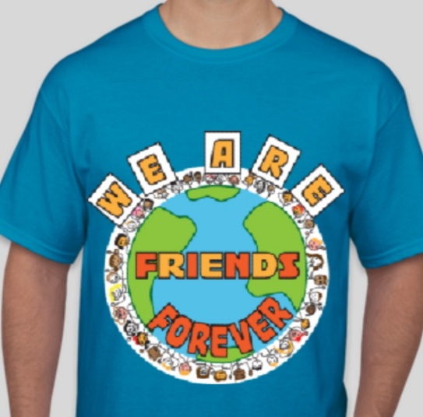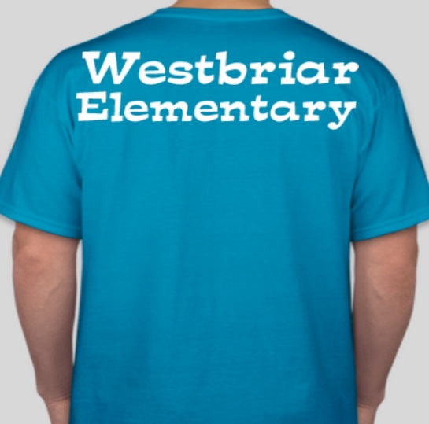
Front Back

The logo, along with the program name, has evolved over time.
Our logo is to remain the same across all chapters to create unity between schools and across school districts. The “We Are Friends Forever” logo goes on the front of t-shirts. The back of t-shirts can reflect the individual chapter and/or school district.
To ensure all students receive a t-shirt, sizes can be selected on parent permission form. It is recommended that, if possible, mentors purchase shirts but little buddies receive free shirts

Continuous Publicity
- Bulletin board: provide information to community about what the program is doing throughout the year
- Document activities completed during the year to share on website, bulletin board, etc.
- Share through: school newsletter, county employee news, community newspaper, social media outreach

Section 5

Buddy Identification

Identifying Potential Buddies
Ideal buddies may be students who:
- struggle socializing with peers
- hesitate to participate in class
- demonstrate the need for behavioral support
- have a difficult time controlling impulses
- may be seeking additional teacher attention
- need assistance managing conflict with peers
- are becoming familiar with American school systems and culture
These students may or may not have an IEP or 504 Plan to reflect their needs. Students participating in the program will likely come from all classrooms, including those designated as “advanced,” “gifted,” etc.
Referring faculty may include teachers, members of the special education screening or child study committees, and/or counselors. Recommendations may also be made by parents and families.
The list of Buddies should be revisited each year; it should be considered whether or not a former Buddy still would benefit from a Friends Forever Mentor.

Section 6

Matching

Making the Matches & Spreadsheet

Making the Matches
- Program Manager meets with school specialists, special education teachers, and 6th grade teachers. These teachers are able to help match students due to their positions which allow them to know the entire student body. Some matches are students that are similar; some matches are students who are opposites who can learn from each other.
- It is ideal to match mentors to buddies who require the most support first

Making the Spreadsheet
- In order to keep track of all students and their locations, it is ideal to create a spreadsheet.
- We have found it easiest to create a google form to help create the spreadsheet.
- The Spreadsheet includes:
  - Headings: buddy, mentor, homeroom teachers, classroom numbers
  - Tab for each role: Buddy Pairings, Coordinators, Tech Crew, Bulletin board, SCA, Students not participating

Program Spreadsheet Example

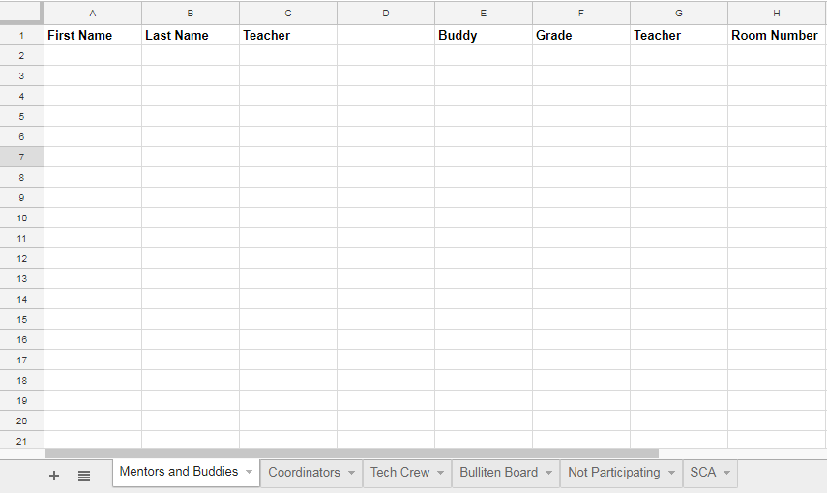

Section 7

Mentor Training

Initial Mentor Meeting & Buddy Introductions

Initial Mentor Meeting
Program Manager speaks to mentors about the significance of their responsibility and the expectations of being a mentor to a younger student. It is explained that buddies look forward to this program every year and they need to take their job very seriously. Examples are given about different personalities they may face with their buddies. It is conveyed that mentors were specifically matched with their buddy. Mentors are informed privately if they are working with a buddy who has additional or exceptional needs. All mentors are reminded that they are responsible for their buddy, but their focus should be on embracing this opportunity and creating memories for their buddy to enjoy!

Buddy Introductions
Coordinators plan how to reveal the buddy/mentor matches. In the past, it has been a PowerPoint or a craft (such as fitting together puzzle names) to reveal matches. There is a serious discussion about the reveal, that there should be no cheering or booing. Mentors are to inform the Program Manager in private following the reveal if they have a personal conflict or concern with their buddy pairing. The Program Manager will alert mentors privately if they will be working with a buddy that may have additional or exceptional needs.
How to Introduce Yourself to Buddy and Classroom Teacher
This takes place the week before the first meeting. Program Manager models for mentors how they should interact with buddies. They receive instructions about how to introduce themselves to the teacher and explain why they’re there. When they interact with their buddy, they should introduce themselves and get down to their level (eye-to-eye communication).
Mentors Go to Meet Buddy in Their Classroom
When mentors visit the classroom, they may go into the room to introduce themselves or the child may come to meet them in the hallway. Mentors receive instructions from Program Manager about how to handle either situation.
Friendship Token
K-3 Make friendship token - buddy name and mentor name
Mentors with younger buddy (K-3) may create a small friendship token (a card, a fall-themed cut-out with a note, etc.) to present to their buddy as a takeaway of their meeting. It should include the mentor’s name for the buddy to share with their parents and family.

Section 8

Meetings

Coordinator Weekly Meetings

Coordinators meet once a week with Program Manager during lunch or recess. They decide what their grade-level group activity will be for the week and make the necessary arrangements to prepare.
For example, if Coordinators choose to complete a craft with their group (often coordinating with seasons or holidays), they would need to write a written request to the art teacher to obtain craft materials. They would also need to work during the week to create an example of the craft.
If Coordinators choose to hold an outdoor activity, they may need to write a written request to the PE teacher(s) to obtain gym equipment; a back-up activity is also planned in the case of inclement weather.
All activities must be approved of by the Program Manager, at which point they are then written on the Weekly Activity Board so teachers and FF participants are aware of where they will meet and what they will be doing.

Other Meetings

Friends Forever Weekly Session
Friends Forever meets weekly. Mentors pick up their buddies from their classrooms and escort them to their meeting location to take part in an activity Coordinators have planned in the week leading up to the session

Tech Crew Meetings
Tech Crew makes a digital folder (ex: Google Share folder) to share with all of Tech Crew, Bulletin Board Crew, and Program Manager. Devices (other than phones, due to privacy concerns related to social media) are used to take pictures of the weekly activities, buddy/mentor pairs, and group photos. Ensure students in FF are not on the photography opt-out list, per school policy. Tech Crew is responsible for uploading pictures to the shared folder by a date each week established by Program Manager. One Tech Crew member should be responsible for checking that pictures have been uploaded each week; this position could be formalized within your chapter.

Bulletin Board Crew Meetings
Bulletin Board Crew submits a sketch of their idea for next month’s bulletin board to Program Manager. Once approved, the Crew creates this bulletin board during their lunch or recess. Bulletin boards typically relate to holiday or season, and photographs (from shared Tech Crew folder) are used to highlight activities that have been completed in Friends Forever meetings. Bulletin board materials may be requested from Program Manager, or they may access materials that have been donated or leftover from school projects. It is advised that there is a designated box of supplies free for the Bulletin Board Crew to use.

Section 9

Monitoring Participants

Monitoring the Friendships
If there is a problem the coordinators are to report this information to the Program Manager. The Program Manager then talks to the coordinator to determine the issue and how to best resolve it. First talk to the mentor and see if you can troubleshoot with the mentor, find out what happened. Then bring in the buddy to help resolve it if needed.

Friendship Problems to Anticipate:
Buddy doesn't like the activities - Prompt the mentor to ask the buddy what they do like to do. Make suggestions for future suggestions that can be given to the coordinator. Come up with back up activities. Check in on the buddy pair the next week.
Mentor is trying to hang out with their friends - Student receives a firm reminder about expectations. Remind that they volunteered for the program and their role in the program.
Not giving enough attention to the buddy or are not engaged - Student is encouraged to choose activities for their buddy that they both will enjoy. Mentors receive adult coaching to help them connect with their buddies.
Buddy doesn’t want to leave their classroom - Mentor can bring games to the hallway outside of the buddy classrooms to make them feel more comfortable and still participate in the program.

Staff Supervision
A special education teacher or instructional assistant is assigned to each grade-level classroom. They monitor the weekly activity and are there to supervise, help coordinators troubleshoot any problems that arise, and keep track of success of buddy and mentor interactions. If a teacher is unavailable for a session, they will notify Program Manager who finds their coverage for the session.

Section 10

Session Activities

Session Activities
Crafts
Kids love to be crafty! The best part of creating a craft with your buddy is that there is no wrong way of doing it. Students can work together to create something for themselves, something for the “little buddy” to take home, or even something to act as part of a larger display for the school.
Board Games
Board games are an easy way for kids to engage and play with one another. Favorite board games such as Candyland, Chutes and Ladders, Monopoly, and Life are always fun. Board games can be found at yard sales for very little money or donated by teachers or families in your community.
Outdoor Activities
The list of outdoor activities you can play are limitless. Students can play together on the playground; have an organized, friendly game; or even hold relay races. Coordinators can communicate with P.E. teachers to coordinate borrowing of needed equipment.
Singing through the halls
FF participants spend time practicing familiar non-denominational holiday songs with their buddies. After practicing, buddies walk through the hallways together in a large group singing as they travel through the building. The whole school opens their doors and everyone enjoys listening to friends and joining in, waving as FF strolls by.

Coordinator Suggested Activities
- Board Games
- Crafts about holidays
- Snails
- Tag
- Pin Elimination
- Mission Impossible
- Kickball
- Make a paper jack-o-lantern
- Freeze Dance
- Jump Ropes
- Roleplay
- Card Making
- Hula Hoops
- Soccer
- Mini Football
- 4 Corners
- Just Dance
- Ring toss game
- Making Mosaic
- Making Paper Lantern
- Making Slime
- Trick or Treat
- Hot Potato Game
- Game Stations
- Oreo Spiders
- Brownie Tree
- Rice Crispy Rudolph
- Olympic Medals
- Clip airplanes
- Origami
- Silent speed ball
- Bingo
- Musical Chairs
- Mission Impossible with Easter Eggs
- Rainbow Tag
- Card making

Section 11

Optional Fundraising to Build Community

Optional Fundraising to Build Community
A 5K/1 Mile Fun Walk is one way to foster your inclusive community and raise awareness about FF. In addition, a charity can be selected as a benefactor of fundraising as an additional motivating factor for school families to register. Community sponsors may be recruited for donations, incentivized through advertising.
While adults will likely need to take on most logistics, students should be involved in marketing this event through flyers, morning news, writing school newsletter articles, etc. Event planning can be tied to economics, marketing, digital citizenship, and communications curriculum.
At the fundraising event, create a booth to tell others about the FF program: its mission, its participants, its benefits, and its future at your school. All signage for the event can include the FF logo as well as the logo of a chosen charity which will benefit from the event. There may also be activity booths created and run by students. A food drive could be held in conjunction with your event.
Partner with school-based clubs such as the SCA and PTA to scale up your event. If significant funds are raised, they could be distributed amongst charity and school programs to incentivize the participation of these groups. Teachers within the school community may also garner participation by offering rewards for students who have registered for your event.
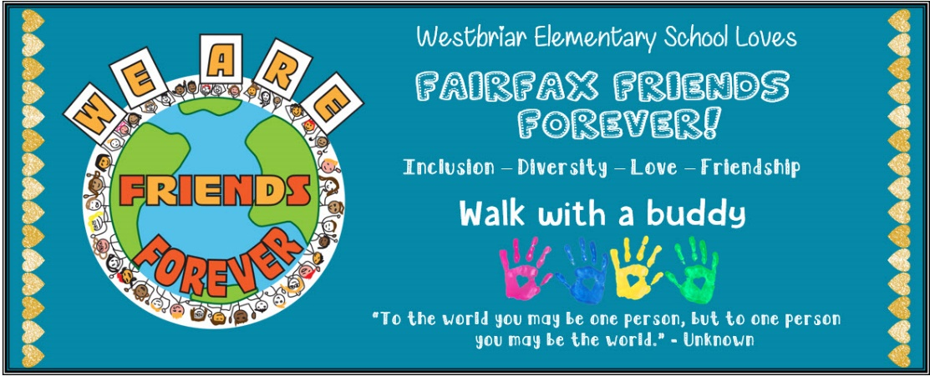

Section 12

Expanding Your Chapter

Expanding Your Chapter

Goals for the expansion
Along with spreading outside Fairfax County Public Schools to other districts in Virginia, FF is intended to expand in the coming years to mentor and foster same-age peer friendships. Buddies in the FF program have benefitted from having an older member, but there is still a need to grow friendships between same-age peers within classrooms. This will allow buddies to have a peer on a daily basis that can be a friend within the classroom, in the lunchroom, and on the playground. This expansion will launch in one grade at a time. The 6th grade mentor will assist this same-age peer friendship, teaching and modeling the use of positive social skills and cooperation.

Section 13

Appendix

Appendix

Student Volunteer Application Example
Student Volunteer Application Template
Buddy Permission Slip Example
Buddy Permission Slip Template
Buddy Continuation Notification Example
Buddy Continuation Notification Template
Friends Forever Presentation Example

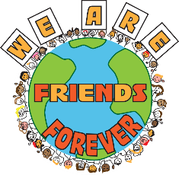Student Volunteer Application
Dear Students,
Thank you for your interest in volunteering to participate in Friends Forever. Your participation is greatly appreciated and is what makes FF so special.
Please select 3 positions you are interested in volunteering to participate in for Friends Forever this year. Rate your choices with 1 being the most desired position. Return your form to your homeroom teacher by Wednesday, September 13th.
Directions: Prioritize 1-3 with one being your first choice for volunteering for FF.
Coordinator_____________
- The coordinator position will be meeting to plan activities each Monday during recess. Coordinators must also be able to arrive at school early each Friday by 8:40 to set up the activities.
Mentor______________
- Mentors meet with their younger buddy each week to play, complete activities, and become friends.
Bulletin Board Member_____________
- Bulletin Board members create and maintain bulletin board sharing FF activities with the school. The BB members will sometimes need to work during recess and/or lunch.
Tech Crew______________
- Tech Crew volunteers take pictures each week to share with the bulletin board members and prepares Power Points as needed.
I am giving permission for my child, _______________________, (please print) to volunteer for Friends Forever.
Parent Signature: ________________________________
Parent e-mail/cell phone: ___________________________________
Please contact Mrs. Alsado for questions.
Sincerely,
(Signature)
Mrs. Alsado
__________________ (date)

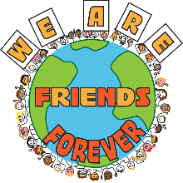Student Volunteer Application
Dear Students,
Thank you for your interest in volunteering to participate in Friends Forever. Your participation is greatly appreciated and is what makes FF so special.
Please select 3 positions you are interested in volunteering to participate in for Friends Forever this year. Rate your choices with 1 being the most desired position. Return your form to your homeroom teacher by _______________________. (date)
Directions: Prioritize 1-3 with one being your first choice for volunteering for FF.
Coordinator_____________
- The coordinator position will be meeting to plan activities each ___________ (day) during recess. Coordinators must also be able to arrive ____________ each ________ (day) by __________ (time) to set up the activities.
Mentor______________
- Mentors meet with their younger buddy each week to play, complete activities, and become friends.
Bulletin Board Member_____________
- Bulletin Board members create and maintain bulletin board sharing FF activities with the school. The BB members will sometimes need to work during recess and/or lunch.
Tech Crew______________
- Tech Crew volunteers take pictures each week to share with the bulletin board members and prepares Power Points as needed.
I am giving permission for my child, _______________________, (please print) to volunteer for Friends Forever.
Parent Signature: ________________________________
Parent e-mail/cell phone: ___________________________________
Please contact ______________________ (Program Manager) for questions.
Sincerely,
_________________________
(Program Manager Signature & Contact Information)

September 2017
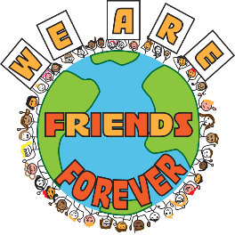
Dear Parents/Guardians,
Congratulations! Your child has been selected by his/her teacher to participate in Westbriar Elementary School’s unique student mentoring program, Friends Forever. The goal of the program is to mentor younger students at our school who could benefit from having an older student as a buddy. The program focuses on developing leadership and confidence skills.
Grade 6 students run the program with teacher support. The students meet each Friday during morning work time to participate in a variety of activities from crafts to outdoor games. We are very proud of our program. Please see the program guide for specifics.
If you have any questions or concerns, please let us know. We will need your signature for your child to participate.
Sincerely,
Mrs. Alsado
(Additional staff signatures)

Student Name: ___________________________________________________
Teacher/Grade: ___________________________________________________
Parent Signature: __________________________________________________
T-Shirt Size (The cost of the shirt is being generously covered by PTA for all buddies)
Youth  Small  (6-8) | Youth  Medium  (10-12) | Youth  Large  (14-16) | Youth  XLarge  (16-18) | Adult  Small | Adult  Medium | Adult  Large | Adult  XLarge

__________________ (date)
Dear Parents/Guardians,
Congratulations! Your child has been selected by his/her teacher to participate in __________ Elementary School’s unique student mentoring program, Friends Forever. The goal of the program is to mentor younger students at our school who could benefit from having an older student as a buddy. The program focuses on developing leadership and confidence skills.
Grade ____ students run the program with teacher support. The students meet each ________ (day) during morning work time to participate in a variety of activities from crafts to outdoor games. We are very proud of our program. Please see the program guide for specifics.
If you have any questions or concerns, please let us know. We will need your signature for your child to participate.
Sincerely,
_____________________ (Program Manager)
(Additional staff signatures)

Student Name: ___________________________________________________
Teacher/Grade: ___________________________________________________
Parent Signature: __________________________________________________
T-Shirt Size (The cost of the shirt is being generously covered by PTA for all buddies)
Youth  Small  (6-8) | Youth  Medium  (10-12) | Youth  Large  (14-16) | Youth  XLarge  (16-18) | Adult  Small | Adult  Medium | Adult  Large | Adult  XLarge

October 2016
Dear Parents/Guardians,
Your child has been a participant in Friends Forever, Westbriar Elementary School’s unique student to student mentoring program. The goal of the program is to mentor younger students at our school who could benefit from having an older student as a buddy. The program focuses on developing leadership and confidence skills.
Grade 6 students run the program with teacher support. The students meet each Friday during morning work time to participate in a variety of activities from crafts to outdoor games. We are very proud of our program.
If you have any questions or concerns, please let your child’s homeroom teacher know.
Sincerely,
Mrs. Alsado
(Additional staff signatures)

Student Name: ___________________________________________________
Teacher/Grade: ___________________________________________________
Parent Signature: __________________________________________________
T-Shirt Size
Youth  Small  (6-8) | Youth  Medium  (10-12) | Youth  Large  (14-16) | Youth  XLarge  (16-18) | Adult  Small | Adult  Medium | Adult  Large | Adult  XLarge | Already has a t-shirt that fits :)
Many students already have a Fairfax Friend Forever shirt from previous years of participation. The shirts are the same design and color as previous years, so if your child still has a shirt that continues to fit, he or she will continue to match!

____________________ (date)
Dear Parents/Guardians,
Your child has been a participant in Friends Forever, ____________ Elementary School’s unique student to student mentoring program. The goal of the program is to mentor younger students at our school who could benefit from having an older student as a buddy. The program focuses on developing leadership and confidence skills.
Grade ____ students run the program with teacher support. The students meet each _________ (day) during ________ time to participate in a variety of activities from crafts to outdoor games. We are very proud of our program.
If you have any questions or concerns, please let your child’s homeroom teacher know.
Sincerely,
________________ (Program Manager)
(Additional staff signatures)

Student Name: ___________________________________________________
Teacher/Grade: ___________________________________________________
Parent Signature: __________________________________________________
T-Shirt Size
Youth  Small  (6-8) | Youth  Medium  (10-12) | Youth  Large  (14-16) | Youth  XLarge  (16-18) | Adult  Small | Adult  Medium | Adult  Large | Adult  XLarge | Already has a t-shirt that fits :)
Many students already have a Fairfax Friend Forever shirt from previous years of participation. The shirts are the same design and color as previous years, so if your child still has a shirt that continues to fit, he or she will continue to match!

Friends Forever Presentation Example
