Language Sampling (Module Two):

Review of Analyses for Conversation Language Samples

A VDOE Professional Development Series
Geralyn R. Timler
James Madison University

Disclosures

Financial:
- Salary from James Madison University
- Received financial compensation from Virginia Department of Education

Nonfinancial:
- Nothing to disclose

Learner Outcomes for Language Sampling Modules
- List optimal language sampling contexts for various age groups and describe best practices for collection of conversation samples (Module One)
- Identify areas of concern in conversational language samples and select analyses for syntactic, morphological, semantic, and pragmatic behaviors (Module Two)
- Implement a protocol for eliciting samples that highlight pragmatic language behaviors and use a rating scale to document these behaviors (Module Three)

Agenda for Module Two
- Strategic tips for identifying analyses that may be needed
- Overview of analysis procedures and possible intervention goals for syntax, morphology, semantics, and pragmatics
- Resources for more information

Which Analyses Should I Do: Three Selection Tips

Tip One: Consider Purpose of Assessment
- Determine eligibility
- Document baseline
- Plan intervention
- Look for error patterns (may or may not have been observed on a norm-referenced test)
- Progress monitoring
- Do analysis aligned with treatment goals

Tip 2: Collect Parent/Teacher Information
- Informed hypothesis strategy for selection of analyses
- Use parent/teacher information to guide your listening of a student’s syntactic, morphological, semantic, and pragmatic language skills

Parent/Teacher Report Measures: Some Examples
- Language Use Inventory (O’Neill, 2009)
- Ages 18 to 47 months (parent report), percentile ranks by 1-month age bands

- Children’s Communication Checklist-2 (CCC-2) (Bishop, 2006)
- Ages 4;0 to 16;11 years (parent report)

- CELF-5 Pragmatics Profile (Wiig, Semel, & Secord, 2013)
- Ages 5;0 to 21;0 years (parent, teacher, student report)

Clinician and Teacher Report Measures:
- CELF-5 Metalinguistics Profile (Wiig & Secord, 2014)
- Ages 9;0 to 21;11 years (clinician completed)

- Pragmatic Language Skills Inventory (Gilliam & Miller, 2006)
- Ages 5;0 to 12;0 years (teacher report)

Children’s Communication Checklist-2 (CCC-2: Bishop, 2006)

70 items divided into 10 scales

A) Speech (“leaves off beginning or endings of words”)

B) Syntax (“leaves out ‘is’”)

C) Semantics (“forgets words he or she knows”)

D) Coherence (“confuses the sequence of events when trying to tell a story”)

Children’s Communication Checklist-2 (CCC-2: Bishop, 2006)

70 items divided into 10 scales

E) Initiation (“it is difficult to stop him or her from talking”)

F) Scripted Language (“provides over-precise information in his or her talk”)

G) Context (“misses the point of jokes and puns”)

H) Nonverbal Communication (“does not look at the person he or she is talking to”)

I) Social Relations (“appears anxious in the company of other children”)

J) Interests (“shows interest in things or activities that most people would find unusual”)

CCC-2 Example: 7-Year-Old
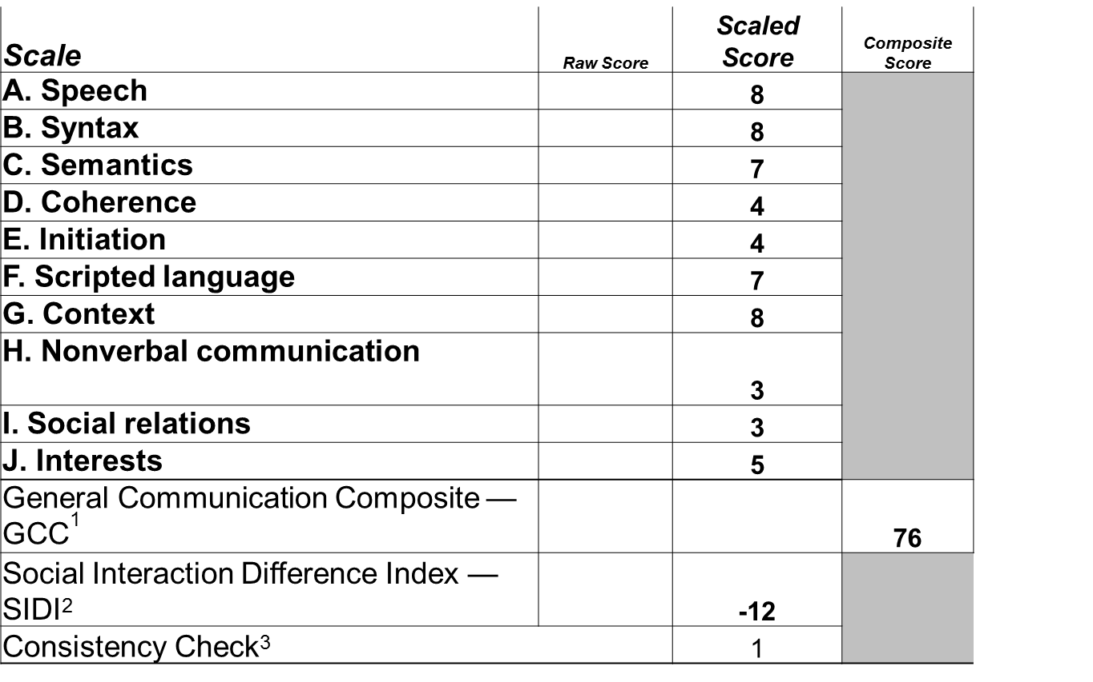
Alternative text for graphic. After the parent completes the CCC-2 rating scale, the clinician
enters all of the ratings into an excel file that is included with the CCC-2 CD Scoring-ROM and this table of scores is created. The main score of interest is the General Communication Composite score or the GCC. When you look inside the examiner's manual, you'll find that the best combination of sensitivity and specificity for identification of a language impairment is a GCC score of 85 or lower. This student has a score of 76 so this clearly suggests a communication impairment. Now the scaled scores will give you information about which area(s) the parents have most concerns about. The scale scores here are based on a mean of 10 plus or minus 3 meaning that scores of 7 or higher indicate performance generally within normal limits. This child has a Scaled Score of 8 in both Speech and Syntax scales. So, we can look at this broadly and say this child probably doesn't have a speech sound disorder or a syntactic disorder. But we do have concerns in Coherence and Initiation because both scaled scores are a 4. When I see a score below 7 in Coherence, I know that I should collect a narrative sample, because in narrative discourse you have to connect your utterances and so you have to use pronouns correctly. I also note that there's some problems here in Nonverbal Communication because he had a scaled score of 3. This could be reading nonverbal cues or displaying of nonverbal cues. So altogether this particular profile suggests that I want to do a pragmatic analysis of several language samples.

Tip Three: Listen to Sample
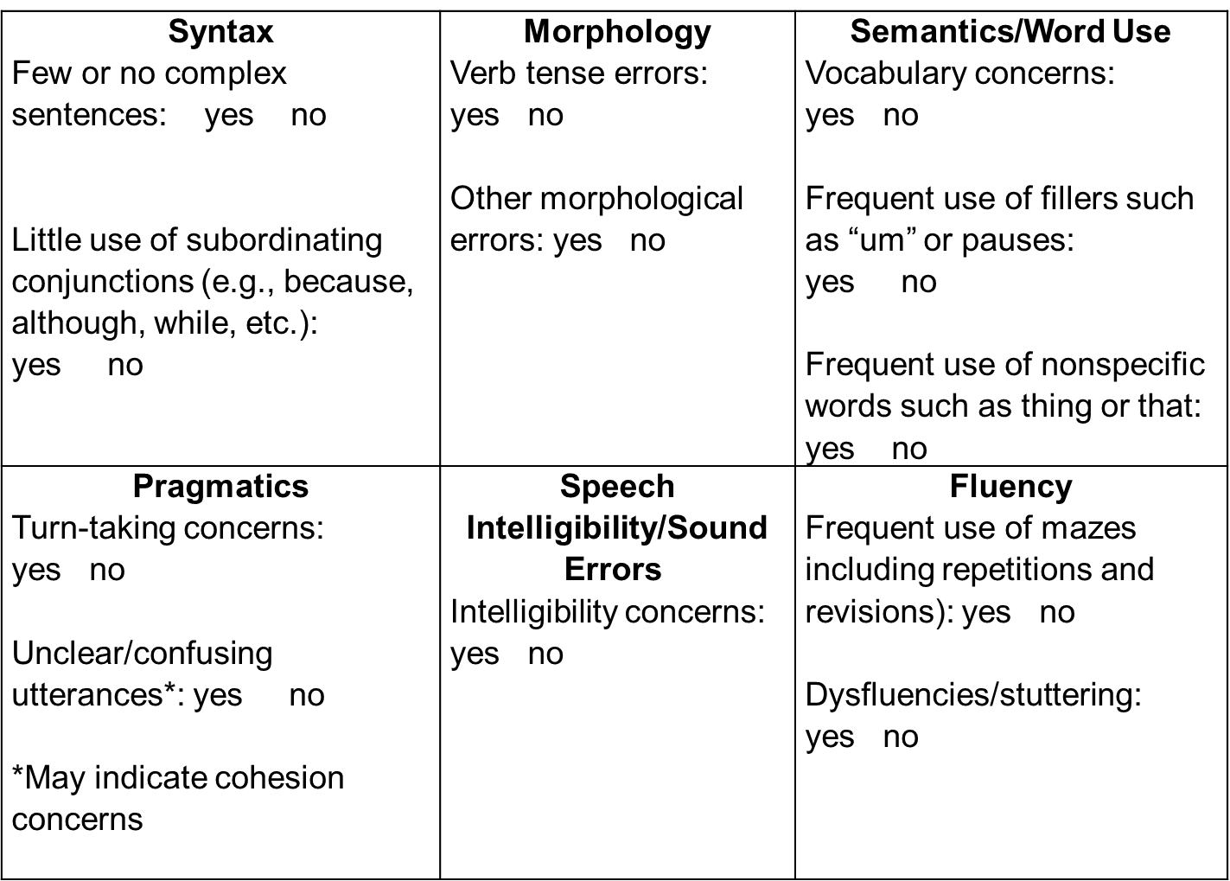
Alternative text for graphic. Here is a cover sheet that is the first page of a "Share
and Tell" rating scale, which we're going to be looking at in the next module. I developed this cover sheet, so that SLPs could make notes about errors, which would guide them in thinking about which analyses they want to do. There are boxes for syntax, morphology, semantics, pragmatics, speech intelligibility, and fluency. Each box has questions and space for writing. So, for example, in syntax, you might note if there are few or no complex sentences and limited use of subordinating conjunctions. In fact, here you could note which subordinating conjunctions you did hear. In morphology, you're going to notice or document verb tense errors and any other kind of morphological errors. In semantics and word use, you might have some general concerns about vocabulary or specifically you might note frequent use of fillers such as "um" or pauses or frequent use of nonspecific words such as "thing" or "that" which could indicate some word access problems. In pragmatics, you might note turn-taking concerns or unclear or confusing utterances, which could indicate a cohesion problem. You can note speech intelligibility concerns or list errors, writing specific substitutions, distortion, or omission errors. The final box is disfluencies or stuttering. You might note frequent repetitions and revisions which are referred to as speech disruptions or mazes. And actually, fillers and like "um" and pauses are also a type of maze, but these are noted in the semantics box.

Review of Language Sample Analyses for Conversation Samples:
1. General procedures
2. Analyses for syntax, morphology, semantics, & pragmatics

General Procedures
- Collect at least 50 utterances
- For syntax, morphology, and semantic analyses:
- May be able to transcribe student utterances only
- Consider using speech-to-text software by repeating student utterances (Pezold, et al., 2020)
- For pragmatics: may need to transcribe clinician utterances too
- Do keep recording in case you need to review student’s pragmatic skills

General Procedures
- Remember to follow transcription conventions for the normative database you will to use to compare student’s performance
- For example, conventions differ for:
- Systematic Analysis of Language Transcripts (SALT; Miller & Iglesias, 2015)
- Sampling Utterances and Grammatical Analysis Revised (SUGAR; Pavelko & Owens, 2017 & 2019)

Transcription Conventions: Morphemes

Morpheme Count Differences

SALT SUGAR*

“gonna” 1 go ing to 3

“dislike” 1 dis like 2

“foolish” 1 fool ish 2

“jump/ed” 2 jump ed 2

*SUGAR conventions give credit for student’s development of derivational morphology

Transcription Conventions: Utterance Segmentation Rules
- Student: “I like juice and I like pop and I like coffee”.
- In SALT: 3 utterances (Note “and” in utterances #2 and #3)
- I like juice.
- And I like pop.
- And I like coffee.

- In SUGAR: 2 utterances (Note omitted punctuation and “and” in utterance #2)
- I like juice and I like pop
- I like coffee

Syntactic Analyses & Goals
- Syntactic Complexity Measures focus on identification of complex sentences
- SALT: Subordination index reflecting clauses per communication-unit (C-unit)
- C-unit Definition: One main clause and attached subordinate clauses
- SUGAR: Clauses per sentence

- Possible Intervention Goals
- Increase number of complex sentences
- Increase diversity of complex sentences

Syntactic Analyses: Help!
- Need a syntax review?
- See SUGAR modules on VDOE website
- See Khan Academy videos in You Tube (note you can share these with middle and high schoolers during your intervention sessions too):
- Dependent and independent clauses
- Subordinating conjunctions
- Clauses
- Types of clauses

Morphological Analyses
- MLU-M: mean length of utterance per morpheme
- Robust clinical marker of language impairment in preschoolers who use Standard American English (SAE)
- Identify/code morphological errors especially in verb phrases
- May see more errors in complex sentences

- BUT: Morphological and syntactic rules differ in Culturally and Linguistically Diverse (CLD) populations
- See Leader’s Project for dynamic assessment
- ASHA practice portal on Spoken Language Disorders

Morphological Goals
- Possible Intervention Goals
- Increase length of noun and verb phrases
- Increase production of specific morphemes (e.g., past tense)
- Reduced MLUsugar: follow up with SUGAR sub analysis (see VDOE SUGAR modules)

Semantic Analyses & Goals
- Normative data available for:
- Number of Total Words/Total Number of Words (NTW/TNW)
- Number of Different Words (NDW): vocabulary diversity (caution: dependent on number of topics discussed in the sample)
- ALSO: Consider a student’s SES when interpreting data!
- Count/describe:
- Number of lexical errors or incorrect word use (Charest & Skoczylas, 2019)
- Number of nonspecific words (thing, stuff, this, it)
- Possible Intervention Goals
- Increase use of curriculum-based vocabulary
- Decrease use of nonspecific words

Speech Disruptions (Mazes)
- Definition: repetitions, revisions, silent pauses of 2 seconds or more, and filled pauses (e.g., um):
- “(I I I) I did/n’t know that.”
- “If we only ran faster, (we we we) she could have catched *caught him.”
- “We could/n’t go because (0:04) (um um) (the car) my mom forgot the gas.”
- If you notice a number of speech disruptions, transcribe them
- Significance of speech disruptions
- Word access/retrieval difficulties
- Formulation difficulties

Speech Disruption/Maze Analysis

Criterion Referenced Cut: More than 7-8 mazes per 100 words indicates significantly “tangled” speech (Paul, Norbury, & Gosse, 2018)

Directions:
- Count the number of words and pauses in mazes and the number of unmazed words
- Recall that mazes include filled and unfilled pauses, repetitions, and revisions
- Divide the number of mazed words & pauses by the number of unmazed words and multiply by 100
- Result is %occurrence of mazes per 100 unmazed words

Speech Disruption: Intervention Goals
- For filled and unfilled pauses and use of nonspecific words possibly indicating word access/retrieval difficulties
- Increase use of curriculum-based academic and social vocabulary
- Teach compensatory strategies for describing vocabulary
- For repetitions and revisions
- Increase production of complex sentences
- Use visual supports for planning of narratives and expository discourse

Pragmatic Analyses: More Info in Next Module
- Count the number of student’s unresponsive and noncontingent (i.e., unexpected/off topic) turns
- Transcribe or count while listening
- Provide comments as well as questions (more in the next module)
- Complete a rating scale while listening/looking at sample
- Rate verbal and nonverbal behaviors
- Need video recording to rate eye contact, facial expression, gestures, body posture, etc.

Pragmatic Analyses
- Cohesion Analysis (ties across utterances)
- Unclear/confusing use of pronouns and articles
- Easiest to view in narrative, expository, and persuasive samples
- “Once two boys, Bill and Ryan, were running away. Then he fall down and he just kept running. So, he got there first.”
- Is it Bill or Ryan?

Pragmatic Analyses: Intervention Goal Examples
- Increase number of consecutive turns in conversation
- Produce three on topic comments or questions
- Use eye contact to monitor listener interest
- And so many more

Summary
- For identification of impairment to determine eligibility and establish baseline:
- Complete comprehensive syntactic, morphological, and semantic analyses
- Pragmatic analysis
- Intervention planning:
- Complete analyses related to concerns after listening to the sample:
- Cohesion analysis
- Speech disruption or maze analysis

Sampling/Transcription Resources
- SALT: https://www.saltsoftware.com/
- SUGAR: https://www.sugarlanguage.org/
- Talkbank: https://talkbank.org/
- Virginia Dept. of Ed. – SUGAR modules and other Professional Development modules for SLPs
- Nippold, A. (2014). Language Sampling with Adolescents: Implications for Intervention. (Plural Publishing)
- Share and Tell Collection Protocol for Eliciting Utterance and Text-Based Samples—see Module Three

Next Steps
- Take the knowledge check for Module Two
- Listen to Module Three, Pragmatic Language Sampling and Analyses

