Comprehensive Literacy Webinar Series
Best Practices for Co-Teaching in the Elementary and Secondary Classrooms

Co-Teaching
Co-Teaching is a special education service delivery model that is designed to help students with disabilities:
- access a rigorous general education curriculum in the least restrictive environment (general education classroom)
- while receiving support from two certified teachers

Regulations Governing Special Education Programs for Children with Disabilities in Virginia (PDF) defines co-teaching and collaboration in the following manner:
- co-teaching” means a service delivery option with two or more professionals sharing responsibility for a group of students for some or all of the school day in order to combine their expertise to meet student needs
- collaboration” means interaction among professionals as they work toward a common goal; teachers do not necessarily have to engage in co-teaching in order to collaborate

In order to provide effective evidence-based practices and specially designed instruction, the general and special education teachers must be involved in:
- co-planning: co-teachers intentionally plan together to facilitate meaningful lessons
- co-instructing: each teacher should be actively involved in the instructional process for all students, and each teacher should bring a unique skill set to the classroom.
- co-assessing: the co-teachers work together to provide and analyze formative and summative assessments which inform instruction

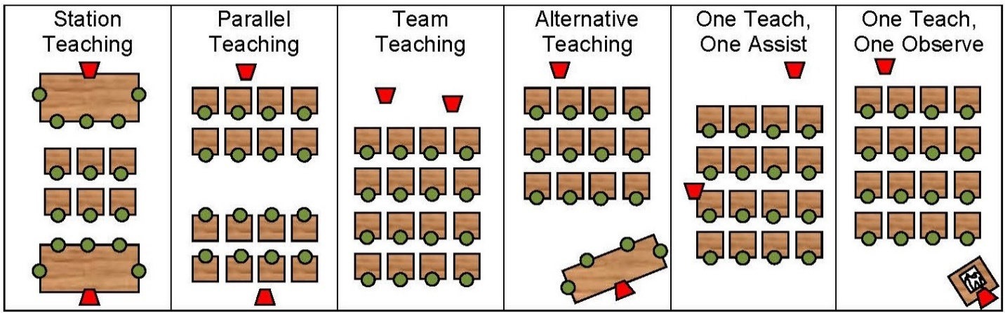

Station , Parallel and Team teaching models decrease the student to teacher ratio and increase the opportunities for student teacher interactions. These models should be used most frequently in the co-taught classroom.

Standards Based IEP VDOE Standard Based IEP webpage
Students with disabilities who have identified weaknesses in language arts must have:
- a standards-based IEP with goals based on a grade level standards
- special education which includes specially designed instruction, supplementary aids and services
- instruction provided in the least restrictive environment and that may be the co-taught classroom

Development of a Standards based IEP:
- describes a process in which the IEP teams has incorporated state content standards in its development
- includes specific accommodations and modifications addressing student’s needs to access the general education instructional program

Does a standards-based IEP imply that the student is on grade-level in that content area?
- no, the student may not be on grade level, but is working toward meeting grade-level expectations and receiving grade-level content instruction.
- the IEP should address what needs to happen in order for the student to meet the grade level standards; the IEP team needs to analyze the student’s current performance, determine what the student needs to learn, and then address specialized instruction, related services and supports in the IEP.

Example of Standard based goal based on Reading Standard of Learning 3.5
By the end of the third grading period, using grade level fictional reading materials and graphic organizers, the student will determine the sequence of events, draw conclusions, and summarize the content with 80% accuracy.
Specially Designed Instruction: Provision of Specially Designed Instruction (SDI); a requirement of IDEA
Specially designed instruction (SDI) means:
- adapting, as appropriate to the needs of an eligible child, the content, methodology, or delivery of instruction (8VAC20-81-10) to:
- address the unique needs of the child that result from the child’s disability; and
- ensure access of the child to the general curriculum so that the child can meet the educational standards that apply to all children within the jurisdiction of the local educational agency
- the provision of aids and services; what the student needs in order to get access to the general education curriculum
Accommodations provide adaptations for a student with a disability without setting different expectations and modifications require that students with disabilities perform objectives that are different from those of the rest of the class (content or task may be reduced in depth and complexity).

Examples of SDI for Reading /Writing
- teacher uses a Multisensory Structured Literacy approach to teaching reading, spelling, and writing
- teacher uses a sentence writing approach to teach students how to write effective sentences
- teacher uses vocabulary linking strategy to teach word meanings
Examples of Accommodations
- extended time on assignments, read aloud, clarify or simplify written directions, provide graphic organizers and visual cues, provide copy of lecture notes, change response mode, reduce amount of copying, pre-teach vocabulary and grammar, Assistive Technology, Google extensions or apps

Generally, accommodations are the same for classroom instruction, classroom assessments, and state assessments. Although accommodations for instruction and assessments are integrally intertwined, it is critical to note that some accommodations may be appropriate for instructional use, yet inappropriate and not permitted for use on state assessments.

Resources:
VDOE Specific Learning disabilities webpage
VDOE Assistive Technology webpage
Assistive Technology Network
VDOE Participation and Inclusion in SOL testing
VDOE Specific Disabilities
AIM:VA, Bookshare
TTAC Online
Regulations Governing Special Education Programs for Children with Disabilities in Virginia

University of Kansas (Strategic Instruction Model “SIM” strategies)
The Word Mapping Strategy (explicit instruction in morphology)
The LINCS Vocabulary Strategy (deep learning of vocabulary)
The Fundamentals of Paraphrasing and Summarizing Strategy (explicit instruction in identifying main idea)
The Self Questioning Strategy (explicit instruction in making predictions and questioning)
Structured Literacy (explicit systematic foundational skills instruction)
Graphic organizers for reading comprehension:
Scholastic
Florida Center for Reading Research
Thinking Maps

