VIRGINIA MIGRANT EDUCATION
  - SERVICE DELIVERY PLAN 2019-2020

December 2019

Prepared By Applied Learning Technology Associates
Bill Bansberg Ed.D.

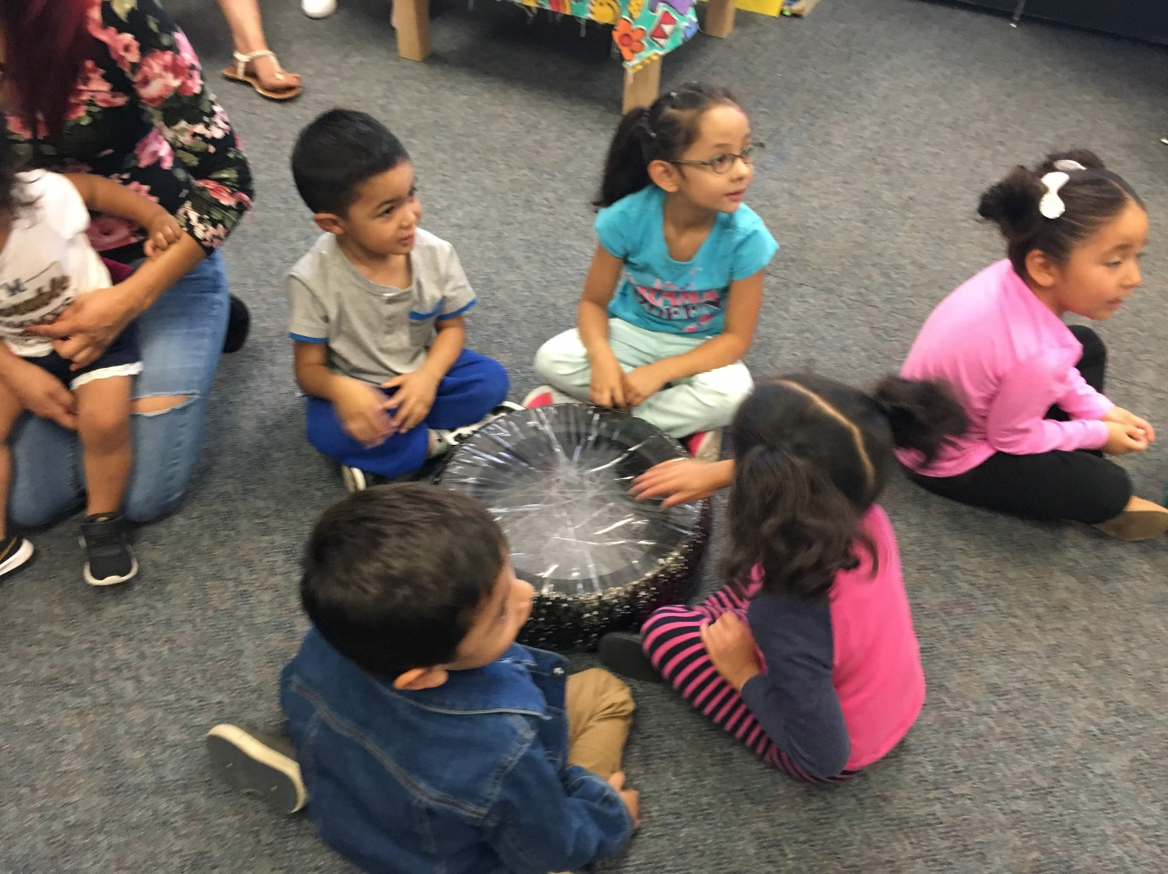

Introduction
The United States Office of Migrant Education requires that all states complete a comprehensive needs assessment in migrant education and use the results of that needs assessment to guide service delivery in the state. In addition, it is required that states use a continuous improvement model and evaluate the impact of the service delivery plan on student needs and finally evaluate the impact of service delivery on meeting student needs. The original guidance from OME is clear in regard to the goal of the needs assessment and the service delivery plan as follows:
The primary purpose of the comprehensive needs assessment is to guide the overall design of the MEP on a statewide basis. It is not sufficient to simply document the need for the program (e.g., 50 percent of migrant students are not proficient in reading, or 30 percent of migrant students do not graduate from high school). Rather, SEAs and local operating agencies must identify the special educational needs of migrant children and determine the specific services that will help migrant children achieve the State’s measurable outcomes and performance targets. . . .
SEAs are also required to develop a comprehensive State plan for service delivery that describes the strategies the SEA will pursue on a statewide basis to help migrant children achieve the performance targets that the State has adopted for all children in reading and math, high school graduation, reducing school dropouts, school readiness (where applicable), and any other performance target that the State has identified for migrant children.
The SEA's comprehensive State plan for service delivery is the basis for the use of all MEP funds in the State. . . .

The Virginia Migrant Education Program comprehensive needs assessment process was completed in 2019. The Virginia CNA committee consists of the district migrant administrators and staff of the six migrant programs. The CNA committee met on April 10, 2019 in Richmond to target needs in concert with the external contractor (Applied Learning Technology Associates - ALTA). Most of the committee members from the six MEP programs participated through video teleconferencing. The committee identified the following concern statements based on current baseline data regarding students’ needs to be investigated further through the CNA process.

The identified concern statements are as follows:

Concern 1: We are concerned that significant numbers of migrant students in Virginia are not proficient in reading/language arts and the migrant program needs to effectively target the foundational skills necessary to ensure that students are acquiring the basic building blocks necessary to master reading and writing.

Concern 2: We are concerned that significant numbers of migrant students in Virginia are not proficient in mathematics and the migrant program needs to effectively target the foundational skills necessary to ensure that students are acquiring the basic building blocks necessary to master essential mathematic skills.

Concern 3: We are concerned that there is a low graduation rate and retention rate for migrant students in Virginia, and there is a need to identify the critical barriers to success and to target the most effective instructional and other strategies to increase graduation rates for migrant students, particularly for those that are priority for service students.

Summary of 2019 Needs Assessment Results

The analysis of the 2019 CNA data was performed by ALTA and the information was used by the CNA committee to develop the recommendations for the service delivery plan. The following summarizes key results:

- The overall assessment of needs in relation to concern statement 1 (migrant students are not achieving proficiency in language arts) indicated:

- The average migrant student had a mean score on 2.28 (Basic) on the state assessment (i.e. significantly less than proficient)
- The mean teacher rating for Priority For Service (PFS) student in language art was 2.28 (Basic) level.
- Language Arts proficiency is significantly lower for migrant students who are Pre-K through 1st grade and in 6th grade.
- The Westmoreland MEP Program has significantly higher language arts proficiency on both the state assessment and the teacher ratings
- The critical areas of need in language arts are writing, reading fluency and reading vocabulary.
- Writing is the highest need across every MEP program
- The highest areas of reading needs identified thorough the assignment of tutorials on the Migrant Literacy NET are phonics and vocabulary.
- The most effective strategies identified by program staff to impact language arts proficiency are small group instruction, tutoring and the Migrant Literacy NET tutorials.
- English language acquisition is a significant barrier to language arts proficiency for many migrant students

- The overall assessment of needs in relation to concern statement 2 (migrant students are not achieving proficiency in math) indicated that the following needs were identified as significant and having an impact on service delivery:

- The average migrant student had a mean score on 2.57 (Basic Plus) on the state math assessment (i.e. moving toward proficient)
- The mean teacher rating for Priority For Service (PFS) student in math was 2.24 (Basic) level.
- Math proficiency is significantly lower for migrant students who are Pre-K through 2nd grade.
- The Westmoreland MEP Program has significantly higher mathematics proficiency on both the state assessment and the teacher ratings
- The critical areas of need in mathematics are algebra readiness, number sense and basic operations, mathematical representations and reasoning.
- English language acquisition is a significant barrier to mathematics proficiency for many migrant students

- The overall assessment of needs in relation to concern statement 3 (barriers to school retention and graduation for migrant students) indicated that the following needs were identified as significant and having an impact on service delivery:

- Need to provide services to enhance proficiency in vocabulary in reading.
- Need to provide services to enhance proficiency in reading comprehension.
- Need to provide services to enhance proficiency in writing.
- Need to provide assistance with issues related to credit accrual & record transfer.
- ESL support for EL students at the secondary level.
- Option to acquire a GED.
- Counseling and parent involvement activities to emphasize the importance of graduation.

Service Delivery

The Office of Migrant Education requires that the service delivery plan "must describe the SEA strategies for achieving the performance targets and measurable outcomes." The guidance also indicates that the state's service delivery strategy must address the unique needs of migrant students as part of the service delivery strategy. The Virginia Service Delivery Plan is keyed to the needs of migrant students based on the results of the comprehensive needs assessment and the last migrant program evaluation. The Virginia CNA committee met on December 4th, 2019 in Richmond to review the CNA results and to create the Service Delivery Plan based on those results.

Development of Performance Targets: Performance targets for Migrant Education are were developed by the CNA committee in response to the results of the needs assessment and reflect the goals established by the Virginia ESSA Plan. The Virginia ESSA Plan was originally approved on September 21, 2017 by the Virginia State Board of Education. The plan indicated proficiency goals for all students disaggregated by group. The following tables are excerpted directly from the Virginia Department of Education Federal Accountability web page. These tables indicate the state performance indicators in language arts, mathematics and graduation.

Reading
**Subgroups that meet or exceed the target must improve from the previous year.
N/A | Baseline | Year 1 Targets | Year 2 Targets | Year 3 Targets | Year 4 Targets | Year 5 Targets | Year 6 Targets | Year 7 Targets  Long Term Goal
Assessment Yr. | 2015-2016 | 2017-2018 | 2018-2019 | 2019-2020 | 2020-2021 | 2021-2022 | 2022-2023 | 2023-2024
Accountability Yr. | N/A | 2018-2019 | 2019-2020 | 2020-2021 | 2021-2022 | 2022-2023 | 2023-2024 | 2024-2025
All students | 73 | 73 | 73 | 73 | 74 | 74 | 74 | 75
Asian students | 87 | 87 | 87** | 87** | 87** | 87** | 87** | 75**
Black students | 58 | 60 | 62 | 65 | 67 | 70 | 72 | 75
Economically Disadvantaged students | 60 | 62 | 64 | 66 | 68 | 70 | 72 | 75
English Learners | 50 | 53 | 57 | 60 | 64 | 67 | 71 | 75
Hispanic students | 62 | 63 | 65 | 67 | 69 | 71 | 73 | 75
Students with Disabilities | 35 | 39 | 45 | 51 | 57 | 63 | 69 | 75
White students | 81 | 81 | 81** | 81** | 81** | 81** | 81** | 75

Math
**Subgroups that meet or exceed the target must improve from the previous year.
N/A | Baseline | Year 1 Targets | Year 2 Targets | Year 3 Targets | Year 4 Targets | Year 5 Targets | Year 6 Targets | Year 7 Targets  Long Term Goal
Assessment Yr. | 2015-2016 | 2017-2018 | 2018-2019 | 2019-2020 | 2020-2021 | 2021-2022 | 2022-2023 | 2023-2024
Accountability Yr. | N/A | 2018-2019 | 2019-2020 | 2020-2021 | 2021-2022 | 2022-2023 | 2023-2024 | 2024-2025
All students | 74 | 74 | 75** | 75** | 75** | 75** | 75** | 70**
Asian students | 89 | 89 | 91** | 91** | 91** | 91** | 91 ** | 70**
Black students | 60 | 60 | 60 | 62 | 64 | 66 | 68 | 70
Economically Disadvantaged students | 62 | 63 | 63 | 64 | 66 | 67 | 68 | 70
English Learners | 55 | 57 | 61 | 62 | 64 | 66 | 68 | 70
Hispanic students | 63 | 64 | 65 | 66 | 67 | 68 | 69 | 70
Students with Disabilities | 39 | 42 | 40 | 46 | 52 | 58 | 64 | 70
White students | 81 | 81 | 83** | 83** | 83** | 83** | 83** | 70**

Federal Four Year Graduation Rate
**Subgroups that meet or exceed the target must improve from the previous year.
N/A | Baseline | Year 1 Targets | Year 2 Targets | Year 3 Targets | Year 4 Targets | Year 5 Targets | Year 6 Targets | Year 7 Targets Long Term  Goal
Assessment Yr. | 2015-2016 | 2017-2018 | 2018-2019 | 2019-2020 | 2020-2021 | 2021-2022 | 2022-2023 | 2023-2024
Accountability Yr. | N/A | 2018-2019 | 2019-2020 | 2020-2021 | 2021-2022 | 2022-2023 | 2023-2024 | 2024-2025
All students | 84 | 84 | 84** | 84** | 84** | 84** | 84** | 84**
Asian students | 90 | 90 | 90** | 90** | 90** | 90** | 90** | 84**
Black students | 82 | 82 | 82 | 82 | 83 | 83 | 83 | 84
Economically Disadvantaged students | 77 | 78 | 79 | 80 | 81 | 82 | 83 | 84
English Learners | 62 | 65 | 68 | 71 | 74 | 77 | 80 | 84
Hispanic students | 81 | 81 | 81 | 82 | 82 | 83 | 83 | 84
Students with Disabilities | 52 | 56 | 61 | 65 | 70 | 74 | 79 | 84
White students | 86 | 86 | 86** | 86** | 86** | 86** | 86** | 84**

The group which most closely represents migrant students in Virginia are the English Learners. Therefore, the performance targets related to language arts, math proficiency and graduation for migrant students reflect similar targets as the state targets for English Learners (EL).

The following performance indicators are based on the Virginia ESSA Plan five year goals and reflect needs assessment results for migrant students:

Performance Target #1 Language Arts Achievement: By the 2024-2025 seventy-five percent of all migrant students enrolled in migrant programs for at least three years will score at the proficient level (rubric score of 3.0 or higher) in language arts based on available state assessment scores or teachers ratings of student proficiency in the language arts standards.
Performance Target #2 Math Achievement: By the 2024-2025 sixty-six percent of all migrant students enrolled in migrant programs for at least three years will score at the proficient level (rubric score of 3.0 or higher) in mathematics based on available state assessment scores or teachers ratings of student proficiency in the language arts standards.
Performance Target #3 Overcoming Barriers to Graduation: By the 2024-2025 academic year 84% of all migrant students eligible to graduate (including EL students) and enrolled in migrant education programs for at least 3 years will graduate on time.

Measurable Program Outcomes
The Office of Migrant Education requires: “The plan must include the measurable outcomes that the MEP will produce statewide through specific educational or educationally-related services. (See section 1306(a)(1)(D) of the statute.) Measurable outcomes allow the MEP to determine whether and to what degree the program has met the special educational needs of migrant children that were identified through the comprehensive needs assessment. The measurable outcomes should also help achieve the State’s performance targets.” Measurable Program Outcomes (MPOs) for Migrant Education were developed by the CNA committee focused on achieving the performance and reflect the specific results of the needs assessment in relation to the goals established by the Virginia ESSA Plan.
Measurable Outcome #1 Phonemic Awareness: By the end of the 2020-2021 school year and each year thereafter, proficiency in phonemic awareness skills in reading will increase by an average of 4 percent for migrant students targeted as below proficient in beginning reading skills as measured by state assessment results, teacher ratings and/or other assessments of student performance.

Measurable Outcome #2 Writing: By the end of the 2020-2021 school year and each year thereafter, proficiency in writing will increase by an average of 4 percent for all migrant students as measured by state assessment results, teacher ratings and/or other assessments of student performance.

Measurable Outcome #3 Vocabulary: By the end of the 2020-2021 school year and each year thereafter, proficiency in reading vocabulary skills will increase by an average of 4 percent for migrant students targeted for reading instruction as measured by state assessment results, teacher ratings and/or other assessments of student performance.

Measurable Outcome #4 Algebra Readiness: By the end of the 2020-2021 school year and each year thereafter, proficiency in algebra readiness skills (patterns, functions, and algebra) will increase by an average of 3 percent for migrant students targeted for mathematics instruction as measured by state assessment results, teacher ratings and/or other assessments of student performance.

Measurable Outcome #5 Number Sense & Basic Operations in Math: By the end of the 2020-2021 school year and each year thereafter, proficiency in number sense and computation will increase by an average of 3 percent for migrant students targeted for mathematics instruction as measured by state assessment results, teacher ratings and/or other assessments of student performance.

Measurable Outcome #6 Mathematical Representation and Reasoning: By the end of the 2020-2021 school year and each year thereafter, proficiency in the Virginia SOL process goals and standards (problem solving, communication, reasoning, connections, and representations) will increase by an average of 3 percent for migrant students targeted for mathematics instruction as measured by state assessment results or teacher ratings and/or other assessments of student performance.

Measurable Outcome #7 Reading Comprehension for Secondary Migrant Students: By the end of the 2020-2021 school year and each year thereafter, proficiency in reading comprehension skills will increase by an average of 5 percent for secondary migrant students identified as less than proficient in reading as measured by state assessment results, teacher ratings and/or other assessments of student performance.

Measurable Outcome #8 Overcoming Barriers to Graduation through Family Engagement: By the end of the 2020-2021 school year and each year thereafter, 75 percent of secondary migrant students and parents who participate in MEP sponsored family engagement activities targeting the importance of graduation will report increased understanding of the importance of school completion as measured by student and parent surveys.

Measurable Outcome #9 Facilitation of Credit Accrual and Record Transfer for Migrant Students: By the end of the 2020-2021 school year and each year thereafter, 75 percent of staff who participate in trainings provided by the MEP program on how to assist migrant students with credit accrual and records transfer will report an increased ability to effectively assist students overcome these barriers to graduation as measured by staff surveys.

Measurable Outcome #10: Assistance to Students Who Dropout: By the end of the 2020-2021 school year and each year thereafter, 100 percent of dropout students will receive information about educational services specific to their situation as measured by agendas and communication logs.

Measurable Outcome #11 Improving School Readiness through Family Engagement: By the end of the 2020-2021 school year and each year thereafter, 75 percent of preschool migrant parents who participate in MEP sponsored family engagement activities targeting the importance of school readiness will report an increased awareness of community resources to help them support the school readiness of their children as measured by parent surveys.

Measurable Outcome #12 School Readiness: By the end of the 2020-2021 school year and each year thereafter, proficiency in school readiness skills will increase by an average of 3 percent for migrant students who participated in preschool as measured by state assessment results, teacher ratings and/or other assessments of student performance.

Local Program Compliance

All local or regional programs who apply for migrant funds must describe in the application how they plan to meet the performance targets and measurable outcomes (MPOs). Districts may choose their own strategies (e.g. use of the Migrant Literacy NET tutorials and lessons, etc.) to address the performance targets and MPOs.

Cooperation and Collaboration with Other ESEA Programs and Other Agencies

The Virginia migrant program director maintains regular meetings with all ESEA programs (including Title 1 Part A, Homeless Education, Title III, etc.) to discuss possibilities for cooperation and collaboration among programs for the benefit of migrant students. In addition, the state migrant program has maintained a long term partnerships with Head Start and other agencies to meet the needs of migrant students.

Service Delivery Recommendations for Local Migrant Programs

The CNA/Service Delivery committee reviewed the data analysis and results for the needs assessment process and provides the following recommendations to local and regional MEP programs for service delivery.

Recommendation 1: Implement tutoring and small group instruction in reading and math for migrant students into academic year and summer programs.

Recommendation 2: Utilize instructional materials specifically designed for migrant students (e.g. materials from the Migrant Literacy NET including the lesson plans and online tutorials for students).

Recommendation 3: Develop individual learning plans for all Priority For Service (PFS) migrant students (e.g. the electronic Success Plans on the Migrant Literacy NET).

Recommendation 4: Utilize bilingual and bicultural staff and materials whenever possible for instruction.

Recommendation 5: Target writing, phonemic awareness, vocabulary and reading comprehension instruction for Priority For Service (PFS) migrant students.

Recommendation 6: Target number sense; basic operations; and mathematical representation and reasoning instruction for Priority For Service (PFS) migrant students in Grades K-4 in math.

Recommendation 7: Target algebra, patterns and functions and measurement for students in grades 5-12 in math.

Recommendation 8: Utilize the electronic graduation plans specifically designed for secondary migrant students on the Migrant Literacy NET to assist students to overcome barriers to graduation.

Recommendation 9: Provide training at PAC meetings and after-school workshops for parents and students to assist in overcoming barriers to high school graduation, to provide parents with strategies to assist their children at home with reading and math and to facilitate support of school programs

Recommendation 10: Utilize course data from MSIX and other sources as well as transcripts to transfer data from high school to high school.

Recommendation 11: Utilize the P.A.S.S. program to fill in credit accrual gaps.

Recommendation 12: Develop strategies and informational resources for students who are dropouts to facilitate academic proficiency in reading and math, credit accrual toward graduation and/or the completion of a GED.

Evaluation

The Office of Migrant Education requires that in the service delivery plan the state must evaluate to what degree the program has been effective in relation to performance targets and measurable outcomes. The service delivery process in Virginia is based upon a continuous improvement model. The steps in the process include the following:

- Identify the needs of migrant students in reading, math, overcoming barriers to graduation to facilitate school success (e.g. attendance, transportation, collaboration, etc.).

- Implement service delivery strategies to achieve the performance targets and measurable outcomes in the service delivery plan designed to meet the needs of migrant students in reading, math, overcoming barriers to graduation and school success. Each local migrant program will have the option to individualize instruction and utilize strategies based on their own needs and structure.

- Evaluate the impact of the service delivery strategies on reading achievement, math achievement, removing barriers to graduation and school success. Utilize results to guide program improvement and to identify additional needs.

The external evaluator, Applied Learning Technology Associates (ALTA), will be used to provide an objective, third-party, researched-based evaluation of the service delivery plan. Both formative and summative evaluation will be implemented. Formative evaluation will include an investigation into the implementation of the service delivery plan. Specifically, districts will be surveyed to ascertain exactly which strategies they implemented to meet the measurable outcomes and performance targets, what materials they used, which students they targeted, and to what extent were the strategies used. In addition, the evaluation will identify local programs that are providing particularly effective services toward meeting the needs of students in order to share best practice with all programs statewide.

The summative evaluation will include two types of data: quantitative and qualitative. The purpose of the summative evaluation is to assess the actual impact on students of the service delivery plan and strategies. Quantitative data will be collected using a variety of methods including data collected on individual student performance in relation to the targeting reading and math skills as well as English language proficiency. The data collected will include state assessment scores (when available), teacher ratings comparing progress from one year to the next, WIDA (ACCESS) scores to measure English language proficiency growth, as well as other data from pre- and post-assessments (if available) targeting reading skills and math skills and overcoming barriers to education. The qualitative data will also include surveys of migrant teachers, administrators and parents regarding the effectiveness of the service delivery strategies toward achieving the measurable outcomes and performance targets.

ALTA will compile and analyze the results of the evaluation and present the findings to the Virginia Comprehensive Needs Assessment/Service Delivery Committee. The results will be used to identify and expand successful practices as well as to target program weaknesses and continuing needs for modification. The committee will make recommendations toward improved service delivery which will be included in a final evaluation report of the effectiveness of the service delivery plan to the State Director of Migrant Education. This report will be completed by Applied Learning Technology Associates (ALTA). The final report will be submitted to the Virginia Director of Migrant Education by December 31st, 2020.

