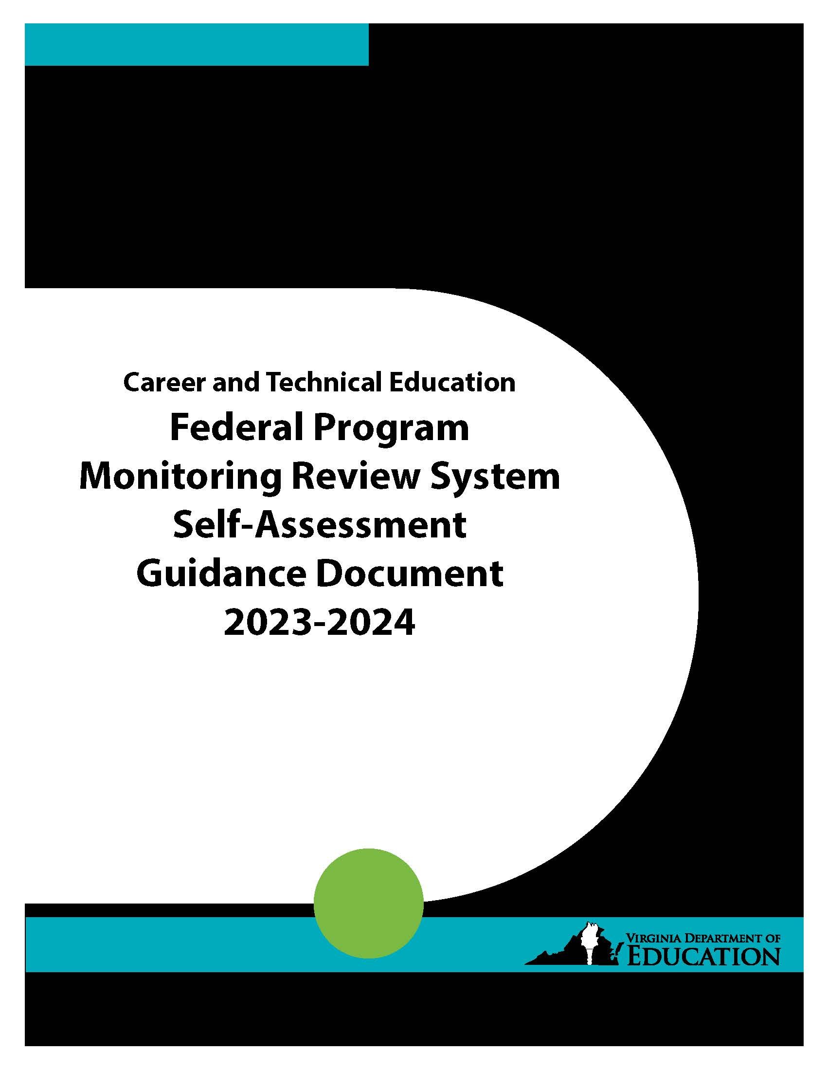

Career and Technical Education
Federal Program Monitoring Review System
Self-Assessment

2023-2024
Complete and submit the Self-Assessment and signed (blue ink) Statement of Assurance by email, with the school division’s 2024-2025 CTE Local Plan by
April 30, 2024 to the
Office of Career, Technical, and Adult Education at: cte@doe.virginia.gov.

The self-assessment template is available on the VDOE website.

For technical assistance contact:
William A. Hatch, CTE Coordinator for Planning, Administration, and Accountability, at
(804) 418-4720; or cte@doe.virginia.gov.

(Rev: 10/2023)
Virginia Department of Education
Office of Career, Technical, and Adult Education
P.O. Box 2120
Richmond, Virginia 23218-2120

INSTRUCTIONS FOR COMPLETING THE
CAREER AND TECHNICAL EDUCATION SELF-ASSESSMENT

The following strategies are offered for completing the self-assessment:

COORDINATION OF MONITORING ACTIVITIES

Each school division should consider designating an individual to coordinate the division's monitoring activities. The local coordinator’s responsibilities might include the following:

- Serve as the liaison between the school division and the Virginia Department of Education, Office of Career, Technical, and Adult Education

- Provide guidance and direction for conducting the self-assessment

- Provide guidance to ensure timely implementation of corrective actions when deficiencies and concerns are identified

- Review reports with the school division superintendent, local school board, and CTE advisory committee

THE ASSESSMENT PROCESS

School divisions are given flexibility in determining how the division will conduct the self-assessment. A school-by-school assessment is recommended and the results compiled into a school division report. School divisions are encouraged to establish a diverse committee to conduct the review. The committee composition should include representatives of the following: school administrators (including building principals), teachers, parents, local advisory committee, support personnel, and other individuals as appropriate. Team members should be knowledgeable about the CTE program and have an understanding of program requirements. The number of individuals on the committee may vary depending on the size of the schools, school division, and CTE program.

Each federal and state requirement for review has been identified in the self-assessment instrument. Careful examination of each standard, question, or statement should be made before determining whether the school division is meeting the requirement. The school division should seek a variety of data sources for an effective review. These might include focus group meetings, interviews, and/or surveys to reach a vast number of individuals, including parents, building principals, teachers, support personnel, and other staff members as appropriate.

The source of documentation used to verify compliance should be indicated in the self-assessment instrument. This documentation must be maintained locally for five years after completion of the self-assessment locally. When the school division determines that it is meeting a requirement, it must ensure that there is adequate documentation to support the determination. Use the comment section to provide an explanation when the committee determines that a school or the school division is not meeting a requirement, an explanation about the identified concern, or any other information for clarification of the review team’s finding. The comments will also help to facilitate the development of a program improvement plan to address any identified deficiencies and actions for overall program improvement. You may submit additional pages as needed.

How do you determine when a standard is in compliance, noncompliance, or that a concern should be noted? The general rule is that a standard is in noncompliance when there is evidence of a specific violation of procedural or other requirement, or when there is evidence of policy, procedure, or routine activity that when applied to individual students results in a violation of requirement/entitlement. When it is determined that the school division is meeting the requirement but there are identified issues that should be addressed, then these issues should be noted as a concern. The goal of the monitoring process is continuous program improvement; therefore, the objective is not only to determine compliance and make necessary corrections, but also to seek ways to improve the program and to achieve improved results for students.

If the self-assessment committee determines that the school division is not meeting a requirement, strategies to correct or address the issue(s) must be established. The plan of action should include all areas identified by the committee as needing attention. The plan must also include the following: (1) identification of the unmet requirement or area of concern, (2) specific corrective action taken or planned, (3) implementation date and person responsible, and (4) method to ensure full implementation. A suggested format for a program improvement plan follows the Requirements for Review of this assessment instrument.

PROGRAM IMPROVEMENT PLANNING

The Virginia Department of Education strives to move the current monitoring process to a system that empowers local divisions to focus on program effectiveness and student results. Through various components such as data collection and self-evaluation, school divisions identify problems, develop and initiate improvement strategies, and verify their effectiveness. The self-assessment provides the opportunity to enhance program planning efforts.

Planning for program effectiveness should not simply be an activity to complete, but a strategic procedure that supports learning and the ongoing improvement of the program. The planning process should identify important, long-range improvement issues and describe a specific set of actions to be undertaken relative to these issues. The process should detail how the division intends to make the desired improvements. Each school division’s strategic planning process should identify improvement issues and develop strategies or activities that will lead to an increase in program effectiveness.

Improvement issues can be the natural outgrowth of where the school division’s program is today and what it wants to become in the future. For this to happen, the school division must first assess its present status. There are internal and external factors that should be examined to help identify improvement issues. Internal factors deal with issues that are within the school division’s direct control and may include, but are not limited to:

- graduation rates
- dropout rates
- attendance rates
- procedural compliance results
- comparative testing results
- program completion rates

External factors generally deal with issues that are outside the school division’s direct control, but should be recognized in the division’s planning efforts. They may include, but are not limited to:

- state and federal program requirements
- recent changes in regulations
- demographic changes

Utilizing such data sources allows the school division to analyze existing gaps between “what is” and "what is desired.” After such an analysis, the school division should be able to identify the critical issues that warrant attention. Strategies deemed to have significant impact on student achievement should be developed to address the program issues. Best practices supported by research, parental involvement, curriculum and instruction, and staff development strongly influence program outcomes and student results. If school divisions are to raise academic performance for all students, monitoring must move beyond a mere event to a process of active strategic planning for program effectiveness.

