TIME AND EFFORT REPORTING

What is “Time & Effort” Reporting?

Time and effort reports are after-the-fact records that reflect how personnel charged directly to a federal grant spent their time for which they are compensated by the Local Educational Agency (LEA) or State Educational Agency (SEA). The salaries and wages of any employee charged to a federal grant must be supported by time and effort documentation that accurately reflects the work that the employee performed. Time and effort reporting applies regardless of the source of the federal funds.

2 C.F.R Part 225 (The Office of Management and Budget’s (OMB) Circular A-87, Cost Principles for State, Local, and Indian Tribal Governments) and 2 C.F.R § 200.430 requires charges to federal awards for salaries and wages must be based on records that accurately reflect the work performed. These records must be supported by a system of internal controls that provides reasonable assurance that the charges are accurate, allowable, and properly allocated. The records must be incorporated into the official records of the LEA and reasonably reflect the total activities for which the employee is compensated by the LEA in compliance with the LEA’s written policy.

The LEA must establish and maintain effective internal control over the federal award that provides reasonable assurance that the LEA is managing the federal award in compliance with federal statutes, regulations, and the terms and conditions of the federal award.

Are Time and Effort Policies and Procedures Necessary?

Written policies and procedures are essential to implementing an effective time reporting system. An LEA should develop instructions for (1) the completion of time and effort reporting; (2) the approval cycle that is required; (3) the processing of personnel charges to federal awards; and (4) the internal review process that will be established to ensure effective internal control over the federal award. Generally, the information should be in sufficient detail to permit an understanding of how the system will operate from the point the time worked to the point the time is recorded in the accounting records and charged to federal awards.

What type of reporting is needed?

Requirements for time and effort records vary based on the number of cost objectives to which an employee’s time is charged.

There are two types of required time and effort records:
- Semi-annual certification forms (employee works on one cost objective)
- Personnel Activity Reports (employee works on multiple cost objectives)

Do I use a Semi-Annual Certification or a Personnel Activity Report?

Semi-annual Certifications
If an employee works solely on a single federal award (i.e. 100% federally funded) or cost objective, charges for the employee’s salary and wages must be supported by periodic certifications that the employee worked solely on that program or cost objective for the period covered by the certification. Those certifications must:
- Be prepared at least semiannually.
- Signed by the employee or supervisor official having firsthand knowledge of the work performed by the employee.

Monthly – Personnel Activity Report (PAR)
If an employee works on multiple activities or cost objectives (i.e., less than 100% federally funded on a single grant), a distribution of the employee’s salary and wages must be supported by a PAR or equivalent documentation. The Appendix lists instances of multiple activities or cost objectives for which PAR is required – that is, if an employee works on:
- More than one Federal Award
- A Federal award and a non-Federal award.
- An indirect cost activity and a direct cost activity.
- Two or more indirect activities that are allocated using different allocation bases.
- An unallowable activity and a direct or indirect cost activity.

PARs must:
- Reflect an after-the-fact distribution of the actual activity of each employee.
- Account for the total activity for which employee is compensated.
- Be prepared at least monthly and must coincide with one or more pay periods.
- Be signed and dated by employee and supervisor.
- Represent Actual effort, not estimated effort!
- Agree to supporting documentation
- Equivalent documentation could include calendar, work product, time log
- Be timely certified after-the-fact, once work is performed (no later than one month)

Note: Time and effort reporting applies to all certificated and classified employees.

What is a cost objective?
The definition of "cost objective" is a function, organizational subdivision, contract, grant, or other activity for which cost data are needed and for which costs are incurred.
A "single cost objective," therefore, can be, for example, a single function or a single grant, or a single activity. As the examples below illustrate, it is possible to work on a single cost objective even if an employee works on more than one Federal award or is funded by a Federal award and a non-Federal award.

Example 1
Funds under Section 611 and 619 of the Individuals with Disabilities Education Act (IDEA)

A preschool special education teacher is funded with 50 percent IDEA section 611 funds and 50 percent with IDEA Section 619 funds.
Teaching preschool special education is an allowable activity under both IDEA sections 611 and 619. Accordingly, the teacher is performing a single cost objective even though she is supported with funds from two separate Federal awards; therefore, she need only file a semiannual certification.

Example 2
Section 611 funds and (State compensatory education funds/local funds)
A special education teacher who works 100 percent of the time with special education students is partially funded by IDEA Section 611 funds with the remaining portion of the teacher’s salary is funded by either State compensatory education funds or local funds. Accordingly, the teacher is performing a single cost objective even though she is supported with a combination of a Federal award and a local or state fund source; therefore, the teacher only needs a semiannual certification.

Single or multiple cost objectives?
In determining whether an employee works on one single or multiple cost objectives, the significant factor is the number of cost objectives on which the employee works, not the number of sources supporting the employee’s salary. The key to determining whether an employee is working on a single cost objective is whether the employee’s salary and wages can be supported in full from each of the Federal awards on which the employee is working, or from the Federal award alone if the employee’s salary is also paid with non-Federal funds.

What other costs are required for time and effort reporting?
Substitutes, stipends, supplemental contracts, and extra hours worked paid out of a federal grant should be included in the time and effort reporting. Documentation to support the charges may include the following:
- Sign-in or attendance logs showing the actual hours or cost objective and the document must be signed by the employee(s) and approved by the supervisor.
- Signed supplemental contracts stipulating the duty or assignment and cost objective.
- Other supporting documents as deemed necessary.

What if we fail to keep time and effort reports?
The lack of time and effort reporting is the single largest audit finding by the US Office of Inspector General (OIG) and by the VDOE Special Education Fiscal Monitoring Team. Without proper time and effort documentation, an LEA cannot prove that the salaries charged to a federal program are allowable. Costs that are not adequately documented become “questioned costs” and are subject to repayment. Since salaries and fringe benefits are the biggest cost item in most IDEA-B and Preschool applications, it is extremely important to be in compliance with the federal time and effort regulations.

What are some common errors in time and effort reporting?
- Time and effort not reviewed and signed by appropriate staff
- Entire day’s schedule not accounted for (only federal time reported)
- Accounting adjustments transferring payroll expenditures to federal programs (from state/local sources) with no supporting time and effort documentation.
- Lack of appropriate time and effort records for employee(s) with supplemental contracts/stipends and extra hours
- Failing to recognize that a change in position, duties, or funding may result in a change in time and effort reporting.
- Reporting time according to the ratios budgeted without regard to how the individual actually worked.
- Time and effort is not being certified after-the-fact or within the appropriate certification cycle

Additional guidance can be found at:
- 2 C.F.R. § 200.430 - Compensation–personal services

- 2 C.F.R. Part 225 Appendix B - Cost principles for State, Local, and Indian Tribal Governments (OMB Circulars A-87)

Any questions or concerns regarding Time & Effort can be directed to Tracie Coleman, special education budget and finance manager at Tracie.Coleman@doe.virginia.gov, or (804) 225-2704.

Please continue to the next page for sample document examples of Semi-Annul Certifications and Personnel Activity Reports.

SAMPLE DOCUMENTS

The sample documents provided are for informational purposes only. Its intended use can be determined by the school division or sub-grantee.

Sample Document 1: Semi-Annual Certification (Single cost objective)
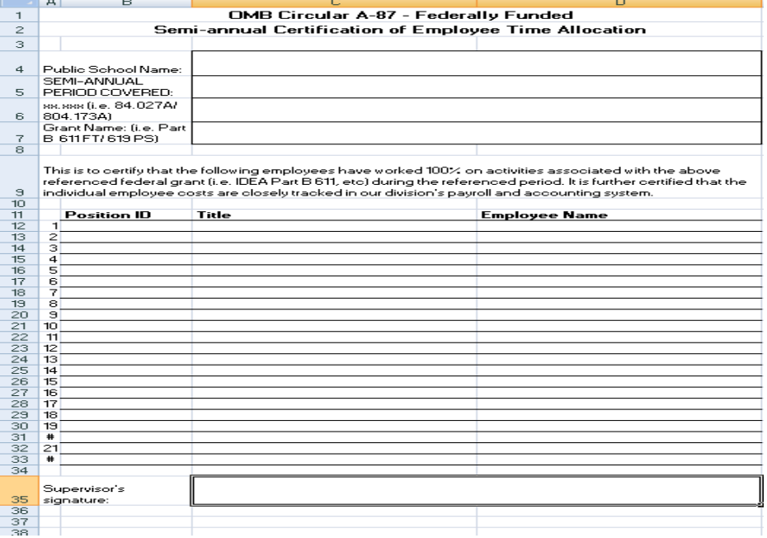

Sample Document 2: Semi-Annual Certification (Single cost objective)
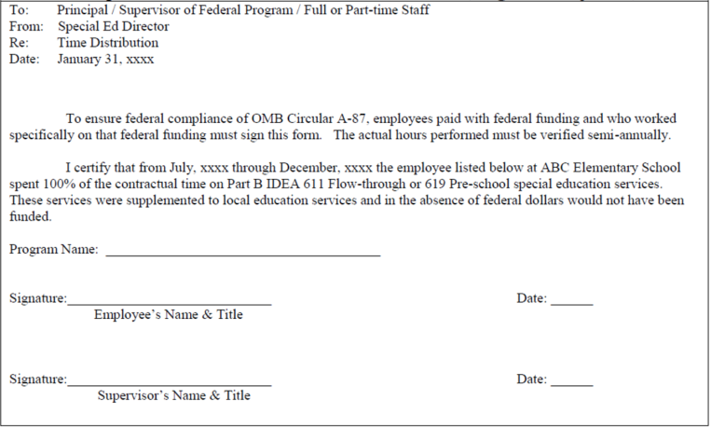

Sample Document 3: Monthly Certification (Multiple cost objective)
