Attachment A
Superintendent’s Memo #298-21
October 22, 2021
Virginia Department of Education

Individuals with Disabilities Education Act (IDEA)
Proportionate Set-Aside Guidance Document

Overview

Each local educational agency (LEA) must spend a proportionate amount of its Sections 611 and 619 allocations on providing special education and related services (including direct services) to home-schooled or parentally-placed private school children with disabilities. Section 300.133 of the Individuals with Disabilities Education Act (IDEA) specifies a formula that an LEA is required to use to determine the proportionate amount the LEA is to make available or spend to meet the requirements
of § 300.132(a).

§ 300.132 (a)

“… To the extent consistent with the number and location of children with disabilities who are enrolled by their parents in private, including religious, elementary schools and secondary schools located in the school district served by the LEA, provision is made for the participation of those children in the program assisted or carried out under Part B of the Act by providing them with special education and related services, including direct services determined in accordance with § 300.137….”

The VDOE’s Department of Special Education and Student Services (SESS) will continue to utilize the web-based application to collect school divisions’ proportionate share calculations for the fiscal year 2021-2022 grant period. This application will be made available through the Virginia Department of Education’s (VDOE’s) Single Sign-On for Web Systems (SSWS) portal.

Background

This information is taken directly from the IDEA federal regulations § 300.133 and Appendix B to Part 300 – Proportionate Share Calculation. Each LEA must expend, during the grant period, on the provision of special education and related services for the parentally-placed private school children with disabilities enrolled in private elementary schools and secondary schools located in the LEA, an amount that is equal to:

- A proportionate share of the LEA’s sub-grant under Section 611(f) of the Act for children with disabilities aged 3 through 21. This is an amount that is the same proportion of the LEA’s total sub-grant under Section 611(f) of the Act as the number of parentally-placed private school children with disabilities aged 3 through 21 enrolled in private elementary schools and secondary schools located in the LEA is to the total number of children with disabilities enrolled in public and private elementary schools and secondary schools located in the LEA aged 3 through 21.
- A proportionate share of the LEA’s sub-grant under Section 619(g) of the Act for children with disabilities aged three (3) through five (5). This is an amount that is the same proportion of the LEA’s total sub-grant under Section 619(g) of the Act as the total number of parentally-placed private school children with disabilities aged three through five enrolled in private elementary schools located in the LEA is to the total number of children with disabilities enrolled in public and private elementary schools located in the LEA aged three (3) through five (5).
Attachment A
Superintendent’s Memo #298-21
October 22, 2021

- As described in Paragraph (2) of this section, children aged three (3) through five (5) are considered to be parentally-placed private school children with disabilities enrolled by their parents in private, including religious, elementary schools if they are enrolled in a private school that meets the definition of elementary school.
- If an LEA has not expended for equitable services all of the funds described in Paragraphs 1 and 2 by the end of the fiscal year for which it was appropriated, the LEA must obligate the remaining funds for special education and related services (including direct services) to parentally-placed private school children with disabilities during the carry-over period of one additional year.
- In calculating the proportionate amount of the IDEA Part B funds that must be expended, the LEA, after a timely and meaningful consultation with a representative, must conduct a thorough and complete child find process to determine the number of parentally-placed children with disabilities attending a private school located in the district. To determine the number of parentally-placed students with disabilities attending private schools, the LEA must conduct an annual count and ensure that the count is done on any date between October 1 and December 1, inclusive, of each year. The count must be used to determine the proportionate share the LEA must spend in providing education to students with disabilities parentally-placed in private schools in the next subsequent fiscal year.
- State and local funds may supplement and in no case supplant the proportionate amount of federal funds required to be expended for parentally-placed students with disabilities under
this part.
- The proportionate share of IDEA funds must be determined before designating funds for any Coordinated Early Intervening Services (CEIS), as specified in § 300.226 of the
IDEA regulations.
- Dollar amounts must be calculated for both Sections 611 and 619 funds. The combined amounts for ages 3 through 5 and ages 3 through 21 represent the total amount that must be set-aside. The total required amount can be spent out of Section 611 funds. Lines 9 and 10 have been added to the Speced-PSA Application to calculate required set-aside amounts under IDEA American Rescue Plan (ARP) funds.

The following image outlines how the proportionate share is calculated.
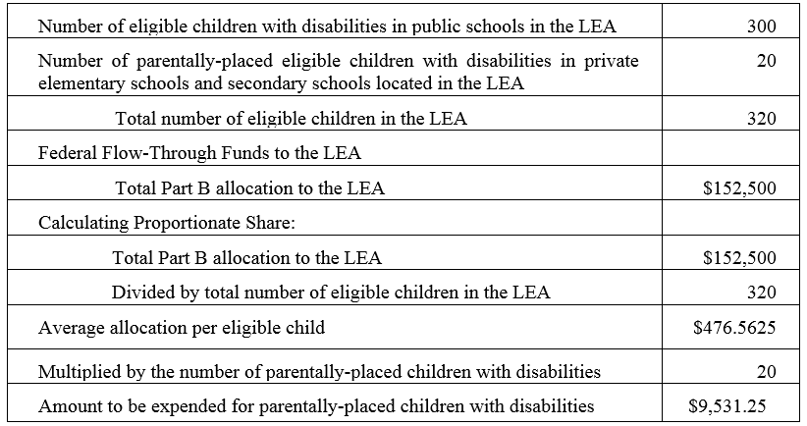

Attachment A
Superintendent’s Memo #298-21
October 22, 2021

Steps in Using the Proportionate Set-Aside (Speced-PSA) Application

General Information

The process for completing the Virginia Department of Education’s (VDOE’s) Proportionate Set-Aside (Speced-PSA) web-based application is provided to guide users reviewing information and to determine the proportionate share of the LEA’s total Part B sub-grants in providing services to home-schooled or parentally-placed private school children aged 3 through 21. The calculated amount will be the school division’s basis when requesting reimbursement through the VDOE’s Online Management of Education Grant Awards (OMEGA) system.

Proportionate share costs are not limited to direct services but can include consultative services, equipment or materials for eligible home-schooled or parentally-placed students with disabilities, or training for private school teachers and other private school personnel.

The LEAs are prohibited from using the set-aside amount for administrative costs, the costs of child find, and the evaluation process of home-schooled or parentally-placed private school students. Two enhancements have been made to the Speced-PSA Application. These enhancements will be covered in greater detail within the appropriate sections of this document.

Accessing and Using the Application

The application can be accessed through the VDOE’s SSWS portal. If the Speced-PSA Application is not available within the user’s menu page, the user must contact the school division’s local SSWS Administrator to obtain access rights. A login ID and password will be provided by the local SSWS Administrator once access rights are granted. The following link can be used to access the
VDOE home page.

- Figure 1 shows how to access the SSWS portal. Click the “SSWS Login” located at the lower right side of VDOE’s home page.

Figure 1
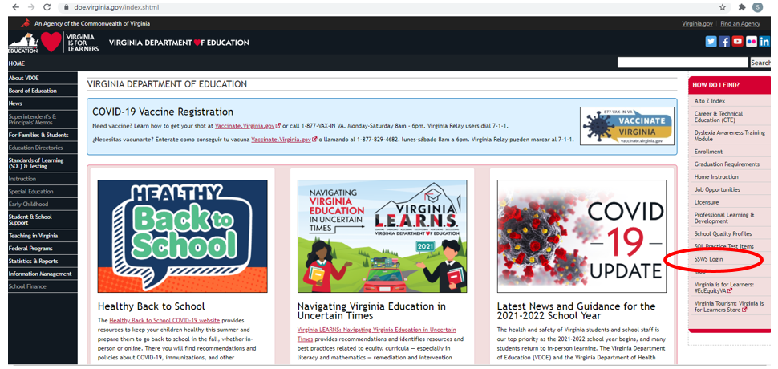

Attachment A
Superintendent’s Memo #298-21
October 22, 2021

- Figure 2 displays the SSWS login screen. The person responsible for reviewing the information will need a login ID and password to access the web-based application. The local SSWS Administrator should be contacted to obtain the SSWS login ID and password.

Figure 2
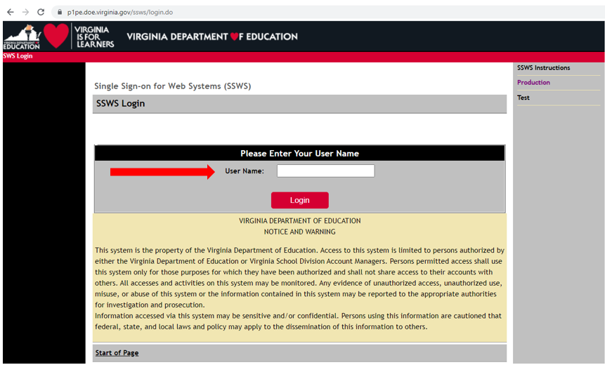

- Figure 3 displays the password screen. The user must have the SSWS login ID and password to access the web-based application.

Figure 3
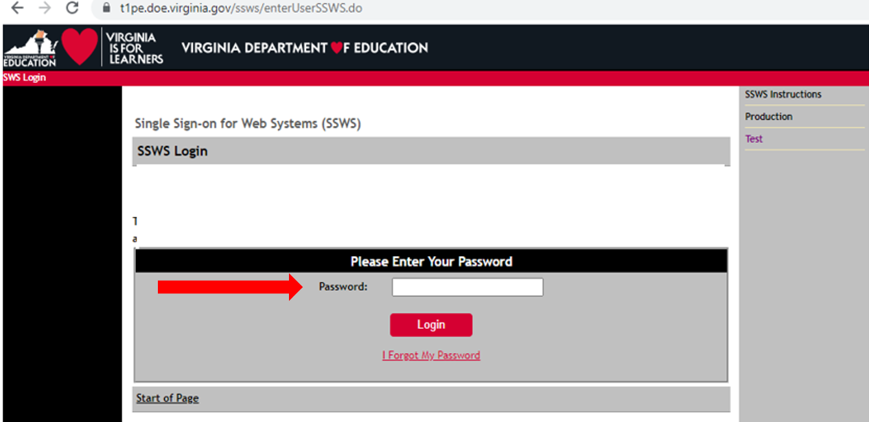

Attachment A
Superintendent’s Memo #298-21
October 22, 2021
- After a successful login, the application menu will display as shown in Figure 4. Select “Special Education Proportionate Set-Aside (Speced-PSA)” from the applications listed in the user’s menu. If it is not available in the user’s menu, the user must contact their local SSWS Administrator to obtain full access rights.

Figure 4
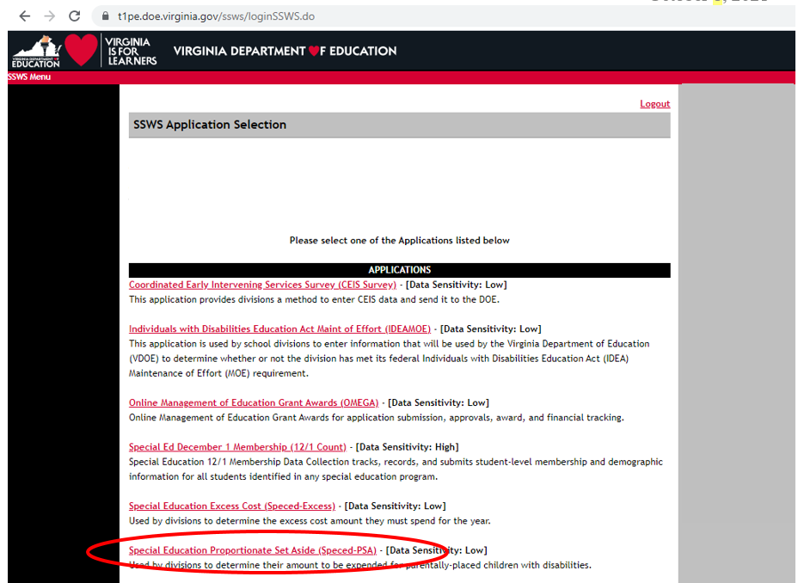

- Figure 5 displays the screen after the Speced-PSA Application is clicked. The collection window must be open for the current fiscal year in order to submit information and for the data to be saved and processed. There are two (2) available options on the upper right side of the page for the user to select.

Worksheet – Selecting this option will display the screen where users can view the information to determine the division’s proportionate share. Line details are described in subsequent pages. Recent enhancements to the application eliminates the need for users to enter child
count data.

Reports – Selecting this option will display the screen where the Verification Report can be viewed or printed. The recent upgrade to the Speced-PSA Application eliminates paper verification. As such, Verification Reports are now approved in electronic form, and LEAs are no longer required to submit signed copies of verification reports to VDOE.
Figure 5
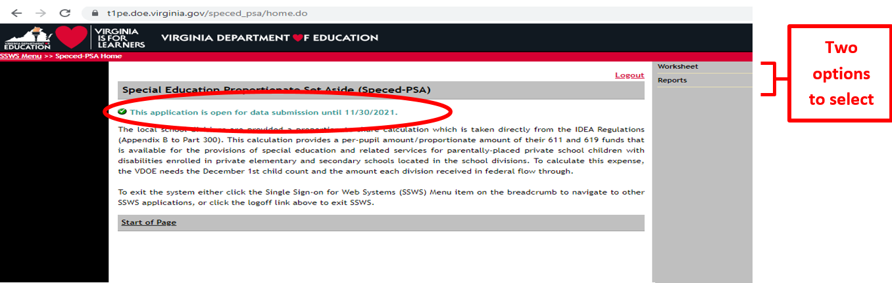
Attachment A
Superintendent’s Memo #298-21
October 22, 2021
- Figure 6 shows what is displayed after selecting the “Worksheet” option from the menu on the upper right side of the screen. This is the screen where data is pre-populated to calculate the division’s proportionate share. The worksheet is composed of Lines 1 to 10. All lines (New for 2021-2022) are auto-generated and auto-calculated. Refrain from using the “back” button when navigating the application as it will cause the application to function incorrectly. Instead, use the options available at the top of the screen. The sample print screen in Figure 6 displays all lines auto populated. The user must verify information related to the number of home-schooled or parentally-placed students found eligible during the child find process but not receiving services during the school year. The number displayed in Lines 1 through 3 is reported in the December 1 Child Count. In addition, amounts in Lines 5 and 8 are pre-populated from OMEGA. Refer to instructions and illustrations starting at page 7.

Figure 6
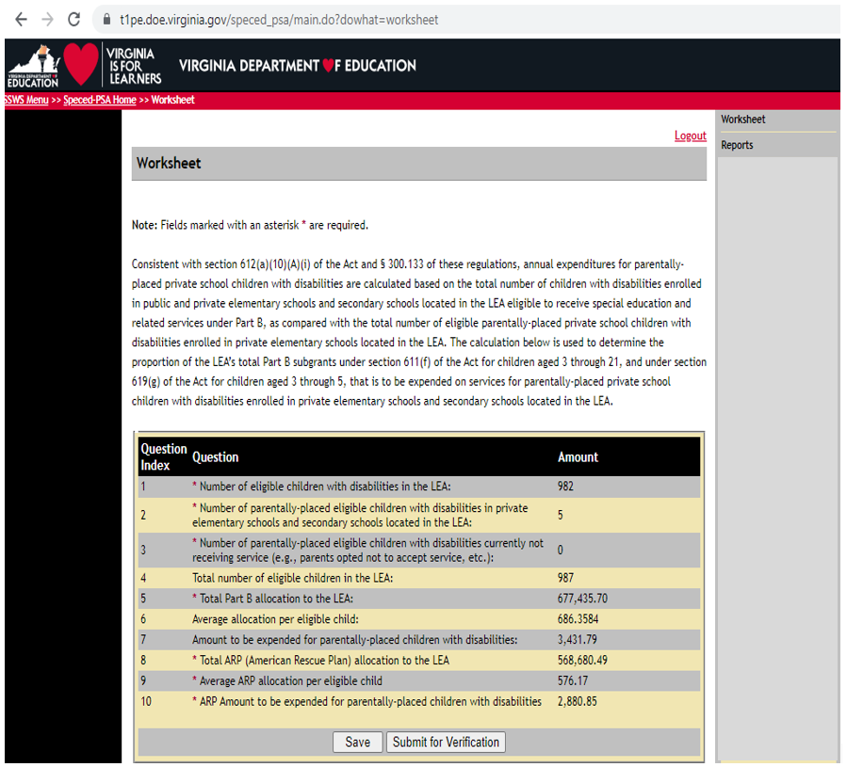

Attachment A
Superintendent’s Memo #298-21
October 22, 2021
The following example is for illustration purposes only:

There are 982 eligible children with disabilities enrolled in the LEA, 5 are eligible parentally-placed children with disabilities currently enrolled and being served in private elementary schools and secondary schools located in the LEA. The division has identified no students as eligible parentally-placed children with disabilities not currently receiving service due to various reasons (i.e., because the parent decided not to accept services from the division, or these were students previously receiving services but left the division). The total number of eligible public and private school children with disabilities is 987. Note: Proportionate share for parentally-placed private school children is based on total children eligible, not children served. The LEA receives a total $677,435.70 in Federal flow-through funds for IDEA regular 611 and 619. Therefore, the LEA must set-aside $3,431.79 of special education or related services funds to the group of parentally-placed private school children with disabilities enrolled in private elementary schools and secondary schools located in the LEA. The LEA also receives a total $568,680.41 in Federal flow-through funds for IDEA ARP 611 and 619. The LEA must set-aside $2,880.85 of special education or related services funds to the group of parentally-placed private school children with disabilities enrolled in private elementary schools and secondary schools located in the LEA.

- An illustration of the above example is shown in Figure 7, and the details of questions 1 to 10 are described in pages 8 and 9.

Figure 7
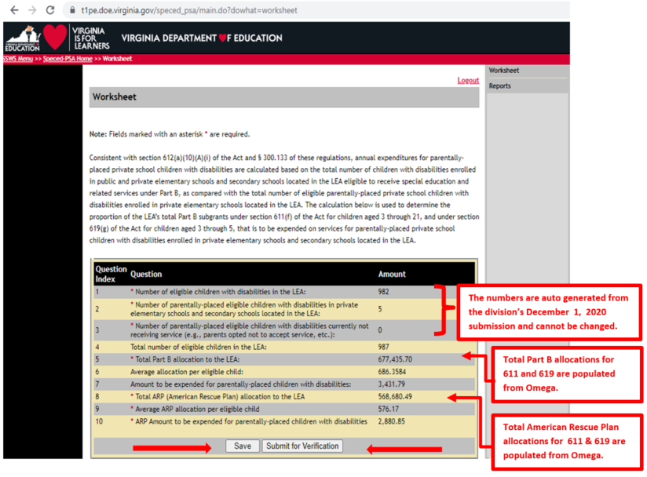

Attachment A
Superintendent’s Memo #298-21
October 22, 2021
- Line 1 – The number of eligible students will be automatically populated from the system using the auto-generated December 1 Child Count submission when the collection window is open. In the example at Figure 7, Line 1 indicates 982 students. This number excludes private school and home-schooled children eligible and served. Eligible students are students who have been evaluated and determined eligible for special education and related services by the division. Served students are students who are receiving special education and related services within the division. Note: The number of eligible students cannot be changed since it is auto-generated from the division’s December 1, 2020, child count submission, duly certified by the division’s superintendent and reported to the U.S. Department
of Education (USED).

- Line 2 – The number of home-schooled or parentally-placed eligible students will be populated from the system using the auto-generated December 1 Child Count. In the example at Figure 7, Line 2 indicates five (5) students. This represents the number of children with disabilities parentally-placed in private school or home-schooled in the LEA after conducting a thorough and complete child find process and ensuring that the count was performed between December 2 of the preceding year to December 1 of the current year (e.g., December 2, 2019–December 1, 2020) and reported in the December 1, 2020, child count report. Note: The number of home-schooled or parentally-placed eligible children with disabilities in private schools cannot be changed since it is auto-generated from the division’s December 1, 2020, child count submission, duly certified by the division’s superintendent and reported to the U.S. Department of Education (USED). Divisions who are serving parentally-placed or home-schooled students that were not reported in their December 1 Child Count report must contact the VDOE for additional guidance in reporting these students.

- Line 3 (New for 2021-2022: the data are auto-generated) – Review the number of home-schooled or parentally-placed students identified during the child find process as being eligible for services (i.e., December 1, 2020) but are not receiving services due to various reasons (e.g., parent has opted not to accept services). The count must be between December 2 of the preceding year to December 1 of the current year. The division is required to set-aside a proportionate amount for the students’ future use. The illustration above indicates zero (0) students in Line 3.

- Line 4 – Auto-generated and represents the total number of students with disabilities in public and private schools and home-schooled. Based on the illustration, Line 4 shows a total of 987 students (sum of Lines 1, 2, and 3). Note: The line total may be more than the actual December 1 Child Count if there are students reported in Line 3.

- Line 5 (Revised for 2021-2022: the amount represents Regular IDEA Part B funds and is auto-generated) – The total FFY 2021-2022 Part B 611 and 619 allocations of the division will be automatically populated from the Online Management Education Grant Awards (OMEGA). In the illustration above, Line 5 indicates $677,435.70 as the actual total Part B funds received. This amount constitutes the sum of Sections 611 and 619 regular
IDEA funds.

Attachment A
Superintendent’s Memo #298-21
October 22, 2021
- Line 6 – Auto-generated average allocation per eligible child. This amount represents the proportionate share of the division’s per eligible child. In the illustration in Figure 7, Line 6 shows $686.3584 (Line 5 divided by Line 4).

- Line 7 – Auto-generated amount to be expended for home-schooled or parentally-placed children with disabilities. This amount represents the total amount of regular IDEA Part B Federal funds that must be set-aside for home-schooled or parentally-placed children with disabilities. In the illustration of Figure 7, Line 7 shows a total amount of $3,431.79 (Line 6 multiplied by the sum of Lines 2 and 3). Note: Any funds not spent or obligated by
June 30, 2022, for special education and related services (including direct services) must be carried forward for one additional year (i.e., July 1, 2022-June 30, 2023). Any unspent funds after the one year carry-over period can be used on other special education and related services. State and local funds may supplement and NOT supplant the proportionate amount of Federal funds required to be expended for parentally-placed students with disabilities.

- Line 8 (New for 2021-2022) – The total FFY 2021-2022 IDEA American Rescue Plan (ARP) 611 and 619 allocations of the division will be automatically populated from the Online Management Education Grant Awards (OMEGA). In the illustration above, Line 8 indicates $568,680.49 as the actual total ARP funds received. This amount constitutes the sum of Sections 611 and 619 IDEA ARP funds.

- Line 9 (New for 2021-2022) – Auto-generated average ARP allocation per eligible child. This amount represents the proportionate share of the division’s per eligible child. In the illustration in Figure 7, Line 9 shows $517.76 (Line 8 divided by Line 4).

- Line 10 (New for 2021-2022) – Auto-generated amount of IDEA ARP to be expended or made available for home-schooled or parentally-placed children with disabilities. This amount represents the total amount of ARP funds that must be set-aside for home-schooled or parentally-placed children with disabilities. In the illustration of Figure 7, Line 10 shows a total amount of $2,880.85 (Line 9 multiplied by the sum of Lines 2 and 3). Note: Any funds not spent or obligated by June 30, 2022, for special education and related services (including direct services) must be carried forward for one additional year
(i.e., July 1, 2022-June 30, 2023). Any unspent funds after the one year carry-over period can be used on other special education and related services. State and local funds may supplement and not supplant the proportionate amount of federal funds required to be expended for parentally-placed students with disabilities.

If the user is ready to submit the worksheet, first click the “Save” button then click the “Submit for Verification” button. If the user is not ready to submit, click the “Save” button and the worksheet will remain open for review. Once the worksheet is submitted, the collection window will automatically lock and the application will notify the superintendent to review and approve the submission. If a revision is needed after the worksheet is submitted but before approval, the user must notify its superintendent to disapprove the submission to unlock the collection window. If a revision is needed after the submission is already approved, the user must contact VDOE to re-open the collection window. NOTE: If a revision is needed after the due date but before approval, the user must contact VDOE via email to re-open the collection window.

Attachment A
Superintendent’s Memo #298-21
October 22, 2021
October 22, 2021Figure 8 displays the screen after the worksheet is submitted. The superintendents or designees are required to sign the certification reports in electronic form using the Superintendent Data Collection Approvals (SDCA) Application (refer to Figure 10, page 11). Manual copies of verification reports are no longer required to be submitted to VDOE.

Figure 8
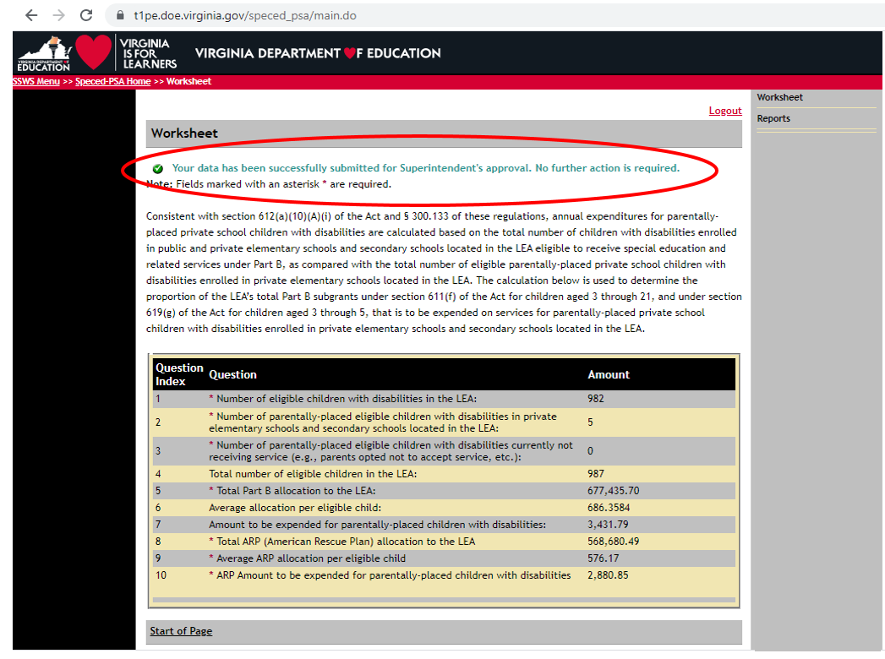

- Figure 9 illustrates the screen for SDCA after the superintendent or designee has successfully logged in to SSWS. A user’s ID and password are required to access the SDCA which can be obtained through the division’s local SSWS Administrator if the application is not available in the superintendent’s or designee’s menu.

Figure 9
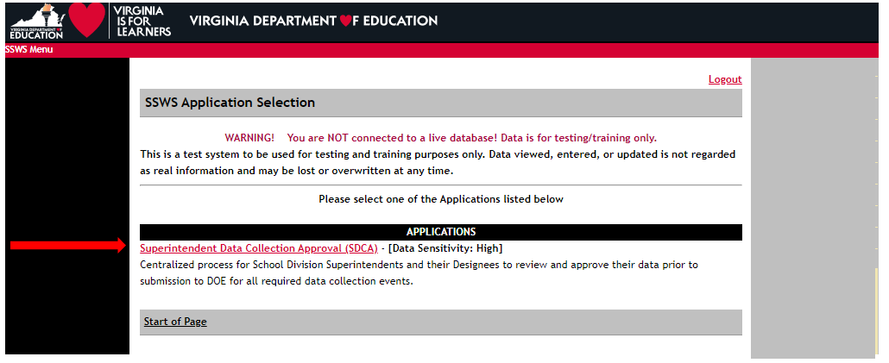

Attachment A
Superintendent’s Memo #298-21
October 22, 2021
- Figure 10 displays the screen after the SDCA menu is clicked. The superintendent or designee must select the “Proportionate Set-Aside Verification Report” in the list of report names for approval to access the verification report.

Figure 10
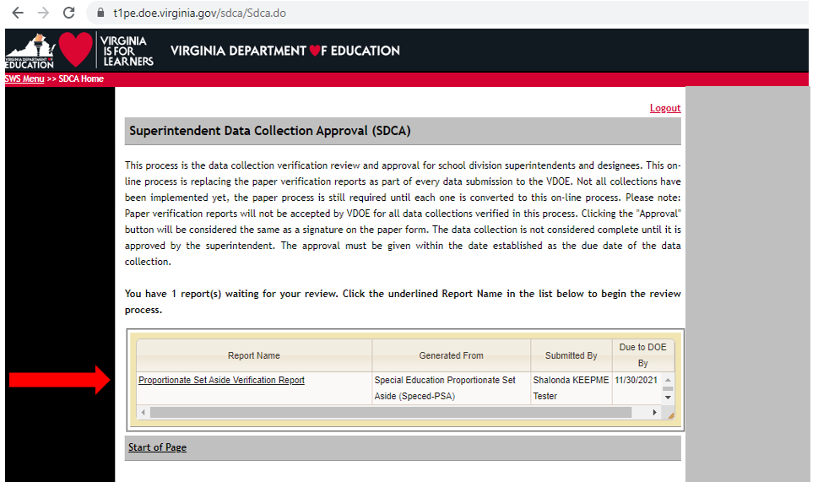

- Figure 11 displays the PSA Verification Report with two functions added: the “Approve” and “Disapprove” buttons. The superintendent or designee must choose one function after review of the submitted data to proceed to the next screen. If the “Approve” function is selected, the submission is completed and the collection window will close (refer to Figure 13). If the “Disapprove” function is selected, the collection window is re-opened and resubmission is required (refer to Figure 14). A data note is required for disapproved submissions.

Figure 11
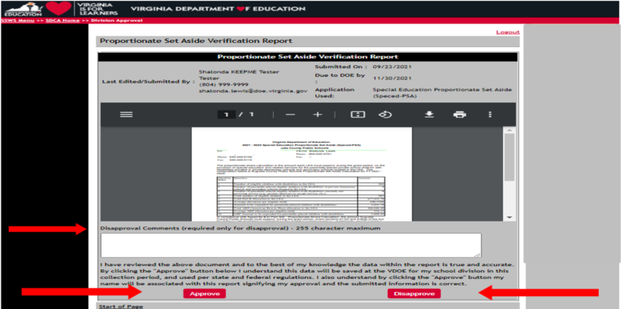

Attachment A
Superintendent’s Memo #298-21
October 22, 2021
- Figure 12 displays the screen after the Approve button is clicked. The approval of the verification report represents the superintendent’s or designee’s electronic signature and indicates accuracy and completeness of the submitted data. If a revision is needed after the approval is completed, or if the superintendent did not electronically sign the verification report after the due date, the division must contact VDOE to re-open the collection window to
complete submission.

Figure 12
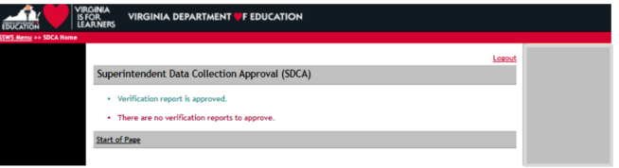

- Figure 13 displays the screen after the Disapprove button is clicked. All disapproved submissions require a data note in the comments box so the system can process the request. Once the disapproved submission is processed, the collection window will automatically re-open and reviews are permitted. If the superintendent did not electronically sign the verification report after the due date, the division must contact VDOE to re-open the collection window to complete submission.

Figure 13
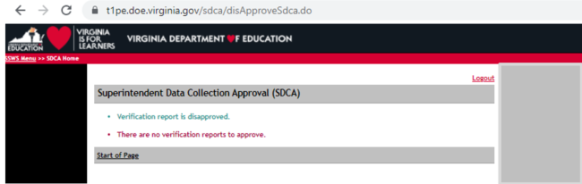

Attachment A
Superintendent’s Memo #298-21
October 22, 2021
- Figure 14 displays the screen after the verification report is approved and completed. The online approval must be made within the established due date of the data collection for the submission to be considered complete. Verification reports that are certified after the collection window closes, after the due date (November 30, 2021), will be tagged as late submission.

Figure 14
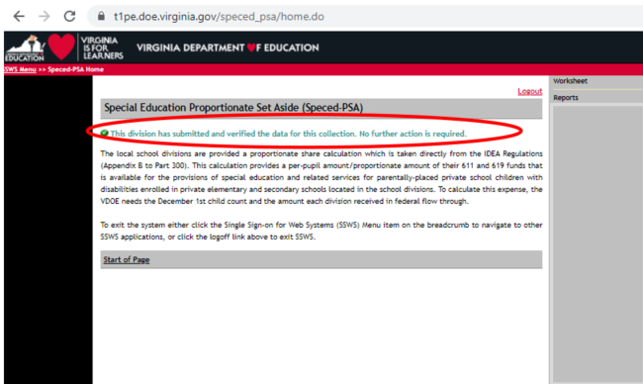

New for 2021-2022 Only
Once the division has submitted the PSA data, school divisions will need to reserve PSA amounts
under object codes “0000” in OMEGA until such time as the division is ready to use reserved PSA funds
for PSA activities. Please do the following to enhance the tracking of PSA budgets and expenses:

- Submit a budget transfer (budget adjustment) in OMEGA for IDEA regular 611 or 619 funds to allocate all non-PSA budget amounts to applicable object code budgets (i.e., object codes 1000, 2000, 3000, 4000, 5000, 6000).

- Submit a budget transfer (budget adjustment) in OMEGA for IDEA ARP 611 or 619 funds to allocate all non-PSA ARP budget amounts to applicable object code budgets (i.e., object codes 1000, 2000. 3000, 4000. 5000 or 6000). If the division’s ARP Budget Transfer has already been approved, the VDOE will submit a budget transfer (budget adjustment) to reserve PSA ARP allocations at the “0000” (unspecified) object code level.

- Once PSA costs are incurred, submit a budget transfer (budget adjustment) in OMEGA to move PSA amounts budgeted at object code “0000’ to the appropriate object code level in OMEGA for approval. Once the PSA budget is approved, a reimbursement request should be submitted in OMEGA and select the PSA dropdown option prior to submitting.

Please note the collection window will open on October 22, 2021, and closes on
November 30, 2021. Divisions not submitting the Speced-PSA calculation will be contacted individually and will be required to follow a protocol to re-open the collection window. This protocol will be shared with those specific school divisions. Late submissions and inaccurate reporting of information may impact the school division’s local determination matrix and may prompt a review.

