RESTRAINT and SECLUSION faqs

The Regulations Governing the Use of Seclusion and Restraint in Public Elementary and Secondary Schools in Virginia govern the use of seclusion and restraint for the purposes of behavioral intervention in the Commonwealth of Virginia’s schools. The Regulations act to “increase communication with parents, and encourage school divisions to be more proactive in their consideration and implementation of positive behavioral interventions.” The Virginia Department of Education (VDOE) presents this Frequently Asked Questions (FAQ) document to assist local school divisions in meeting the requirements set forth in the Regulations.

What Training is Required per the Regulations Governing the Use of Seclusion and Restraint in Public Elementary and Secondary Schools in Virginia (8VAC20-750)?

- Initial (level 1) training: All school personnel must receive initial training regarding the regulations, policies, and procedures governing the use of physical restraint and seclusion. This requirement may be satisfied by having school personnel view the online training: ODU Restraint and Seclusion Training. The training provided by VDOE is not mandatory, however, all personnel must receive comparable training that includes the elements listed in the Regulations (8VAC20-750-100).

- Advanced (level 2) training: advanced training is only required of one administrator in every school building and for school personnel assigned to work with any student whose IEP team or 504 committee determined that the student is likely to be physically restrained or secluded. The key word is “assigned,” not every staff member working with a child are an assigned staff member. Advanced training includes skills related to positive behavior support, conflict prevention, de-escalation, and crisis response including follow-up support and social-emotional strategy support for students, staff and families. Any initial or advanced training must be evidence-based.

- Which training programs must a school division employ in order to comply with the advanced training requirements in the regulations? This is a local decision, however, please note that the advanced training must be evidenced-based. The VDOE is not permitted to endorse any particular training programs.

How Do I Access The Training Videos?

The restraint and seclusion trainings, created by the VDOE, can satisfy the level 1 training requirements for the restraint and seclusion regulations as well as the initial teacher licensure requirement regarding behavior intervention and support training. The modules are located online at the Center for Implementation and Evaluation of Education Systems at Old Dominion University (ODU).

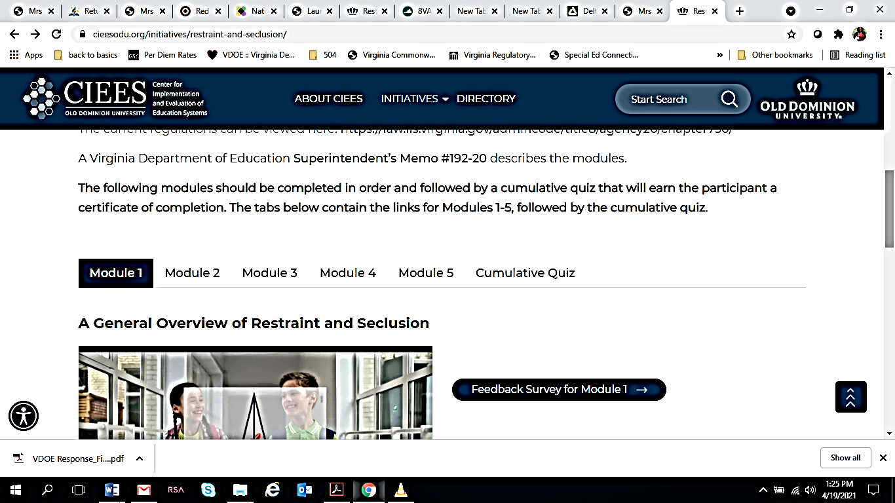

- Once the modules are completed, a quiz can be taken to receive a certificate that can be used as evidence for credit to be provided to the local school division. To access the quiz, click on the cumulative quiz tab and then scroll down to take quiz now.

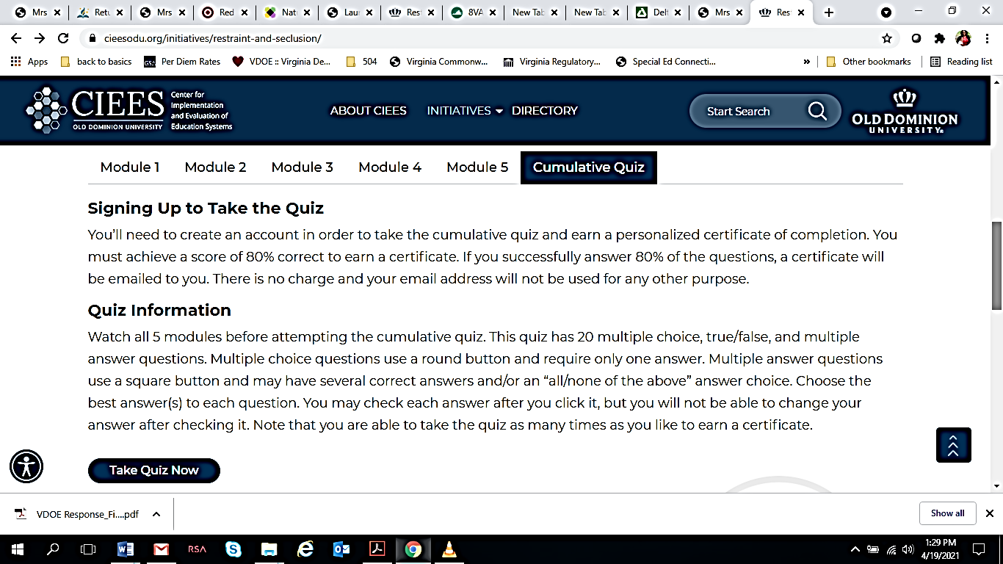

- On the next page, scroll down and click on Start Quiz.
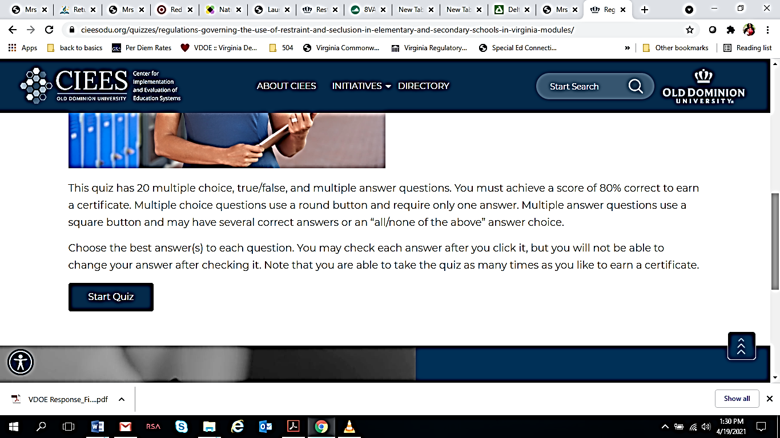

- You will be prompted to sign in or sign up. Click sign up if you have not yet created an account.
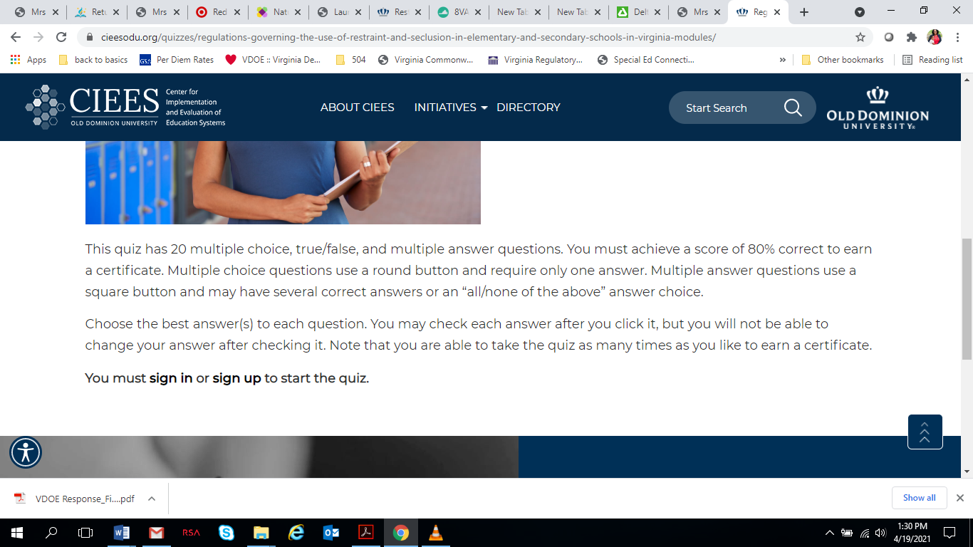

- You will be taken to the next page to register.

- Create a username, and a password. Enter your email, first and last name, and then click register your account.

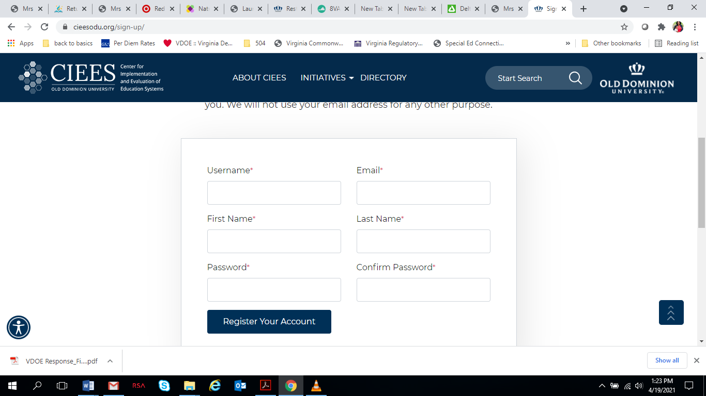

If you have any difficulty with these steps, please contact Ann Maydosz at CIEES at (757) 683-5372 or amaydosz@odu.edu.

How will Schools Report Compliance with Restraint and Seclusion Regulations?
The VDOE will use the data reported to the Superintendent of Public Instruction (8VAC20-750-90. Annual reporting) to integrate monitoring and compliance activities with existing reviews. Special education staff should expect this to become a part of verification, and routine and targeted monitoring activities in local school divisions and their special education programs.

Can Individuals or School Divisions Request a List of Division Personnel who have Completed the Training?
The VDOE cannot provide a list of individuals who have completed the training because the agency does not maintain the certificates. The VDOE does ensure, however, that a certificate is able to be issued to each individual who has successfully completed the training and school divisions should request a copy and maintain them in the employee’s file.

How Can we Assist School Support Personnel with the Training and Quiz?
The VDOE suggests that staff be provided the option to view the modules and quiz as a group and be given the opportunity to ask questions that may assist their understanding. Note that while the quiz must be taken individually to earn a certificate, a school division may provide an overview or study guide to support staff’s understanding.

Given the Pandemic, What Should we Do if Staff Refuse to be Trained?
The training is available to all staff online at: ODU Restraint and Seclusion Training, so staff may take the training in a preferred environment. The regulations require this training for staff to ensure the safety of all those involved, so whether your school division is serving a student in person or virtually, the training requirements will need to be met per the regulations. School division policies regarding essential job functions may lend additional guidance.

When Should Staff be Trained on the Regulations? Is There a Specific Timeline?
Implementation of the Regulations went into effect on January 1, 2021. At that time all school staff were required to be trained before working with students. As new staff members join a division, their requirement for this training should be identified and opportunities for training should be provided. Based on the regulations and the intent of the Virginia Board of Education, all school personnel must receive the initial training. As such, the training should be completed as soon as possible.

What is the Guidance on Granting Recertification Points for Teaching Staff who were Awarded a Certificate for Completing the Training and Quiz?
The verification of recertification points falls to the employing school division. In response to requests for clarification, the certificate for successful completion of the training and quiz was modified September 26, 2020, to read, “For reporting purposes toward potential recertification hours for Virginia teachers, successful completion of the Understanding the Regulations Governing the Use of Restraint and Seclusion in Elementary and Secondary Schools in Virginia modules and quiz takes approximately 1.5 hours. Individuals should contact their employing school division to discuss recertification points for this activity.” Individuals who successfully earned a certificate before this time were emailed to inform them of this statement.

How Can a Written Transcript of the Training Modules be obtained?
Email the Center for Implementation and Evaluation of Education Systems at CIEES@odu.edu for transcripts.

Who should be Contacted in the case of Technical difficulties with the Quiz or Certificate? What if a Member of Staff Loses Their Certificate?
Email the Center for Implementation and Evaluation of Education Systems at CIEES@odu.edu for technical assistance.

8VAC20-750-5.A, Refer also to the ”substance” portion of the explanation of the proposed Regulations Governing the Use of Seclusion and Restraint in Public Elementary and Secondary Schools in Virginia, 8 VAC20-750-5-8 VAC20-750-110.
Refer to the ”Issue” portion of the explanation of the proposed Regulations Governing the Use of Seclusion and Restraint in Public Elementary and Secondary Schools in Virginia, 8 VAC20-750-5-8 VAC20-750-110.

