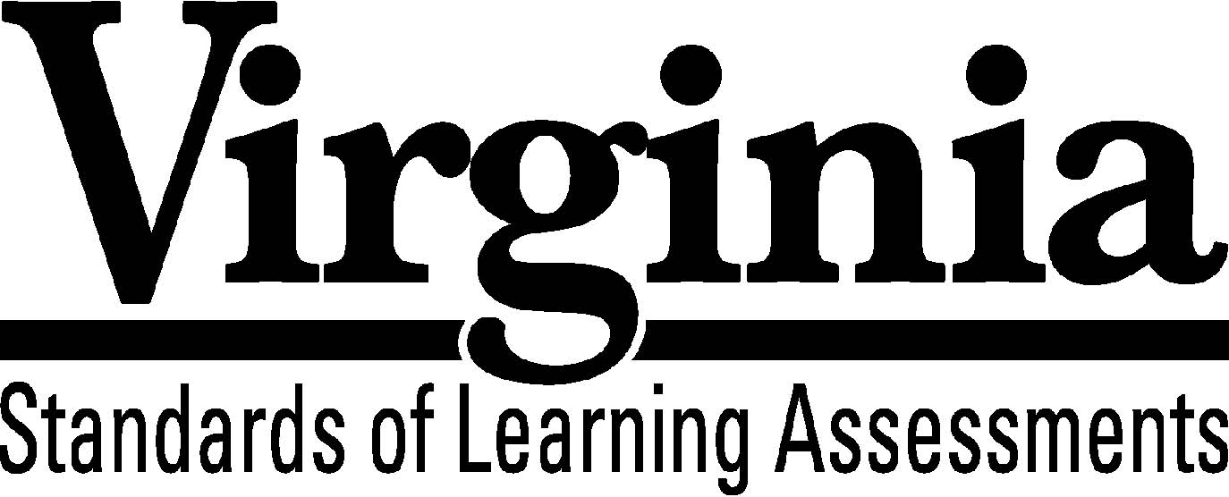

Test Blueprint

Grade 8 Mathematics

2009 Mathematics

Standards of Learning
This revised test blueprint will be effective beginning with the fall 2015 test administration.

Notice to Reader

In accordance with the requirements of the Civil Rights Act and other federal and state laws and regulations, this document has been reviewed to ensure that it does not reflect stereotypes based on race, color, national origin, sex, age, or disability.

The Virginia Department of Education does not discriminate on the basis of race, color, national origin, sex, age, or disability in employment or provisions of service.
Copyright ©2015 by the Commonwealth of Virginia, Department of Education, P.O. Box 2120, Richmond, Virginia 23218-2120. All rights reserved. Except as permitted by law, this material may not be reproduced or used in any form or by any means, electronic or mechanical, including photocopying or recording, or by any information storage or retrieval system, without written permission from the copyright owner. Commonwealth of Virginia public school educators may reproduce any portion of this test blueprint for noncommercial educational purposes without requesting permission. All others should direct their written requests to the Virginia Department of Education, Division of Student Assessment and School Improvement, at the above address or by e-mail to Student_Assessment@doe.virginia.gov.

Grade 8 Mathematics

Standards of Learning

Test Blueprint

TABLE OF CONTENTS
General Test Information………………………………………………………..1
Defines common terms

Test Blueprint Summary Table………………………………………………….3
Organizes the SOL and the number of items assessed

Expanded Test Blueprint……...…………………………………………………4
Full text of each SOL as organized for the test

General Test Information

Test Blueprint
Much like the blueprint for a building, a test blueprint serves as a guide for test construction. The blueprint indicates the content areas that will be addressed by the test and the number of items that will be included by content area and for the test as a whole. There is a blueprint for each test (e.g., grade 3 reading, grade 5 mathematics, grade 8 science, Virginia and United States History).

The Grade 8 Mathematics blueprint contains information for two types of tests, the online computer adaptive test (CAT) and the traditional test. A CAT is a customized assessment for each student based on how the student responds to the questions. This is in contrast to the traditional test in which all students who take a particular version of the test respond to the same test questions.

All online versions of the Grade 8 Mathematics test (including Plain English, Plain English audio, and regular audio) will be computer adaptive beginning in fall 2015. All paper versions of the test (including Plain English, large print, and Braille) will be administered using the traditional format.

Reporting Categories
Each test covers a number of Standards of Learning. In the test blueprint, the SOL are grouped into categories that address related content and skills. These categories are labeled as reporting categories. For example, a reporting category for the Grade 8 Mathematics Standards of Learning test is Measurement and Geometry. Each of the SOL in this reporting category requires the student to measure or solve a problem related to two or three dimensional figures. When the results of the SOL tests are reported, the scores will be presented for each reporting category and as a total test score.

Assignment of Standards of Learning to Reporting Category
In the Grade 8 Mathematics SOL test, each SOL is assigned to only one reporting category. For example, SOL 8.1a-b is assigned to “Number, Number Sense, Computation and Estimation.”

Standards of Learning Excluded from Testing
In some content areas, there are SOL that do not lend themselves to assessment within the current format of the SOL tests. The SOL not tested are listed as Excluded from Testing at the end of the blueprint for each test. For example, in Grade 8 Mathematics, SOL 8.6b cannot be appropriately assessed within the current format.

Coverage of Standards of Learning
Due to the large number of SOL in each grade level content area, every Standard of Learning will not be assessed on every SOL test. By necessity, to keep the length of a test reasonable, each test will sample from the SOL within a reporting category. All SOL are eligible for inclusion on the traditional forms as well as the CAT forms.

Use of the Curriculum Framework
The Grade 8 Mathematics Standards of Learning, amplified by the Curriculum Framework, define the essential understandings, knowledge, and skills that are measured by the Standards of Learning tests. The Curriculum Framework asks essential questions, identifies essential understandings, defines essential content knowledge, and describes essential skills students need to master.

Grade 8 Mathematics

Test Blueprint Summary Table

Reporting Category | Grade 8 SOL | Number of Items  Computer Adaptive (CAT) Format | Number of Items  Traditional Format
Number, Number Sense, Computation and Estimation | 8.1a-b  8.2  8.3a-b  8.4  8.5a-b | 12 | 14
Measurement and Geometry | 8.6a  8.7a-b  8.8a-b  8.9  8.10a-b  8.11 | 13 | 14
Probability, Statistics, Patterns, Functions, and Algebra | 8.12  8.13a-b  8.14  8.15a-c  8.16  8.17 | 20 | 22
Excluded from Testing | 8.6b
Number of Operational Items |  | 45 | 50
Number of Field-Test Items* |  | 8 | 10
Total Number of Items on Test |  | 53 | 60

*Field-test items are being tried out with students for potential use on subsequent tests
and will not be used to compute students’ scores on the test.

Grade 8 Mathematics

Expanded Test Blueprint

Reporting Category: Number, Number Sense, Computation and Estimation
Number of Items: 12 (CAT) 14 (Traditional)
Standards of Learning:

8.1 The student will
a) simplify numerical expressions involving positive exponents, using rational numbers,
order of operations, and properties of operations with real number; and
b) compare and order decimals, fractions, percents, and numbers written in scientific
notation.

8.2 The student will describe orally and in writing the relationships between the subsets of
the real number system.

8.3 The student will
a) solve practical problems involving rational numbers, percents, ratios, and
proportions; and
b) determine the percent increase or decrease for a given situation.

8.4 The student will apply the order of operations to evaluate algebraic expressions for given
replacement values of the variables.

8.5 The student will
a) determine whether a given number is a perfect square; and
b) find the two consecutive whole numbers between which a square root lies.

Reporting Category: Measurement and Geometry
Number of Items: 13 (CAT) 14 (Traditional)
Standards of Learning:

8.6 The student will
a) verify by measuring and describe the relationships among vertical angles,
adjacent angles, supplementary angles, and complementary angles.

8.7 The student will
a) investigate and solve practical problems involving volume and surface area
of prisms, cylinders, cones, and pyramids; and
b) describe how changing one measured attribute of a figure affects the volume and surface area.

8.8 The student will
a) apply transformations to plane figures; and
b) identify applications of transformations.
8.9 The student will construct a three-dimensional model, given the top or bottom, side, and front views.

8.10 The student will
a) verify the Pythagorean Theorem; and
b) apply the Pythagorean Theorem.

8.11 The student will solve practical area and perimeter problems involving composite plane figures.

Reporting Category: Probability, Statistics, Patterns, Functions, and Algebra
Number of Items: 20 (CAT) 22 (Traditional)
Standards of Learning:

8.12 The student will determine the probability of independent and dependent events with and without replacement.

8.13 The student will
a) make comparisons, predictions, and inferences, using information displayed in graphs; and
b) construct and analyze scatterplots.

8.14 The student will make connections between any two representations (tables, graphs, words, and rules) of a given relationship.

8.15 The student will
a) solve multistep linear equations in one variable with the variable on one and two sides of the
equation;
b) solve two-step linear inequalities and graph the results on a number line; and
c) identify properties of operations used to solve an equation.

8.16 The student will graph a linear equation in two variables.

8.17 The student will identify the domain, range, independent variable or dependent variable in a given
situation.

Standards of Learning Excluded from Testing:

8.6 The student will
b) measure angles of less than 360°.

