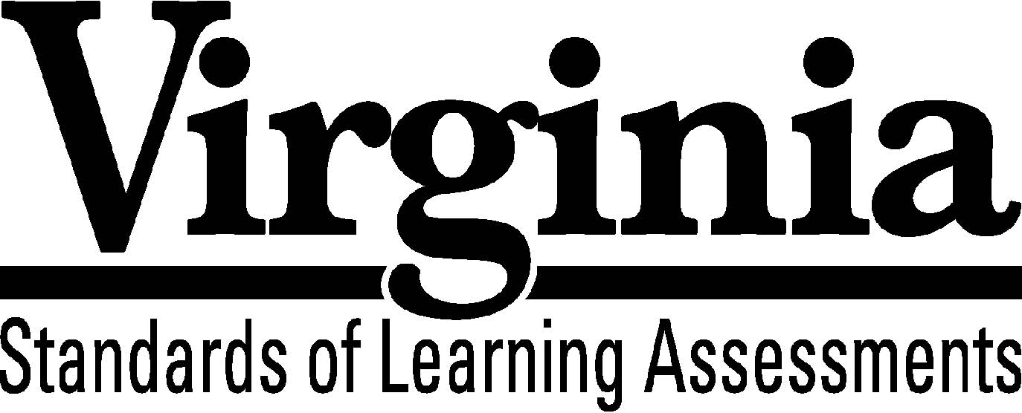

Test Blueprint

Geometry

2009 Mathematics

Standards of Learning
This revised test blueprint will be effective with the administration of the 2011-2012 Mathematics Standards of Learning (SOL) tests.

Notice to Reader

In accordance with the requirements of the Civil Rights Act and other federal and state laws and regulations, this document has been reviewed to ensure that it does not reflect stereotypes based on race, color, national origin, sex, age, or disability.

The Virginia Department of Education does not discriminate on the basis of race, color, national origin, sex, age, or disability in employment or provisions of service.
Copyright ©2010 by the Commonwealth of Virginia, Department of Education, P.O. Box 2120, Richmond, Virginia 23218-2120. All rights reserved. Except as permitted by law, this material may not be reproduced or used in any form or by any means, electronic or mechanical, including photocopying or recording, or by any information storage or retrieval system, without written permission from the copyright owner. Commonwealth of Virginia public school educators may reproduce any portion of this test blueprint for noncommercial educational purposes without requesting permission. All others should direct their written requests to the Virginia Department of Education, Division of Student Assessment and School Improvement, at the above address or by e-mail to Student_Assessment@doe.virginia.gov.

Geometry
Standards of Learning

Test Blueprint

TABLE OF CONTENTS
General Test Information………………………………………………………..1
Defines common terms

Test Blueprint Summary Table………………………………………………….2
Organizes the SOL and the number of items assessed

Expanded Test Blueprint……...…………………………………………………3
Full text of each SOL as organized for the test

General Test Information

Test Blueprint
Much like the blueprint for a building, a test blueprint serves as a guide for test construction. The blueprint indicates the content areas that will be addressed by the test and the number of items that will be included by content area and for the test as a whole. There is a blueprint for each test (e.g., grade 3 reading, grade 5 mathematics, grade 8 science, Virginia and United States History).

Reporting Categories
Each test covers a number of Standards of Learning. In the test blueprint, the SOL are grouped into categories that address related content and skills. These categories are labeled as reporting categories. For example, a reporting category for the Geometry Standards of Learning test is Polygons, Circles, and Three-Dimensional Figures. Each of the SOL in this reporting category addresses properties, measurement, or applications of polygon, circles, and three-dimensional figures. When the results of the SOL tests are reported, the scores will be presented for each reporting category and as a total test score.

Assignment of Standards of Learning to Reporting Category
In the Geometry SOL test, each SOL is assigned to only one reporting category. For example, SOL G.1a-d is assigned to “Reasoning, Lines, and Transformations.”

Standards of Learning Excluded from Testing
In some content areas, there are SOL that do not lend themselves to assessment within the current format of the SOL tests. The SOL not tested are listed as Excluded from Testing at the end of the blueprint for each test.

Coverage of Standards of Learning
Due to the large number of SOL in each grade level content area, every Standard of Learning will not be assessed on every version (form) of an SOL test. By necessity, to keep the length of a test reasonable, each version will sample from the SOL within a reporting category. Every SOL in the blueprint will be tested within a three year period, and all of these SOL are eligible for inclusion on each version of an SOL test.

Use of the Curriculum Framework
The Geometry Standards of Learning, amplified by the Curriculum Framework, define the essential understandings, knowledge, and skills that are measured by the Standards of Learning tests. The Curriculum Framework asks essential questions, identifies essential understandings, defines essential content knowledge, and describes essential skills students need to master.

Geometry

Test Blueprint Summary Table

Reporting Category | Geometry SOL | Number of Items
Reasoning, Lines, and Transformations | G.1a-d  G.2a-c  G.3a-d  G.4a-g | 18
Triangles | G.5a-d  G.6  G.7  G.8 | 14
Polygons, Circles,  and Three-Dimensional Figures | G.9  G.10  G.11a-c  G.12  G.13  G.14a-d | 18
Excluded from Testing | None | blank
Number of Operational Items | blank | 50
Number of Field-Test Items* | blank | 10
Total Number of Items on Test | blank | 60

*Field-test items are being tried out with students for potential use on subsequent tests
and will not be used to compute students’ scores on the test.

Geometry

Expanded Test Blueprint

Reporting Category: Reasoning, Lines, and Transformations
Number of Items: 18
Standards of Learning:

G.1 The student will construct and judge the validity of a logical argument consisting of a set of premises and a conclusion. This will include
a) identifying the converse, inverse, and contrapositive of a conditional statement;
b) translating a short verbal argument into symbolic form;
c) using Venn diagrams to represent set relationships; and
d) using deductive reasoning.

G.2 The student will use the relationships between angles formed by two lines cut by a transversal to
a) determine whether two lines are parallel;
b) verify the parallelism, using algebraic and coordinate methods as well as deductive proofs; and
c) solve real-world problems involving angles formed when parallel lines are cut by a
transversal.

G.3 The student will use pictorial representations, including computer software, constructions, and coordinate methods, to solve problems involving symmetry and transformation. This will include
a) investigating and using formulas for finding distance, midpoint, and slope;
b) applying slope to verify and determine whether lines are parallel or perpendicular;
c) investigating symmetry and determining whether a figure is symmetric with respect
to a line or a point; and
d) determining whether a figure has been translated, reflected, rotated, or dilated, using
coordinate methods.

G.4 The student will construct and justify the constructions of
a) a line segment congruent to a given line segment;
b) the perpendicular bisector of a line segment;
c) a perpendicular to a given line from a point not on the line;
d) a perpendicular to a given line at a given point on the line;
e) the bisector of a given angle,
f) an angle congruent to a given angle; and
g) a line parallel to a given line through a point not on the given line.

Reporting Category: Triangles
Number of Items: 14
Standards of Learning:

G.5 The student, given information concerning the lengths of sides and/or measures of angles in triangles, will
a) order the sides by length, given the angle measures;
b) order the angles by degree measure, given the side lengths;
c) determine whether a triangle exists; and
d) determine the range in which the length of the third side must lie.
These concepts will be considered in the context of real-world situations.

G.6 The student, given information in the form of a figure or statement, will prove two triangles are congruent, using algebraic and coordinate methods as well as deductive proofs.

G.7 The student, given information in the form of a figure or statement, will prove two triangles are similar, using algebraic and coordinate methods as well as deductive proofs.

G.8 The student will solve real-world problems involving right triangles by using the Pythagorean Theorem and its converse, properties of special right triangles, and right triangle trigonometry.

Reporting Category: Polygons, Circles, and Three-Dimensional Figures
Number of Items: 18
Standards of Learning:

G.9 The student will verify characteristics of quadrilaterals and use properties of quadrilaterals to solve real-world problems.

G.10 The student will solve real-world problems involving angles of polygons.

G.11 The student will use angles, arcs, chords, tangents, and secants to
a) investigate, verify, and apply properties of circles;
b) solve real-world problems involving properties of circles; and
c) find arc lengths and areas of sectors in circles.

G.12 The student, given the coordinates of the center of a circle and a point on the circle, will write the equation of the circle.

G.13 The student will use formulas for surface area and volume of three-dimensional objects to solve real-world problems.
G.14 The student will use similar geometric objects in two- or three-dimensions to
a) compare ratios between side lengths, perimeters, areas, and volumes;
b) determine how changes in one or more dimensions of an object affect area and/or
volume of the object;
c) determine how changes in area and/or volume of an object affect one or more
dimensions of the object; and
d) solve real-world problems about similar geometric objects.

