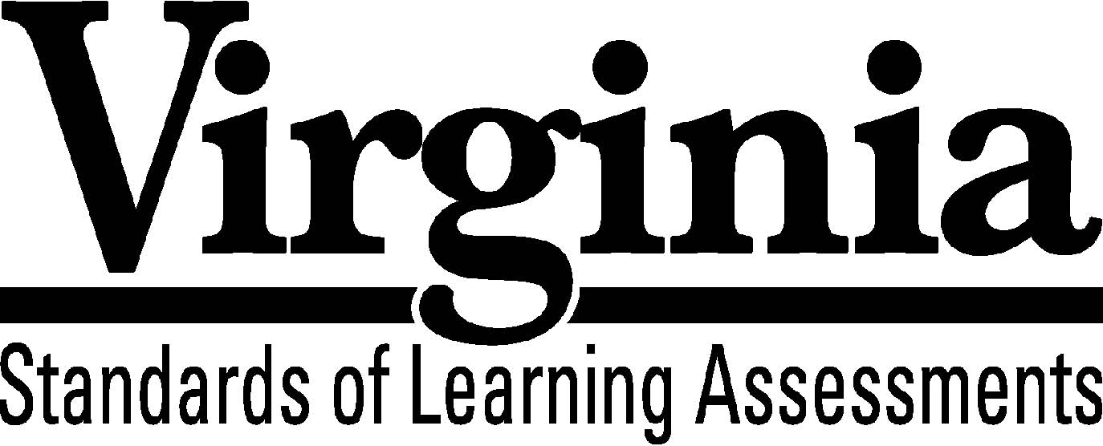

Test Blueprint

Algebra II
2009 Mathematics
Standards of Learning

This revised test blueprint will be effective with the administration of the 2011-2012 Mathematics Standards of Learning (SOL) tests.

Revised November 1, 2011
Notice to Reader
In accordance with the requirements of the Civil Rights Act and other federal and state laws and regulations, this document has been reviewed to ensure that it does not reflect stereotypes based on race, color, national origin, sex, age, or disability.
The Virginia Department of Education does not discriminate on the basis of race, color, national origin, sex, age, or disability in employment or provisions of service.
Copyright ©2010 by the Commonwealth of Virginia, Department of Education, P.O. Box 2120, Richmond, Virginia 23218-2120. All rights reserved. Except as permitted by law, this material may not be reproduced or used in any form or by any means, electronic or mechanical, including photocopying or recording, or by any information storage or retrieval system, without written permission from the copyright owner. Commonwealth of Virginia public school educators may reproduce any portion of this test blueprint for noncommercial educational purposes without requesting permission. All others should direct their written requests to the Virginia Department of Education, Division of Student Assessment and School Improvement, at the above address or by e-mail to Student_Assessment@doe.virginia.gov.
Algebra II Standards of Learning
Test Blueprint

TABLE OF CONTENTS

General Test Information………………………………………………………..1 Defines common terms
Test Blueprint Summary Table………………………………………………….2 Organizes the SOL and the number of items assessed
Expanded Test Blueprint……...…………………………………………………3 Full text of each SOL as organized for the test

General Test Information

Test Blueprint
Much like the blueprint for a building, a test blueprint serves as a guide for test construction. The blueprint indicates the content areas that will be addressed by the test and the number of items that will be included by content area and for the test as a whole. There is a blueprint for each test (e.g., grade 3 reading, grade 5 mathematics, grade 8 science, Virginia and United States History).

Reporting Categories
Each test covers a number of Standards of Learning. In the test blueprint, the SOL are grouped into categories that address related content and skills. These categories are labeled as reporting categories. For example, a reporting category for the Algebra II Standards of Learning test is Equations and Inequalities. Each of the SOL in this reporting category addresses the solution or application of equations or inequalities. When the results of the SOL tests are reported, the scores will be presented for each reporting category and as a total test score.

Assignment of Standards of Learning to Reporting Category
In the Algebra II SOL test, each SOL is assigned to only one reporting category. For example, SOL AII.1a-d is assigned to “Expressions and Operations.”

Standards of Learning Excluded from Testing
In some content areas, there are SOL that do not lend themselves to assessment within the current format of the SOL tests. The SOL not tested are listed as Excluded from Testing at the end of the blueprint for each test.

Coverage of Standards of Learning
Due to the large number of SOL in each grade level content area, every Standard of Learning will not be assessed on every version (form) of an SOL test. By necessity, to keep the length of a test reasonable, each version will sample from the SOL within a reporting category. Every SOL in the blueprint will be tested within a three year period, and all of these SOL are eligible for inclusion on each version of an SOL test.

Use of the Curriculum Framework
The Algebra II Standards of Learning, amplified by the Curriculum Framework, define the essential understandings, knowledge, and skills that are measured by the Standards of Learning tests. The Curriculum Framework asks essential questions, identifies essential understandings, defines essential content knowledge, and describes essential skills students need to master.

Algebra II

Test Blueprint Summary Table

Reporting Category | Algebra II SOL | Number of Items
Expressions and Operations | AII.1a-d  AII.3 | 13
Equations and Inequalities | AII.4a-d  AII.5 | 13
Functions and Statistics | AII.2  AII.6  AII.7a-h  AII.8 AII.9  AII.10  AII.11  AII.12 | 24
Excluded from Testing | None
Number of Operational Items | blank | 50
Number of Field-Test Items* | blank | 10
Total Number of Items on Test | blank | 60

*Field-test items are being tried out with students for potential use on subsequent tests and will not be used to compute students’ scores on the test.

Algebra II

Expanded Test Blueprint

Reporting Category: Expressions and Operations
Number of Items: 13
Standards of Learning:

AII.1 The student, given rational, radical, or polynomial expressions, will
a) add, subtract, multiply, divide, and simplify rational algebraic expressions;
b) add, subtract, multiply, divide, and simplify radical expressions containing rational
numbers and variables, and expressions containing rational exponents;
c) write radical expressions as expressions containing rational exponents and vice
versa; and
d) factor polynomials completely.

AII.3 The student will perform operations on complex numbers, express the results in
simplest form using patterns of the powers of i, and identify field properties that are
valid for the complex numbers.

Reporting Category: Equations and Inequalities
Number of Items: 13
Standards of Learning:

AII.4 The student will solve, algebraically and graphically,
a) absolute value equations and inequalities;
b) quadratic equations over the set of complex numbers;
c) equations containing rational algebraic expressions; and
d) equations containing radical expressions.
Graphing calculators will be used for solving and for confirming the algebraic solutions.

AII.5 The student will solve nonlinear systems of equations, including linear-quadratic and
quadratic-quadratic, algebraically and graphically. Graphing calculators will be used as
a tool to visualize graphs and predict the number of solutions.

Reporting Category: Functions and Statistics
Number of Items: 24
Standards of Learning:

AII.2 The student will investigate and apply the properties of arithmetic and geometric
sequences and series to solve real-world problems, including writing the first n terms,
finding the nth term, and evaluating summation formulas. Notation will include Σ and
an

AII.6 The student will recognize the general shape of function (absolute value, square root, cube root, rational, polynomial, exponential, and logarithmic) families and will convert between graphic and symbolic forms of functions. A transformational approach to graphing will be employed. Graphing calculators will be used as a tool to investigate the shapes and behaviors of these functions.
AII.7 The student will investigate and analyze functions algebraically and graphically. Key concepts include
a) domain and range, including limited and discontinuous domains and ranges;
b) zeros;
c) x-and y-intercepts;
d) intervals in which a function is increasing or decreasing;
e) asymptotes;
f) end behavior;
g) inverse of a function; and
h) composition of multiple functions.
Graphing calculators will be used as a tool to assist in investigation of functions.

AII.8 The student will investigate and describe the relationships between solutions of an equation, zeros of a function, x-intercepts of a graph, and factors of a polynomial expression.
AII.9 The student will collect and analyze data, determine the equation of the curve of best fit, make predictions, and solve real-world problems, using mathematical models. Mathematical models will include polynomial, exponential, and logarithmic functions.
AII.10 The student will identify, create, and solve real-world problems involving inverse variation, joint variation, and a combination of direct and inverse variations.
AII.11 The student will identify properties of a normal distribution and apply those properties to determine probabilities associated with areas under the standard normal curve.
AII.12 The student will compute and distinguish between permutations and combinations and use technology for applications.

