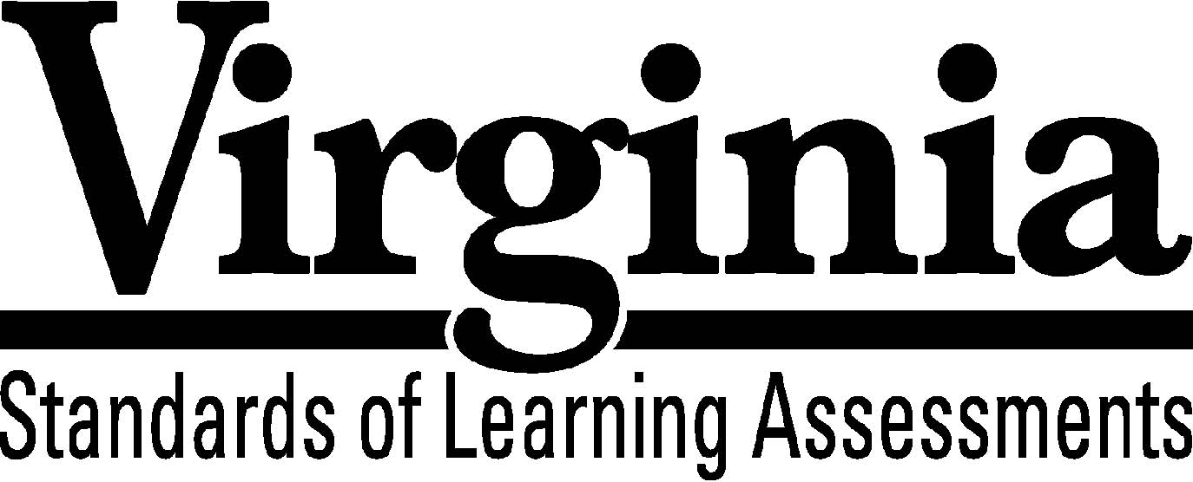

Test Blueprint

Algebra I

2009 Mathematics

Standards of Learning
This revised test blueprint will be effective with the administration of the 2011-2012 Mathematics Standards of Learning (SOL) tests.

Notice to Reader
In accordance with the requirements of the Civil Rights Act and other federal and state laws and regulations, this document has been reviewed to ensure that it does not reflect stereotypes based on race, color, national origin, sex, age, or disability.

The Virginia Department of Education does not discriminate on the basis of race, color, national origin, sex, age, or disability in employment or provisions of service.
Copyright ©2010 by the Commonwealth of Virginia, Department of Education, P.O. Box 2120, Richmond, Virginia 23218-2120. All rights reserved. Except as permitted by law, this material may not be reproduced or used in any form or by any means, electronic or mechanical, including photocopying or recording, or by any information storage or retrieval system, without written permission from the copyright owner. Commonwealth of Virginia public school educators may reproduce any portion of this test blueprint for noncommercial educational purposes without requesting permission. All others should direct their written requests to the Virginia Department of Education, Division of Student Assessment and School Improvement, at the above address or by e-mail to Student_Assessment@doe.virginia.gov.
Algebra I
Standards of Learning

Test Blueprint

TABLE OF CONTENTS
General Test Information………………………………………………………..1
Defines common terms

Test Blueprint Summary Table………………………………………………….2
Organizes the SOL and the number of items assessed

Expanded Test Blueprint……...…………………………………………………3
Full text of each SOL as organized for the test

General Test Information

Test Blueprint
Much like the blueprint for a building, a test blueprint serves as a guide for test construction. The blueprint indicates the content areas that will be addressed by the test and the number of items that will be included by content area and for the test as a whole. There is a blueprint for each test (e.g., grade 3 reading, grade 5 mathematics, grade 8 science, Virginia and United States History).

Reporting Categories
Each test covers a number of Standards of Learning. In the test blueprint, the SOL are grouped into categories that address related content and skills. These categories are labeled as reporting categories. For example, a reporting category for the Algebra I Standards of Learning test is Equations and Inequalities. Each of the SOL in this reporting category addresses the solution or application of equations or inequalities. When the results of the SOL tests are reported, the scores will be presented for each reporting category and as a total test score.

Assignment of Standards of Learning to Reporting Category
In the Algebra I SOL test, each SOL is assigned to only one reporting category. For example, SOL A.2a-c is assigned to “Expressions and Operations.”

Standards of Learning Excluded from Testing
In some content areas, there are SOL that do not lend themselves to assessment within the current format of the SOL tests. The SOL not tested are listed as Excluded from Testing at the end of the blueprint for each test.

Coverage of Standards of Learning
Due to the large number of SOL in each grade level content area, every Standard of Learning will not be assessed on every version (form) of an SOL test. By necessity, to keep the length of a test reasonable, each version will sample from the SOL within a reporting category. Every SOL in the blueprint will be tested within a three year period, and all of these SOL are eligible for inclusion on each version of an SOL test.

Use of the Curriculum Framework
The Algebra I Standards of Learning, amplified by the Curriculum Framework, define the essential understandings, knowledge, and skills that are measured by the Standards of Learning tests. The Curriculum Framework asks essential questions, identifies essential understandings, defines essential content knowledge, and describes essential skills students need to master.

Algebra I

Test Blueprint Summary Table

Reporting Category | Algebra I SOL | Number  of Items
Expressions and Operations | A.1  A.2a-c  A.3 | 12
Equations and Inequalities | A.4a-f  A.5a-d  A.6a-b | 18
Functions and Statistics | A.7a-f  A.8  A.9  A.10  A.11 | 20
Excluded from Testing | None
Number of Operational Items | blank | 50
Number of Field-Test Items* | blank | 10
Total Number of Items on Test | blank | 60

*Field-test items are being tried out with students for potential use on subsequent tests
and will not be used to compute students’ scores on the test.

Algebra I

Expanded Test Blueprint

Reporting Category: Expressions and Operations
Number of Items: 12
Standards of Learning:

A.1 The student will represent verbal quantitative situations algebraically and evaluate these expressions for given replacement values of the variables.

A.2 The student will perform operations on polynomials, including
a) applying the laws of exponents to perform operations on expressions;
b) adding, subtracting, multiplying, and dividing polynomials; and
c) factoring completely first- and second-degree binomials and trinomials in one or two variables. Graphing calculators will be used as a tool for factoring and for confirming algebraic factorizations.

A.3 The student will express the square roots and cube root of whole numbers and the square root of a monomial algebraic expression in simplest radical form.

Reporting Category: Equations and Inequalities
Number of Items: 18
Standards of Learning:

A.4 The student will solve multistep linear and quadratic equations in two variables,
including
a) solving literal equations (formulas) for a given variable;
b) justifying steps used in simplifying expressions and solving equations,
using field properties and axioms of equality that are valid for the set of real
numbers and its subsets;
c) solving quadratic equations algebraically and graphically;
d) solving multistep linear equations algebraically and graphically;
e) solving systems of two linear equations in two variables algebraically and graphically; and
f) solving real-world problems involving equations and systems of equations.
Graphing calculators will be used both as a primary tool in solving problems and to verify algebraic solutions.

A.5 The student will solve multistep linear inequalities in two variables, including
a) solving multistep linear inequalities algebraically and graphically;
b) justifying steps used in solving inequalities, using axioms of inequality and
properties of order that are valid for the set of real numbers and its subsets;
c) solving real-world problems involving inequalities; and
d) solving systems of inequalities.

A.6 The student will graph linear equations and linear inequalities in two variables, including
a) determining the slope of a line when given an equation of the line, the graph of the line, or two points on the line. Slope will be described as rate of change and will be positive, negative, zero, or undefined; and
b) writing the equation of a line when given the graph of the line, two points on the line, or the slope and a point on the line.

Reporting Category: Functions and Statistics
Number of Items: 20
Standards of Learning:

A.7 The student will investigate and analyze function (linear and quadratic) families and their characteristics both algebraically and graphically, including
a) determining whether a relation is a function;
b) domain and range;
c) zeros of a function;
d) x- and y-intercepts;
e) finding the values of a function for elements in its domain; and
f) making connections between and among multiple representations of functions
including concrete, verbal, numeric, graphic, and algebraic.

A.8 The student, given a situation in a real-world context, will analyze a relation to determine whether a direct or inverse variation exists, and represent a direct variation algebraically and graphically and an inverse variation algebraically.

A.9 The student, given a set of data, will interpret variation in real-world contexts and calculate and interpret mean absolute deviation, standard deviation, and z-scores.

A.10 The student will compare and contrast multiple univariate data sets, using box-and-whisker plots.

A.11 The student will collect and analyze data, determine the equation of the curve of best fit in order to make predictions, and solve real-world problems, using mathematical models. Mathematical models will include linear and quadratic functions.

