Attachment A, SNP Memo No. 2021-2022-02
August 10, 2021

Back to School Toolkit

School Year 2021-2022

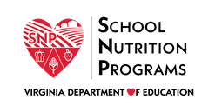
Last updated on 08/04/2021

Table of Contents

Introduction 3
Procuring Foods 4
Dealing with Staff Shortages 7
Receiving and Storing Foods 9
Preparing Meals 11
Serving Meals in Various Settings 18
Child Nutrition Program Meal Patterns 19
Sample Lunch Menu 20
Sample Breakfast Menus and Recipes 23
Recipe: Peaches and Cream Overnight Oats 26
Recipe: Egg and Cheese Burrito 27
Recipe: Egg and Avocado Toast 28
Recipe: Chicken Sausage and Cheese Croissant 30
Recipe: Blueberry Breakfast Parfait 31
References 32

Introduction
Objective: The purpose of this toolkit is to provide information and resources to encourage the preparation and service of local, seasonal, fresh foods in Virginia schools and education sites. Topics include serving locally procured, freshly prepared meals, basic culinary skills, tips for serving meals in various settings, ideas for working with limited staff, and strategies for improving the quality of foods served.
Background: The COVID-19 pandemic required flexibility, resiliency, and changes to the way schools purchased, prepared, and served students. The changes required emergency use of processed and packaged products. In order to serve Virginia students healthy, high-quality foods during the 2021-2022 school year, the Virginia Department of Education, Office of School Nutrition Programs (VDOE-SNP) encourages schools/sites to transition back to menus featuring minimally processed, fresh, scratch cooked meals.
Target Audience: School/site nutrition directors and staff, administrators, and community partners.

Procuring Foods
The 2021-2022 school year provides an opportunity to review procurement practices and to purchase minimally processed, fresh foods while taking advantage of lower cost items via the use of USDA Foods and the Department of Defense Fresh Fruit and Vegetable program (DoD Fresh). School nutrition professionals are aware of a range of procurement regulations at the local, state, and federal levels and navigating those regulations can sometimes seem daunting. The following resources will assist school/child nutrition professionals in navigating procurement procedures and programs.

USDA Foods for Schools
The link below provides best practices for managing USDA Foods in Schools during school year 2021-2022. Topics include a review of changes to the Foods Available List, information on USDA Foods entitlement, USDA Foods direct delivered products, the National Processing program, and the DoD Fresh program. Actions to assist with managing USDA Foods orders and utilization of USDA Foods inventories are discussed.
Link: USDA Webinar: Managing USDA Foods for Schools Entitlement, Orders, and Inventories in SY 2021-2022

DoD Fresh Produce Program
The DoD Fresh Produce program allows schools to use federal entitlement dollars to buy fresh produce. Advantages of the DoD Fresh Produce program include greater buying power, consistent deliveries, emphasis on high quality, a large variety of produce items including pre-cuts and locally grown, and an easy-to-use ordering website with funds tracking.
Link: DoD Fresh program

Local Procurement
Procuring Local Foods for Child Nutrition Programs covers procurement basics, defining local, where to find local products, and the variety of ways child nutrition program operators can purchase locally in accordance with regulations. This resources is designed to help nutrition programs procure more locally grown foods.
Link: USDA Procuring Local Foods for Child Nutrition Programs

Virginia Harvest of the Month
The Virginia Harvest of the Month program strives to increase student consumption of seasonal agricultural products, grown and produced in Virginia. The program features a Virginia product for each month of the year and provides resources for schools to connect the classroom, school garden, and cafeteria.
Link: Virginia Harvest of the Month program

Farm to Freezer Approach
Farm to Freezer is a method of procuring and preparing local, fresh produce to be served on menus during off-season months. Using this model, produce is prepared and frozen either onsite or at a central kitchen. An example of the Farm to Freezer approach is zucchini procured in July through a local farmer. The zucchini is shredded, frozen, and stored to be used later in a zucchini bread recipe. In February, during the cold months of winter, the zucchini is removed from the freezer and used in freshly baked zucchini bread.
Link: The Dirt: Farm to School Supports Local Through the Winter Weather
Link: The Chef Ann Foundation: Connecting Communities through Scratch Cook School Food

Local Food Tracking Tool
The Local Food Tracking Tool, an Excel file which includes a collection of farm to school tracking worksheets, is designed to help school/child nutrition professionals track of their farm to school activities to facilitate accurate completion of farm to school surveys and the USDA Farm to School Census. Use of these tracking sheets is not required by the VDOE-SNP but is recommended. DoD Fresh Produce that is labeled as local can count if it meets the school food authority's (SFA's) definition of local. The VDOE-SNP encourages farm to school participants to adapt these sheets to best suit their needs.
Link: VDOE-SNP Training and Resources - Local Food Tracking Tool

School Food Ingredient Guide
This guide is a resource for school food leaders and manufacturers alike who are committed to improving the overall quality, nutritional value, and safety of food provided to all students in every school. The resource highlights unwanted ingredients to eliminate and ingredients to watch out for as new food products are developed and others are modified. The science-based tool was created primarily by school nutrition professionals, for school nutrition professionals, in partnership with Center for Science in the Public Interest (CSPI).

Link: CSPI’s School Food Ingredient Guide

Institute of Child Nutrition (ICN)
This training resource provides a basic overview of federal procurement principles and covers a host of topics related to sourcing and purchasing local foods. This training highlights the mechanisms that schools/sites may use to purchase local products while abiding by federal procurement regulations, as well as the areas within solicitations where schools/sites can express their desire for local products.
Link: ICN Procuring Local Foods for Child Nutrition Programs

Dealing with Staff Shortages
The following tips are intended to assist school/child nutrition directors with providing excellent customer service while dealing with staff shortages. Note: These are general tips; not all tips will be applicable to the unique needs of each SFA.
- Utilize more speed scratch cooking. Speed scratch cooking will allow for greater seasonal flexibility, simplify menu development and redesign, allow staff to cross-utilize main ingredients without additional inventory, and offer efficiency through staff production schedules and control of labor costs.
- Utilize technical education programs. Many school/child nutrition programs have developed partnerships with career and technical education (CTE) culinary arts and agricultural programs. Culinary arts students can earn workplace readiness credentials by working hands-on in school cafeterias. Agricultural classes can grow and harvest nutritious ingredients to use in school/child nutrition programs.
- Increase marketing of the school/child nutrition program through signage, social media, newsletters, email, and automated calls. Be creative with social media posts and utilize as many platforms as possible, such as Facebook, Twitter, Instagram, and TikTok.
- Consider parent and community volunteers as kitchen staff substitutes. Many parents are looking for ways to volunteer at their child(ren)’s school. Create substitute positions for willing parents and community members. They can be trained and on-call.
- Find ways to utilize kitchen and cafeteria space more efficiently to reduce unnecessary steps and backtracking. Eliminating unnecessary steps lowers production time, reduces confusion, and ensures a well-organized and orderly system to encourage cleanliness, simplicity, and food safety.
- Consider implementing a central kitchen where food is received, prepared, and distributed to satellite school kitchens for service.
- Revise staffing procedures. Transition from several staff working shorter hours to fewer staff working longer hours. Cross train employees and enhance available culinary training so staff members are more versatile in the kitchen.
- Take advantage of equipment that offers timesaving techniques such as self-portioning systems and tools.
- Analyze/adjust school menus to pair labor-intensive items with simpler items. Serve the most popular menu items on days with lower staff absenteeism.
Additional strategies may be found in the following resource, which focuses on implementing staff safety techniques, reducing staff turnover, and improving staff communication and morale.
Link: No Kids Hungry's Guide to Emerging Strategies and Tactics for School Meal Service

Receiving and Storing Foods
All kitchen staff must be trained on key kitchen procedures including receiving and storing foods. A workforce that is knowledgeable in this area will allow managers to maximize the productivity of the kitchen team, prevent waste, and reduce the possibility of cross contamination.

Receiving Foods
Receiving foods is the food service authority’s first contact with food. In order to make sure food is safe while receiving, train staff to inspect products immediately upon arrival. Employees should be knowledgeable on appropriate temperatures, acceptable packaging, and quality specification of received goods for a more efficient and safer food production process. The National Restaurant Association provides the following suggestions.
Temperature
- Receive cold food at 41º or lower;
- Receive hot food at 135º or higher;
- Freezer foods should be frozen solid;
- Eggs must be received at 45º or lower.
Packaging
Reject products for any of the following reasons:
- Food that has ice crystals. Ice crystals indicate the product may have thawed and refrozen;
- Dented, rusty, or bulging cans;
- Packaging with tear, holes, punctures, leaks, or water stains;
- Items with pest damage or expired use-by dates.
Link: The Chef Cyndie Good Receiving Practices Video

Product Storage
Once food is purchased and received, it must be stored correctly to ensure safety. It is critical for a foodservice provider to practice accurate storage protocol. The ability to do this will reduce wasted time searching for goods and will safeguard against waste. Well-managed storage will lend itself to faster food production.
The National Restaurant Association provides the following tips on product storage:
- Store all food that is time and temperature controlled for safety at 41º or lower.
- Alphabetize spices to decrease time spent looking for ingredients.
- Label all stored food. The label must include the name of the food, and the date by which is should be sold, eaten, or discarded.
- Incorporate the first-in, first out (FIFO) method. FIFO is the process of rotating food in storage to use the oldest inventory first to reduce food spoilage.
- Organize refrigerated food to prevent cross-contamination. This will protect against foodborne illness and familiarize staff with product placement.
Link: The Chef Cyndie Storing Food the RIGHT Way Video
Link: The National Restaurant Association Food Safety Article
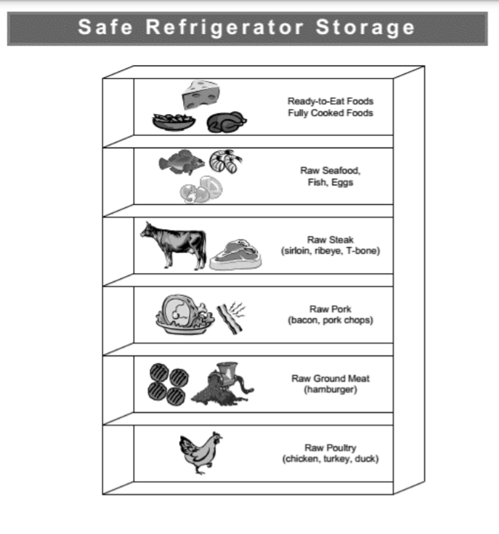

Preparing Meals
Fresh, scratch-cooked meals require fundamental culinary skills. Proper knife handling, measuring skills, and utilization of production schedules and records will improve efficiency, safety, and operations in school/child nutrition kitchens.

Food Preparation
The kitchen staff’s ability to execute fundamental food preparation tasks will speed up the flow of food through the kitchen while helping eliminate the potential risk to food safety. These food preparation skills include an understanding of basic kitchen equipment, various culinary skills, and the ability to stay organized, also known as mise en place. Chef Cyndie Culinary Institute and the Institute of Child Nutrition (ICN) has provided the following food preparation videos as a resource.
Link: Chef Cyndie’s Basic Kitchen Equipment – Pans Video
Link: Chef Cyndie’s Basic Kitchen Equipment – Utensils Video
Link: Chef Cyndie’s Batch Cooking Video
Link: Chef Cyndie’s Food Preparation Video
Link: ICN's Mise en Place Video

Knife Skills
Safety is just one of the many benefits of proper knife skills. A sharp blade ensures speed, efficiency, consistency, and overall presentation. Improving knife skills will result in better food production, reduced waste, and financial savings. The following training video is designed to improve knife safety skills.
Link: Cooking for Kid’s Knife Safety Video
Knife safety starts with knowing what type of knife is most useful for the task. The ICN provides a 15-minute training that focuses on types of knives.
Link: ICN’s Types of Knives Lesson
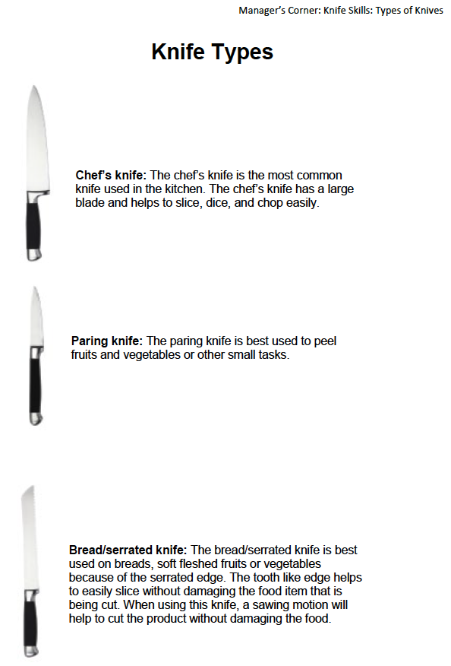
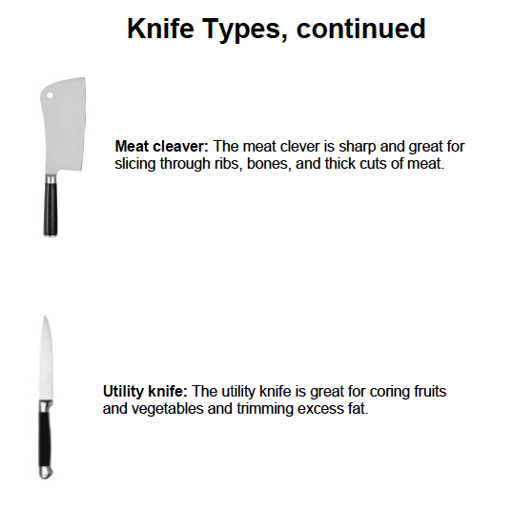
Knowing how to efficiently prepare commonly used produce items will decrease preparation time and improve safety. The following training videos will assist school/child nutrition professionals with selecting and preparing specific produce items:
- Tomatoes* (USDA Produce Lab, 2021)
- Broccoli and Cauliflower* (USDA Produce Lab, 2021)
- Romaine* (USDA Produce Lab, 2021)
- Cucumbers* (USDA Produce Lab, 2021)
- Strawberries* (USDA Produce Lab, 2021)
- Apples* (USDA Produce Lab, 2021)
- Butternut Squash* (Oregon Child Nutrition Programs, 2017)
- Bananas (USDA Produce Lab, 2021)
- Oranges (USDA Produce Lab, 2021)
*Indicates a food item that may be produced in Virginia and/or is a Virginia Harvest of the Month produce item.

Measuring
Following a standardized recipe ensures consistency in quality, portion size, and cost control. To follow a standardized recipe, school nutrition professionals must understand how to properly measure ingredients and know the difference between measuring by volume or weight. The following training videos explain the difference between weighing and measuring food to produce consistent results.
Link: VDOE-SNP Culinary Weights and Measures Training
Link: Chef Cyndie’s Culinary Solutions Center Training Video
Link: ICN Measuring Training Video
Link: ICN Weighing Training Video

Par Levels and Inventory Control
Par levels are the ideal amount of inventory an operation should have on hand at all times. Accurate and regular inventory management will ensure that optimal levels of product are on hand while decreasing the chance of mishaps such as food spoilage due to overordering. The formula for determining par stock is:
Par level = (Inventory used each week + safety stock buffer) / number of deliveries
Keeping precise records of par stock begins with understanding how to track inventory. There are two methods for tracking inventory.
- Physical inventory – The entire stock is manually counted and recorded on a regular basis. After the count is taken the operation determines a reorder point for each item.
- Perpetual inventory – Calculated by recording items as they come in and as they are used. This method tracks and records items as they are added to or subtracted from the inventory.
Once inventory has been recorded, managers should forecast using previous sales data to create an ideal par stock for each item.
Link: ICN’s Inventory Management and Tracking

Production Schedules
A production schedule is a detailed food preparation plan that allows a food service manager to maximize staff skills while ensuring food quality control. More specifically, it is a printed guide showing all the food preparation tasks that need to be performed on a particular day. Creating and managing an organized production schedule will ensure operational efficiency. Production schedules should include the name of employee, the food preparation station to be used, the ingredients to prepare, and each item's par level.
Benefits of a daily production schedule include:
- Speeding up preparation time. An organized production schedule helps nutrition professionals stay on task and enables cross utilization of similar ingredients. In addition, it reduces the required number of staff members needed to execute a recipe. It enables staff to perform the service in fewer steps.
- Reduces food waste. Accurate par levels prevent your staff from over-preparing and contributing to food waste, while also cutting down on the risk of spoilage of perishable ingredients.
- Reduces wait times for students. When kitchen tasks are completed ahead of time, cooks can prepare dishes more quickly and reduce wait times in cafeteria lines.
- Simplifies the inventory process and food cost calculation.
- Provides easier estimation of product usage and ordering procedure.
- Cuts down on storage space and simplifies organizational practices.
Successful kitchen preparation starts with an organized production schedule. The more tasks that can be performed ahead of time, the more streamlined the kitchen operation will be. The VDOE-SNP Production Schedule Template previewed below can be edited for kitchen efficiency.
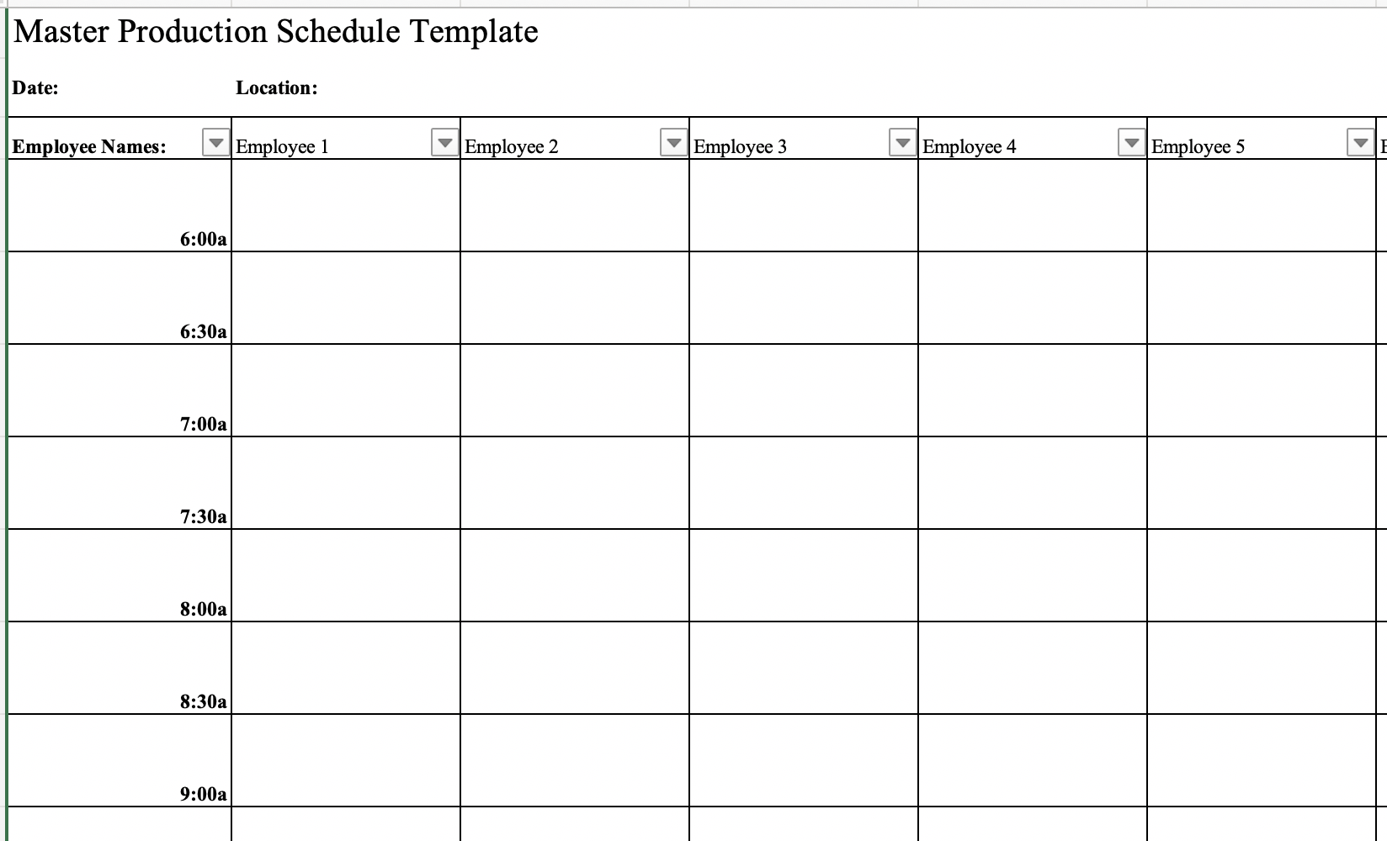

Steps for Creating a Production Schedule

Step 1: Review the menu items offered for the day and detail production steps required for each ingredient.

Step 2: Determine number of portions to prepare and quantities of ingredients needed according to estimated usage and past sales trends.

Step 3: Assign tasks to kitchen employees on the production schedule and communicate expectations clearly to employees. Review the production schedule before the work begins and consistently refer to the production schedule throughout operations.

Production Records
All schools participating in the National School Lunch Program (NSLP) and School Breakfast Program (SBP) must complete daily menu production records for all meals. A production record is a working tool that outlines the type and quantity of foods that need to be purchased and available for the meal service. A guide to completing a production record and an example of a completed production record is available in the Download Forms section of SNPWeb. Production records should include:
- name of site;
- grade group;
- meal date;
- meal type (breakfast or lunch);
- food components and other items, including
substitutions and condiments;
- recipe or food product used;
- planned number of portions and serving sizes;
- total amount of food prepared;
- amount of leftover food;
- total quantity of food used; and
- number of reimbursable meals served.
Link: USDA Production Record Example (Appendix 4.A)
Link: ICN’s iLearn Course: Production Records

Serving Meals in Various Settings
The lingering effects of COVID-19 may still impact meal service in Virginia schools during the 2021-2022 school year. The traditional service line in the cafeteria setting may no longer be the best way to feed students. Below are tips and resources for serving fresh, minimally processed meals in various settings.

Virtual and Hybrid Learning
Drive-thru or Curbside: Establish a distribution point that allows for a line of waiting vehicles without backing up onto the street. Providing whole fruits and vegetables cuts down on packaging and these items may be purchased locally.
Walk-Up: Insert traffic cones, tape, or chalk marks at least six feet apart on the ground to show how far apart groups should wait. Provide meals in a pleasant environment to improve participation, such as near a shady park with benches.
Mobile Route Delivery: Select accessible locations near where families live, like housing communities and apartment complexes. Maintain consistency with location and schedules so families know when to pick up a meal.
Bus Route Delivery: Prioritize use of existing school bus routes, rather than modifying or creating new routes, so students and families can easily access a familiar location. Ensure time and temperature control with ice packs and utilize thermometers often.

In-Person Learning
Meals Served in the Classroom: Create a plan between teachers and school nutrition staff to return reusable items to the cafeteria, including handling used or dirty non-disposable food service items with gloves. Maintain communication with teachers and administration to build a strong relationship.
Meals Served in the Cafeteria: Avoid offering any self-serve food or drink options, such as hot and cold food bars, salad or condiment bars, and drink stations. Serve grab-and-go items or individually plated meals, instead. Offer fresh prepared and less processed items to improve participation.
Link: CDC’s Safely Distributing School Meals During COVID-19
Link: No Kids Hungry's Guide to Emerging Strategies and Tactics for School Meal Service

Child Nutrition Program Meal Patterns
Due to COVID-19, Virginia school divisions are taking advantage of the USDA waiver allowing participation in the Seamless Summer Option (SSO). The SSO allows free meals for all enrolled students in Virginia schools. The SSO has less paperwork, making it easier for schools to feed children.
Ensure that your program is following the correct meal pattern. Due to COVID-19, the USDA is allowing waivers for multiple aspects of the federally funded meal programs. For the 2021-2022 school year, most schools have applied for and been approved to participate in the SSO in place of the NSLP. This waiver allows flexibility in meal patterns, meal service, and operations. To see differences between the programs, the USDA created a program comparison chart.

Seamless Summer Option (SSO)
Link: USDA SSO Information

National School Lunch Program (NSLP)
Link: USDA NSLP Meal Pattern

Child and Adult Care Food Program (CACFP)
Link: USDA CACFP Meal Pattern

Summer Food Service Program (SFSP)
Link: USDA SFSP Meal Pattern

Sample Lunch Menu
The following lunch menu highlights USDA Foods available for the 2021-2022 school year to create a meal pattern focusing on variety, scratch cooking, and nutritional quality. Ensure that the correct amounts of each food item are being provided by referencing the Child Nutrition or CN label on each product. If a CN label is not available, the USDA Food Buying Guide may be used to calculate ounce equivalence for grains and meat/meat alternate foods. The menus are intended to provide ideas on utilizing USDA Foods in order to provide flexibility to the grade level being served. Use the meal pattern resources on page 19 to ensure compliance with federal regulations.

Sample Lunch Menu
Monday | Tuesday | Wednesday | Thursday | Friday
Entrée 1:  - Chicken fajita tacos (Chicken Fajita Strips #100117, Cheese pepper jack, shredded #111220)  Entrée 2:  - Turkey taco salad (Turkey taco filling #1100119, Cheese pepper jack, shredded #111220)  Vegetable:  - Vegetarian beans (#100364)  - Tomato salsa* (#110186)  - Shredded romaine*  Fruit:  - Mixed berry cup* (#110859)  - Asian pear*  Milk:  - Skim milk  - 1% Milk | Entrée 1:  - Beef burger with cheddar (Beef patty, cooked #110711, Cheddar cheese #110254)  Entrée 2:  - Tuna sandwich (Tuna, #100195, White cheddar cheese #110253)  Vegetable:  - Three bean salad* (Garbanzo beans, can #100360, Green beans, can #100307)  - Carrot sticks, fresh*  - Tomato slices, fresh*  Fruit:  - Sliced apple* or applesauce (#110541)  - Sliced cantaloupe*  Milk:  - Skim milk  - 1% milk | Entrée 1:  - Oven Roasted Chicken with a freshly baked roll (Chicken #110080, Flour #100421))  Entrée 2:  - Turkey & provolone roll up (Turkey, deli breast sliced #110554)  Vegetable:  - Cucumber sticks, fresh*  - Steamed broccoli* (#110473)  - Potato wedges* (#100355)  Fruit:  - Sliced peaches*  - Blackberries*  Milk:  - Skim milk  - 1% milk | Entrée 1:  - Italian pasta with meatballs (Meatless spaghetti sauce, #110177, Pasta, spaghetti, enriched #100425, Cheese, mozzarella, shredded #100021)  Entrée 2:  - Sunflower seed butter & jelly (Sunflower seed butter, #100935)  Vegetable:  - Kale side salad*  - Steamed peas and carrots* (Peas #100315, Carrots #111052)  - Red pepper strips*  Fruit:  - Asian pear*  - Sliced strawberries*  Milk:  - Skim milk  - 1% milk | Entrée 1:  - Homestyle chicken legs (Chicken legs #100113)  Entrée 2:  - Pulled pork sandwich (Pork, pulled, unseasoned, frozen #110730)  Vegetable:  - Carrot sticks, fresh*  - Mashed sweet potatoes* (#100317)  - Corn and bean salad* (Corn, can #100313, Garbanzo beans, can #100360)  Fruit:  - Sliced cantaloupe*  - Watermelon cubes*  Vegetable:  - Red pepper strips*  Milk:  - Skim milk  - 1% milk
*Indicates a food item that may be produced in Virginia

Sample Breakfast Menus and Recipes
In order to promote nutritious breakfast practices across Virginia, the VDOE-SNP created the Breakfast Club, a group of stakeholders charged with advocating and promoting healthier breakfast menus and foods. The sample menu provides ideas from programs across Virginia that emphasize the Club’s best practices for serving nutrient-dense breakfasts. This menu may be used by new and seasoned directors alike for breakfast ideas. A select number of featured recipes are also included. Use the meal pattern resources on page 19 to ensure compliance with federal regulations.

VDOE-SNP Breakfast Club
Collaboration from the Club provides guidance and resources for Virginia school divisions to offer nutrient-dense, quality breakfasts. To learn more about the quarterly Breakfast Club meetings or to highlight a smart breakfast choice in your school, please contact Laura Burns, VDOE-SNP Wellness Policy Specialist, via email at Laura.Burns@doe.virginia.gov.

Grab and Go Breakfast Menu – Week 1
Monday | Tuesday | Wednesday | Thursday | Friday
Entrée 1:  - Hard-boiled egg pops (Arlington City Public Schools. Recipe from the American Egg Board Association)  Entrée 2:  - Blueberry parfait (Waynesboro City Public Schools)  Fruit:  - Sliced strawberries*  - Blueberries*  Vegetable:  - Sweet potato hash*  Milk:  - Skim milk  - 1% milk | Entrée 1:  - Blueberry yogurt smoothie with granola (Newport News City Public Schools)  Entrée 2:  - Breakfast chicken on a whole grain biscuit (Richmond City Public Schools)  Fruit:  - Sliced Virginia apple*  - Sliced cantaloupe*  Milk:  - Skim milk  - 1% milk | Entrée 1:  - Scrambled egg and cheese on a whole grain croissant (Danville City Public Schools)  Entrée 2:  - Whole grain bagel with cream cheese and sliced tomatoes* (Cumberland County Public Schools)  Fruit:  - Sliced peaches*  - Blackberries*  Milk:  - Skim milk  - 1% milk | Entrée 1:  - Peaches and cream overnight oats (Chesterfield County Public Schools)  Entrée 2:  - Fun fruit breakfast pizza (Child Nutrition Recipe Box)  Fruit:  - Asian pear*  - Sliced strawberries*  Milk:  - Skim milk  - 1% milk | Entrée 1:  - Egg and cheese breakfast burrito (Middlesex County Public Schools)  Entrée 2:  - Sunflower seeds with a whole grain muffin (Harrisonburg City Public Schools)  Fruit:  - Sliced cantaloupe*  - Watermelon cubes*  Vegetable:  - Red pepper strips*  Milk:  - Skim milk  - 1% milk
*Indicates a food item that may be produced in Virginia

Grab and Go Breakfast Menu – Week 2
Monday | Tuesday | Wednesday | Thursday | Friday
Entrée 1:  - Breakfast wrap (Virginia Department of Justice)  Entrée 2:  - Turkey sausage, boiled egg, & toast (Virginia School for the Deaf and Blind)  Fruit:  - Blueberries*  - Sliced cantaloupe*  Vegetable:  - Red pepper strips*  Milk:  - Skim milk  - 1% milk | Entrée 1:  - Chicken sausage and cheese croissant (Henrico County Public Schools)  Entrée 2:  - Breakfast basket (National Dairy Council)  Fruit:  - Watermelon cubes*  - Asian pear*  Milk:  - Skim milk  - 1% milk | Entrée 1:  - Fruit & yogurt parfait with granola (Powhatan County Public Schools)  Entrée 2:  - Bacon & egg biscuit (Pulaski County Public Schools)  Fruit:  - Sliced peaches*  - Sliced strawberries*  Vegetable:  - Sweet potato hash*  Milk:  - Skim milk  - 1% milk | Entrée 1:  - Cheddar omelet with hash browns (Salem City Public Schools)  Entrée 2:  - Banana and nut butter breakfast sushi (Humane Society)  Fruit:  - Sliced cantaloupe*  - Sliced Virginia apple*  Milk:  - Skim milk  - 1% milk | Entrée 1:  - Egg and avocado toast (Staunton City Public Schools)  Entrée 2:  - Choice of low-sugar cereals with seasonal fruit (PHILLIPS School)  Fruit:  - Blackberries*  - Sliced strawberries*  Milk:  - Skim milk  - 1% milk
*Indicates a food item that may be produced in Virginia

Sample Recipes from Virginia Schools

Recipe: Peaches and Cream Overnight Oats
Source: Chesterfield County Public Schools
Group: Breakfast
Number of Portions: 1
Size of Portion: 1 each
Serving tool: 10 oz. spoodle
Meal Component Contribution: 1 oz. equiv. whole grain, 1 oz. equiv. meat/meat alternate, ½ cup fruit
HACCP Process: Process #1 – No cook
Ingredient | Quantity | Directions
Yogurt, vanilla, low fat | 4 oz. | Wash your hands. Put on disposable gloves.
Oats, rolled, whole grain, quick cooking | ¼ cup | In a large bowl, combine dry oats, yogurt, and milk.
Milk, 1%, white | 1 oz. | Intentionally left blank
Peaches, diced and drained | ½ cup | Stir in drained, diced peaches.
Intentionally left blank | Intentionally left blank | Measure 10 oz. with a spoodle into a 12 oz. parfait cup. Place lids on cups and refrigerate overnight.  - CCP: Hold at 41℉ or below.
Notes:
When available, fresh, local peaches may be used in place of canned peaches. Substitute ½ cup of ripe peaches for ½ cup of canned peaches. ½ cup of any seasonal fruit may be used in place of ½ cup of peaches.
HACCP Standard Operating Procedure – Use hand washing procedures before starting recipe.
HACCP Standard Operating Procedure – Wash all produce before starting this recipe.

Recipe: Egg and Cheese Burrito
Source: Middlesex County Public Schools
Group: Breakfast
Number of Portions: 25
Size of Portion: 1 wrap
Meal Component Contribution: 1 oz. equiv. whole grain, 3 oz. equiv. meat/meat alternate
HACCP Process: Process #2 – Same Day Service
Ingredient | Quantity | Directions
Egg Patty | 1 each (1 oz.) | - Wash your hands. Put on disposable gloves.
Intentionally left blank | Intentionally left blank | - Heat egg patty in 350℉ oven to internal temp of 165℉  - CCP: Cook to 165℉
Flour tortilla, whole grain, 6 inch | 1 each (1.1 oz.) | - Place two cooked egg patties in tortilla.
Cheese, American yellow, slice | 1 slice (½ oz.) | - Top egg patty with one slice of cheese.
Intentionally left blank | Intentionally left blank | - Fold tortilla into wrap.
Intentionally left blank | Intentionally left blank | - Wrap in foil sheet.  - CCP: Hold at minimum of 155℉
Notes:
Diced red pepper may be added to the burrito for additional flavor and texture.
HACCP Standard Operating Procedure – Use hand washing procedures before starting recipe.
HACCP Standard Operating Procedure – Wash all produce before starting this recipe.

Recipe: Egg and Avocado Toast
Source: Staunton City Public Schools
Group: Breakfast
Number of Portions: 12
Size of Portion: 1 sandwich
Meal Component Contribution: 2 oz. equiv. whole grain, 3 oz. equiv. meat/meat alternate, ¼ cup vegetable (vegetable category: other)
HACCP Process: Process #2 – Same Day Service
Ingredient | Quantity | Directions
Intentionally left blank | Intentionally left blank | - Wash your hands. Put on disposable gloves.
Intentionally left blank | Intentionally left blank | - Preheat the oven to 350°F.
English muffin, whole grain | 12 each | - Line a baking sheet with parchment paper, lay opened faced each English muffin onto lined sheet.
Olive oil | 6 Tbsp. | - Evenly spread ½ tsp. of olive oil on each muffin half.
Intentionally left blank | Intentionally left blank | - Slow-toast the English muffins on the middle rack of the oven for 10 minutes, turning over at 5 minutes.
Avocado, whole, large, ripe | 3 each | - Cut the avocado in half. Using a chef’s knife, slice through the avocado lengthwise until you feel the pit. Separate avocado into two even halves. Remove the pit. Slice 6 even lengthwise cuts through avocado, being careful not to cut through the peel. Scoop out the slices with a tablespoon.
Boiled egg, cooked, medium | 12 each | - Slice each boiled egg in 4 even coin shapes.
Intentionally left blank | Intentionally left blank | - Remove the toasted muffins from the oven. Add 4 egg slices and 3-4 slices of avocado on each muffin.
Intentionally left blank | Intentionally left blank | - Serve in a grab and go service container.  - CCP: Hold for cold service at 41°F or below.

Notes:
HACCP Standard Operating Procedure – Use hand washing procedures before starting recipe.
HACCP Standard Operating Procedure – Wash all produce before starting this recipe.

Recipe: Chicken Sausage and Cheese Croissant
Source: Henrico County Public Schools
Group: Breakfast
Number of Portions: 100
Size of Portion: 1 sandwich
Meal Component Contribution: 1 oz. equiv. whole grain, 1.5 oz. equiv. meat/meat alternate
HACCP Process: Process #2 – Same Day Service
Ingredient | Quantity | Directions
Intentionally left blank | Intentionally left blank | - Wash your hands. Put on disposable gloves.
Chicken sausage patty, cooked, thawed | 100 each | - Preheat oven to 325°F. Spray a sheet pan with non-stick spray. Place sausage patties in a single layer on sheet pan.
Intentionally left blank | Intentionally left blank | - Cook sausage patties in 325°F oven for approximately 7-9 minutes if thawed. (If sausage patties are frozen, cook for 9-11 minutes)  - CCP: Heat sausage patties to 165°F or higher for at least 15 seconds.
Croissant, whole grain | 100 each | - Slice each croissant in half.
Cheese, American, slice | 100 slices | - Assemble 1 sausage patty and 1 slice of cheese inside the sliced croissant. Serve warm.  - CCP: Hold for hot service at 140°F or higher.
Notes:
HACCP Standard Operating Procedure – Use hand washing procedures before starting recipe.
HACCP Standard Operating Procedure – Wash all produce before starting this recipe.

Recipe: Blueberry Breakfast Parfait
Source: Waynesboro City Public Schools
Group: Breakfast
Number of Portions: 1
Size of Portion: 1 Parfait
Meal Component Contribution: 1.75 oz. equiv. whole grain, 1 oz. equiv. meat/meat alternate, 1 cup fruit
HACCP Process: Process #1 – No cook
Ingredient | Quantity | Directions
Intentionally left blank | Intentionally left blank | - Wash your hands. Put on disposable gloves.
Yogurt, vanilla, low-fat | 4 oz. | - In a 9 oz. parfait cup, layer ingredients in the following order:  - 2 oz. yogurt  - ½ cup blueberries  - 2 oz. yogurt
Granola | ½ cup | - Pour ½ cup of granola in parfait cup lid insert.
Blueberries, fresh or frozen | ½ cup | - Seal lid and hold in a cooler at 41°F or below for service.  - CCP: Hold for cold service at 41°F or below.
Notes:
½ cup of seasonal fruit may be used in place of ½ cup of blueberries.
HACCP Standard Operating Procedure – Use hand washing procedures before starting recipe.
HACCP Standard Operating Procedure – Wash all produce before starting this recipe.

References
Cross-Contamination. (2017, November 28). Tazwell Health Department.
Hitchcock Farms. (2020, March 11). 3 Speed Scratch Cooking Fundamentals You Need to Know. Retrieved July 26, 2021.
Institute of Child Nutrition. (n.d.-a). Knife Skills. Culinary Institute of Child Nutrition. Retrieved July 26, 2021.
Institute of Child Nutrition. (n.d.-b). Weights and Measures. Culinary Institute of Child Nutrition. Retrieved July 26, 2021.
Institute for Child Nutrition. (2021). Procuring Local Foods for Child Nutrition Programs. Resources A-Z. Retrieved July 26, 2021.
Lean Restaurants. (2019, August 29). Kitchen prep production sheet: The Backbone of a Successful kitchen. Retrieved July 26, 2021.
Maxey, T. (2021). Harvest of the month. Virginia Agriculture in the Classroom. Retrieved July 26, 2021.
National Restaurant Association. (2021). Foundations of Restaurant Management & Culinary Arts Level 1 Student Activity Guide (2nd Edition) [E-book]. In Foundations of restaurant management & culinary arts: level 1 (pp. 86–87). National Restaurant Association.
No Kid Hungry. (2020, April 30). Emerging strategies and tactics for meal service during school closures related to the coronavirus. Center for Best Practices. Retrieved July 26, 2021.
Orderly. (n.d.). Inventory Par Levels: How to Calculate Them and Why They’re Important. Ben Baggett. Retrieved August 2, 2021.
USDA Food and Nutrition Service. (2021, February 1). Managing USDA foods for schools’ entitlement, orders, and inventories in SY 2021-2022. USDA. Retrieved July 26, 2021.
USDA Food and Nutrition Service. USDA DoD fresh fruit and vegetable program. (2021, July 30). Retrieved July 26, 2021.
USDA Food and Nutrition Service. Procuring local foods for child nutrition programs. (2015, August 17). Retrieved July 26, 2021.
Virginia Department of Education. (n.d.). Training & resources. Virginia Department of Education Office of School Nutrition Programs. Retrieved July 26, 2021.
WebstaurantStore. (2018, October 9). Principles of commercial kitchen design. Facility layout and design. Retrieved August 2, 2021.

