Virginia School Nutrition Path to Readiness and Recovery from COVID-19:

A Toolkit for Virginia School Nutrition Directors

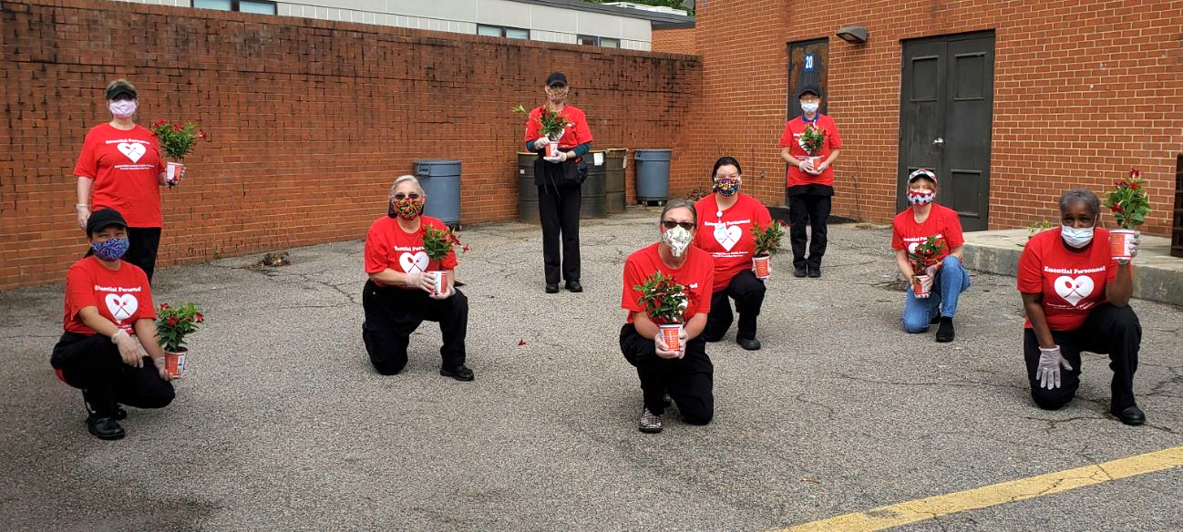
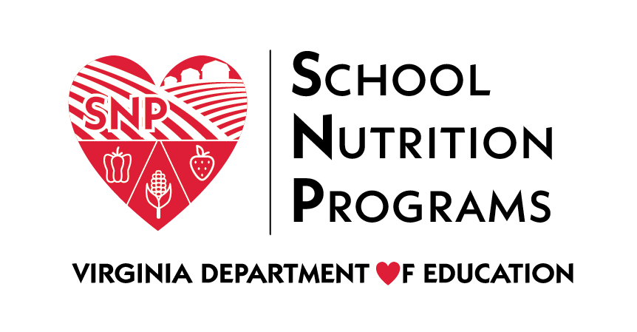
Last Updated on July 16, 2020

Introduction
The Virginia Department of Education, Office of School Nutrition Programs (VDOE-SNP) developed the following guidance to support school nutrition directors in developing their plans and strategies for continued meal service to Virginia children. The purpose of this guidance is to assist school nutrition directors and staff in making sound decisions to ensure the continuity of nutritious, safe, and reliable meals for all students.
The toolkit is designed as a living framework to provoke thought and guide your planning meetings. One tip is to create a binder and keep all planning documents together.
The VDOE reopening plan, based on guidance from Governor Northam and known as Recover, Redesign, Restart 2020, provides a summary of limits for each phase of reopening and serves as a quick reference to assist in decision-making.
Use the information in this toolkit to design your plan and communicate that plan to your school division leaders. The checklists within this toolkit contain both actionable items and thoughtful considerations. Check off items as you complete them or simply to acknowledge that you have considered and addressed them.
This toolkit also includes extensive menu planning resources. These resources include sample menus, recipes, production records, and a certification workbook.
Toolkit Updates
The toolkit will be updated periodically as the situation and guidance change. Each new version of the toolkit will be dated and all changes highlighted so users can easily identify new information.
Cover Photo Credit
The school nutrition team from Falling Creek Elementary in Chesterfield County is celebrated by parents on school lunch hero day.

Table of Contents
Introduction 2
Table of Contents 3
Virginia Recover, Redesign, and Restart Phases 4
School Nutrition Programs Planning 6
Annual Application 6
Participate in School Opening Planning 6
Food Service Models 6
Best Practices 7
Virtual Learning Only 7
Cafeteria Serving Line 7
Classroom 7
Take Home Meals 8
Incorporating OVS 8
Hallway Kiosk, Classroom, and Take Home Meals 8
Planning Checklists 9
Meal Service Checklists 10
Operations Checklists 17
Administrative Checklists 22
Resources 27
Menu Planning Resources 29
National School Lunch Program Meal Pattern 30
Traditional Five Day Menu Plan Week 1 31
Traditional Five Day Menu Plan Week 2 32
Hybrid Menu Plan 33
Virginia Harvest of the Month Suggestions 38
Farm to School Resources for Menu Planning 39
Back to School Recipes 41
Additional Recipe and Menu Planning Resources 42
Production Records 43
Example Production Record 44
Menu Certification Workbook Example 45
Office of School Nutrition Programs Breakfast Club 46

Virginia Recover, Redesign, and Restart Phases
Category | Phase 1 | Phase 2 | Phase 3
In-Person Instruction | In addition to child care programs and schools issued a variance, programs may be offered to special education students. | All previously permitted options, plus in-person instruction for preschool through third grade, instruction for English learners, and summer camp programs in school buildings are permitted. | In-person instruction can be offered to all students; however, physical distancing measures should be implemented.
Gathering Limits (applies to offices, classrooms, cafeterias, auditoriums, graduation ceremonies, etc.) | Max size of 10 individuals per room or bus. | Gathering limit increased to 50 if other physical distancing measures are in place. | Gathering limit increased to 250 if other physical distancing measures are in place.
Physical Distancing | Maintain six feet of physical distance between desks, tables, and workstations and between students and staff to the greatest extent possible. | Maintain six feet of physical distance to the greatest extent possible. | Maintain six feet of physical distance to the greatest extent possible; however, if six feet of distance is not feasible, schools should implement a combination of face coverings and a minimum of three feet of distance between everyone present.
Bus Capacity | Six-foot distancing with a max capacity of 10 students. | Physical distance should be created between children on school buses when possible. | Physical distance should be created between children on buses when possible.
Recess | Groups of 10 or less, physically distanced. | Groups of 50 or less, physically distanced, and with minimal mixing of groups. | Consider limiting the size of groups participating in outdoor activities/recess, with a priority on physical distancing and limiting mixing classrooms.
Health Screenings and Temperature Checks | If possible, conduct daily health screenings for symptoms and history of exposure for students and staff. | If possible, conduct daily health screenings for symptoms and history of exposure for students and staff. | If possible, conduct daily health screenings for symptoms and history of exposure for students and staff.
Face Coverings | Staff should wear cloth face coverings in times when at least six feet of physical distancing cannot be maintained. Schools should encourage the use of face coverings for students as developmentally appropriate in settings where six feet of physical distancing cannot be maintained. | Staff should wear cloth face coverings in times when at least six feet of physical distancing cannot be maintained. Schools should encourage the use of face coverings for students as developmentally appropriate in settings where six feet of physical distancing cannot be maintained. | Staff should wear cloth face coverings in times when at least six feet of physical distancing cannot be maintained. Schools should encourage the use of face coverings for students as developmentally appropriate in settings where six feet of physical distancing cannot be maintained.
Athletics and Extracurricular Activities | Prohibited. | Limited athletics and extracurricular activities with physical distancing. | Limited athletics and extracurricular activities with physical distancing.

School Nutrition Programs Planning

Annual Application
SFAs must submit for approval the Annual Applications for Participation in the National School Lunch Program (NSLP), School Breakfast Program (SBP), Special Milk Program (SMP), Seamless Summer Option (SSO), and the Afterschool Snack Program (ASP) by July 15, 2020. Refer to SNP Memo No. 2020-2021-04, School Year 2020-2021 Annual Application Packet, Guidance for Waiver Election, Toolkit Distribution, and COVID-19 Considerations for School Meal Service, for information on the specific sections of the application relating to COVID-19 school operations.

Participate in School Opening Planning
Providing meals to students is critical to the success of school reopening. Request a seat at the table with division leadership. If you are excluded from these important meetings, identify a school nutrition advocate, such as your supervisor, division business official, division health staff member, school board member, etc.
- Develop key messages to communicate program concerns, challenges, and celebrations.
- Develop an organized list of key considerations and concerns. Keep it top-line; be succinct.
Provide weekly briefings to administrators; include brief updates, program data, successes, new concerns, regulation changes, and problems solved.

Food Service Models
Food service models must meet the needs of the school division opening plan. There are three general scenarios for opening school: all virtual learning, hybrid opening, and open as usual. To meet the needs of all students, it is likely that implementing more than one food service model will be necessary, including different models for breakfast and lunch. Division directors should develop multiple plans and be prepared to shift models as needed.
- Explain the impact of various food service models to division administration.
- Discuss meal schedules with administration; all models will increase serving times and may require additional staff.
Consider a No Outside Food policy to mitigate bidirectional transfer of germs from home, transportation, and school.

Best Practices
- Develop your plans now! Have a plan for all service models and be ready to adapt new models as needed.
- Include a school nutrition manager on your planning team.
- Incorporate Offer Versus Serve (OVS) into all food service models, if possible.
- Use cashless transactions only, to reduce customer contact.
- Implement Community Eligibility Provision (CEP) in all eligible schools and divisionwide, if possible.

Virtual Learning Only
Meals provided for all virtual learning may be distributed through processes similar to the spring school closure.
- Multiple meals may be provided.
- OVS is encouraged.
- Guidance for counting and claiming procedures must be followed.

Cafeteria Serving Line
The serving model everyone knows! Familiarity may feel good to students, teachers, and school nutrition staff. In this model, students use the serving line to select their meals. You may implement traditional service by plating student-selected items or pre-assembling reimbursable meal options and allowing students to select additional meal components (e.g., vegetable, fruit, grain, milk).
- Plan for longer serving times to support physical distancing.
- You may be able to offer minimal à la carte items.
- Do not allow students to self-serve any items including food, milk, condiments, and utensils.

Classroom
Meals in the classroom (MIC) can follow your current breakfast in the classroom (BIC) model.
- All meals may need to be prepared at once, eliminating batch cooking.
- Additional support staff may be needed.
- OVS is encouraged.
Hallway kiosks can provide multiple points of service allowing small groups of students to pick up their meals. Pre-assembled reimbursable meal options may be offered and students may select additional meal components (e.g., vegetable, fruit, grain, milk).
Classroom service may include meals picked up in the cafeteria by a teacher or student or delivered to classrooms by school nutrition staff. You might also implement a meal count or pre-order system so that the precise numbers of meals are delivered.

Take Home Meals
Reopening scenarios that include designated virtual learning days increase complexity for menus, production, participation, service, and administration. In such scenarios, take home meals may be provided at the end of the school day in quantities to last until the next attendance day. Take home meals may be provided on virtual learning days. If your division’s academic calendar includes non-instructional teacher workdays, meals may not be provided using the NSLP or the SBP. As an alternative, eligible schools may provide meals using the Child and Adult Care Food Program (CACFP).
- Meal service options may include distribution on the school bus, kiosks as students exit, classroom delivery, and curbside pickup.
- Parent pickup is permitted.
- OVS is encouraged.

Incorporating OVS
The goal of OVS is to reduce waste and allow students to choose the foods they want to eat. It also helps reduce overall food costs. OVS is recommended for all food service models.
Training must be provided for any non-school nutrition employees whose responsibilities include meal distribution, counting, and claiming. This includes people such as teachers, teacher aides, bus drivers, bus aides, volunteers, etc.

Hallway Kiosk, Classroom, and Take Home Meals
Offer a pre-bagged or boxed reimbursable meal (e.g., entrée and vegetable or fruit) and give students choices for vegetables, fruits, grain, and milk to allow students to have the foods they enjoy.
As a health mitigation practice to protect students and staff, no self-service of food, beverages, condiments, or meal kits is recommended.
For tips about OVS, see the links to the USDA tip sheets in the Resources section of this toolkit.

Planning Checklists
The following checklists are designed to guide school nutrition directors in serving students in an ever-changing climate. Use the checklists as a reference for guiding school nutrition staff and school division administration in decision-making. Items on the checklist may be actionable items or ideas and recommendations to consider.

Meal Service Checklists
Cafeteria Serving Line
Familiar to students and staff; minimal changes needed to accommodate various attendance scenarios.
Check Box | Cafeteria Serving Line
Traditional service, plating student-selected food items OR
pre-assemble reimbursable meals and students select desired additional meal components and items.
 | Floor markings to help students stay six feet apart; coordinate with custodial services and administration.
 | Designate entrance and exit flow paths and stagger use.
 | Staffing: you may need two servers per line.
 | School nutrition team develops meal schedule with school administration; allow sufficient time to prepare and serve meals.
 | Select à la carte items, if offered.
 | Additional sneeze guards along the serving line and at the cashier station, if possible.
 | Accommodation for special dietary needs; identifying students and meals.
Water: USDA regulations, 7 CFR 210.10(a)(1)(i) and 220.8(a)(1), requires schools to make water available during meal service.
Suggestions: offer water served by an adult or access to water fountains or faucets to fill water bottles.
Pending VDOE requested waiver of the requirement to offer water. See State Waivers section.
 | Procedures for students to wash hands before and after eating.
 | Meal packaging: hinged trays, boxes, bags, or combination; no open trays.
 | No self-service (e.g., foods, beverages, condiments, utensils, etc.).
 | Counting and claiming procedures: student roster, check-off list, portable electronic devices, other; students must be counted by eligibility status.
 | Cashless transactions only, to reduce customer contact.
 | Provide food safety and meal accountability training to school staff and volunteers as needed.
 | Communicate with administration at each school regarding meal schedules, type of meal service, cashless transactions, and additional support needed (e.g., teachers, paraprofessionals, etc.).
 | Advise families of cashless transactions, how meals will be served, and staff health and safety protocol.
Notes and Reminders

Classroom Service
Build on a successful BIC model; may be labor intensive, but minimizes student movement.
Check Box | Classroom Service
 | Hallway kiosks: floor markings to help students stay six feet apart; coordinate with custodial services and administration.
 | Hallway kiosks: identify equipment needed to serve and hold food. Consider equipment that you already have that could be repurposed.
 | Hallway kiosks: identify location and electrical needs.
 | Classroom delivery: meals picked up in the cafeteria by a teacher or student or delivered by school nutrition staff.
 | Classroom delivery: meal counts or pre-orders for classroom delivery.
 | Classroom delivery: identify how meals will be transported (e.g., insulated bags, wagons, etc.).
 | Incorporate OVS.
 | Staffing: additional support staff may be needed.
 | School nutrition team develops meal schedule with school administration; allow sufficient time to prepare and serve meals.
 | Establish procedures for handling trash: identify trash bins and bags needed.
 | Accommodation for special dietary needs: identify students and meals.
Water: USDA regulations, 7 CFR 210.10(a)(1)(i) and 220.8(a)(1), requires schools to make water available during meal service.
Suggestions: offer water served by an adult or access to water fountains or faucets to fill water bottles.
Pending VDOE requested waiver of the requirement to offer water. See State Waivers section.
 | Procedures for students to wash hands before and after eating.
 | Meal packaging: hinged trays, boxes, bags, or combination; no open trays.
 | No self-service (e.g., foods, beverages, condiments, utensils, etc.); required in Phase 2, recommended in Phase 3.
 | Counting and claiming procedures: student roster, check off list, portable electronic devices, other; students must be counted by eligibility status.
 | Cashless transactions only, to reduce customer contact.
 | Provide food safety and meal accountability training to school staff and volunteers as needed.
 | Communicate with administration at each school regarding meal schedules, type of meal service, cashless transactions, and additional support needed (e.g., teachers, paraprofessionals, etc.).
 | Advise families of cashless transactions, how meals will be served, and staff health and safety protocol.
Notes and Reminders

Take Home Meals
Meals will be provided to students on virtual learning days only.
Check Box | Take Home Meals
 | On non-instructional days, eligible schools may provide meals using CACFP At-Risk.
 | Decide to provide individual meals or bulk distribution.
 | Decide how meals will be distributed: kiosks, curbside, mobile meals, student or parent pickup on non-school day, bus routes, etc.
 | Consider burden on students to transport meals home (bus, walking, and biking).
 | Consider how meals will be kept food safe until they get home.
 | Decide to provide cold meals, heat and eat, or a combination.
 | Incorporate OVS.
 | Staffing: additional support staff may be needed; consider a separate team.
 | Space to pack meals to provide physical distancing of school nutrition staff, such as the cafeteria.
 | Communicate appropriate food safety instructions to customers, including how long items can be held at room temperature, which items need to be refrigerated, how to reheat items, and when to discard items. A template is provided in the Resources section of this toolkit.
 | Accommodation for special dietary needs; identify students and meals.
 | Meal packaging: hinged trays, boxes, bags, or combination.
 | No self-service (e.g., foods, beverages, condiments, utensils, etc.); required in Phase 2, recommended in Phase 3.
 | Counting and claiming procedures: student roster, check off list, portable electronic devices, other; students must be counted by eligibility status.
 | Cashless transactions only, to reduce customer contact.
 | Provide food safety and meal accountability training to school staff and volunteers as needed.
 | Communicate with administration at each school regarding meal schedules, type of meal service, cashless transactions, and additional support needed (teachers, paraprofessionals, etc.).
 | Advise families of cashless transactions, how meals will be served, and staff health and safety protocol.
Notes and Reminders

Menu
Develop your menu now! The menu is the driving force of success for all school nutrition programs. See menu planning in Resources section.
Check Box | Menu Development
 | Cycle menus for breakfast, lunch, and take home meals: keep it short; 1-2 weeks; adapt as attendance model changes.
 | Repeat the menu within the same week; if there are different students attending day to day, the menu may be repeated.
 | Keep the menu simple; multi-step foods may be difficult to prepare and serve; incorporate items that are suitable to the type of meal service.
 | Incorporate on-hand inventory into the menu cycle.
 | Maximize use of USDA Foods.
 | Utilize Virginia Harvest of the Month vegetables and fruits.
 | Plan one hot entrée and one cold entrée each day; eases adaptation to unexpected changes.
 | Include student favorites; be creative (e.g., bento box, salads, “deconstructed”, etc.).
 | Be prepared to adapt to changing attendance models.
 | Have a backup plan ready to mitigate product shortages.
 | Adopt or adapt VDOE-SNP sample menu templates.
 | Maintain par levels of shelf-stable foods to meet product availability gaps.
 | Identify product availability with distributors.
Notes and Reminders

Operations Checklists
Staffing
Supporting your staff encourages optimal performance and success. Build awareness of staffing challenges.
Check Box | Staffing
 | Evaluate current staffing needs.
 | Enhance recruiting and hiring practices now; may need more substitute staff if regular staff is quarantined or sick.
 | Cross-train staff to perform essential activities in the event of key absences.
 | Develop two work teams to limit exposure, if possible, based on alternate workdays, meal service, workweeks, or who comes into contact with the public.
 | Develop two work teams: one to prepare and serve onsite meals and another to prepare and distribute take home meals.
 | Additional staff or hours may be needed to prepare and distribute kiosk or classroom meals.
 | Additional staff or hours may be needed to prepare and distribute take home meals.
 | Extra hours may be needed for meal preparation and distribution; discuss with human resources.
 | Be prepared to transfer staff to other buildings as needed.
 | Recruit other school employees looking for additional hours.
Notes and Reminders

Health and Safety
Protect school nutrition staff, students, and others involved in serving customers.
Check Box | Health and Safety
 | All staff follows CDC and VDH recommendations.
 | Train all staff according to CDC and VDH guidance: personal hygiene, cleaning, sanitizing, physical distancing, and recognizing COVID-19 symptoms.
 | Refresh basic food safety training.
 | Maintain physical distancing: stay at least six feet apart (two arms’ length), when possible.
 | Delineate six-foot workstations in the kitchen, food service, and food delivery areas to minimize contact with co-workers and students.
 | Clean, sanitize, and disinfect frequently touched surfaces such as kitchen countertops, cafeteria and service tables, carts, light switches, and handles of doors, equipment, and carts, throughout the day.
 | Actively require sick employees to stay home: staff with cough, shortness of breath, fever, or other symptoms of illness.
 | Store mobile phones away from all workstations. Phones can be a vehicle for germs and viruses, including COVID-19.
 | Wash aprons, potholders, cleaning cloths, and other soft textiles after each meal service.
 | Allow only school nutrition staff, custodial staff, kitchen maintenance staff, delivery personnel, and approved volunteers to enter preparation and service areas.
 | Move or stagger workstations to ensure six feet of separation between co-workers and between staff and customers; you may need to use the cafeteria as an additional food preparation area.
 | Post safety signage provided by the VDOE-SNP.
Notes and Reminders
Training
Training is vital now, more than ever. Document all training.
Check Box | Training
 | Develop means to provide virtual training: Zoom, Google Meet, etc. Work with your IT department.
 | Establish guidelines for training at school that include physical distancing for all school nutrition staff.
 | Train all staff according to CDC and VDH guidance: personal hygiene, cleaning, sanitizing, physical distancing, and recognizing COVID-19 symptoms.
 | Train staff to perform and enforce all health and safety protocols listed in the preceding section.
 | Train staff how to implement all food service models and adapt to changing situations.
 | Train staff how to clean POS, computers, keyboards, and mouse.
 | Provide OVS training for any non-school nutrition employees whose responsibilities include meal distribution, counting, and claiming. This includes people such as teachers, teacher aides, bus drivers, bus aides, volunteers, etc.
Notes and Reminders

Supplies
Establish and maintain par levels of key supplies.
Check Box | Supplies
 | Face coverings.
 | Disposable gloves.
 | Hand soap.
 | Hand sanitizer; at least 60 percent alcohol.
 | Surface sanitizer/disinfectant; EPA approved to kill COVID-19 virus (see the Resources section in this toolkit).
 | Disposable disinfectant wipes for use where meals are served (e.g., kiosks, classrooms, etc.).
 | Aprons, potholders, cleaning cloths, and other soft textiles in quantities to have a fresh set for each meal service.
 | Meal packaging: boxes, bags, etc.
 | Food item packaging: soufflé cups with lids, bags, foil wraps, deli paper, etc.
 | Heat and eat containers: oven ready and microwave ready.
 | Paper towels.
 | Trash cans for kiosks and classrooms.
 | Trash bags for kiosks and classrooms.
Notes and Reminders

Equipment
Meal delivery and remote meal service may require new or additional equipment.
Check Box | Equipment
Apply for available equipment grants. See the Resources section in this toolkit.
For equipment ideas and information about No Kid Hungry funding options, please contact Catherine Spacciapoli, Program Manager, No Kid Hungry Virginia (cspacciapoli@strength.org).
 | Mobile serving cart.
 | Mobile warmers.
 | Transport boxes or bags.
 | Portable serving line.
 | Utility carts.
 | Coolers and insulated bags.
 | Portable POS.
 | Bagging equipment to self-package items.
Notes and Reminders

Administrative Checklists
Communication
Communicate often with all stakeholders!
Check Box | Communication
 | Request participation in planning meetings for reopening school.
 | Develop key messages.
 | Communicate program concerns and challenges: staffing, time to prepare and serve meals, accountability, etc.
 | Communicate to administration and families regarding meal pricing by eligibility status. Meals are not free to all students and schools must follow guidance for counting and claiming meals.
 | Communicate with school nutrition staff regularly: status of plans, employee safety, etc.
 | Communicate with families: explain current program operation, relevant celebrations, and challenges.
 | Inform distributors of estimated meal counts and discuss product availability.
 | Send staff regular safety reminders.
 | Celebrate successes by sharing with division administration.
 | Encourage and support your school nutrition team; staff may experience stress and exhaustion.
Notes and Reminders

Finance
Financial stability is uncertain. Closely monitor your finances and share with business officials.
Check Box | Finance
 | Consider CEP for all eligible schools and divisionwide, if possible. Calculate estimated additional revenue; share with division administration. The CEP application is due July 31, 2020.
 | Meal debt may increase as a result of family financial insecurity.
 | Consider Provision II or universal free meals; calculate cost estimate and develop a plan to present to division administration.
 | Complete financial assessment tool provided by the VDOE-SNP; update monthly and share with division administration.
 | Consider increased costs for face coverings, gloves, and hand sanitizer.
 | Calculate estimated increase in meal debt in non-CEP schools and share with division administration.
 | Consider increase in cost of paper goods for packaging foods and meals.
 | Consider increased labor costs for additional hours and staff.
 | Consider printing costs for food safety and cooking instructions.
 | Purchase of new equipment: portable POS and other equipment related to meal service and distribution.
 | Write flexibility into bids wherever possible.
 | Calculate estimated loss of revenue from decreased participation and share with division administration.
 | Calculate estimated loss of revenue from à la carte sales, catering, etc. and share with division administration.
 | Modify annual budget to reflect current forecasts and projections.
 | Modify bid items and quantities for food and supplies.
Notes and Reminders
Federal Waivers
United States Department of Agriculture.
Check Box | Federal Waivers
Nationwide Waiver to Allow Non-congregate Feeding in the Child Nutrition Programs
Program operators may provide non-congregate meals during COVID-19-related operations throughout school year 2020-2021.
To notify the VDOE of your intent to participate in this waiver, see Superintendent’s Memo No. 180-20, Planning for School Year 2020-2021.
Nationwide Waiver to Allow Parents and Guardians to Pick Up Meals for Children
Program operators in a state with an approved waiver allowing non-congregate meal distribution during COVID-19-realted operations may distribute meals to a parent or guardian to take home to their children. However, program operators must maintain accountability and program integrity. This includes putting in place processes to ensure that meals are distributed only to parents or guardians of eligible children, and that duplicate meals are not distributed to any child. Only SFAs electing to participate in non-congregate feeding can elect to use this waiver. This waiver is effective July 1, 2020, through June 30, 2021.
To notify the VDOE of your intent to participate in this waiver, see Superintendent’s Memo No. 180-20, Planning for School Year 2020-2021.
Nationwide Waiver to Allow Meal Pattern Flexibility in the Child Nutrition Programs
Provides a waiver of the requirements to meet meal pattern requirements for the NSLP, SBP, and CACFP during school year 2020-2021. This waiver is granted on a case-by-case basis and will require documentation that program operators are not able to meet the meal pattern due to COVID-19-related issues.
To notify the VDOE of your intent to participate in this waiver, see Superintendent’s Memo No. 180-20, Planning for School Year 2020-2021.
Nationwide Waiver to Allow OVS Flexibility for Senior High Schools in the National School Lunch Program
Waives the requirement for high schools to participate in OVS during school year 2020-2021.
To notify the VDOE of your intent to participate in this waiver, see Superintendent’s Memo No. 180-20, Planning for School Year 2020-2021.
Nationwide Meal Times Waiver
This waiver allows program operators to select flexible meal times throughout school year 2020-2021.
To notify the VDOE of your intent to participate in this waiver, see Superintendent’s Memo No. 180-20, Planning for School Year 2020-2021.
Notes and Reminders
State Waivers
Virginia Department of Education, Office of School Nutrition Programs.
Check Box | State Waivers
Waiver of the Requirement to Serve Potable Water
The VDOE-SNP is requesting a waiver of the requirement to offer potable water at breakfast and lunch. This will allow program operators the flexibility in making sure students have access to water at breakfast and lunch.
Additional information will follow as it becomes available
Waiver of the Requirement of Offering Educational or Enrichment Activity with CACFP At-Risk and Afterschool Meals

The VDOE is requesting a waiver of the requirement to provide an educational or enrichment activity when offering afterschool meals and snacks through the CACFP or NSLP.
Additional information will be released as it becomes available.
Notes and Reminders

Resources
- VDOE-SNP resources (SNPWeb)
  - Menu Planning resources (see pages 29-54)
  - Keep Food Safe inserts (see page 28)
  - Financial Assessment Tool
- USDA
  - OVS Tip Sheet for Food Service Managers (NSLP)
  - OVS Tip Sheet for Food Service Managers (SBP)
- Centers for Disease Control and Prevention resources
  - CDC Considerations for Schools
  - Stay Home when You are Sick! sign (also available in Spanish)
  - Stop the Spread of Germs sign (available in multiple languages)
  - How to Safely Wear and Take Off a Cloth Face Covering sign (also available in Spanish)
  - Please Wear a Cloth Face Covering sign (also available in Spanish)
  - Toolkit for K-12 Schools
- Institute of Child Nutrition resources
  - How to Wash Your Hands sign (English)
  - How to Wash Your Hands sign (Spanish)
- LunchAssist resources
  - LunchAssist COVID-19 toolkits and templates
  - Face Mask Safety Precautions sign
  - Social Distancing Cards (two kitchen signs; multiple options) (English and Spanish)
- EPA List N: Disinfectants for Use against SARS-CoV-2 (COVID-19)
- School Nutrition Association COVID-19 Thought Starters on Reopening Schools for SY 2020-2021
- No Kid Hungry
- School Food Handler: Food Safety SOPs
  - Proper Wearing and Caring of Face Masks
  - Washing Hands
  - Non-Congregate Feeding
  - Holding Hot and Cold Potentially Hazardous Foods
- School Nutrition Foundation, Food Delivery Systems
- Training Resources
  - CDC
    - Video (1:33): Prevent COVID-19 Wear a Cloth Face Covering

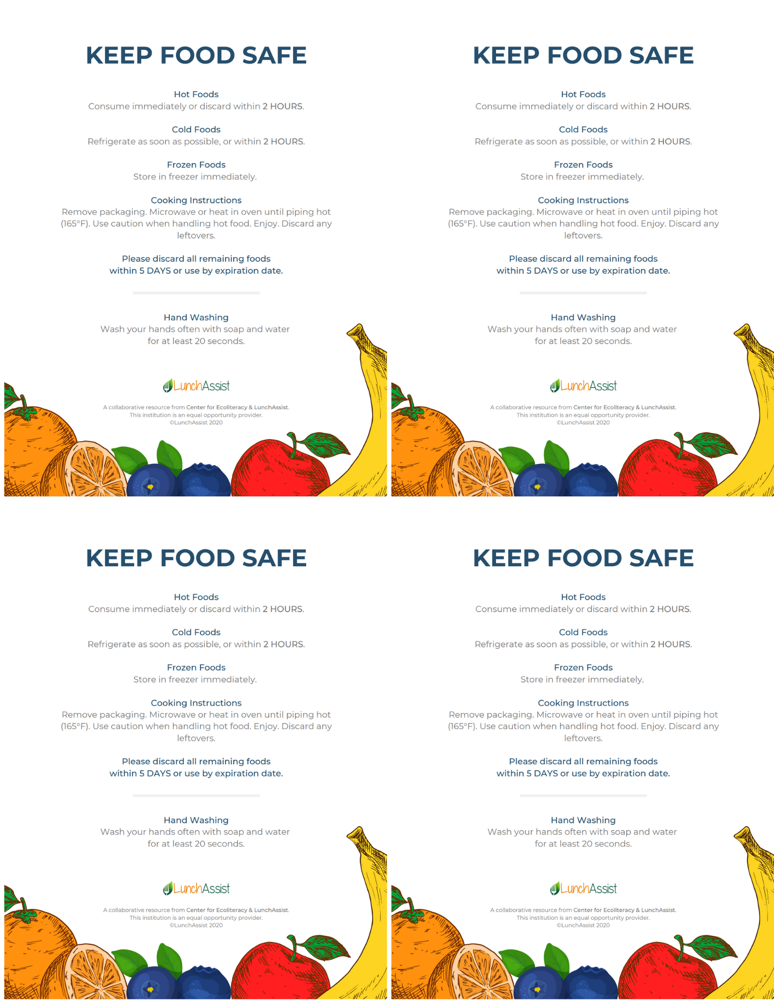

Menu Planning Resources
The following resources are designed to assist schools with menu planning for the 2020-2021 school year. Many of the entrée items can be purchased through USDA Foods or DOD Fresh produce. HOM Vegetable or HOM Fruit indicates that the vegetable or fruit on that day can be substituted with the Virginia Harvest of the Month (HOM) vegetable or fruit. Ounce equivalents for grains and meat/meat alternates and cups of fruits and vegetables vary depending on the grade level being served. Make sure the required minimum amounts of food components and vegetable subgroups are being met to follow the NSLP meal pattern for the grade level being served.

National School Lunch Program Meal Pattern
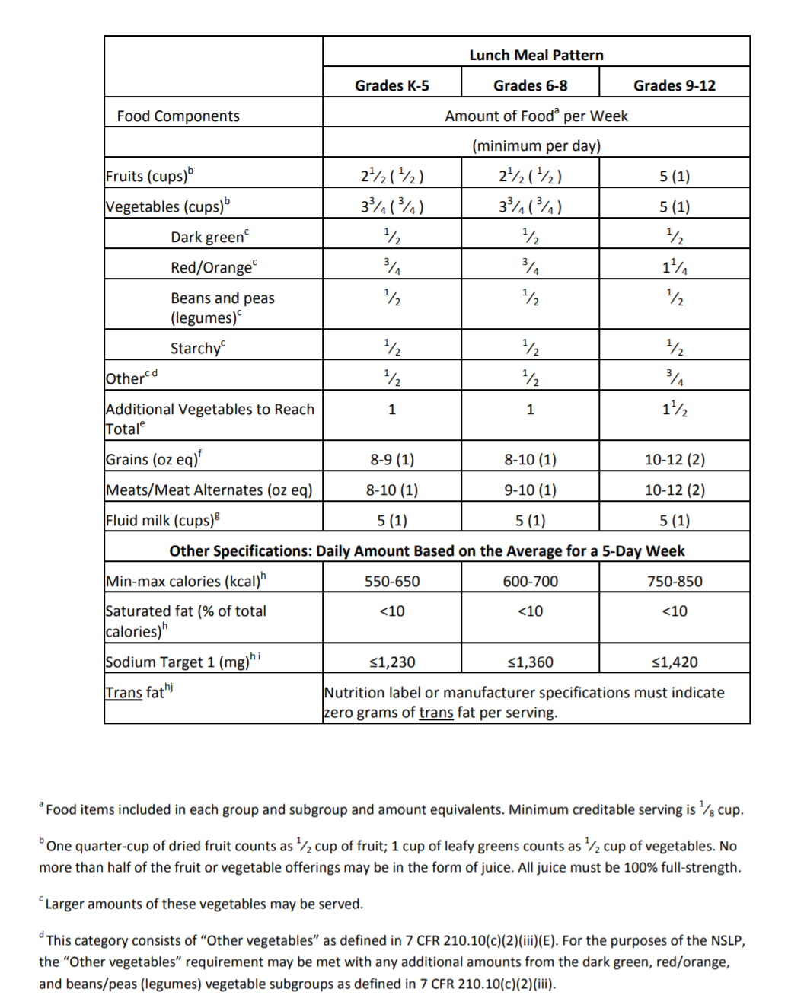

Traditional Five Day Menu Plan Week 1
Week 1 | Monday | Tuesday | Wednesday | Thursday | Friday
Hot Entrée | Oven Roasted Chicken with Roll | BBQ Pulled Pork Sandwich | Fish Sticks with Roll | Macaroni and Cheese with Breadstick | Southwest Tacos
Cold Entrée | Turkey and Pepperoni Hoagie | Chef Salad with Roll | Ham and Cheese Sandwich | Turkey Pastrami Sandwich | Hummus Bento Box with Cheese Stick and Roll
Vegetable | HOM Vegetable Sweet Potato Bites  Celery Sticks | Creamy Coleslaw  Sweet Corn | Broccoli  Green Beans | Steamed Spinach  Baby Carrots | Cucumber Slices  Three Bean Salad
Fruit | Apple Slices  Orange | Pear  Banana | Mixed Fruit  Apple | HOM Fruit  Applesauce Cups  Pear | Pineapple Tidbits  Apple
Milk | Choice of Milk | Choice of Milk | Choice of Milk | Choice of Milk | Choice of Milk
*Check each product specification sheet to ensure the correct amount is served to meet the meal pattern guidelines.
Recipes Included: BBQ Pork Sandwich, Creamy Coleslaw, Ham and Cheese Sandwich, Hummus, Macaroni and Cheese, Mexicali Corn, Spinach, Sweet Potato Fries, Three Bean Salad, Turkey Tacos
Menu Notes: Substitute available meats, cheeses, and egg on the Chef Salad. Sandwich meats and cheeses may also be substituted on the cold sandwiches.
Harvest of the Month:

January – Sweet Potatoes
February – Butternut Squash
March – Kale
April – Lettuce
May – Strawberries
June – Cucumber
July - Zucchini
August - Tomatoes
September - Peppers
October - Apples
November - Cabbage
December - Spinach

Traditional Five Day Menu Plan Week 2

Week 2 | Monday | Tuesday | Wednesday | Thursday | Friday
Hot Entrée | Spaghetti with Meat Sauce | Orange Chicken with Rice | Grilled Cheese Sandwich | Supreme Pizza | Hamburger
Cold Entrée | Hummus and Cheese Wrap | Bento Box with Yogurt, Cheese Stick, and Roll | Black Bean Hummus with Tortilla Chips | Chef Salad with Roll | BBQ Chicken Wrap
Vegetable | HOM Vegetable Lettuce and Tomato Side Salad  Sweet Corn | Cucumber Slices  Roasted Butternut Squash | Red and Green Pepper Strips  Tomato Soup | Steamed Broccoli  Celery Sticks | Baked Beans  Baby Carrots
Fruit | Pear  Applesauce | Strawberry Cup  Apple Slices | Apple  Pineapple Tidbits | HOM Fruit  Pear  Orange | Mixed Fruit  Grapes
Milk | Choice of Milk | Choice of Milk | Choice of Milk | Choice of Milk | Choice of Milk
*Check each product specification sheet to ensure the correct amount is served to meet the meal pattern guidelines.
Recipes Included: Spaghetti with Sauce, Black Bean Dip, Baked Beans, Butternut Squash, Orange Chicken, Tomato Soup
Menu Notes: Substitute available meats, cheeses, and egg on the Chef Salad. Sandwich meats and cheeses may also be substituted on the cold sandwiches.
Harvest of the Month:
January – Sweet Potatoes
February – Butternut Squash
March – Kale
April – Lettuce
May – Strawberries
June - Cucumber
July - Zucchini
August - Tomatoes
September - Peppers
October - Apples
November – Cabbage
December - Spinach

Hybrid Menu Plan
The Hybrid Menu Plan is designed for schools that accommodate students on school campus part-time. The following Hybrid Menu represents only one potential scenario of alternating school meals and take home meals. In this scenario, Group A and Group B alternate days in school and days virtual learning. During week 1, Group A will be in school Monday, Wednesday, and Friday and will be virtual Tuesday and Thursday. During week 1, Group B will be in school Tuesday and Thursday and will be virtual Monday, Wednesday, and Friday. During week two, the schedules for Group A and B will switch. Take home meals will be sent home with the students during their days in school to be consumed for the following school day. For example, during week 1 when Group A is in school on Monday, they will take their Tuesday meal home for consumption on Tuesday. Be sure to check each product specification sheet to ensure the correct amount of food is served to meet the meal pattern guidelines for each grade level.

Hybrid Week 1
Week 1 In School
Week 1 | Monday | Tuesday | Wednesday | Thursday | Friday
Student Group | Group A | Group B | Group A | Group B | Group A
Hot Entrée | Oven Roasted Chicken with Roll | Oven Roasted Chicken with Roll | BBQ Pulled Pork Sandwich | BBQ Pulled Pork Sandwich | Supreme Pizza
Cold Entrée | Turkey and Pepperoni Hoagie | Turkey and Pepperoni Hoagie | Ham and Cheese Sandwich | Ham and Cheese Sandwich | Hummus Bento Box with Cheese Stick and Roll
Vegetable | Baked Beans  Sweet Potato Bites | Baked Beans  Sweet Potato Bites | Creamy Coleslaw  Sweet Corn | Creamy Coleslaw  Sweet Corn | HOM Vegetable  Cucumber Slices  Steamed Spinach
Fruit | HOM Fruit Apple Slices  Orange | HOM Fruit Apple Slices  Orange | Mixed Fruit  Banana | Mixed Fruit  Banana | Pineapple Tidbits  Apple
Milk | Choice of Milk | Choice of Milk | Choice of Milk | Choice of Milk | Choice of Milk

Week 1 Take Home
Monday Take Home for Tuesday | Tuesday Take Home for Wednesday | Wednesday Take Home for Thursday | Thursday Take Home for Friday | Friday Take Home for Monday
Group A | Group B | Group A | Group B | Group A
Chef Salad with Roll  Broccoli  Pear  Choice of Milk | Chef Salad with Roll  Broccoli  Pear  Choice of Milk | Bento Box with Yogurt, Cheese Stick and Roll  Red Pepper Strips  Strawberry Cup  Choice of Milk | Bento Box with Yogurt, Cheese Stick and Roll  Red Pepper Strips  Strawberry Cup  Choice of Milk | Hummus and Cheese Wrap  Baby Carrots  Apple  Choice of Milk
*Check each product specification sheet to ensure the correct amount is served to meet the meal pattern guidelines.

Hybrid Week 2
Week 2 In School
Week 2 | Monday | Tuesday | Wednesday | Thursday | Friday
Student Group | Group B | Group A | Group B | Group A | Group B
Hot Entrée | Spaghetti with Meat Sauce | Spaghetti with Meat Sauce | Southwest Tacos | Southwest Tacos | Supreme Pizza
Cold Entrée | BBQ Chicken Wrap | BBQ Chicken Wrap | Turkey Pastrami Sandwich | Turkey Pastrami Sandwich | Hummus Bento Box with Cheese Stick and Roll
Vegetable | Lettuce and Tomato Side Salad  Green Beans | Lettuce and Tomato Side Salad  Green Beans | Sweet Corn  Three Bean Salad | Sweet Corn  Three Bean Salad | HOM Vegetable  Cucumber Slices  Steamed Spinach
Fruit | Pear  Applesauce  HOM Fruit | Pear  Applesauce  HOM Fruit | Strawberry Cup  Orange | Strawberry Cup  Orange | Pineapple Tidbits  Apple
Milk | Choice of Milk | Choice of Milk | Choice of Milk | Choice of Milk | Choice of Milk

Week 2 Take Home
Monday Take Home for Tuesday | Tuesday Take Home for Wednesday | Wednesday Take Home for Thursday | Thursday Take Home for Friday | Friday Take Home for Monday
Group B | Group A | Group B | Group A | Group B
Chef Salad with Roll  Broccoli  Orange  Choice of Milk | Chef Salad with Roll  Broccoli  Orange  Choice of Milk | Black Bean Hummus with Tortilla Chips  Red Pepper Strips  Apple  Choice of Milk | Black Bean Hummus with Tortilla Chips  Red Pepper Strips  Apple  Choice of Milk | Hummus and Cheese Wrap  Baby Carrots  Apple  Choice of Milk
*Check each product specification sheet to ensure the correct amount is served to meet the meal pattern guidelines.

Virginia Harvest of the Month Suggestions
January
Sweet Potatoes – Suggested servings may be cubed, sliced, halved, or mashed. Cooking options may be steamed, baked, or boiled.
February
Butternut Squash – Servings may be cubed, sliced, or mashed. Cooking options may be steamed or baked.
March
Kale – Serving may be chopped raw in a salad or chopped or steamed and served hot.
April
Lettuce – Servings may be chopped raw in a salad or used to top chicken sandwiches or burgers.
May
Strawberries – Servings may be raw as a fruit side or topping salads and oatmeal.
June
Cucumbers – Suggested servings include raw slices or sticks. May be used to top salads or dip with hummus.
July
Zucchini – Servings may be raw slices or sticks for dipping in hummus or bean dip. May also be served steamed or sautéed.
August
Tomatoes – Raw wedges may be served as a side or on a salad. Slices may be served with sandwiches, wraps or burger.
September
Peppers – Raw slices may be served as a side with hummus or bean dip. Fresh peppers can top salads or add crunch to turkey wraps.
October
Apples – Raw slices may be served as the fruit side on the menu with hummus or peanut butter. May also be served whole or chopped on a salad.
November
Cabbage – Servings may be shredded in slaw or in soups.
December
Spinach – Servings may be fresh in salads or as a topping on pizzas and sandwiches.

Farm to School Resources for Menu Planning
Virginia Produce Availability Calendar
The Virginia Department of Agriculture and Consumer Services (VDACS) developed the Virginia Fruit and Vegetable Availability Calendar to inform consumers when produce is seasonally available in the Commonwealth. This calendar assists with planning seasonal menus, tastings, and promotions to highlight local growers and nutrition education centered around available product.
Farm to School Activity Tracking Tool (Excel Sheet)
The Farm to School Activity Tracking Tool is designed to help school nutrition professionals keep track of their projects, activities, and local food purchases. This data will assist with meeting wellness policy benchmarks and farm to school goals, and it provides a promotional data set for the school or child nutrition program. The VDOE encourages school and child nutrition programs to adapt these sheets as desired.
Virginia HOM User Guide
The Virginia HOM User Guide provides guidance on using the HOM campaign materials. It covers the following topics:
- using the campaign materials;
- planning a seasonal menu, farmer outreach, and promotional events;
- procuring local foods, developing specifications, and tracking local food purchases;
- engaging school and community partners;
- planting and connecting with school gardens; and
- promoting school and child nutrition programs through local food.
Virginia Market Maker
Virginia Market Maker is a free online database sponsored by Virginia Cooperative Extension and VDACS. The database features buyers, farmers, ranchers, farmers, markets, and processors/packers searchable by state or by region. School and child nutrition programs can register as buyers to seek products and can search the buy/sell forum to find seasonally available products and compare prices between vendors. Search “Farm to School” in the Method of Sale search filter to find products available for sale to schools.
Virginia Farm to School Network/National Farm to School Network
The Virginia Farm to School Network connects growers, distributors, local nonprofits, and school garden supporters with school nutrition professionals in each of the eight Superintendent’s Regions. Members receive contact information for statewide contacts. The National Farm to School Network provides resources to support farm to school efforts.
Virginia Produce Availability Calendar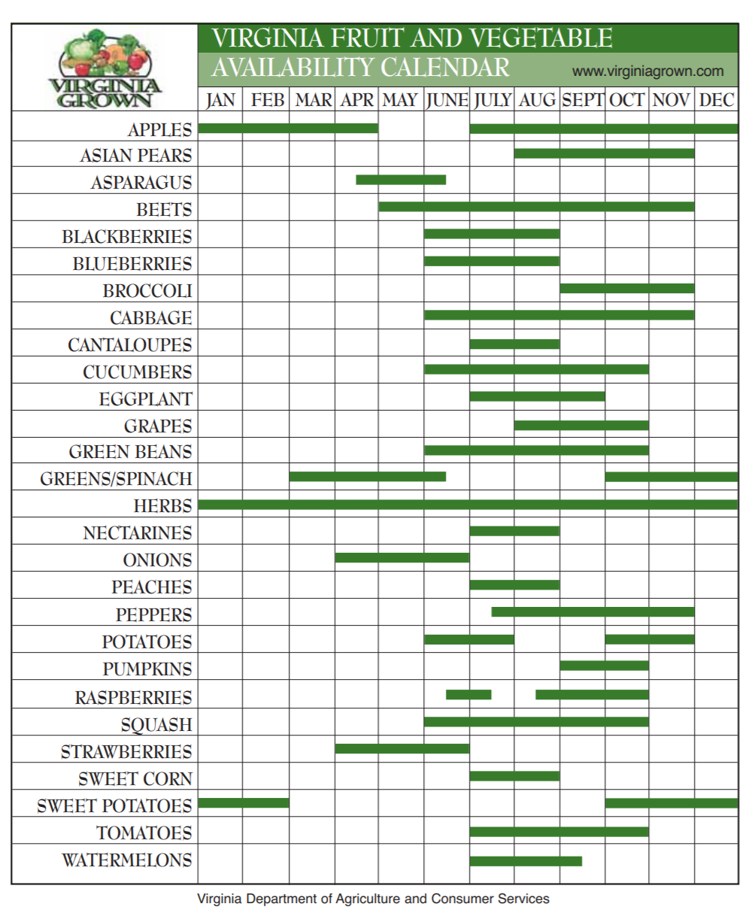

Back to School Recipes
Week 1
- BBQ Pork Sandwich
- Creamy Coleslaw
- Ham and Cheese Sandwich
- Hummus
- Macaroni and Cheese
- Mexicali Corn
- Spinach
- Sweet Potato Fries
- Three Bean Salad
- Turkey Tacos
Week 2
- Spaghetti with Sauce
- Black Bean Hummus
- Baked Beans
- Butternut Squash
- Orange Chicken
- Tomato Soup

Additional Recipe and Menu Planning Resources
Recipes
- Child Nutrition Recipe Box, Child Nutrition Sharing Site, Institute for Child Nutrition
- School Recipes and Menus, The Lunch Box, Chef Ann Foundation
- School Garden Cookbook, Captain Planet Foundation
- Healthier Kansas Menus and Recipes, Kansas State Department of Education
- Fresh from the Farm: The Massachusetts Farm to School Cookbook, Massachusetts Department of Agricultural Resources
Menu Planning
- Smart Foods Planner, Alliance for a Healthier Generation
- Menu Planner for School Meals, USDA Food and Nutrition Services
- Serving Up a Successful School Breakfast Program, Wisconsin Department of Public Instruction

Production Records
The VDOE-SNP Production Record Template can be downloaded from SNPWeb under Download Forms. Menu production record instructions are also available on SNPWeb. A sample production record for the Traditional Menu Plan in this toolkit is available as well as a sample production record for the Hybrid Menu Plan. Make sure to update the highlighted information when using these sample production records and change any information that is not consistent with the menu being served.

Example Production Record
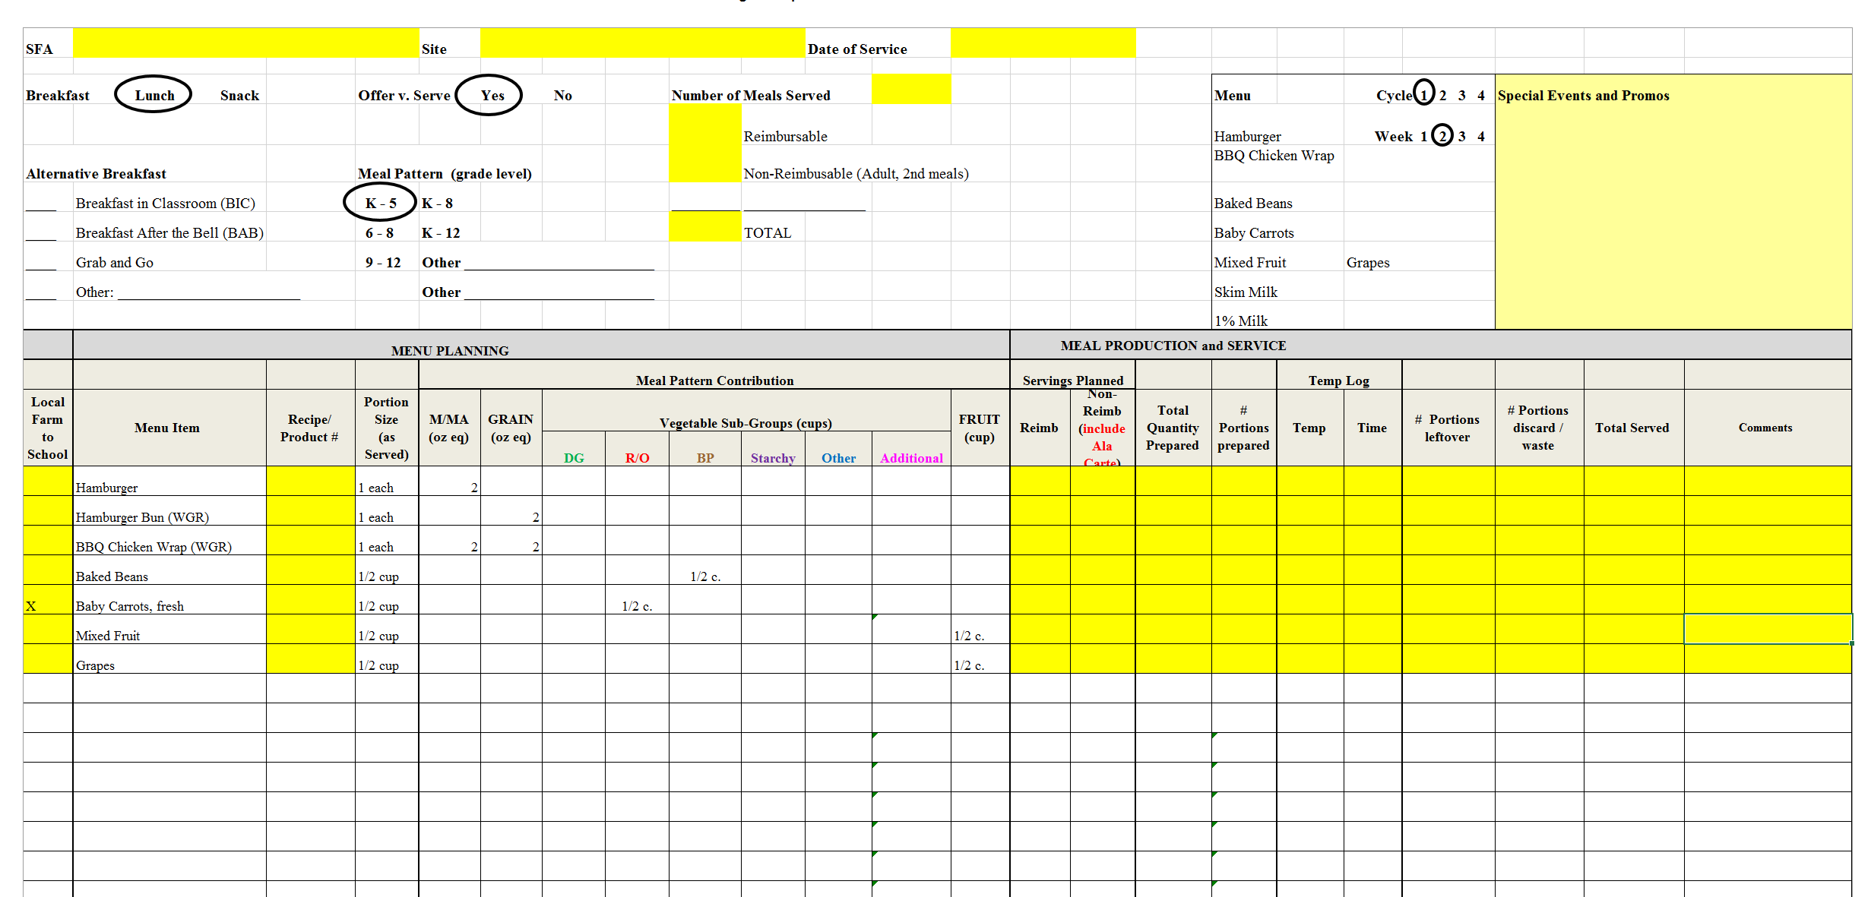

Menu Certification Workbook Example
The menu certification workbook must be completed for each menu cycle at each grade level. Once the workbook is completed, it outlines whether or not the menu is meeting the minimum requirements for the meal pattern. A menu certification workbook has been started for the menu outlined in this toolkit on SNPWeb under Download Forms. Blank menu certification workbooks can be downloaded from the USDA Food and Nutrition Services Website.
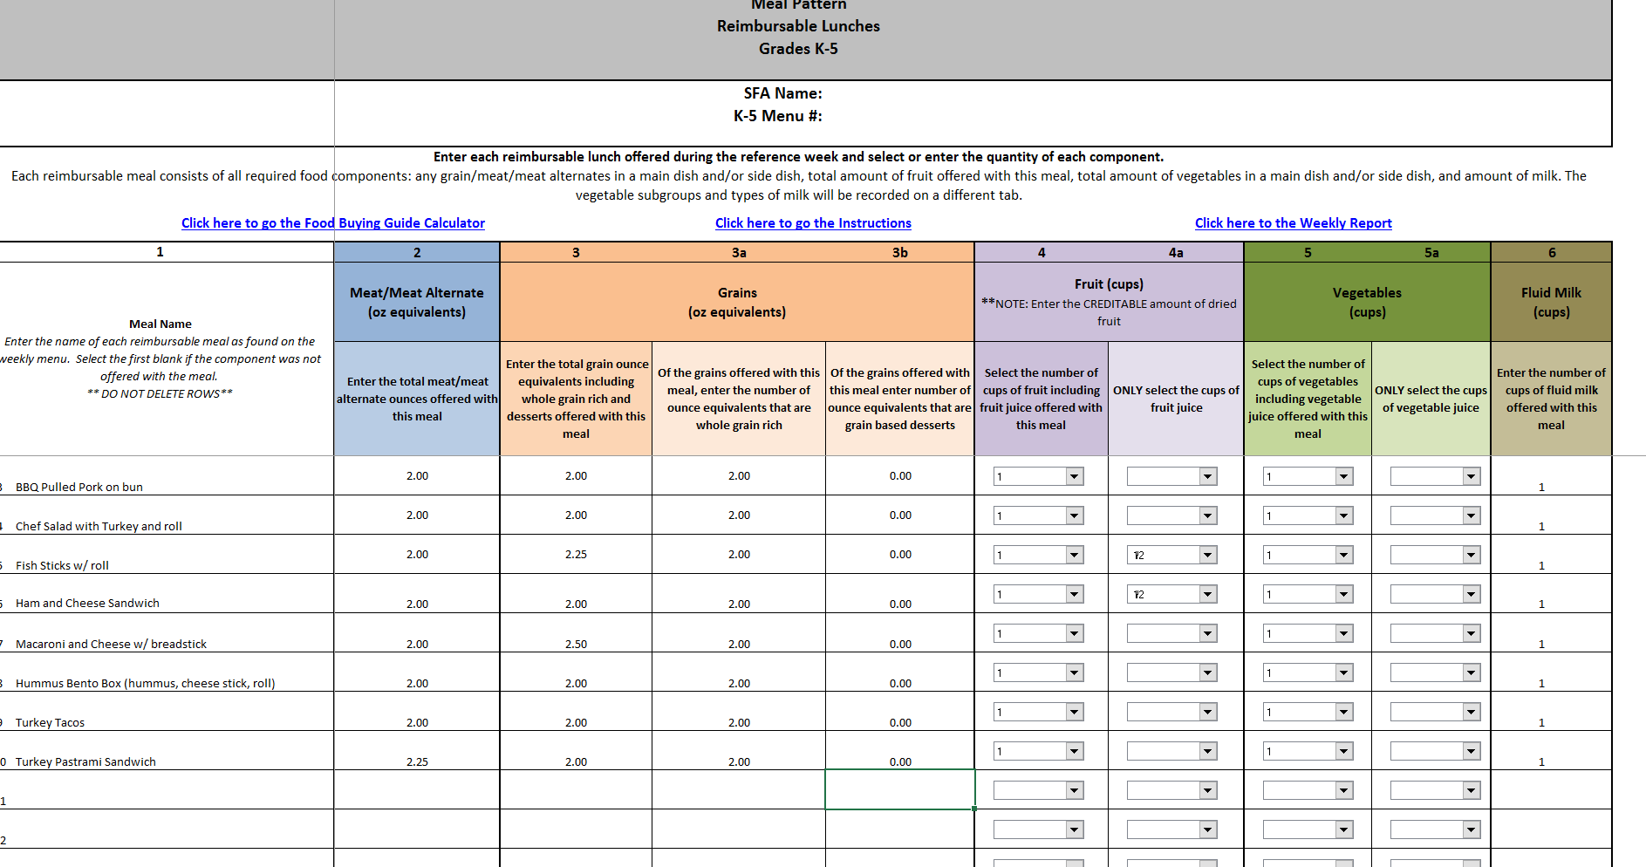

Office of School Nutrition Programs Breakfast Club
Promoting Nutritious Breakfast across the Commonwealth of Virginia
The mission of the Breakfast Club taskforce is to promote equity in school meals to ensure all children have access to healthy food in Virginia schools.
The taskforce is a subgroup of the No Kid Hungry Virginia Breakfast Stakeholders. The group is comprised of nutrition and equity professionals from multiple sectors including the Virginia Poverty Law Center, Virginia Foundation for Healthy Youth, Greater Richmond Fit4Kids, No Kid Hungry Virginia, The Dairy Alliance, and school nutrition directors from multiple Virginia counties. The shared goal is to discuss and promote recommendations and best practices to help improve the nutritional quality of school breakfast.
The Breakfast Club is responsible for discussing and rating best practices for serving and promoting a nutritious breakfast. To protect the integrity of school breakfast programs, the taskforce focuses on making a visible and lasting difference in communities, relieving the barrier of hunger for students to focus on learning.
This report includes best practices from the Breakfast Club taskforce in response to the VDOE’s goal to achieve 70 percent average daily school breakfast participation among free and reduced students compared to school lunch participation. The best practices address: consumption of high quality protein, removing barriers to access, reducing consumed sugar, and increasing participation by providing new, innovative menu items.
Best Practice 1: Remove barriers to access by initiating or expanding alternative breakfast models, such as breakfast in the classroom, grab and go breakfast, and/or second chance breakfast.
Recommended by: The National Institutes of Health published a study in August 2013 entitled “The effects of breakfast on behavior and academic performance in children and adolescents.” The study found that breakfast consumption is associated with positive outcomes for diet quality, weight status and lifestyle factors. Breakfast has been suggested to positively affect learning in children in terms of behavior, cognitive, and school performance.
Resources for divisions: Breakfast After the Bell Pre-Implementation Checklist
This resource created by No Kid Hungry Virginia can help prepare schools for implementation of a new alternative breakfast model to increase the chances of maintaining a successful program.
Partners for Breakfast in the Classroom
Use this implementation guide for guidance on how to implement or expand an alternative breakfast model. It also includes frequently asked questions, success stories from school divisions, tips for teachers and education professionals, and available grants to apply for.
Exemplar schools: Dickenson County Schools in Clintwood, Virginia, provides grab and go carts featuring smoothies, parfaits, and cold milk.
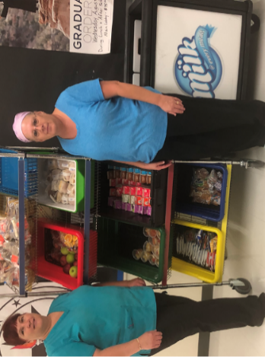
Figure 1. Two Cafeteria Workers Standing in Front of a Grab and Go Breakfast Cart in Dickenson County

Chesterfield County provides grab and go breakfasts at 54 out of 66 sites. Implementing grab and go breakfast has increased breakfast participation rates in the division.
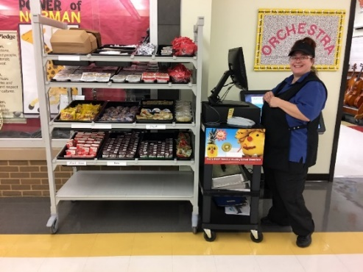
Figure 2. Chesterfield County's Grab and Go Cart
Best Practice 2: Increase the consumption of high-quality protein for students’ growth, development, and learning.
Recommended by: The Division of Agriculture at the University of Arkansas System promotes the benefits of eating protein at breakfast. A study published in the Journal of the Academy of Nutrition and Dietetics entitled “The Role of Breakfast in Health: Definition and Criteria for a Quality Breakfast” shows that breakfasts containing high-quality protein, such as eggs, have significantly influenced fullness when compared with breakfasts that were matched for energy density but with lower-quality proteins.
Resources for divisions: American Egg Board’s Eggs in Schools
This tool provides school division’s with breakfast recipes, nutritional analysis, success stories from divisions, how-to videos, social media posts, and sample menus for menu planners. Downloadable resources are also available such as a toolkit with posters, bulletin boarders, logos, and stickers.
Exemplar school: Staunton City Schools in Staunton, Virginia serves egg and avocado toast in a grab and go container. With a side of fruit, the egg and avocado Toast contains all components for a reimbursable breakfast meal for any student to fill up and have the energy to learn and grow throughout the school day.
Figure 3. Egg and Avocado Toast from Staunton City Schools, VA

Best Practice 3: Reduce sugar consumption by decreasing the number of days fruit juice is offered; serving more fresh fruit in place of fruit juice.
Recommended by: A 2019 study released in the Journal of Nutrition Education and Behavior titled “Juice Displaces Milk and Fruit in High School Lunches” found that on days when juice was served as part of the reimbursable meal 7.4 percent fewer fruits were selected with lunches. In addition to increasing sugar content of the meal, the results also found that on these days 8.2 percent fewer bottles of water and 24.4 percent fewer bottles of 100 percent juice were sold a la carte, indicating a reduction in a la carte sales as well.
Resources for divisions: Fruit juice is often cheaper than buying whole fruit such as apples or pears. The USDA Department of Defense Fresh Fruit and Vegetable Program provides schools with fresh produce in exchange for USDA Foods entitlement dollars. By utilizing entitlement dollars, divisions can offset the cost of purchasing fruit and reduce the reliance on fruit juice as a cheaper option. The Produce for Better Health Foundation provides information on nutrition, storage, and handling for a variety of fruits.
Exemplar schools: Although we were not able to identify Virginia schools which follow this best practice, it is interesting to note other regions which are limiting fruit juice in schools. Austin Independent School District in Austin, TX offers fresh fruit a minimum of three times per week in their breakfast in the classroom program. San Francisco Public Schools in California utilized their Wellness Policy to prohibit sweetened beverages and100 percent fruit juice across the division. If your school or division is currently implementing this best practices and you would like to be recognized, please reach out to the VDOE Wellness Policy Specialist, Laura Burns, at laura.burns@doe.virginia.gov.
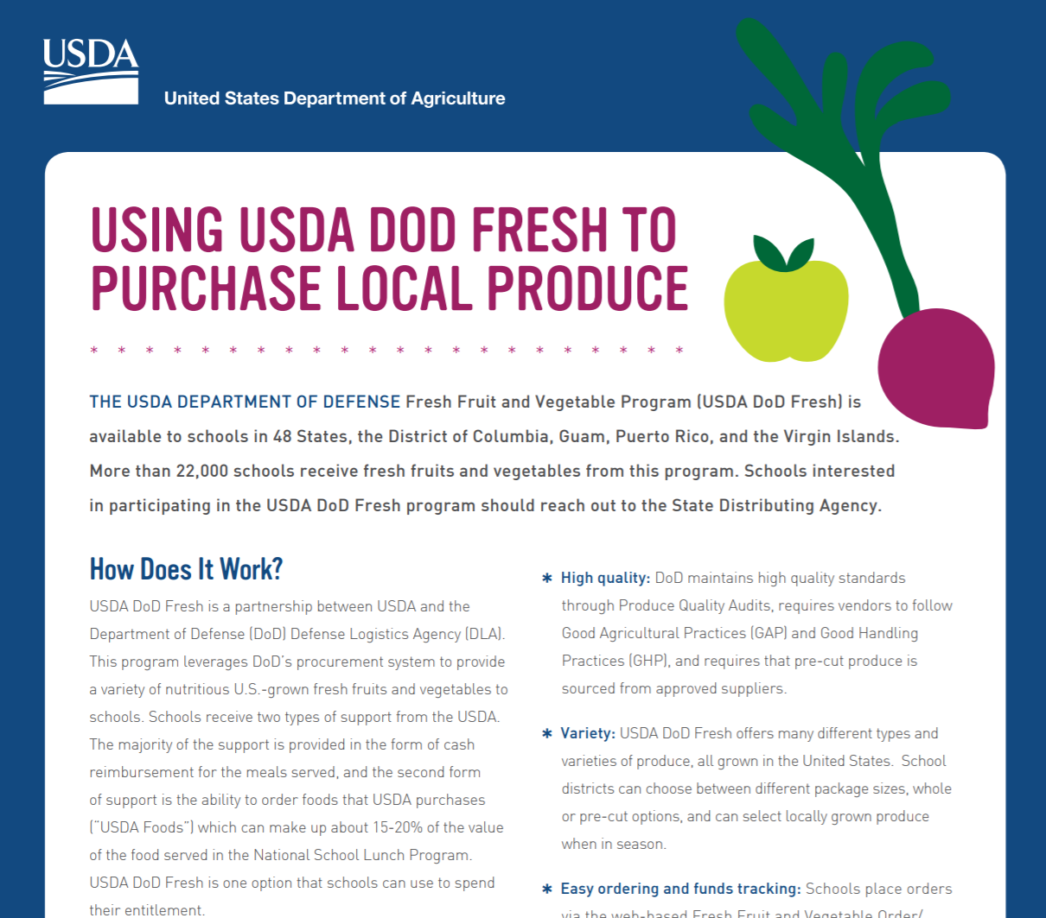
Figure 4. Infographic for Using USDA DOD Fresh foods
Best Practice 4: Increase participation by providing innovative new foods and menu items.
Recommended by: USDA Food and Nutrition Services recommends adjusting the school menu to reflect students’ suggestions and occasionally serving special meals that contain students’ favorite food items.
Resources for divisions:
School Meals That Rock
Students’ food trends and expectations are constantly changing and nutrition programs need to adapt to these changes by staying up to date with new items and implementing promotional menus.
Team Nutrition Popular Events Idea Booklet
This booklet provides creative ideas and how-to instructions for themed events that focus on nutrition. In the activity “You Control the School Menu: Vote for Your Favorite”, students can rate new menu items and provide feedback on whether or not they would like that item to continue on the school menu.
Exemplar school: Menchville High School in Newport News, Virginia, serves a grab and go blueberry breakfast smoothie to get students excited about breakfast.
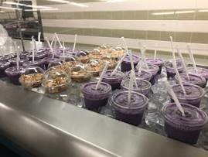
Figure 5. Blueberry Smoothies on a Serving Line in Newport News Public Schools

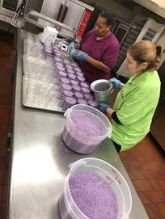
Figure 6. Cafeteria Workers Preparing Bulk Blueberry Smoothies in Newport News Public Schools

Best Practice 5: Reduce sugar consumed by students during breakfast by replacing sweet items with savory items.
Recommended by: One of the key recommendations from the Dietary Guidelines for Americans 2015-2020 for a healthy eating pattern is to limit intake of calories from added sugars. A 2015 study, Sugar in School Breakfast: A School Districts Perspective looked at the sugar content in school breakfast at Houston ISD. The study found that although schools are meeting the guidelines set forth by USDA, the high sugar content is an issue for parents and students. The division outlined efforts to reduce added sugar in breakfast such as removing sweet rolls and pastries and swapping regular cereals for lower sugar cereals.
Resources for divisions:
Smart Food Planner
This resource from the Alliance for a Healthier Generation has recipes and four-week cycle menus that can be useful for food service directors to use in their district.
Serving Up a Successful School Breakfast Program
This guide gives tips for implementing a success school breakfast program and sample menu plans and recipes for school breakfast.
Exemplar school: In the elementary schools of Richmond Public Schools, Greater Richmond Fit4Kids worked with the school nutrition program to change the breakfast menu and replace high sugar items with more savory choices. Pop tarts and donuts were taken off the breakfast menu and replaced with breakfast pizza, chicken biscuits, and egg breakfast burritos. Flavored milk was also removed from the breakfast menu. Handouts were distributed via the division website to the community about the changes.
Breakfast before:
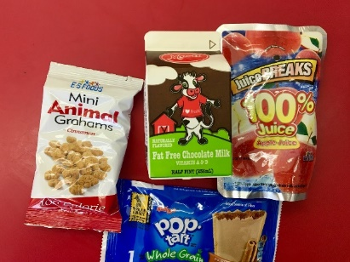
Figure 7. A Richmond Public Schools Entrée before Switching to Less Sugary Entrée Items

Breakfast after:
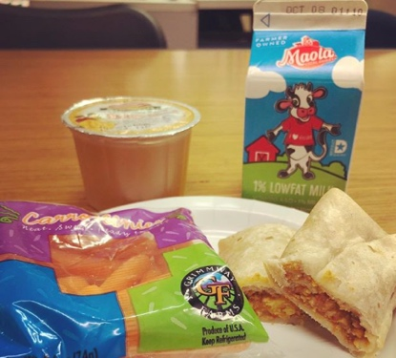
Figure 8. A Richmond Public Schools Entrée after Switching to Less Sugary Entrée Items

