English Instructional Plan – Research and Debates 6-8
Primary Strand: Research 6.9, 7.9, 8.9
Integrated Strand/s: Reading 6.6, 7.6, 8.6 Communication and Multimodal Literacies 6.1, 7.1, 8.1
Essential Understanding:
- understand that research questions may need to be broadened or narrowed based on available sources
- understand that a primary source is an original document or a firsthand or eyewitness account of an event.
- understand that a secondary source discusses information originally presented somewhere else. Secondary sources provide analysis, interpretation, or evaluation of the original information.
- understand the purposeful and responsible use of the Internet.
- understand that there are consequences of plagiarism according to the guidelines established by local school divisions.
Essential Knowledge, Skills, and Processes:
- understand and use the online, print, and media references
- evaluate the validity and authenticity credibility of texts, using questions, such as:
  - Does the writer have something to gain from his opinion?
  - Does the information contain facts for support?
  - Is the same information found in more than one source?
  - Is contact information provided?
  - Is there a copyright symbol on the page?
  - What is the purpose of the page?
  - What is the date of the most recent publication?
- avoid plagiarism and its consequences by giving credit whenever using another person’s media, facts, statistics, graphics, images, music and sounds, quotations, or paraphrases of another person’s words.
- differentiate between a primary and secondary source.
- provide a list of sources using a standard form for documenting primary and secondary sources

Primary SOL:
- 6.9, 7.9 Find, evaluate, select, and synthesize appropriate resources to create a research product. 8.9 Find, evaluate, and select appropriate resources to create a research product.
Reinforced (Related Standard) SOL:
- All of 6.1, 7.1, and 8.1 .
- All of 6.6, 7.6, and 8.6
Academic Background/Language: Students will need to understand vocabulary needed for debates including Affirmative vs. Opposing, Resolved, Argument, Opposing position. Students should also have familiarity with evidence and vocabulary relevant to each debate topic. Students will need to have background knowledge of using primary and secondary sources, analyzing and synthesizing information relevant to the topic as well as understanding how to cite sources properly.

Materials:
- Debate organizer
- Possible debate topics:
  - Peer pressure is more useful than harmful.
  - All middle school students should be required to take a foreign language.
  - Everyone should be a vegetarian.
  - Athletes and entertainers should earn large sums of money. (SOL prompt)
  - Owning a pet is important. (SOL Prompt)
  - Honesty is always the best policy. (SOL Prompt)
  - Teachers should be replaced by computers.
  - Receiving grades in classes should be abolished.
  - Education is the key to future success.
  - Technology has changed the way people communicate.
  - School teaches the tools necessary to succeed in life.
  - Students feel more stress now that in the past.
  - It is sometimes right for the government to restrict freedom of speech.
  - Students should be held legally responsible for bullying.
  - Single sex schools are better for education.
  - The government should provide wireless service for everyone.
  - All students should be required to volunteer in the community.
  - Owning a pet is important.

Student/Teacher Actions: What should students be doing? What should teachers be doing?
- The teacher will gather relevant debate topics that may be of interest to students. The teacher will present to the students the process of presenting one side of a topic.
- The teacher will introduce to students the idea of debate and developing a position with supporting evidence. Check this resource for specific steps in introducing and teaching the format of debate. Help students to understand the process of forming their debate argument with the debate organizer. Model the use of the debate organizer through a sample topic, such as “Owning a pet is important”(See modeled example below)
- The teacher will assign students to groups and allow them to choose a debate topic of interest. The teacher will make sure there are two groups per debate topic so that two viewpoints can argue against each other.
- Students will collaborate in groups of four to six students to gather valid reliable evidence to support their topic and their side of the topic.
- Students will use the debate organizer to organize their argument and the viewpoint they present. Teacher will use the modeled example of the graphic organizer to support students in developing their arguments. The teacher will work with small groups and guide them as they choose appropriate evidence. The teacher may prompt, “Is that a valid resource that includes your evidence?”, or “Please explain more about why that resource is appropriate evidence to your argument.” The teacher may also prompt students to think about the opposing argument that they could face in the debate. By guiding students in understanding that opposing arguments and evidence exist, they can better prepare for the opposing argument that ultimately gets shared. Students may use this information to better structure their own supporting arguments.
- Students in groups around the affirmative and the negative positions of the same topic will use the Debate Structure below to engage in a short debate with their classmates as the audience. Groups will take turns debating in front of the class against the opposing team. Students will be evaluated for presenting their findings with effective evidence as a collective group.

Basic Debate Structure
**This structure requires students to narrow their arguments on the issue.**
Resolved (Affirmative): 2 minutes to present their case

Opposing (Negative): 2 minutes to present their case

Opposing (Negative) Rebuttal and Summary: 2 minutes

Resolved (Affirmative) Rebuttal and Summary: 2 minutes

- Students who are observing the debate will complete a “Who Won This Debate” form in order to interpret who won the debate.
Assessment (Diagnostic, Formative, Summative):
- The teacher will formatively assess student understanding and ability to master the intended skills through observation and providing verbal feedback as needed in the areas of: strength of argument, effectiveness of communication, use of proper evidence to support their argument, student ability to identify credible internet sites, properly cited sources, and a lack of plagiarism. Additional enhanced scope and sequence resources include instructional plans around the credibility of resources, how to properly cite sources and how to ensure that resources are not plagiarized. These plans can be sequenced as such to compliment the overall instruction associated with the research strand.
- The teacher may summatively assess the students through the success of their argument in the debate setting.
Writing Connections:
- Students will organize their argument and evidence in writing in preparation for the debate setting. Students will use the Debate organizer to write their argument and supporting evidence as a group.
- Students will use the “Who won the Debate” form to evaluate their peers and write an appropriate response to who they believe had the stronger argument in the debate.

Extensions and Connections (for all students):
- Students may compose a well-written persuasive essay incorporating evidence found to support the given topic, making sure to correctly cite sources.
- The class may use a gallery walk to reflect on the debate process and outcomes.
- Students may create a podcast supporting their debate topic and share out with other classes, students, or teachers.
- Students may interview a community member to get additional support for their argument and position in the debate.
- Students may research the impact of the debate structure and topic on the community.

Strategies for Differentiation:
- The teacher will provide reliable resources and sites for students to use in developing their debate argument.
- The teacher will provide sentence frames to support classroom discussion and presentation of positions and arguments: “My debate topic is ______________.”, “I believe that ______________ because the evidence I found in ___________ states _____.”, I respect what my opponent said but _____________.”, “In conclusion, my team and I state that _______________.”
- The teacher will provide a list of essential vocabulary with definitions.
- Students may choose a debate topic from the list or develop an idea
- Students will choose up to five other team members (depending on the size of the class.

Note: The following pages are intended for classroom use for students as a visual aid to learning.
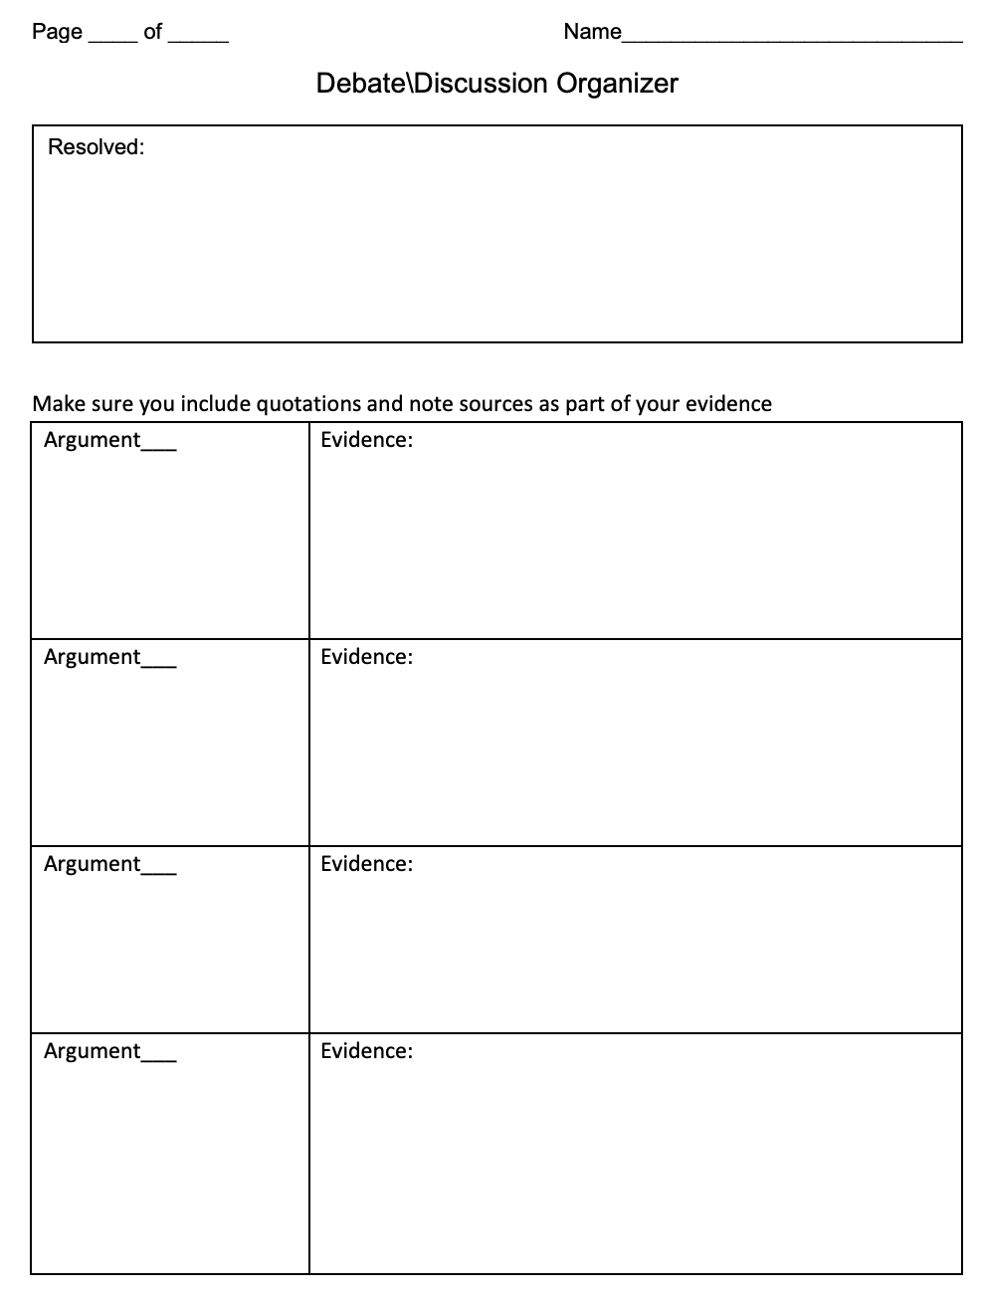
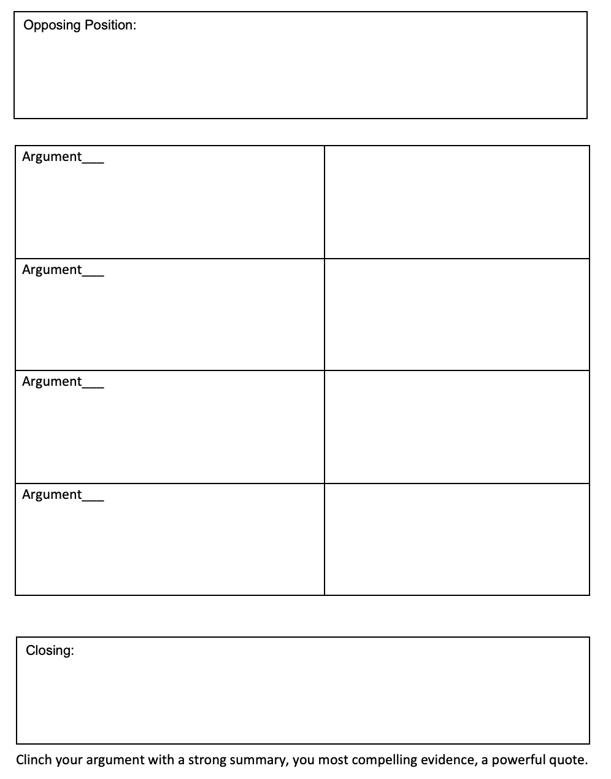

Sample Debate Organizer
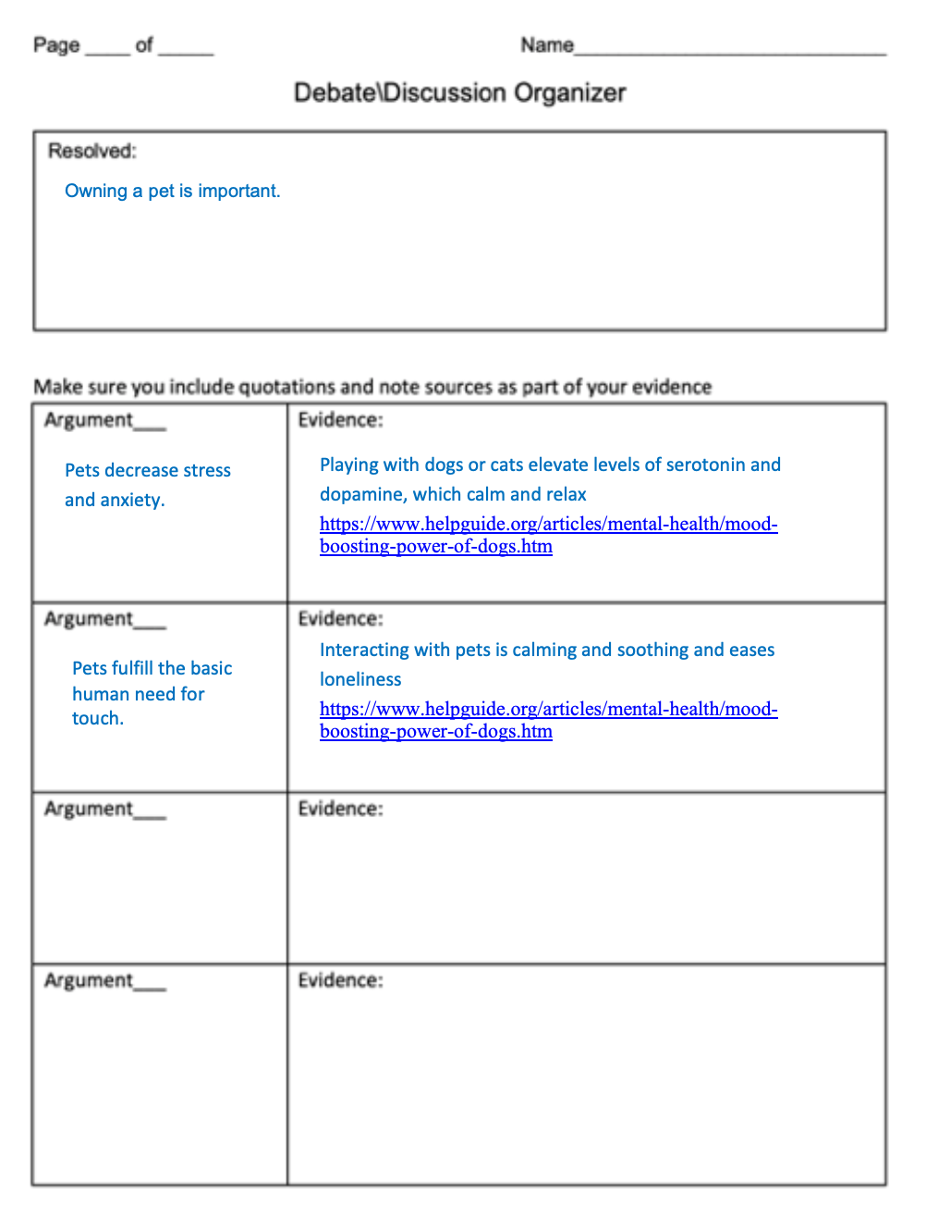
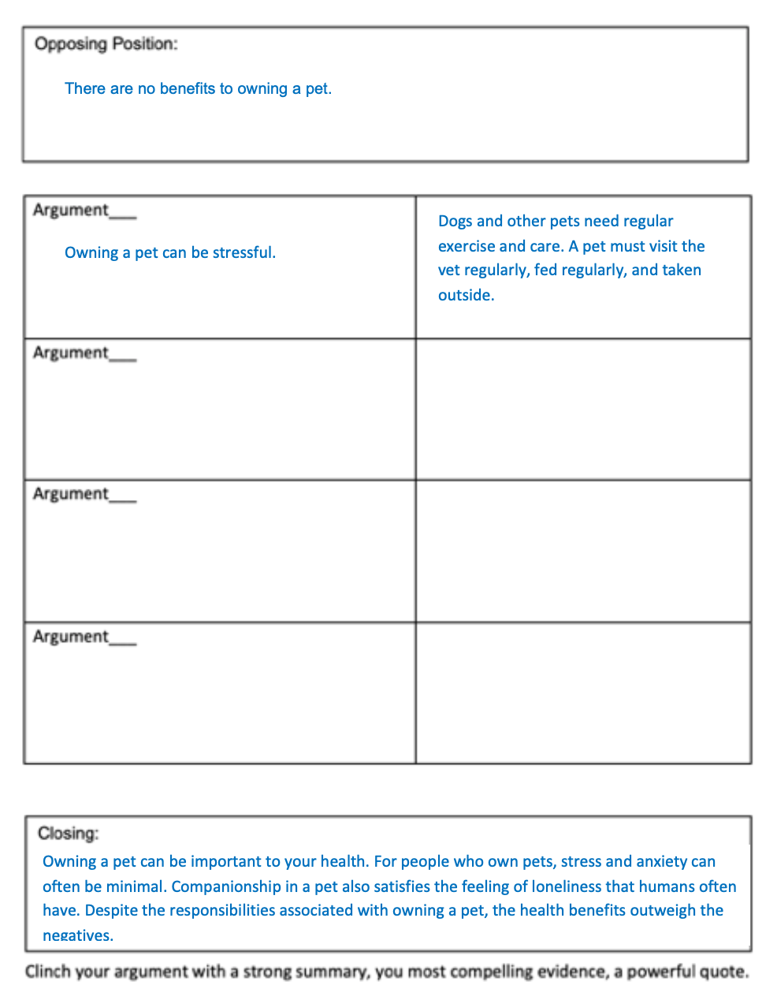

Who Won the Debate? Form
