English Instructional Plan – Citing Sources 6-8
Primary Strand: Research 6.9, 7.9, 8.9
Integrated Strand/s: Communication and Multimodal Literacies 6.1, 7.1, 8.1 Reading 6.6, 7.6, 8.6
Essential Understanding:
- understand to avoid plagiarism, credit must be given when using another person’s ideas, opinions, facts, statistics, or graphics.
- understand the purposeful and responsible use of the Internet.
- understand that there are consequences of plagiarism according to the guidelines established by local school divisions.
Essential Knowledge, Skills, and Processes:
- Evaluate the validity and credibility of information, using questions such as
  - Is there a copyright symbol on the page?
  - What is the purpose of the page?
  - What is the date of the most recent publication?
- avoid plagiarism and its consequences by giving credit whenever using another person’s media, facts, statistics, graphics, images, music and sounds, quotations, or paraphrases of another person’s words.
Primary SOL: Research 6.9d, 7.9d, 8.9e Cite primary and secondary sources

Reinforced (Related Standard) SOL: Reading 6.6, 7.6, 8.6 Read and demonstrate comprehension of a variety of nonfiction texts.

Academic Background/Language: Students will need to understand vocabulary related to citations including author and title. Students will need to have knowledge and an understanding of the copyright symbol.

Materials:
- Sample materials to be cited (novels, scholarly articles, reports, websites)
- Citation Guide Documents
- Citation Guided Support Document
- Evidence Sheet

Student/Teacher Actions: What should students be doing? What should teachers be doing?
- The teacher will gather a variety of content relevant materials to begin practicing the citing of sources.
- The teacher will define bibliography, “A list of the books and other sources that are referred to in a scholarly work-such as an essay, term paper, dissertation, or a book. The bibliography usually lists the references in alphabetical order.”
- The teacher will show an example of a bibliography and discuss with students how a bibliography can be created and organized based on the type of source.
- The teacher will instruct students in how to properly cite sources using the citation guide.
- Students will create a bibliography of the materials that have been provided to them. Students may use an evidence sheet that they may have previously completed to aid in properly citing sources. The teacher will provide feedback and support students in creating a properly cited bibliography.
Assessment (Diagnostic, Formative, Summative):
- The teacher will formatively assess student work through the collection of evidence sheets and evaluate for student understanding of how to properly cite sources.
Writing Connections:
- Students will work to create a properly cited bibliography or will complete an evidence sheet to include at least ten different sources.

Extensions and Connections (for all students):
- Students may use famous historical documents (Bill of Rights, Declaration of Independence, Mayflower Compact, etc.) to create a bibliography using proper citations.
- Students may compose an evidence sheet to include at least ten different sources (bibliography) in preparing for a newly chosen research project.

Strategies for Differentiation:
- The teacher may provide reliable sources for students.
- The teacher may provide sentence frames for students to explain their citations to their peers or to the teacher. Sample sentence frames could include: “This is cited like this because ____________.”, “Why did you __________?”, “I know how to __________.”,
“I do not understand ____________.”, “Why do we ___________.”
- The teacher may provide a list of essential vocabulary with definitions relevant to lesson.
- The teacher may instruct students on how to create a “simplified” citation.
(Example: Author(s). “Title of Article.” Title of Website, Day, month, and year published.)

Note: The following pages are intended for classroom use for students as a visual aid to learning.

Citation Guide - Grade 6-7
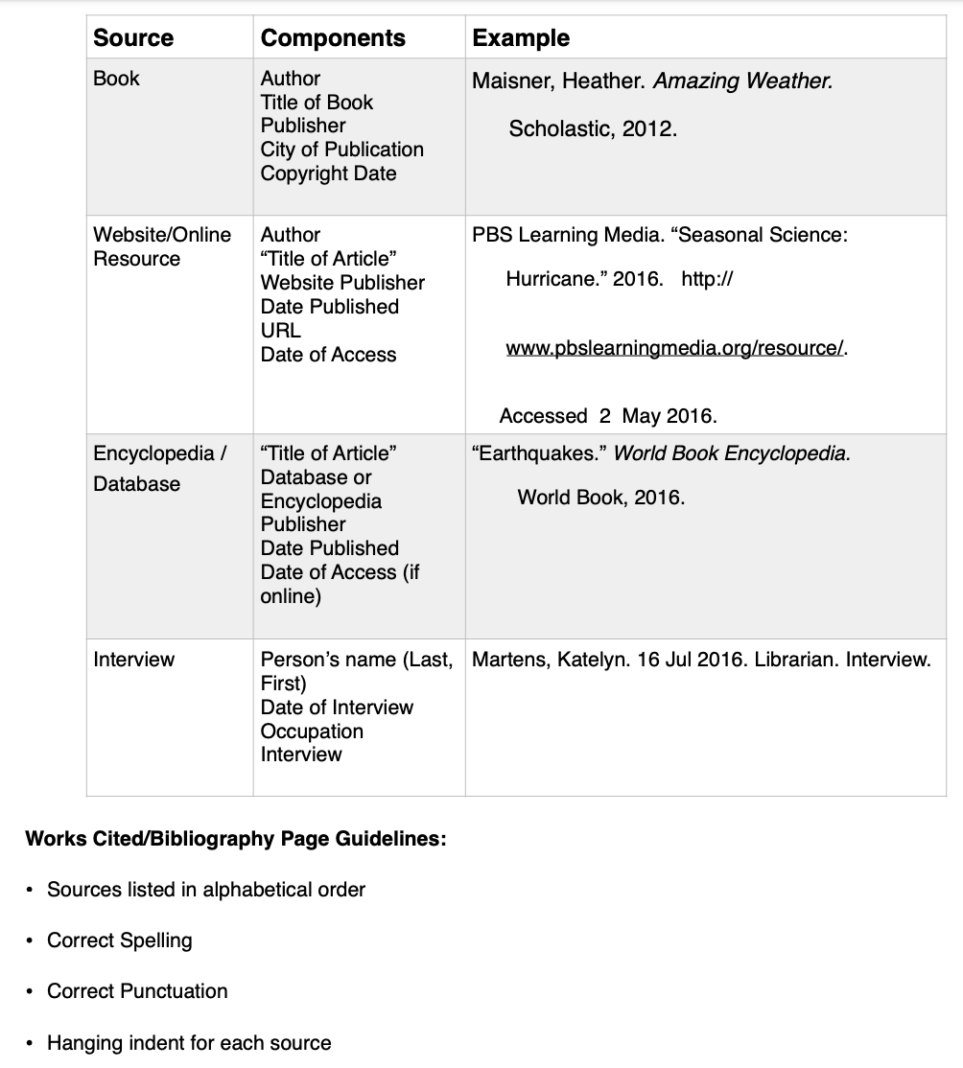

Citation Guide – Grade 8
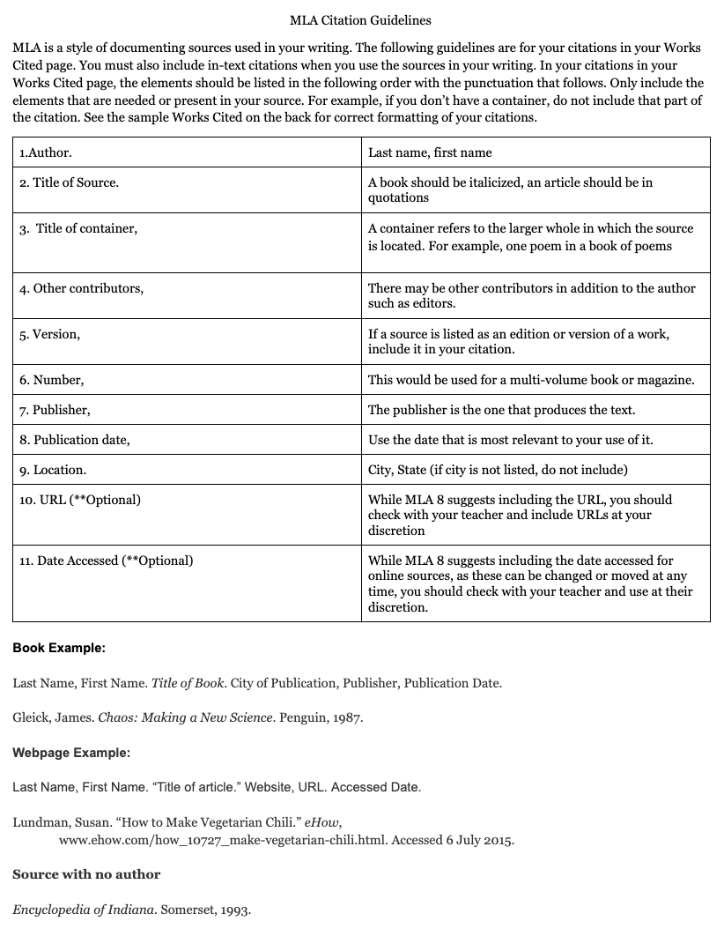

Citation Guided Support
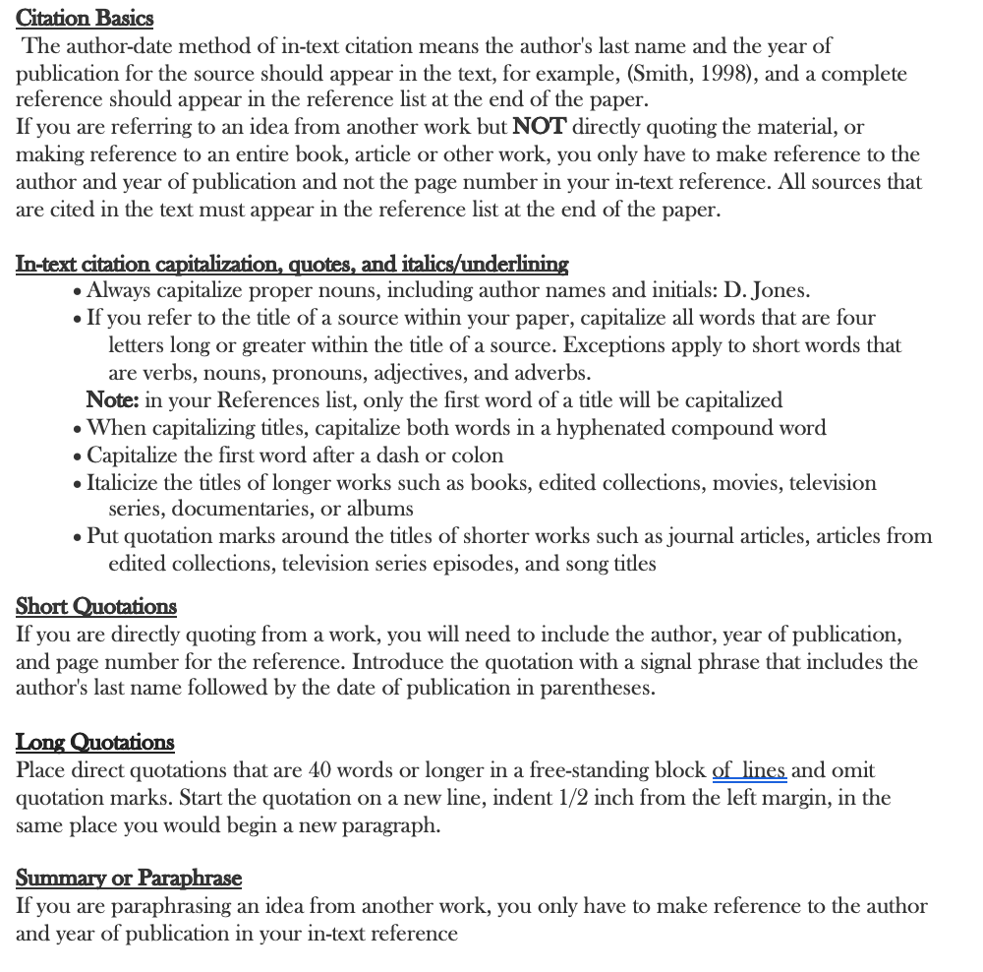

Evidence Sheet
