Instructional Plan – Vocabulary Lesson-at-a-Glance 8-9

Primary Strand: 8.6 and 9.5 – Reading

Integrated Strand/s: Writing, Communication and Multimodal Literacies

Essential Understanding:
- understand that an author’s viewpoint is conveyed through word choice and persuasive language
- recognize an author’s use of connotations, and persuasive language to convey viewpoint
- understand that an author’s credentials and experiences contribute to his/her viewpoint
- understand an author’s viewpoint refers to a bias or subjectivity toward the subject; a viewpoint can be positive or negative

Essential Knowledge, Skills, and Processes:
- recognize and identify an author’s use of connotations and persuasive language to convey a viewpoint
- determine an author’s point of view or purpose in a text
- analyze how the author acknowledges and responds to conflicting evidence or viewpoints
- identify an author’s position/argument within informational text

Primary SOL: 8.6e - Analyze the author’s qualifications, viewpoint, word choice, and impact.

Reinforced (Related Standard) SOL:
- 8.1c - Collaborate with others to exchange ideas, develop new understandings, make decisions, and solve problems.
- 8.6c - Skim materials to develop an overview or locate information.
- 8.6d - Make inferences and draw conclusions based on explicit and implied information using evidence from text as support.
- 8.6k - Evaluate, organize, and synthesize information for use in written and other formats.
- 8.6l - Analyze ideas within and between selections, providing textual evidence.
- 9.5e - Identify a position/argument to be confirmed, disproved, or modified.
- 9.5h - Draw conclusions and make inferences on explicit and implied information using textual support as evidence.

Academic Background/Language:
- The teacher will have previously taught figurative language, literary devices, and connotation/denotation.

Materials:
- Video: Determine the tone of a text by analyzing word choice (optional)
- Video: U.S. Entry into World War I (optional)
- Copies of “Hyphenated Americans” address by Theodore Roosevelt (excerpt below) full text here
- Copies of the Vocabulary Chart
- Copies of Author’s Tone and Impact of Word Choice Chart
- List of Tone Vocabulary (optional)
- Chart paper or interactive whiteboard to display 7-Step Vocabulary
- Highlighters

Student/Teacher Actions: What should students be doing? What should teachers be doing?

Day 1
- The teacher will begin the lesson by providing historical context prior to reading.
- The teacher will inform students that they will read a speech given by former President Theodore Roosevelt, to a group of Irish-Catholics, entitled Hyphenated-Americans. The President at the time was Woodrow Wilson and World War I had broken out just over a year earlier. At the time of the speech, the term “Hyphenated-American” was an epithet (negative term) to describe citizens who were believed to not be fully loyal to America.
- The teacher can build background further by showing the video U.S. Entry into World War I to reinforce the purpose of Roosevelt’s speech and to give students a sense of the political climate of the time period.
- Next, the teacher will introduce key vocabulary from the text (suggested vocabulary—condemn, naturalize, nationality, asset, institute, industrial, labor, renounce).
- Before reading Hyphenated Americans, the teacher will choose up to 5 words from the text and follow the process below for each (an example is included):
- Teacher says the word; students repeat the word 3 times
- Teacher provides an example of how the word is used in context
- Teacher provides the dictionary definition
- Teacher provides a student-friendly definition
- Teacher discusses important features of the word that could provide deeper understanding, to include affixes, multiple meanings, cognates, grammar, spelling, synonyms, antonyms, etc.
- Students engage in activities with a partner using the word orally
- Students use the word in a reading or writing activity tied to the lesson
- Examples of activities for Step 6:
  - Popcorn – the teacher asks a question or presents a scenario and students call out their answer as it comes to them
  - Ping-pong – students trade off with a partner using the word in a sentence (using teacher-provided sentence frame) for 30-60 seconds
  - Turn and talk – the teacher asks a question or presents a scenario; students turn and talk to their partner using the word in their answer
  - Mix-Pair-Share – Students move around the room and when prompted, pair with a nearby partner. The teacher asks students a question and they discuss with their partner.
- As an exit pass, the students will complete the Vocabulary Chart.

Day 2
- The teacher will introduce the lesson by telling students that they will learn about how an author’s word choice affects the meaning of a passage, as well as reveals the author’s attitude, or tone, toward a subject.
- The teacher can show the video Determine the tone of a text by analyzing word choice.
- The students will take notes on the steps in the video on how to analyze an author’s choice of words OR the teacher can model these steps using a previously read text.
- The teacher will set the purpose for reading, by displaying on the board the essential question “What Does It Mean to Be an American?” and tell students to keep this question in mind as they are reading Roosevelt’s speech.
- Next, the teacher will pass out copies of Hyphenated Americans and ask students to scan the text for repeated words/phrases and any words that “stand out” and then highlight them.
- The teacher will then put students into groups using the Kagan strategy Numbered Heads Together:
  - Students work in groups of 4
  - Teacher assigns each person in a group a number
  - Teacher reads a section of the text aloud then poses a discussion question (display on board)
  - Allow students 2 minutes to put their heads together to figure out the answer
  - Teacher calls on a student by number to be the spokesperson for the group to share out the answer
  - Repeat these steps until done reading
- Suggested discussion questions include:
  - What is the purpose of Roosevelt’s speech?
  - What is he arguing; is his argument still valid today?
  - How does Roosevelt feel about hyphenated Americans?
  - What is Roosevelt’s definition of an American?
  - What does he consider to be the duties of new immigrants?
  - Consider how the video you watched on WW1 relates to Former President Roosevelt’s speech.
  - What message is he trying to convey to his fellow Americans and why is it relevant/critical at this point in time in history?
- The teacher will pass out the Author’s Tone and Impact of Word Choice chart and ask students to reread the speech and look for quotes that convey the author’s tone.
- To close the lesson, the students will participate in a think-pair-share to discuss how the quotes reveal Roosevelt’s attitude toward hyphenated Americans.

Assessment (Diagnostic, Formative, Summative)
- Using key vocabulary from the beginning of the lesson, explain in a well-written paragraph how the text relates to the essential question, “What Does It Mean to Be an American?” Cite examples from the text.
- The completion of the Vocabulary Chart and the Author’s Tone and Impact of Word Choice Chart can be utilized as formative assessments.

Writing Connections:
- Compare/contrast Roosevelt’s stance on immigrants/immigration to present-day beliefs.
- Write an argumentative essay on modern day attitudes about hyphenated Americans.
- Analyze the quote below. Do you agree or disagree?
  - “The foreign-born population of this country must be an Americanized population - no other kind can fight the battles of America either in war or peace. It must talk the language of its native-born fellow-citizens, it must possess American citizenship and American ideals. It must stand firm by its oath of allegiance in word and deed and must show that in very fact it has renounced allegiance to every prince, potentate, or foreign government.”

Extensions and Connections (for all students)
- Students can analyze the speech for examples of rhetorical devices such as ethos, logos and pathos and create a presentation based on their analysis.

Strategies for Differentiation
- Teacher will provide copies of guiding questions or display them on the board
- Allow the use of dictionaries for students to look up unknown words.
- Students will work in pairs or small groups.
- Students with accommodations use available technology to allow them to access an audio recording of the story.
- Students with accommodations have the option to choose a shorter story with a lower Lexile level.
- Scaffold the activity by completing a portion of the Vocabulary Notes chart.
- For English Learners, find stories representative of their culture and language backgrounds.
- Provide ELs with sentence frames/starters to help get the conversation started when they are in their small groups. For example, “At first I thought ____ but now I think____ because ____. I like how this article uses ____ to show ____. This word/phrase stands out to me because ____.”

Note: The following pages are intended for classroom use for students as a visual aid to learning.

Excerpts from “Hyphenated Americans” address by Teddy Roosevelt
I stand for straight Americanism unconditioned and unqualified, and I stand against every form of hyphenated Americanism. I do not speak of the hyphen when it is employed as a mere convenience, although personally, I like to avoid its use even in such manner. I speak and condemn its use whenever it represents an effort to form political parties along racial lines or to bring pressure to bear on parties and politicians, not for American purposes, but in the interest of some group of voters of a certain national origin, or of the country from which they or their fathers came.
Americanism is not a matter of creed, birthplace or national descent, but of the soul and of the spirit. If the American has the right stuff in him, I care not a snap of my fingers whether he is Jew or Gentile, Catholic or Protestant. I care not a snap of my fingers whether his ancestors came over in the Mayflower, or whether he was born, or his parents were born, in Germany, Ireland, France, England, Scandinavia, Russia or Italy or any other country. All I ask of the immigrant is that he shall be physically and intellectually fit, of sound character, and eager in good faith to become an American citizen. If the immigrant is of the right kind I am for him, and if the native American* is of the wrong kind I am against him….
….Now for our own citizens. We represent many different race strains. Our ancestors came from many different Old World nationalities. It will spell ruin to this nation if these nationalities remain separated from one another instead of being assimilated to the new and larger American life.
The children and our children’s children of all of us have to live here in this land together. Our children’s children will intermarry, one another, your children’s children, friends, and mine. Even if they wished, they could not remain citizens of foreign countries….The effort to keep our citizenship divided against itself by the use of the hyphen and along the lines of national origin is certain to breed a spirit of bitterness and prejudice and dislike between great bodies of our citizens.

Vocabulary Chart

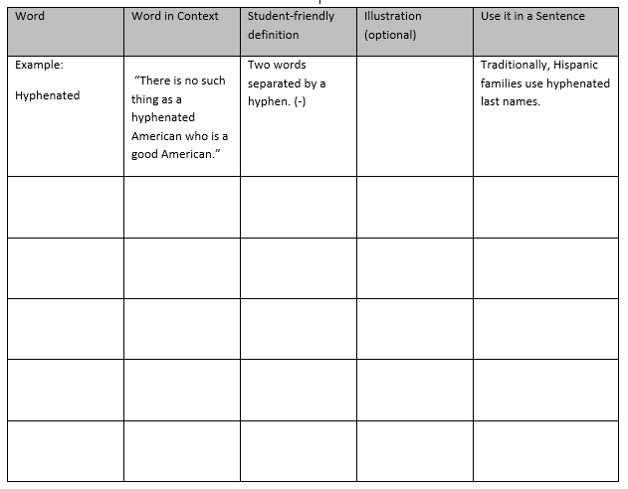

Author’s Tone and Impact of Word Choice

Directions: In the first columns, keep track of the quotes that carry strong emotion or are repeated throughout the text. Next, record the line where the quote can be found. Then describe the tone. Finally, explain what the quotes reveal about the author’s attitude toward “hyphenated Americans.”

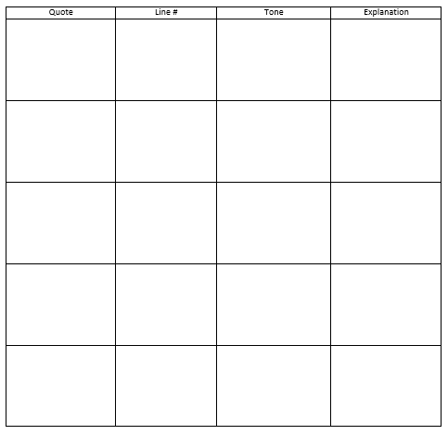

Infer: What impact did the speech have on the audience and other Americans at the time?

