English Instructional Plan –Using Word Maps to Expand Vocabulary (Grade 6, 7, 8)
Primary Strand: Reading 6.4, 7.4, 8.4
Integrated Strand/s:
Essential Understanding:
- understand that word structure can be analyzed to show relationships among words
- understand that affixes and Greek and Latin roots are clues to determine meanings of words
- recognize that many words have multiple meanings and that context and dictionaries are both supportive in determining which meaning is most appropriate
Essential Knowledge, Skills, and Processes:
- use common Greek or Latin affixes and roots as clues to the meaning of a word (e.g., aud – hearing, listening, or sound audience, auditory, audible)
- separate and recombine known word parts to predict the meaning of unfamiliar words, such as separating poly from polygon and phone from telephone to predict the meaning of polyphony
- use context clues to determine meanings of unfamiliar words in text, such as examples, restatements, and contrast
- consult word reference materials to find the pronunciation of a word or to determine or clarify its meaning
- determine or clarify the meaning of unknown and multiple-meaning words and phrases based on reading and content.
- use both context and reference skills independently to determine the nuances and connotations of words.

Primary SOL: 6.4a, 7.4a The student will identify word origins and derivations.
7.4f, 8.4e The student will use word-reference materials to determine meanings and etymology.

Reinforced SOL
6.4e The student will use word-reference materials
7.4f, 8.4e The student will use word-reference materials to determine meanings and etymology.

Academic Background/Language: Students should have basic knowledge that we can understand the meanings of words by breaking them apart. Students should be familiar with basic roots, prefixes, and suffixes.

Materials:
- Dictionaries, paper or online
- Copies of the attached Word Map graphic organizer

Student/Teacher Actions: What should students be doing? What should teachers be doing?
- Instruct students that they will use a word map to record not only a word’s dictionary definition(s), but also its etymology (root, affix, and country of origin), its multiple meanings, its related words, and its alternate forms.
- Distribute copies of the attached Word Map worksheets, and have students write the word biology in the word box in the center of the page.
- Have students look up biology in the dictionary, and direct them to the etymology of the word (typically found in brackets). Have students copy the word’s etymology in the Etymology box, adding the words for clarification (e.g., G means German).
- Direct students to the first definition, and have them write it in the First Meaning box. Have them also identify and write the part of speech associated with that meaning. Then, have students repeat this step for the other definitions.
- Have students write other words formed from this word, e.g., biological, biologist. Show them that these other forms can be found either within the word’s entry itself or in separate entries near the main word.
- Have students determine and record the typical reference for the word--in what context the word is typically used: e.g., science, careers, living things. The typical reference should be one or two words referring to the category of information where the word is most often found.
- Have students create a sentence that uses the word contextually. Emphasize that the best sentence is not a repetition of a definition but a creative sentence that goes beyond the basic definition and includes the context clues.
- Repeat this exercise with other words, particularly words generated from a list of common roots, prefixes, and /or suffixes. For example, a list of words ending in -ology will teach students that the root means “the study of”. Such lists can be found in teacher editions of textbooks, as well as elsewhere.
- Continue to discuss the parts and origins of words that you find in the texts that you re reading. Challenge students to find the origin and definitions of words they don’t know.
Assessment (Diagnostic, Formative, Summative):
- The teacher may formatively assess student knowledge and understanding through the completion of 2-3 different word maps. Students should be provided feedback about their work in breaking apart words and investigating word meaning through the use of a dictionary and the word map graphic organizer.
- The teacher can support student learning through immediate feedback and conferencing about creative sentence creation that includes context clues for the word that has been “mapped”.
Writing Connections:
- Students will work to form sentences that provide contextual meaning to works that have been word mapped.

Extensions and Connections (for all students):
- The teacher may support students in using multiple vocabulary words within a narrative writing piece.
- The teacher may provide students with additional words to map as they are broken apart and defined.

Strategies for Differentiation
- The teacher will provide immediate feedback to students who need support in mapping new words.
- The students may work in pairs or small groups to discuss the meanings of words.
- The teacher may provide students with sentence frames to discuss the meanings of their words: “The word ______ means _______ because I know that ______ means ______.” (Ex., The word microbiology means the study of small organisms because I know that ology means the study of and micro means small.”

Note: The following pages are intended for classroom use for students as a visual aid to learning.

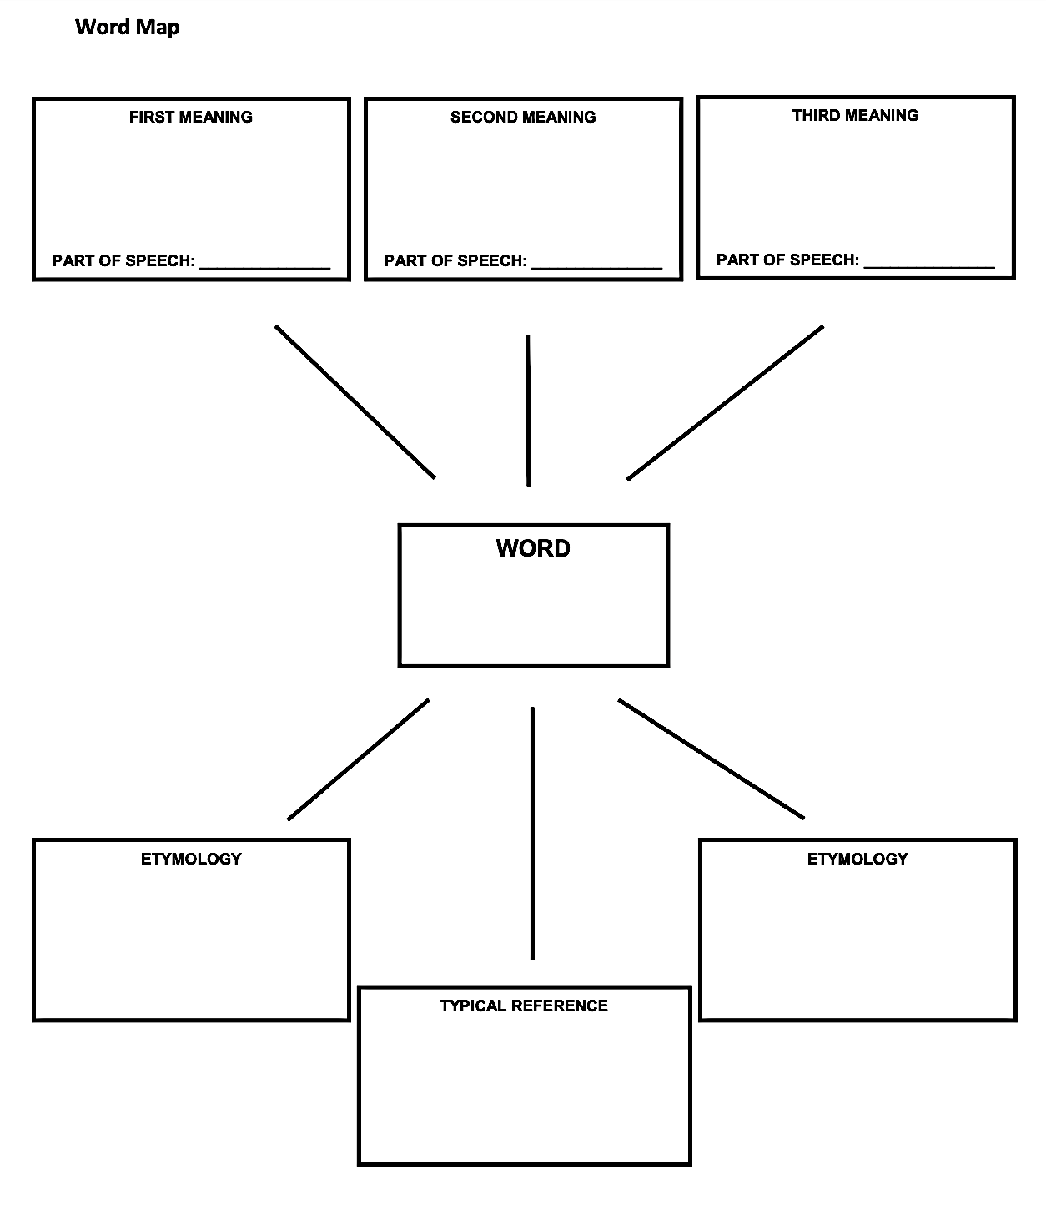

Sentence using the word contextually:

______________________________________________________________________________

____________________________________________________________________________________________________________________________________________________________

