English Instructional Plan – Using vocabulary skits to connect unfamiliar words by tapping into social emotional memory
After being introduced to a series of new words through a cloze reading activity, students will create mind maps (using graphics, word origin maps, and meaningful sentences) to learn a set of words that will be used within a thematic unit. Once students have some time exploring the words, they will be tasked with creating vocabulary skits that connect the words to their personal experiences, so that they will encode the words by tapping into their emotional memory. This activity will include a model lesson, but is intended for teachers to adapt to any set of words. The content of the lesson is best suited for 8th grade.

Primary Strand: 8.4/8.5 – Reading

Integrated Strand/s: Writing, Communication/Multimodal Literacies

Essential Understanding:
- recognize that words have nuances of meaning, including figurative, connotative, and technical, that help to determine the appropriate meaning
- understand that affixes and Greek and Latin roots are clues to determine meanings of words

Essential Knowledge, Skills, and Processes:
- use common roots to determine the meaning of unfamiliar words and make connections with word families (e.g., -phobia, and -ology)
- recognize the relationships among words related by structure and derivation, such as polygraph and graffiti
- distinguish among the connotations of words with similar denotations
- recognize that synonyms may have different connotations (e.g., elderly and mature; youthful and juvenile, inexpensive and cheap) and describe the impact on text
- use context as a clue to the meaning of a word or phrase
- use both context and reference skills independently to determine the nuances and connotations of words.

Primary SOL: 8.4 (can be modified for 6.4 and 7.4)
8.4 - The student will apply knowledge of word origins and figurative language to extend vocabulary development within authentic texts.
8.4a - Use context, structure, and connotations to determine meaning and differentiate among multiple meanings of words and phrases.
8.4b - Use roots, affixes, synonyms, and antonyms to determine the meaning(s) of unfamiliar words and technical vocabulary
8.4f - Discriminate between connotative and denotative meanings and interpret the connotation
8.4g - Extend general and cross-curricular vocabulary through speaking, listening, reading, and writing.

Reinforced (Related Standard) SOL:
- 8.2 (can be modified for 6.2, 7.2) - The student will develop and deliver multimodal, interactive presentations collaboratively and individually.
- 8.2c - Use effective verbal and nonverbal communication skills to deliver multimodal presentations.
- 8.2e - Respond to audience questions and comments.
- 8.2g - Evaluate presentations.

Academic Background/Language
- Students should be familiar with a Thematic Unit, Cloze Reading, and Mind Maps.

Materials
- Vocabulary list (from text), 10-15 words suggested
- Cloze Activity for Introducing Vocabulary
- Mind Maps
  - Meaningful Sentences
- Vocabulary Skits

Student/Teacher Actions: What should students be doing? What should teachers be doing?

Before starting on this project, consider choosing your vocabulary from a list of texts that will be used in a thematic unit. For example, select a fiction text, a non-fiction text, and a poem that all connect to a broad theme. Erik M. Francis’ book Now That’s a Good Question! has numerous suggestions and resources on how to create a compelling driving question for a unit. PBLworks.org also provides a useful framework for how to map out a thematic unit. This resource can be modified for any thematic unit with its own set of vocabulary words.

The resource is based on a unit with the driving question: How does prejudice emerge? The texts from CommonLit.org in the unit include:
- The Blue-Eyed, Brown-Eyed Exercise (informational text)
- They’re Made Out of Meat (short-story)
- Gate A-4 (poem)

The vocabulary list for the unit combines challenging words from those texts, as well as concepts students may need to understand in order to better evaluate the theme and eventually answer the driving question. The vocabulary list is as follows:
- Prejudice
- Emerge
- Sentient
- Subservient
- Segregation
- Minority
- Chastise
- Privilege
- Aspect
- Timid
- Exemplify
- Probe
- Quadrant
- Apprehensive
- Bias

The activities below work best when done in this order; however, the duration of time spent depends on the class. These activities should span several class periods as the intention is to involve students in a sustained vocabulary practice.

- Once you have chosen the words for the unit, introduce the new vocabulary to students by using a Cloze Reading Activity.
- According to Marilee Sprenger’s 101 Strategies to Make Academic Vocabulary Stick, “...write a “cloze” sentence for each of the words you are about to study on the board, drawing a blank line to stand in for each vocabulary word. Read the first sentence with students following along and have students suggest words to fill in the blank. Post all the suggestions on the board.
- After students have run out of ideas, read each version of the sentence (or call on students to read the different versions), inserting the suggested words one by one.
- After all of the suggested words have been tried, tell students which vocabulary word is correct. It may or may not be one of the words that the students brainstormed.
- After going through all the sentences in this manner, discuss each new vocabulary word with the class and celebrate all of the synonyms they have generated for each word.
- Although this is an introductory activity, it can also be used for rehearsal or review or to test student comprehension” (Sprenger, 24). While reviewing the words, be sure to discuss the connotative and denotative meaning of the words (sample included).
- Once the students have followed the cloze reading protocol, they will create mind maps that incorporate graphics, word origins, and meaningful sentences to deepen their understanding of the words and create associations with the words that will help them stick. Encourage students to look up the word in a paper or online dictionary to explore its multiple meanings while they work on this task (sample included).
- If this is the first time teaching students how to write a meaningful sentence, refer to the example in the materials section.
- Model the first word with the students, taking suggestions as to how to fill in the chart.
- You may want students to do a few more with a partner, then progress to completing the chart individually.
- After the students complete the chart, consider one or both of these follow up activities to provide students with the opportunity to practice the words before a formal assessment.
  - Vocabulary Story - Individual or partner activity: Task students to compose a story with a clear beginning, middle, and end or an argument with a counterclaim that includes 10 out of 15 of the vocabulary words. This is a great opportunity for students to work on whatever writing skill (grammar or composition) the class is currently focused on. For example, if you are working on commas in a series, correct use of FANBOYS, or compound sentences, include these stipulations in your directions.
    - Sample Directions: With your partner or on your own, you will create a story using 10 (minimum) of the vocabulary words from our new unit. If you use ALL 15 you will get bonus points! In order to get FULL credit, you must use the words correctly and your story has to have a clear beginning, middle, and end. Think about the elements of a story (PLOT) to help you. Your story should not exceed three paragraphs.
- Snowball Fight - Whole class activity: The purpose of this activity is to get students moving around the room to match words with their definition. In order to play this game, write the words and their corresponding definitions on separate sheets of paper. I recommend using half sheets of paper. Once the pieces of paper are ready, shuffle them so that the words and definitions are far apart. Depending on the class size, you may have to duplicate words/definitions so that every student will get a piece of paper or some students may have multiple pieces of paper. This should be done before the class meets. Once you are ready to play, have a few students pass out the pieces of paper. Explain that they are about to have a “snowball fight”. Direct students to crumple up their paper and hold onto it. If possible, get students to form a large circle in the room while holding onto their “snowball” or stand by their desks. Explain the following: When I say go (or whatever word you want), you will throw your “snowball” across the room--directing the snowballs to hit below the waste. Once the “snowballs” hit the ground, find one “snowball,” un-crumple it, and read the word or definition to yourself. After that point, try to find your matching word/definition. The activity is complete when all matches are made.
- Finally, create vocabulary skits which allow students to connect the vocabulary words to their personal experiences, so that they will encode the words by tapping into their emotional memory. This activity could be used as a summative assessment (sample included).

Assessment (Diagnostic, Formative, Summative)
- The students will complete the Cloze Reading Activity as a diagnostic assessment.
- Mind Maps, vocabulary story, and the snowball fight will be considered formative assessments.
- The students are assessed on the Vocabulary Skits as a summative assessment.

Writing Connections:
- The mind maps, vocabulary story, and vocabulary skits involve writing; however, this activity is intended to increase students' vocabulary so that they may use these words in future compositions.

Extensions and Connections (for all students)
- Create a Google Form with a short answer response that contains the same “cloze” sentences and project the results.
- Use Flipgrid.com or wordcloud.com to view and discuss student answers represented by frequency, etc.
- Begin a student-created paper, digital class dictionary, or Padlet wall that includes all words of study for the year - including the words students encounter during independent reading, life, or in required texts.

Strategies for Differentiation
- Students with accommodations use available technology to allow them to access audio recordings of the texts.
- Students with accommodations have the option to choose alternative texts with a lower Lexile level.
- The teacher will provide copies of guiding questions or display them on the board.
- Students will work in pairs or small groups.
- For English Learners, find texts representative of their culture and language backgrounds.
- Provide ELs with sentence frames/starters to help get the conversation started when they are in their small groups. For example, “At first I thought ____ but now I think____ because ____. I like how this passage uses ____ to show ____. This word/phrase stands out to me because ____.”

Note: The following pages are intended for classroom use for students as a visual aid to learning.

Cloze Activity for Introducing Vocabulary Example

Sentences curated by dictionary.com

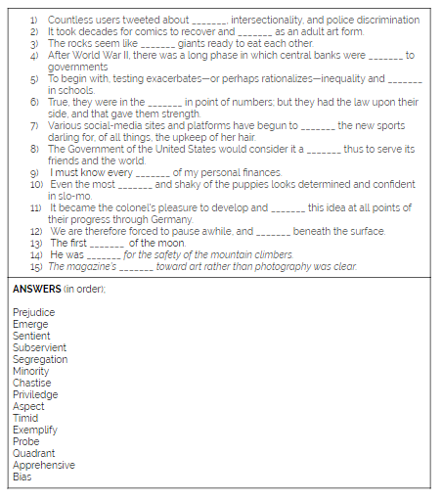

Mind Maps Example

Students can recreate this template on paper or create one digitally. The purpose of this activity is for students to make connections with the word, so if they want to add more images, sentences, or symbols they can. Whatever you determine, create your non-negotiables as the template you share out with students. Once students have the template or specific guidelines, model an example with them. Below is a filled in example using this framework.

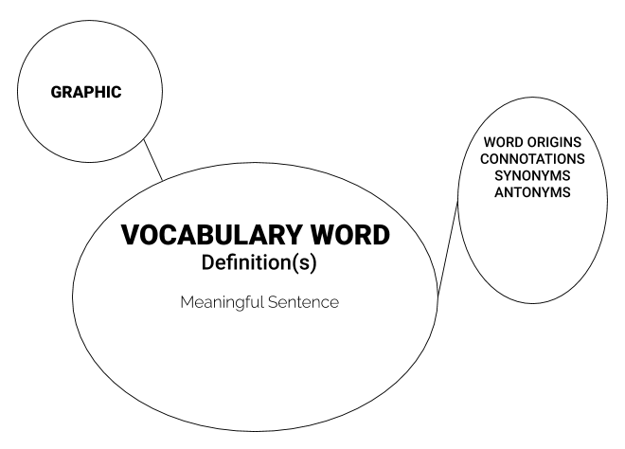

Meaningful Sentences Example

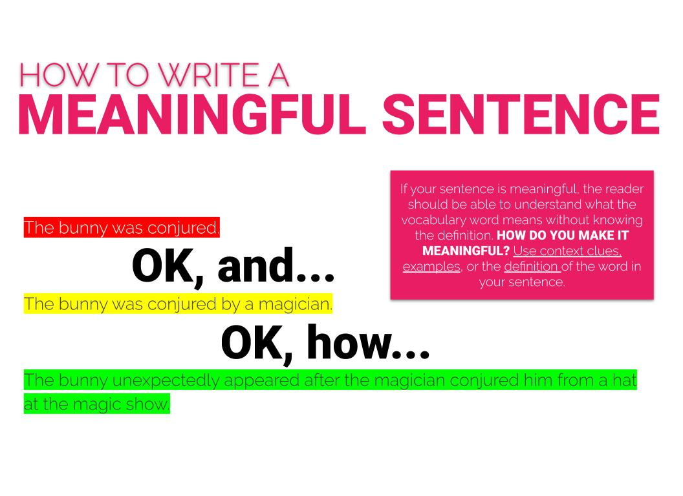

Vocabulary Skits Example

Students will create skits that associate the vocabulary word with something they have experienced or read about. The purpose of this activity is for students to deepen their understanding of the word by connecting it to prior knowledge. Depending on the size of the class, you may have to alter these directions. This is based on a class size of 30, with 15 words.

Students will divide into two groups, each group will be given a list with the vocabulary words numbered 1-15, both lists should be identical. Give students two to three minutes to determine a team name. Once teams are named, break the groups of fifteen into 5 groups of three or three groups of five. Students in each group will be accountable for composing a skit that uses their 3 or 5 words (depending on group size). Students will perform their skits for the class--each group will face off against members from the opposing group that used the same words. Students will evaluate skits using the chart below. Winners will be determined based on student and teacher input.

What is a Skit?
A skit is a short piece of writing that is performed for an audience. Typically, skits are short 3-5 minutes and humorous.

How do you write a Skit?
For the purposes of this activity, first review your groups 3-5 words. Think about everything you know about these words from their denotation, dictionary definition, connotations, and how they are used in context. What connections do you see amongst the words? What experiences do you have with these words? Take a moment to brainstorm these connections with your group by writing down any connections you have to the words (text-to-self, text-to-text, or text-to-world). Once you have your brainstorm, create a short scene or snapshot of characters experiencing these words within the context of your story. Try to ground your skit by creating a clear tone. Use this resource as a refresher on how author’s use tone: 115 Words to Describe an Author's Tone
Your skit should not exceed 5 minutes.

Who will you perform your skit for?
You will perform your skit for your peers and teacher. Everyone must participate in the skit.

How will you be evaluated?

