Instructional Plan – Vocabulary Lesson-at-a-Glance 6-7

Primary Strand: 6.4/6.5 and 7.4/7.5 - Reading

Integrated Strand/s: Writing/Communication and Multimodal Literacies

Essential Understanding:
- understand that the author uses images to craft a message and create characters
- understand that imagery and figurative language enrich texts
- recognize an author’s craft as the purposeful choice of vocabulary, sentence formation, voice, and tone.

Essential Knowledge, Skills, and Processes:
- consult word reference materials (e.g., dictionaries, glossaries, thesauruses, both print and online) to find the pronunciation of a word or determine or clarify its meaning
- determine or clarify the meaning of unknown and multiple-meaning words and phrases based on reading and content
- identify setting as time and place
- explain plot as
  - the development of the central conflict and resolution
  - the sequence of events in the story
  - the writer’s map for what happens, how it happens, to whom it happens, when it happens, why it happens, and where it happens
- identify characters as protagonist and antagonist
- identify point of view and distinguish between first and third person
- determine a theme(s) and explain how it is developed through specific details
- identify internal and external conflicts, including
  - internal conflicts within characters
  - external conflicts between characters
- describe how a fictional plot is often episodic, and how characters develop as the plot moves toward a resolution
- notice an author’s craft, including use of
  - language patterns
  - sentence variety
  - vocabulary
  - imagery
  - figurative language
  - word choice to develop mood and tone
- differentiate among a variety of fictional genres, including short story, novel, and drama
- describe how characters change as a result of incidents in the plot
- compare and contrast two or more texts on the same topic or with similar themes
- use evidence from the text(s) for support when drawing conclusions and making inferences
- analyze how an individual, event, or idea is introduced, illustrated, and elaborated in a text (e.g., through examples or anecdotes)
- demonstrate comprehension and apply strategies to write about what is read

Primary SOL: 6.4f - Extend general and specialized vocabulary through speaking, listening, reading, and writing.

Reinforced (Related Standard) SOL:

- 6.1c - Participate in collaborative discussions with partners building on others’ ideas.
- 6.5a - Explain how an author uses character development to drive conflict and resolution.
- 6.5f - Draw conclusions and make inferences using the text for support.
- 6.5g - Identify the characteristics of a variety of genres.
- 7.1a - Communicate ideas and information orally in an organized and succinct manner.
- 7.4f - Extend general and specialized vocabulary through speaking, listening, reading, and writing.
- 7.5a - Describe the elements of narrative structure including setting, character development, plot structure, theme, and conflict.
- USII.7 - The student will apply social science skills to understand the major causes and effects of American involvement in World War II by
  - USII.7c - explaining and evaluating the impact of the war on the home front.

Academic Background/Language:
- The teacher will have previously taught the elements of a plot diagram.

Materials:
- Images from the website Skirball Cultural Center for the gallery walk
- Copies of The Bracelet, by Yoshiko Uchida
- Copies of the Vocabulary Notes Chart
- Chart paper or interactive whiteboard to display 7-Step Vocabulary

Student/Teacher Actions: What should students be doing? What should teachers be doing?
Day 1
- The teacher will introduce the lesson by building background with a gallery walk. Teacher will choose, print and display pictures around the room from the Skirball Cultural Center.
- The teacher will instruct students to silently move throughout the room and examine each photograph carefully. When they are done, students will return to their seats and think-write-pair-share about their reaction to the photos and predict what message the photographer is trying to convey.
- The teacher will ask for volunteers to share their reflections with the class.
- The teacher will proceed by explaining the context of the photographs and the historical significance: “Shortly after the United States entered WWII against Japan, American President Roosevelt signed an executive order that drove approximately 117,000 Japanese, men, women, and children from their homes, first into assembly centers located in abandoned fairgrounds and racetracks, and later into guarded prison camps. Most of them were American citizens who had been born here and who had done nothing wrong.”
- Next the teacher will show the following video of personal accounts of the internment period:
  - Looking Like the Enemy
- The teacher will ask students to think back to their predictions about the photographs and share their thoughts on Padlet or Flipgrid now that they understand the historical context.
- The teacher will end the lesson by telling students that during the next class period, they will read a short story, based on these historical events, about a girl whose family was forced to move to an assembly center in San Francisco, California and leave her best friend behind.

Day 2
- The teacher will introduce the lesson by stating that students will read The Bracelet, by Yoshiko Uchida, who was forced, along with her family to live at the Tanforan Racetrack.
- The teacher will tell student that the story is historical fiction, which means that although the characters are fictional, the setting and events are based on historical accounts.
- The teacher will then present students with the vocabulary lesson based on the instructions (suggested word list: evacuated, interned/internment, thrust, forsaken, aliens, stable, stall)
- Before the lesson, the teacher will choose up to 5 words from the text and follow the process below for each (an example has been included):
  - Teacher says the word; students repeat the word 3 times
  - Teacher provides an example of how the word is used in context
  - Teacher provides the dictionary definition
  - Teacher provides a student-friendly definition
  - Teacher discusses important features of the word that could provide deeper understanding, to include affixes, multiple meanings, cognates, grammar, spelling, synonyms, antonyms, etc.
  - Students engage in activities with a partner using the word (see examples).
  - Students use the word in a reading or writing activity tied to the lesson
- Examples of Activities for Step 6:
  - Popcorn – the teacher asks a question or presents a scenario and students call out their answer as it comes to them
  - Ping-pong – students trade off with a partner using the word in a sentence (using teacher-provided sentence frame) for 30-60 seconds
  - Turn and talk – the teacher asks a question or presents a scenario; students turn and talk to their partner using the word in their answer
  - Mix-Pair-Share – Students move around the room and when prompted, pair with a nearby partner. The teacher asks students a question and they discuss with their partner.
- As an exit pass, students will complete the Vocabulary Notes Chart (see attached).

Day 3
- The teacher will review the terms from the previous lesson on the elements of a plot diagram.
- The teacher will tell students that after reading The Bracelet, they will create a plot diagram of the story.
- The teacher will pass out a copy of The Bracelet to each student.
- The teacher will read the story aloud using the oral cloze method (teacher reads out loud and leaves out strategic words for students to fill in).
- The teacher will stop periodically during reading to check for understanding by asking guiding questions about the setting, plot, characters and events.
- After reading, students will get into small groups and discuss the similarities and differences between the video and the story.
- To close the lesson, students will participate in a Think-Pair-Share to answer the question: What lesson did the main character learn?

Assessment (Diagnostic, Formative, Summative):
- As an assessment, students will create a plot diagram of The Bracelet. They can choose to create it on poster board, PowerPoint (or Google Slides/Draw), or using the interactive tool on ReadWriteThink

Writing Connections:
- Students write a letter from the point-of-view of the character Ruri to Laurie, describing her experience at the camp, using key vocabulary (3-5 words), and citing examples from the text.
- Students write a letter to President Franklin D. Roosevelt, using key vocabulary (3-5 words) and text evidence, explaining your position on Japanese internment camps in America.
- Students can respond to the following questions:
  - How did the historical setting of the text motivate the character or characters?
  - What impact did the setting have on the plot?
  - If the setting changed, how would the plot change?
  - If the characters behaved differently in the story, how would the plot change?

Extensions and Connections (for all students):
- Have students research additional information of the historical context based on the visuals they reviewed (at the onset of the lesson) and based on the text they read.
- Using current events in today’s society, students compare and contrast the historical context of the story with recent news articles.
- Using two different texts, students pretend to switch the main characters in both stories. Then have the students rewrite the story based on that character’s behavior. (For example, if you switch the shark in Jaws with the friendly dolphin in Flipper, the plot would completely change.)

Strategies for Differentiation:
- Teacher will provide copies of guiding questions or display them on the board
- Allow the use of dictionaries for students to look up unknown words.
- Students will work in pairs or small groups.
- Students with accommodations use available technology to allow them to access an audio recording of the story.
- Students with accommodations have the option to choose a shorter story with a lower Lexile level.
- Scaffold the activity by completing a portion of the Vocabulary Notes chart.
- For English Learners, find stories representative of their culture and language backgrounds.
- Provide ELs with sentence frames/starters to help get the conversation started when they are in their small groups. For example, “At first I thought ____ but now I think____ because ____. I like how this article uses ____ to show ____. This word/phrase stands out to me because ____.”

Note: The following pages are intended for classroom use for students as a visual aid to learning.

Example of 7-Step Vocabulary Activity

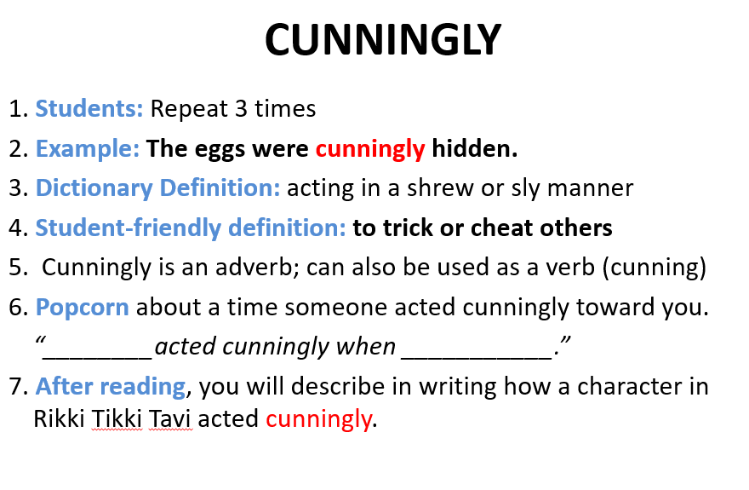

Vocabulary Notes Chart – The Bracelet

