English Instructional Plan – Understanding Connotation 7-8
Primary Strand: Reading 7.4, 8.4
Integrated Strand/s: Writing 7.7, 8.7
Essential Understanding:
- understand that word structure can be analyzed to show relationships among words
- recognize that many words have multiple meanings and that context and dictionaries are both supportive in determining which meaning is most appropriate
- understand that words have nuances of meaning, including figurative, connotative, and technical that help to determine the appropriate meaning.
Essential Knowledge, Skills, and Processes:
- use context clues to determine meanings of unfamiliar words in text, such as examples, restatements, and contrast
- determine or clarify the meaning of unknown and multiple meaning words and phrases based in reading and content
- distinguish among the connotations of words with similar denotations
- recognize that synonyms may have different connotations
Primary SOL: 7.4d Identify connotations; 8.4f Discriminate between connotative and denotative meanings and interpret the connotation.
Reinforced (Related Standard) SOL: 7.7, 8.7 (Write reflectively to explain and analyze an experience, a skill, or an event, and as a response to reading)
Academic Background/Language: Students must be familiar with connotation and how to identify the intention or feeling that a word may imply through the way it is used in text. Students must also be able to identify the difference between positive connotation and negative connotation.

Materials
- Copies of Lincoln’s “The Gettysburg Address” (available online)

Student/Teacher Actions: What should students be doing? What should teachers be doing?
- Explain to students that connotation refers to the feeling a word conveys and can imply when used in a text.
- Have students read through “The Gettysburg Address” for broad comprehension. Then, have them reread the first paragraph carefully and identify all words with positive connotations and all words with negative connotations. Have them list the words on a T chart, like this:
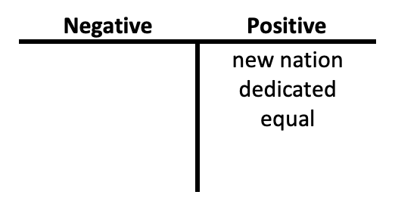
- Have students continue with the remaining paragraphs. After paragraph two, their charts might include the following:
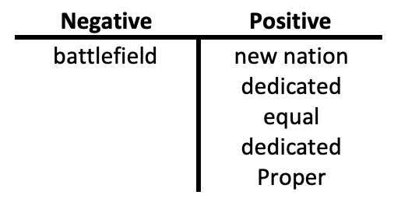
- Be sure students include repeated uses of the same word (e.g., dedicated). After paragraph three, their charts might resemble this:
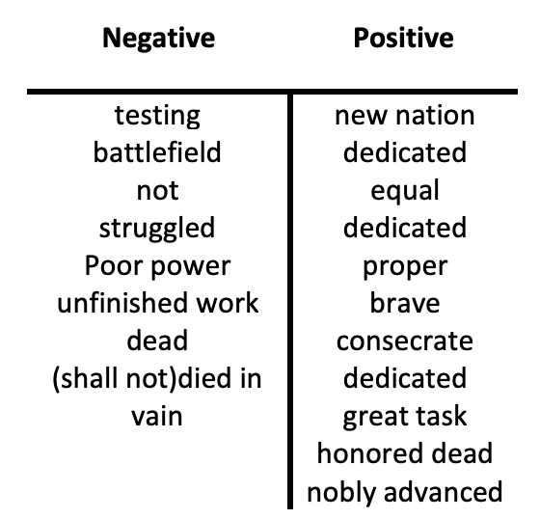
- Once students have finished the re-reading and word analysis, have them identify the column of words that contains greater emotion, greater meaning, and therefore greater impact.
- Discuss ways the use of other words (synonyms) for the words in the positive column might have affected the impact of Lincoln’s speech (e.g., leaders for fathers, or goal for great task).
- Have students write a summary of their reactions to the word choices Lincoln made for this famous speech.
- Continue to discuss connotations of words in texts read in the classroom.
Assessment (Diagnostic, Formative, Summative):
- The teacher will provide feedback to students as they make decisions about whether words have a positive or negative connotation.
- The teacher will conference with students once they begin to write their reactions to the word choices Lincoln made for the famous speech.
Writing Connections:
- Students will write a summary of their reactions to the word choices Lincoln made for his famous speech. Students’ summary will take on the form of a reflective essay.
Extensions and Connections (for all students):
- Students may have the opportunity to analyze the connotation of additional text; famous speeches, primary source documents, interviews, fictional text, etc.
- The teacher may allow students to edit a narrative writing piece of their peer’s and identify where the writer implies positive or negative connotation within their writing.

Strategies for Differentiation
- The teacher may use a different speech or text with more relevant content knowledge connections.
- The students may work together to prepare and organize their reflective essay about connotation of language within “The Gettysburg Address”.

