Instructional Plan – Identifying Denotation and Connotation 7-8

Primary Strand: 7.4 and 8.4 – Reading

Integrated Strand/s: Communication and Multimodal Literacies

Essential Understanding:
- Recognize that words have nuances of meaning (figurative, connotative, and technical), which help determine the appropriate meaning

Essential Knowledge, Skills, and Processes:
- Recognize that words have nuances of meaning (figurative, connotative, and technical), which help determine the appropriate meaning
- Distinguish among the connotations (associations) of words with similar denotations (definitions) (e.g., refined, respectful, polite, diplomatic, condescending), recognizing that some words have technical meanings based on context such as stern
- Recognize that synonyms may have connotations (e.g., elderly and mature; youthful and juvenile)

Primary SOL: 8.4e – The student will discriminate between connotative and denotative meanings and interpret the connotation.

Reinforced (Related Standard) SOL:
- 7.4d - The student will identify connotations.

Academic Background/Language:

Materials
- Sticky notes
- Whiteboard
- Copies of Words to the Wise worksheet
- Copies of Sports Team Names Connotations worksheet

Student/Teacher Actions: What should students be doing? What should teachers be doing?
- Ask students to imagine they were being introduced to someone who knows nothing about them. You would want to be described in the best way possible. From each pair or words (below), choose the one you would want to be used and explain why.
  - Easy-going OR slack
  - Patient OR pushover
  - Leader OR bossy
  - Decisive OR stubborn
- Distribute copies of the Words for the Wise worksheet and discuss the difference between Connotation and Denotation. Explain that the association of a word can be emotional or cultural; therefore, there may be different connotations for the same word.
- Have students work in small groups of three or four students to complete the Words to the Wise worksheet.
- Create a Word Wall that includes Positive, Neutral, and Negative categories.
- Provide students with sticky notes or plain paper. Have students write a word (and a draw a picture) of a word that has the same denotative meaning as the word “old” but that can be identified with a positive, neutral, or negative connotation.
- Have the students place their words/pictures on the board in the connotative category that they think fits the best.
- Hold a class discussion on the different connotations of the word “old,” asking students if they think some of the words could be placed in more than one category and explain why.
- Now have students write a word/picture (on a sticky note) for words with the same denotative meaning as “young.” Collect all of the sticky notes and have the students vote on which connotation they associate with the words. If students have differing opinions, have them explain why they chose positive, neutral, or negative.
- Distribute copies of the Sports Team Names Connotations worksheet. Have the students complete the worksheet independently, then share their responses with a partner.
- Close the lesson by reminding students that the association of a word can be emotional or cultural; therefore, there may be different connotations for the same word.

Assessment (Diagnostic, Formative, Summative)
- Students are assessed on the Words to the Wise worksheet and the Sports Team Names Connotations worksheet as formative assessments.

Writing Connections:
- Students write a well-written paragraph explaining why they chose the team name and logo for Activity Three on the Sports Team Names Connotations worksheet.

Extensions and Connections (for all students)
- Create a Word Wall for the students using Padlet. Using Pixabay (or another royalty free image website), have students find images to match the connotations of their words. Students can then upload their words/images to the Padlet Word Wall.
- Create a Flipgrid topic for word connotations. Have students draw a picture and hold it up in front of their camera or upload a royalty free image. Students can then type their word or record themselves saying it. Students can then explain if the word has a positive, neutral, or negative connotation. Students can view their classmates’ words on Flipgrid.

Strategies for Differentiation:
- Students with accommodations use available technology to allow them type their words and find royalty free images.
- Scaffold the activity by competing a portion of the chart/worksheet.
- Allow English Learners to work in small groups to help develop language, learn the content, and hear other students’ thinking.
- Provide ELs with sentence frames/starters to help get the conversation started when they are in their small groups. For example, “At first I thought ____ but now I think____ because ____. I like how this word/picture uses ____ to show ____. This word/phrase stands out to me because ____.”

Note: The following pages are intended for classroom use for students as a visual aid to learning

Words to the Wise
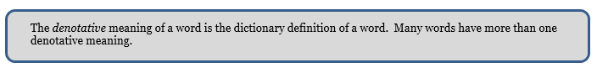
Give two denotative meanings of the word “sharp” and use each in a sentence.

Sentence 1: ___________________________________________________________________

Sentence 2: ___________________________________________________________________

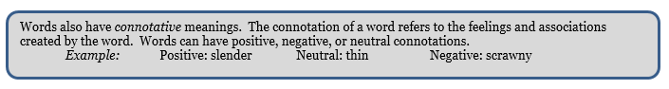
Fill in words below that have the same denotative meaning as the word “inexpensive” but that can be identified with the following connotations:

Positive: ________________________________________________________________________

Neutral: ________________________________________________________________________

Negative: _______________________________________________________________________
Look at the following words, all of which have the denotative meaning “house:”

home hut shack mansion cabin chalet
abode dwelling shanty domicile residence

Decide if each word has a positive, negative, or neutral connotation and fill in the chart below.
Be prepared to defend your answer.

Make a list of words that have the same denotative meaning as the words “dumb” and “smart.”

Sports Team Names Connotations

Activity One:
Complete the chart based on the potential names for new professional athletic teams.

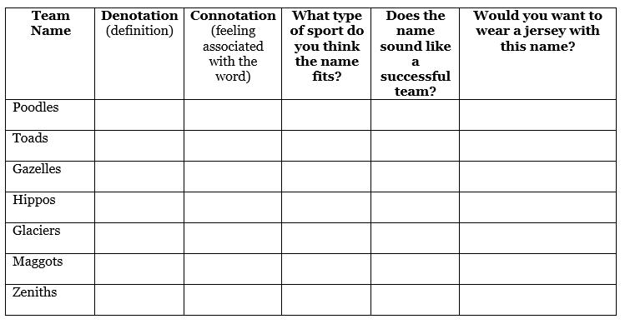

Activity Two:
Brainstorm and record a list of current team names from professional and amateur sports.

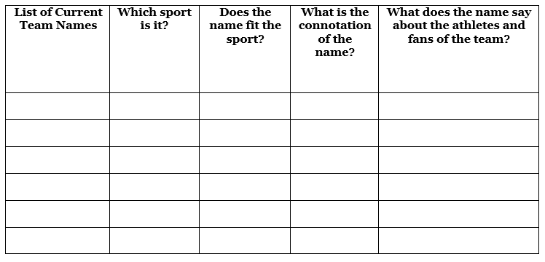

Activity Three:
You have been given the job to name a new professional athletic team.
Decide what type of sport the team plays, and then choose a name that has a positive connotation. Design the t-shirt below to advertise your new team. List the connotations of the team name on the t-shirt. Your t-shirt must include the following:
- team name
- connotations of the team name
- logo design
- the definition of the name
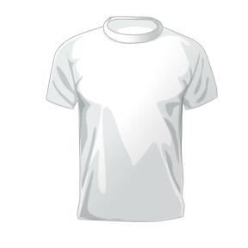

Activity Four:
Go to www.nike.com and click on Customize to design an athletic shoe to for your new professional athletic team. After you finish designing it, share it with me or take a screen shot.

