English Instructional Plan – Identifying Text Features in Nonfiction Grades K-2
Primary Strand: Reading: K.9, 1.10, 2.8
Integrated Strand/s: Communication and Multimodal Literacies
Essential Understanding:
All students should:
- understand that nonfiction texts provide information
- understand that text features serve a purpose.
- understand a variety of strategies assist with comprehension of nonfiction texts.
Essential Knowledge, Skills, and Processes:
To be successful with this standard, students are expected to:
- explain how illustrations and images contribute to and clarify text
- skim text for section headings, bold type, and picture captions to help set a purpose for reading
- use print clues, such as bold type, italics, and underlining, to assist in reading
- use text features to make, revise, and confirm predictions, locate information, and answer questions
- use text features to make, revise, and confirm predictions, locate information, and answer questions
- preview reading material and set a purpose by looking at the book’s cover and graphics and by reading titles and headings
- identify and use text features to locate facts and information in a text
- distinguish between information provided by pictures or illustrations and information provided by words in the text
- read various nonfiction forms, including letters, lists, recipes, newspapers, and magazines
Primary SOL:
K.9b Preview the selection using text features including text of content, heading, pictures, captions and maps.
1.10d Identify text features such as pictures, headings, charts, and captions
2.8a Preview the selection using text features including text of content, heading, pictures, captions and maps.
Reinforced (Related Standard) SOL:

Academic Background/Language:
Text features are used to help organize, predict, categorize and understand nonfiction text. We see text features in various forms of text including but not limited to our Science text books, Social Studies textbooks, websites and articles. Some examples of text features are table of contents, headings, pictures, captions, maps, indices, and charts.
Sentence starters for oral or written communication
- Pictures in nonfiction books help us ...
- Look at this nonfiction text, I can locate the following text features ...
- Illustrations and pictures make nonfiction text more interesting because ...
- When I preview the (text features), I can learn ...
- The (text feature) helps me as a reader by ...

Materials
- Various forms of text: recipes, nonfiction books, posters, flyers, brochures
- “Walk About” recording poster

Student/Teacher Actions: What should students be doing? What should teachers be doing?
- Introduce text features to students by showing students examples and explain their purpose.
- Display various examples of text features around the room
- Have students walk around the room and place sticky notes to identify text features in real texts/on anchor charts, big books....
- After students have walked examined each example come together as a class to reflect.
  - Reflect as a class, “How text features help us, as readers, to better understand text? How text features help readers find information?”
Assessment (Diagnostic, Formative, Summative)
- Have students point to text features identified orally by the teacher. (Students can also identify the purpose of each feature.)
- Write several text features on a sticky note and have students post them on the correct text feature in a real text.
- Have students create a poster of their favorite animals. Provide students with a list of text features that you would like to see present on the poster.
Writing Connections:
- Have students draw a picture or give students a picture and have them write a caption.
- Encourage students to write nonfiction text to text features such as pictures with captions, headings, maps, diagrams.
Extensions and Connections (for all students)
- Matching game: Have students match an illustration of the text feature to the name.
- I Spy!: While working in groups, provide students with nonfiction books. Have them locate various text features - you can either give them a graphic organizer or stick notes to identify the features.
- Create and display a chart listing each text feature. Whenever you read a nonfiction text, write the title and mark any text features that were present.
- Ask students various questions where they will have to use the text features to find the answer.

- Provide students with nonfiction text: ask students various questions where they will have to use text features to answer them.
  - What is the definition of ---
  - Which chapter starts on page 10?
  - What does the map on page 12 tell the reader?
Strategies for Differentiation
- Have students work in partners
- Provide multiple examples of text with text features
- Model for students before they complete independently
- Provide students with an anchor chart showing examples of text features
- Reteach in small group settings
- Use sentence frames during lesson: “The heading is located --” “The caption is located -- it helps the reader--”
Note: The following pages are intended for classroom use for students as a visual aid to learning.

I Spy!
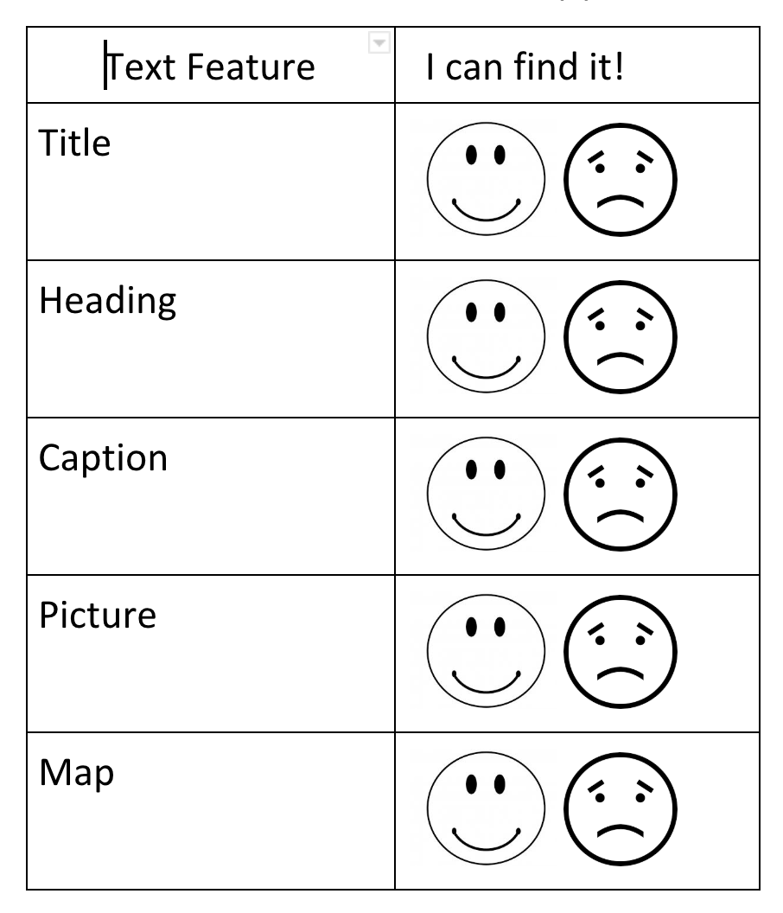
*As you are reading fill in the table with the text features the students “spied” while reading
I SPY a ...
*Sample anchor chart
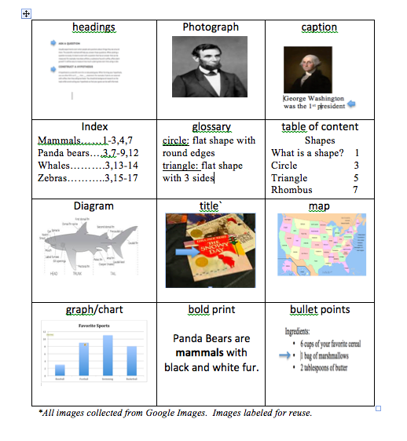

*sample matching game

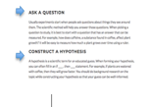 | headings | 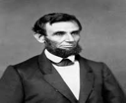
photograph | 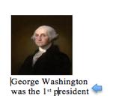 | caption
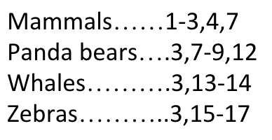 | index | 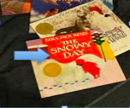
title | 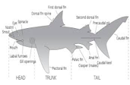 | diagram

circle: flat shape with round edges  triangle: flat shape with 3 sides | glossary | 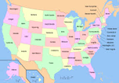
map | 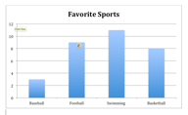 | graph
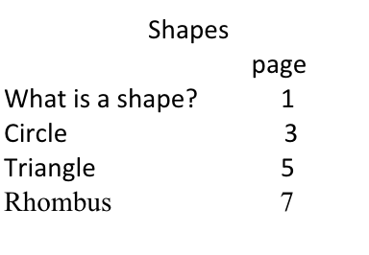 | table of content | Panda Bears are mammals with black and white fur.
bold print | 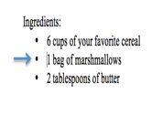 | bullet points

