English Instructional Plan – Using Paired Passages for Deeper Analysis 8-10
Primary Strand: Reading 8.6, 9.5, 10.5
Integrated Strand/s: Writing 8.7, 9.6, 10.6 Communication and Multimodal Literacies 8.1, 9.1, 10.1

Essential Understanding:
- understand that analysis of a text should be based on text references, not personal opinion
- understand that an author’s patterns of organization can aid comprehension
- understand that text features are created purposefully and are an aid to comprehension
- understand that skilled readers of nonfiction texts apply different reading strategies.

Essential Knowledge, Skills, and Processes:
- analyze two or more texts with conflicting information on the same topic and identify how the texts disagree
- analyze organizational patterns to aid comprehension
- understand that text features are created purposefully and are an aid to comprehension
- understand that skilled readers of nonfiction texts apply different reading strategies.
- organize information from two texts, while maintaining the intended purpose of each original text

Primary SOL: 8.6l, 9.5k, 10.5h Analyze ideas within and between selections providing textual evidence
Reinforced (Related Standard) SOL:
- 8.7 Write in a variety of forms to include narratives, expository, persuasive, and reflective.
- 9.6 Write in a variety of forms to include expository, persuasive, reflective, and analytic.
- 10.6 Write in a variety of forms to include persuasive, reflective, interpretive, and analytic.

Academic Background/Language:
- How context clues help determine meaning of unfamiliar words and how to create a meaningful sentence using the definition, example, synonym, or antonym of that word.
- How to compare and contrast
- How to construct a thesis statement to form an argument
- How to embed text evidence in writing

Materials:
- Song (Only need to play the first 33 seconds)
- Texts
  - Video: Why Teens should sleep in on school days
  - Common Lit Text: Teenagers who don’t get enough sleep at higher risk for mental health problems
  - Extension text can be used to broaden discussion or scope: Common Lit Text: Sleepy Suspects are way more likely to falsely confess to a crime
- Butcher paper or whiteboard/chalkboard for Graffiti walk
  - Graffiti walk questions: Is sleep important? Do teens need more sleep than children or adults? What are some obstacles for getting a good night's sleep? Do routines make a difference in your ability to sleep?
- Graphic organizer for paired passages
- Assessment rubric

Student/Teacher Actions: What should students be doing? What should teachers be doing?
Before the lesson starts:
- Set up materials for the Grafitti walk.
- Use butcher paper or your white/chalk board to write one question on each paper. These are listed in the materials section.
- Post the questions around your room. Make sure the questions are spaced out so that students are able to move around the room with ease.
To introduce this lesson, play the first 33 seconds of the Beatles song “Good Morning, Good Morning”.
- When the song is finished, survey students on the average number of hours they sleep.
  - There are a number of ways you may survey your students. If you have access to technology, consider creating a google form or using Kahoot to poll students and display the results. If you do not have access to technology, or want to get students moving, use the corners of your room to create a range. Example: Corner 1 = 1-3 hours, Corner 2 = 3-5 hours, Corner 3 = 5-7 hours, Corner 4 = 7-10 hours. No matter the method, the purpose is for students to build their schema for the average amount of sleep their class gets a night.
- After the students have been polled, direct them to the questions posted around the room for the gallery walk. You may say, “In a moment, you will be asked to think about and respond to the following questions: Is sleep important? Do teens need more sleep than children or adults? What are some obstacles for getting a good night's sleep? Do routines make a difference in your ability to sleep? You are not expected to know the “right” answer, but make sure you explain your response. A simple yes or no does not help us understand your thinking. You will have 3 minutes to respond to each question, but we will be following a silent protocol. This is your opportunity to answer the question without any interruptions. If you are finished with your response before the 3 minutes are up you may move to the next question. When you are finished, take a seat and remain silent until the final timer goes off.”
  - Graffiti walk procedure: Divide your class in equal groups of four then begin the graffiti walk. Give students 3 minutes to respond to each question before asking them to continue to the next question. By telling students to follow a silent protocol you are asking them to only share their thoughts by writing them down. Students are allowed to respond to other comments on the butcher paper as they see fit, but the response needs to be in written form. While students are responding, pay attention to what they are writing and try to condense and summarize their work. Once the final timer goes off, verbally summarize student responses by comparing and contrasting their answers to the class. The teacher will use student responses to model how they are summarized and include supporting explanations.
- Explain to the students that they will learn how to apply knowledge of text features and organizational patterns to analyze selections. This process includes comparing passages in order to gain a deeper understanding of a topic or idea. The teacher will prompt students to think about the subject that will be explored today.
  - Students should respond with something about teens and sleep.
- Distribute the graphic organizer for students to use while analyzing the video and article.
  - While watching the video, model reading comprehension strategies by pausing periodically to check for understanding. For example, before the video starts, ask, “What do you think the main idea of the video will be?” Students should be able to glean this information by the video title: “Why Teens Should Sleep in On School Days.” Pause the video at 23 seconds to ask, “What do you think the phrase 'bane of my existence means’ based on the context clues?” etc.
  - After the video is complete, ask students to collaborate with a partner to complete the corresponding questions about the video. Depending on your students, be aware that you may want to provide feedback regarding the questions about the video before continuing with the article. Students will then buddy read the article with their partner.
  - During partner reading, students should highlight and annotate the text when they notice similarities and differences between the previously viewed video and the article.
  - As the students read the article they should work together to complete the Venn diagram organizer. Students should notice similarities or differences between the video and the text in regards to the supporting evidence and facts that are presented. The teacher may provide feedback, circulate amongst groups, and prompt students with these questions,
    - “How is the structure of the video similar or different to that of the article?”
    - “What is one fact that is contradicted from one source to the next?”
    - “In what way does the multimedia and text support answers to the initial questions you responded to at the beginning of the lesson?”
    - “How can rereading text support our understanding?”
    - “What strategy/strategies did you use to make a comparison between the video and the text?”
- Students will use their graphic organizer to build a thesis statement for their argument about teens and sleep. Students will work to create a multi-paragraph response that uses evidence from the paired text and video and the graphic organizers to develop an argument about how much sleep teens need.

Assessment (Diagnostic, Formative, Summative):
- The graphic organizer may be used as a formative check point and be used as a means to provide feedback to students about the information they have gathered from the video and/or article.
- Once students have completed the graphic organizer, they will be directed back to the original questions from the graffiti walk. Students will have to write a multi-paragraph response using one of the questions to create a thesis statement for their argument. Students must incorporate at least two pieces of evidence from the video and or the
article to make their case. Depending on the amount of time given, this could be a summative assignment.

Writing Connections:
- This lesson incorporates writing throughout the use of the graphic organizer, composing a thesis statement that defines an argument, and within a culminating multi-paragraph response.

Extensions and Connections (for all students):
- You can use the assessment questions that are provided in CommonLit, but always preview assessment questions in advance as they vary in difficulty and purpose.
- If the activity is too short, or you want students to read additional material, use this article titled Night Lights have a Dark Side in order to extend the activity. If you do this, you may want to modify the graphic organizer and re-label the original chart with this article’s title.
- Follow up lesson may include extending the concept of the importance of teen sleep to how lack of sleep affects everyone by using this article.

Strategies for Differentiation:
- Create a class anchor chart with visual displays for students who may need a visual reminder of how to create a thesis statement.
- If a partnership is struggling or not working effectively students may get additional teacher support or be divided into new groups.
- Students who need additional supports may receive sentence stems to help in completion of the graphic organizer.
- Students who are not sure how to formulate their multi-paragraph response may be given sentence starters to guide them.
- Struggling students may be expected to use one piece of text evidence.
- Students who excel may be asked to read an additional resource to strengthen their response.
- Students may work in groups or individually.

Note: The following pages are intended for classroom use for students as a visual aid to learning.

Graphic Organizer for Paired Passages
Fill in the organizer while you watch the video.
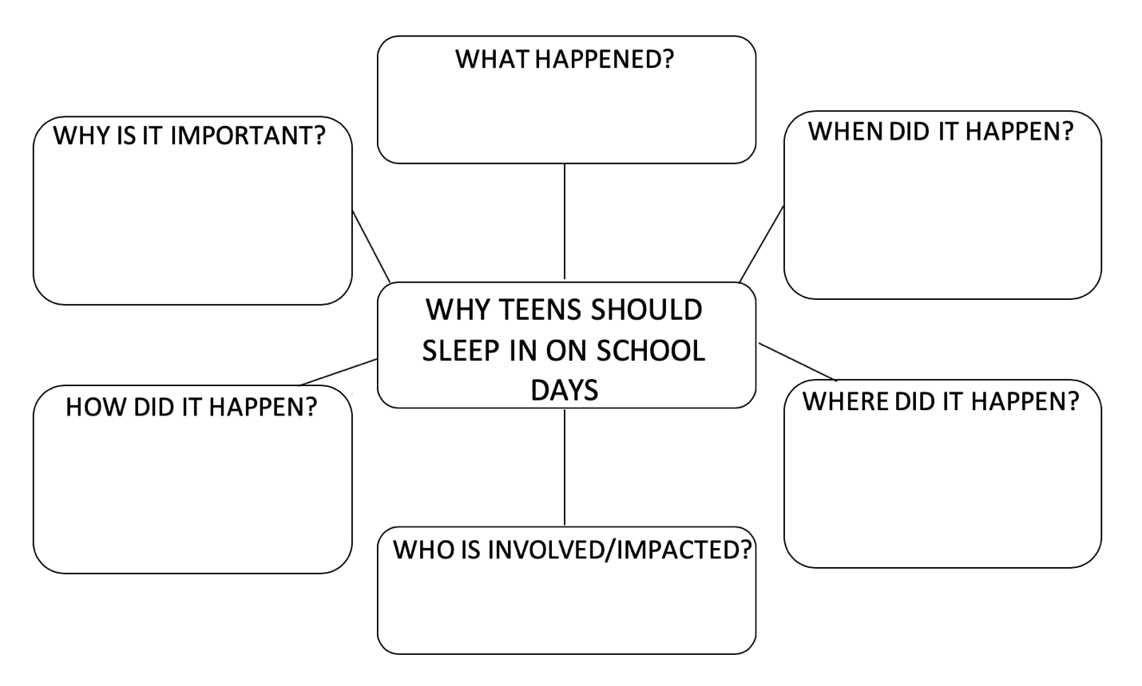

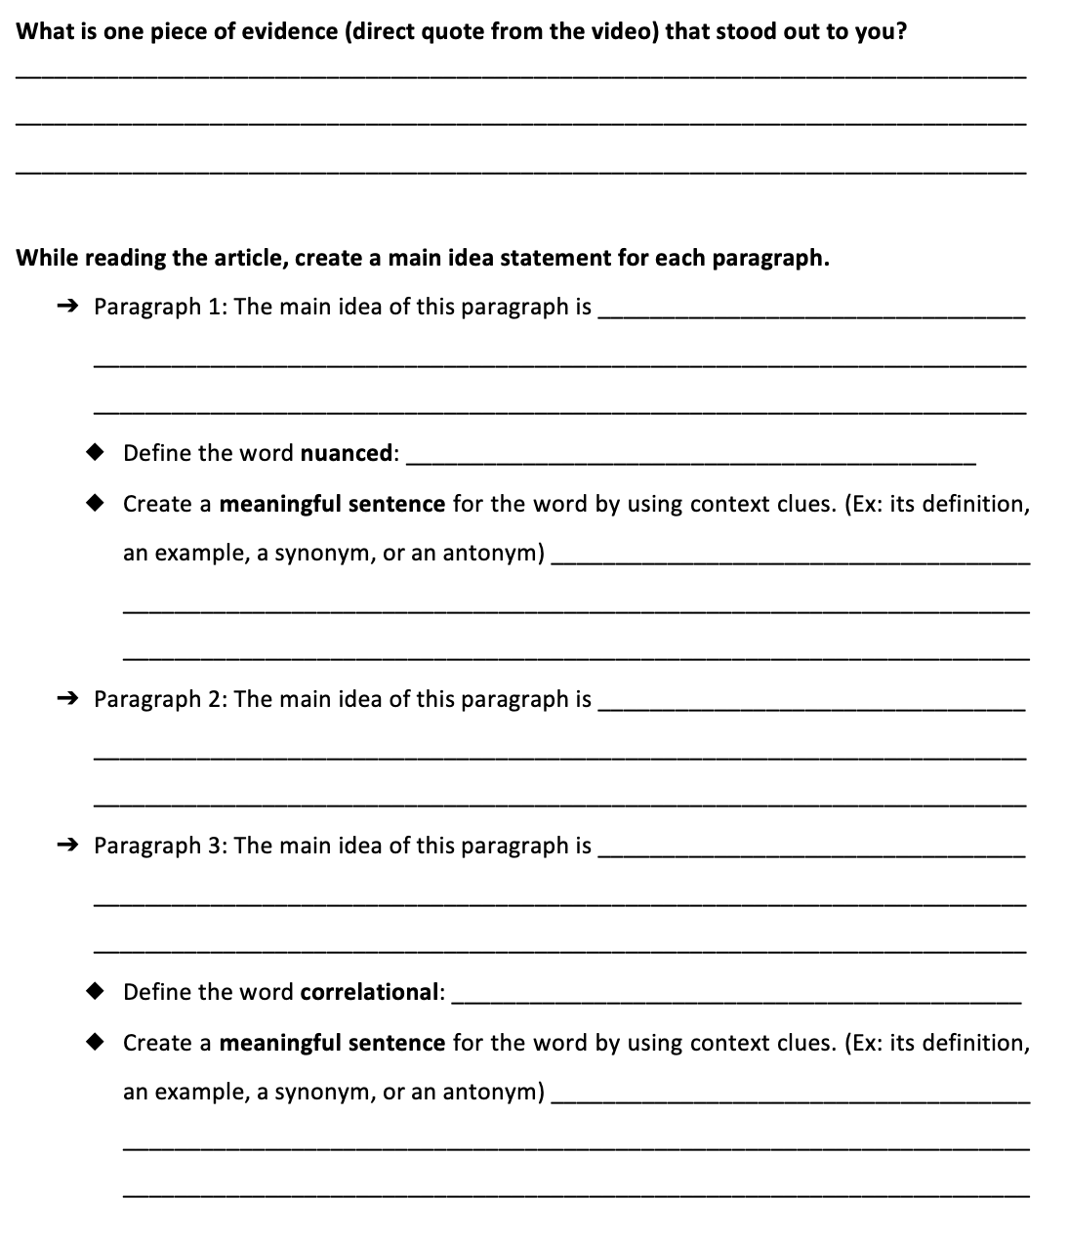

After watching the video and reading the article, compare and contrast the two texts by filling in the Venn diagram.

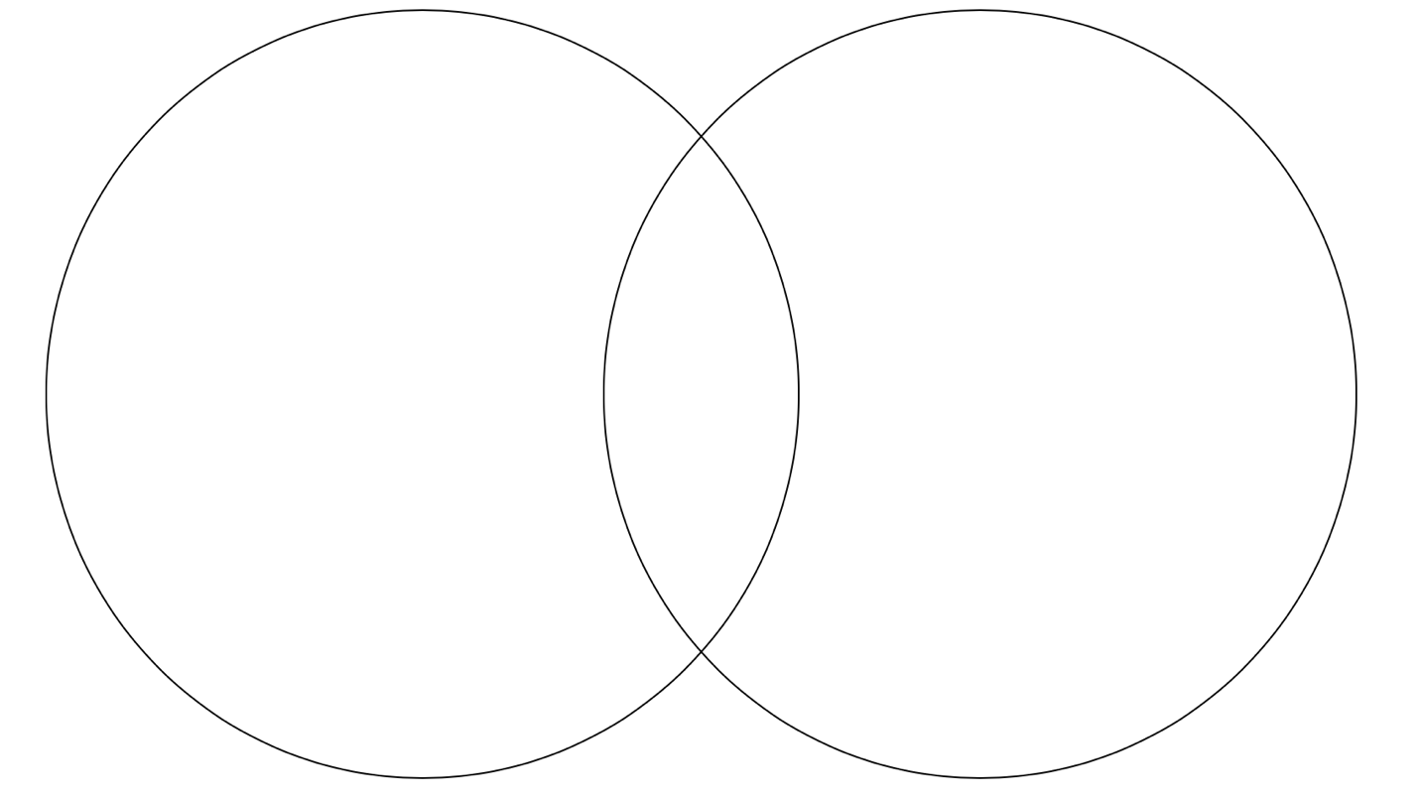

Assessment Rubric
Exceeds Expectations | Meets Expectations | Areas for Growth
 | Clear thesis statement
 | Little to no grammar or punctuation errors
 | Understanding of the texts based on evidence cited
 | Original examples or evidence introduced

