English Instructional Plan – Using non-fiction texts to make inferences and draw conclusions 8-9
Primary Strand: Reading 8.6, 9.5

Integrated Strand/s: Writing 8.7, 9.6 Communication and Multimodal Literacies 8.1, 9.1

Essential Understanding:
- understand that the analysis of a text should be based on text references, not personal opinion
- understand that an author’s viewpoint is conveyed through word choice and persuasive language
- understand that an author’s viewpoint refers to bias or subjectivity toward the subject; a viewpoint can be positive or negative
- recognize an author’s use of connotations, and persuasive language convey viewpoint
- understand that there are strategies including context, structural analysis, and reference sources, for determining the meaning of unfamiliar and technical vocabulary.
- understand that skilled readers of nonfiction texts apply different reading strategies.

Essential Knowledge, Skills, and Processes:
- recognize and identify an author’s use of connotations and persuasive language to convey a viewpoint
- determine an author’s point of view or purpose in a text
Primary SOL: 8.6d Make inferences and draw conclusions based on explicit and implied information, 9.5b Make inferences and draw conclusions based on explicit and implied information using evidence from text as support.

Reinforced (Related Standard) SOL:

8.6e, 9.5c Identify the source viewpoint, and purpose of texts;

8.6k Organize and synthesize information for the use in written and other formats;

8.6l. 9.5k Analyze ideas within and between selections providing textual evidence.
- 8.7 Write in a variety of forms to include narrative, expository, persuasive, and reflective.
- 9.6 Write in a variety of forms to include expository, persuasive, reflective, and analytic.

Academic Background/Language:
- Understand the differences between explicit and implicit information
- Understand inferencing
- Understand how to identify evidence from text as support

Materials:
- “You are what you bring” visuals
- Text:
  - Excerpts from the Life of Frederick Douglass text- recommended chapters VII or XI. Read prior to assigning to determine appropriateness for your students.
  - Explicit vs Implicit Characterization organizer
- Assessment materials
  - Butcher paper or large paper to create anchor charts
  - Anchor Activities
- Extension:

What Aspects of Our Identities do we Show to Others

Student/Teacher Actions: What should students be doing? What should teachers be doing?
Before the lesson starts, post the images from the ‘You are what you bring’ around the room. Put the images far enough apart so students can view them in groups.
- The teacher should make the learning objective for the day clear: Today we will learn how to make inferences and draw conclusions based on explicit and implied information.
- Project, write, or display the following definitions for students:
  - EXPLICIT INFORMATION: Any information that is clearly stated or spelled out. There is no room for confusion.
  - IMPLICIT INFORMATION: Any information that is understood, but not clearly stated.
  - INFERENCE: An educated guess based on evidence both implicit and explicit.
- The teacher will collect a brown bag of sample food items (this will be a model of a typical school lunch). The teacher may use real food items or clip art pictures of lunch foods. Ask students to think about the explicit and implicit information about the school lunch. Students will have the opportunity to make inferences about the school lunch in the brown bag and discuss whether the information they are gathering is explicit or implicit. From there, the teacher will transition into the You Are What You Bring activity.
- Keep the definitions visible to students while they complete this activity. You may choose to jigsaw the activity as follows:
  - Divide class into three groups.
  - Each group of students will be given one of the “You are what you bring” pictures. Group 1 will receive the “you are what you bring” picture #1, group 2 will receive the “you are what you bring” picture #2, and group 3 will receive the “you are what you bring” picture #3. Each group will have five minutes to discuss the picture and determine the implicit and explicit information that is gathered from it. As well, students will discuss any inferences that they can make about the person who may be carrying these items.
  - Once the time is up, allow students to share (as groups) with the class about their picture.
- After the activity, allow students to choose a partner. With their partner, they will read excerpts from The Narrative of the Life of Frederick Douglass.
- After reading the assigned article once, partners will work to close read for a second time. During close read #2, students will work together to complete the graphic organizer. The graphic organizer’s purpose is to guide students in determining the explicit and implicit character traits of Frederick Douglass.
- Once students complete the graphic organizer, they will use the “fold the line” strategy by pairing up with another set of partners for 30 seconds at a time. Fold the line is a strategy used to increase student engagement and offers multiple opportunities to share out with different peers, in this case pairs of student groups. During each 30 second share out one person needs to share either a piece of implicit or explicit information and what proof supports this idea. Every 30 seconds, students will move down the line and then become paired with a new student group to share with; students may repeat this 3-4 times to share out with 3-4 student groups.

Assessment (Diagnostic, Formative, Summative)
- Formatively, the teacher may provide feedback to pairs of students as they are completing their graphic organizers. Once students have completed the graphic organizer, they will be tasked with creating an anchor chart to show what they know about the concept. The teacher may use the link to Anchor Activities (in the materials section) to determine how you wish to assign this.

Writing Connections:
- Use the discussion questions in CommonLit to create a writing prompt. Discussion questions appear after the assessment questions. Teachers may view these at any time by either clicking directly on the ‘discussion questions’ tab in the activities section or the answer key for the text.

Extensions and Connections (for all students)
- What Aspects of Our Identities do we Show to Others
- Ask students to make an inference about their book by identifying implicit and explicit information from the text.
- Quizizz Practice: https://quizizz.com/admin/quiz/5bade09700821f00194d7c6a

Strategies for Differentiation
- If students are struggling to understand the concept, watch this video before or after the “You Are What You Bring” activity: https://www.youtube.com/watch?v=GfpOMHkYyeg
- If a pair of students is struggling or not working together effectively, they may be provided additional teacher support or be divided into new groups.
- Students who need additional supports may receive a partially filled in organizer.
- Students may work in groups or individually.

Note: The following pages are intended for classroom use for students as a visual aid to learning.

You Are What You Bring #1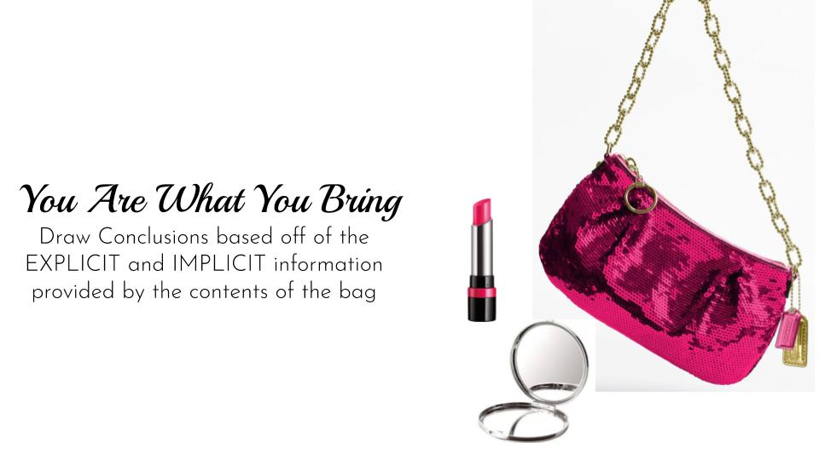
You Are What You Bring #2

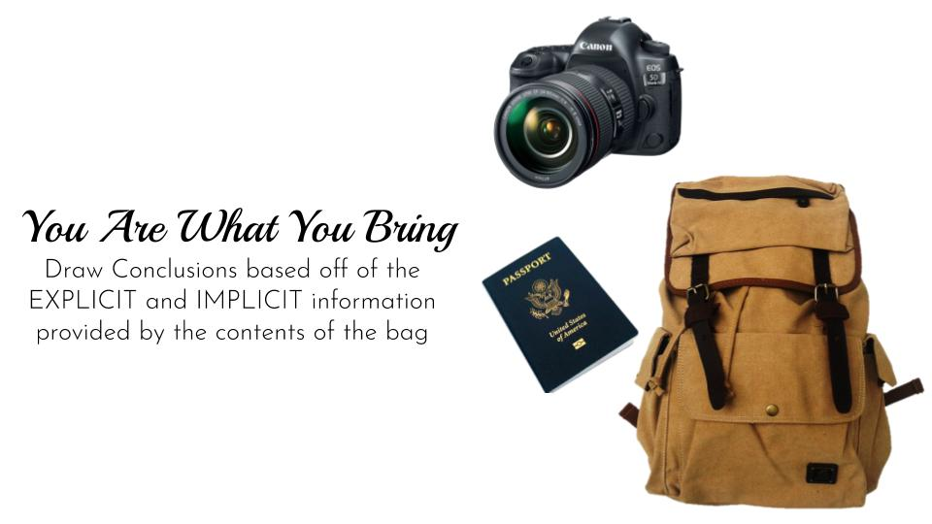

You Are What You Bring #3

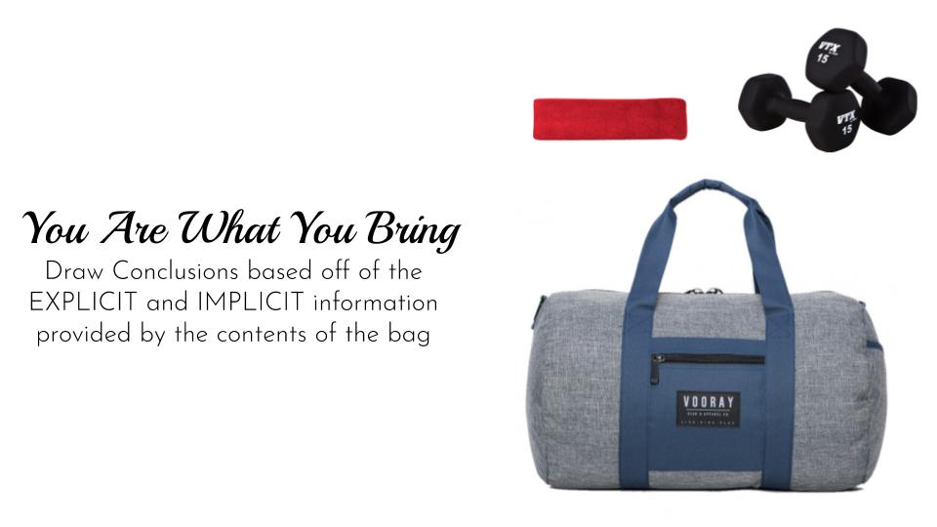

Graphic Organizer