English Instructional Plan – Literary Analysis through Close Reading
This resource package will identify a concise way to complete literary analysis of text through the close reading process. The close reading process will be taught and used to annotate the text in order to identify how to answer text-dependent questions, determine meanings of unfamiliar words, determine how author’s word choice and imagery contributes to the meaning of the text, and to explain how character development may drive conflict and resolution in fictional text. Each plan will represent a passage or passages that offer student choice, but will give teacher a clear understanding on how to teach the strategies that support literacy analysis of any text.
Primary Strand: 6.5, 7.5, 8.5, 6.6, 7.6, 8.6 – Fiction and Non-Fiction Reading Comprehension
Integrated Strand/s: 6.1, 7.1, 8.1, 6.7, 7.7, 8.7 – Communication and Multimodal Literacy & Writing
Essential Understanding:
- understand that analysis of a text should be based on textual references, not on personal opinion.
- understand that the author uses images to craft a message and create characters
- understand that imagery and figurative language enrich texts
- recognize an author’s craft as the purposeful choice of vocabulary, sentence formation, voice, and tone.
- understand that an author’s voice and tone stem from word choice and the stylized use of literary devices
- recognize that each member brings a unique viewpoint to the group
Essential Knowledge, Skills, and Processes:
- analyze the interactions between individuals, events, and ideas in a text
- explain characterization as the way an author presents a character and reveals character traits by
  - what a character says
  - what a character thinks
  - what a character does
  - how other characters respond to the character
- identify and analyze narrative elements
- identify conflicts
- describe how a fictional plot is often episodic, and how characters develop as the plot moves toward a resolution
- notice an author’s craft, including use of
  - language patterns
  - sentence variety
  - vocabulary
  - imagery
  - figurative language
  - word choice to develop mood and tone
- understand and analyze elements of an author’s style, including
  - dialogue
  - sentence structure
  - language patterns
  - word choice to develop tone
  - voice
- analyze an author’s choice of words and images
- compare and contrast two or more texts on the same topic or with similar themes.

Primary SOL:
6.5, 7.5, 8.5 The student will read and demonstrate comprehension of a variety of fictional texts, literary nonfiction, and poetry.
6.5c Explain how an author uses character development to drive conflict and resolution
6.5e, 7.5g Describe how word choice and imagery, and literary device, including figurative language to contribute to the meaning of a text
6.5h, 8.4a Identify and analyze the author’s use of figurative language
7.5b Identify and explain the theme(s)
8.5a Analyze how authors’ development of characters, conflict, point of view, voice, and tone convey meaning.
8.5d Explain the use of symbols and figurative language
8.5h Compare and contrast the authors’ use of word choice, dialogue, form, rhythm, and voice in different texts.
8.5i Compare and contrast authors’ styles.
6.5k, 7.5j, 8.5j Use reading strategies to monitor comprehension throughout the reading process.
6.6, 7.6, 8.6 The student will read and demonstrate comprehension of a variety of nonfiction texts.
6.6k, 7.6m, 8.6m Use reading strategies to monitor comprehension throughout the reading process.

Reinforced (Related Standard) SOL:
6.1, 7.1, 8.1 The student will participate in, and contribute to conversations, group discussions, and oral presentations.
6.7, 7.7, 8.7 The student will write in a variety of forms, to include narrative, expository, persuasive, and reflective, with an emphasis on narrative and reflective writing.

Academic Background/Language:
- Students will need to understand the close reading process or have seen it modeled by the teacher
- Students will need to be familiar with how to answer text-dependent questions
- Students will need to have some familiarity with how to determine the meaning of unknown words
- Students will need to have experience in determining how authors’ word choice and imagery contributes to the meaning of the text
- Students will need to understand the terms:
  - characterization
  - conflict and resolution
  - point of view
  - figurative language
  - theme

Materials
- The War of the Wall (short story) by Toni Cade Bambara or a similar fictional text from www.commonlit.org
- The teacher may choose to pair fiction with nonfiction for further text analysis; paired nonfiction may be: This is not a Small Voice by Sonia Sanchez, The Poppy Lady by Barbara Elizabeth Walsh, or Nipsey Hustle Street Art in Los Angeles breathes life into legacy (all found on www.commonlit.org)
- Text-Dependent questions that match the text (see below)(if using common lit you may also reference guiding questions through guided reading mode)
- Close Reading Anchor Chart (see below)
- Analyzing Characters Graphic Organizer (see below)

Student/Teacher Actions: What should students be doing? What should teachers be doing?
- This plan is presented and intended to take multiple class periods, possibly over the course of 1-2 weeks. This plan will identify how to take a piece of fictional text through the close reading process but the close reading process can be used to examine the same piece of text through multiple lenses or many different texts along the same theme or topic through a focused lens.
- The teacher will present the close reading process (use graphic below) to students and remind them that they can analyze text closely by reading it multiple times with one or more purposes.
- The teacher will model the close reading process with a sample fictional text. The teacher will introduce the text. Prior to the first read, the teacher will set the purpose for reading; the comprehension focus (i.e. noticing theme, identifying characterization and the effect on the plot, conflict, and resolution, figurative language, inferencing). The teacher will guide students in making predictions and gathering prior knowledge about the topic of the text before the first read as well. The modeled text will be read three times. For each read, the teacher will present a task, a graphic organizer, or a question to discuss. Each read will allow students to discover more about the text and to develop a deeper understanding of the theme, connections, and authors’ meaning of the text. The first read is used to “get the gist”; students may begin to understand the main ide or theme, they can summarize the text, and begin to have noticing’s and wonderings about the text. The second read is to help students dig a little deeper; students may notice text structure, identify difficult vocabulary, determine authors word choice and meaning. The third read is to help students put it all together; Students may be able to make larger connections from the text to other text or to comprehension foci they may have had in previous units, or identify author’s purpose overall.
- Students will use this close reading process to examine a new text (The War of the Wall or other text chosen by the teacher) with a small group or partner.
- The teacher will explain that the purpose of the close reading of this text will be to practice analyzing how character interactions develop the conflict in a story. Students will need to pay attention to the dialogue or actions that take place between characters and how they lead to problems. In this particular plan, it is important to note that through the three reads the tasks will be structured in a 3-2-1. The first read will have three associated tasks, the second read will have two associated tasks, and the third read will have one associated task.
- Students will be instructed to begin the first read. While reading they will need to focus on three tasks. The students will circle any unknown words while reading. The students will annotate (in the margins or on their own notes sheet) what they may notice or wonder about the characters, plot, and story structure while reading. The third task will be to write a concise summary (with the most important key ideas) of the short story.
- The teacher will ask students to pair up and share the information they gathered from the first read. It will be important for students to share any confusing ideas, and ask their classmate to help clarify the meanings of words to gain a clear understanding of text. Students will pair up two to three times so that they are able to share with multiple classmates and gather more of an understanding of the text.
- Teachers will then ask students to complete a second read. During the second read, students will first work to answer text-dependent questions about the text. The teacher may choose to use the text dependent questions below or use guided reading mode and allow students to answer the guiding questions as they read and submit them through commonlit.org. The second task for students during this read is to take notes on what dialogue or actions by the characters may cause or develop the conflict. Students may use the characterization graphic organizer to complete this task.
- The teacher will pair up students and ask them to check their text-dependent questions or discuss the guiding questions with each other. The students will then find a different partner to discuss the characterization they made note of on their graphic organizer. The teacher will check in during these discussions and engage in discussions to develop deeper meaning of the text with students.
- Students will be asked to complete their third and final read with one focus in mind. The teacher will ask students to make deeper connections with the text. Students will engage in small group discussions about how this text connects to their lives, real world experiences, other text they may have read, or to prior historical knowledge. Students will highlight specific points in the text that lead them to make connections. Students should annotate or make notes that clarify their connections as they are reading.
- Students will meet in small groups to share parts of the text that they highlighted and annotated to explain the connections they made to the text.
- The teacher may choose to pair this fictional text with nonfiction text and perform the close reading process with the nonfiction text. The teacher may adjust the tasks associated with each reading of the text as to meet the needs of other comprehension foci.
Assessment (Diagnostic, Formative, Summative)
- The teacher will formatively assess student understanding of the text throughout the three read process as they monitor and join student discussions.
- The teacher will formatively assess students through their written summary during the first read, the text dependent questions during the second read, and their discussion of the text during all three reads.
- The teacher may use the close reading process with an unfamiliar text to summatively assess students’ knowledge of analyzing a literary text.
Writing Connections:
- The students will complete annotations of the text within the first and third reads during this process.
- The students will complete a written summary of the text during the first read.
- The students may write or journal about their text connections as closure to the third read.

Extensions and Connections (for all students)
- Students may complete the close reading process with paired text around a theme or unit.
- Students may complete the close reading process through a nonfiction lens.
- Students may extend the close reading process by adding tasks to each read as appropriate to the text.

Strategies for Differentiation
- The teacher may assign particular students together for discussion opportunities so as to support students who have difficulty understanding complex text.
- For struggling readers, consider creating an opportunity for small groups to read the text aloud during each stage of the close reading process.
- Provide sentence starters for struggling students to use during discussion opportunities after each read.
- The teacher may also decide to increase the rigor of each task associated with the reading.

Note: The following pages are intended for classroom use for students as a visual aid to learning.
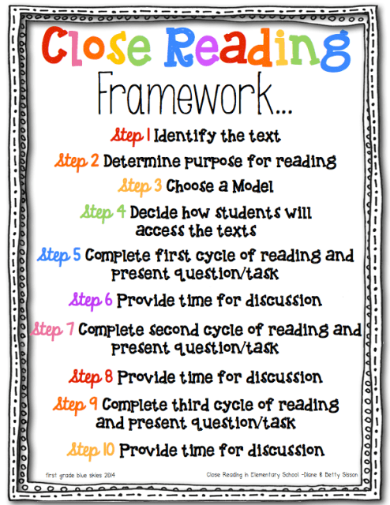
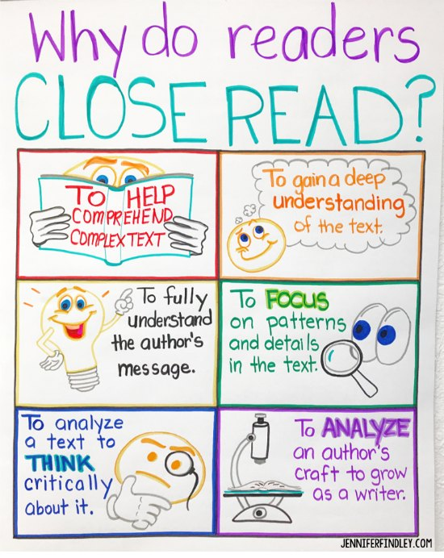
Text-Dependent Questions: The War of the Wall
