English Instructional Plan – Women’s Equality, Civil Rights, and the Super Hero: Using Paired Passages to engage student learning outcomes
Students will read paired passages about different aspects of women’s fight for equality or the Civil Rights Movement. These readings will provide background knowledge to students to connect these movements to two superheroes: Wonder Woman and Black Panther. This will allow students to analyze the intersection between historical movements and superheroes through various forms of writing.

Primary Strand: 8.5/8.6, 9.5/9.6 - Reading

Integrated Strand/s: Writing/Communication/Multimodal Literacies

Essential Understanding:
- understand characterization as the way that an author presents a character and reveals character traits
- understand that poetic devices are used in prose and poetry
- read several texts on a similar topic and synthesize what is read
- analyze how a text makes connections among and distinctions between individuals, ideas, or events (e.g., through comparisons, analogies, or categories)
- activate prior knowledge before reading
- make predictions prior to and during the reading process
- read several texts on a similar topic and synthesize what is read

Essential Knowledge, Skills, and Processes:
- identify the elements of narrative structure, including:
  - setting – time and place
  - character(s), either:
    - static – remaining the same during the course of the story, or
    - dynamic – changing during the course of and as a result of the story
- recognize different plot patterns including subplots
- analyze poetic devices in prose and poetry, including:
  - word choice;
  - figurative language;
  - symbolism;
  - imagery;
  - rhyme;
  - rhythm;
  - repetition
- evaluate an author’s choice of words and images
- determine a theme of a text and analyze its development over the course of the text
- activate prior knowledge before reading by use of:
  - small-group or whole-class discussion;
  - anticipation guides; and
  - preview of key vocabulary.
- use text structures such as the following to enhance comprehension and note taking:
  - boldface and/or italics type;
  - type set in color;
  - underlining;
  - indentation;
  - sidebars;
  - illustrations, graphics, and photographs;
  - headings and subheadings

Primary SOL: 8.5 - The student will read and analyze a variety of fictional texts, narrative nonfiction, and poetry.

Reinforced (Related Standard) SOL:
- 8.5a - Explain the use of symbols and figurative language.
- 8.5b - Make inferences and draw conclusions based on explicit and implied information using evidence from text as support.
- 8.5c - Explain how authors use characters, conflict, point of view, voice, and tone to create meaning.
- 8.5d - Understand the author’s use of conventional elements and characteristics within a variety of genres.
- 8.5l - Use prior and background knowledge as a context for new learning.
- 8.6a - Draw on background knowledge and knowledge of text structure to understand selections.
- 8.6b - Make inferences and draw conclusions based on explicit and implied information using evidence from text as support.
- 8.6k - Evaluate, organize, and synthesize information for use in written and oral formats.

Academic Background/Language
- Students should be familiar with paired passages, expository and creative writing, storyboards, and annotation.

Materials
- Choice Board Option 1: Women’s Equality/Wonder Woman
- Choice Board Option 2: Civil Rights Movement/Black Panther
- Copies of Trifles
- Trifles Discussion Groups PowerPoint
- Summarizing PowerPoint
- Copies of History of the 19th Amendment Article
- Copies of Nonfiction Annotation
- Copies of An Obstacle
- Copies of Poetry Annotation
- Website: Wonder Woman Profile
- Video: The History of Wonder Woman
- Website: DC Comics Educators’ Guide
- Website: How to Read Comics
- Copies of Expository Writing Rubric
- Copies of Creative Writing Rubric
- Copies of Storyboard Rubric and Story Planning
- Copies of Establishing Setting
- Copies of Establishing Characters
- Copies of Everyday Use
- Video: Profile of Alice Walker (Meet the Author)
- Copies of Empowering the Black Panther Movement
- Website: The Real History Behind the Black Panther
- Copies of I, Too Poem
- Video: History of Black Panther
- Website: Assorted Black Panther Comics

Student/Teacher Actions: What should students be doing? What should teachers be doing?
This assignment can be taught a number of different ways, so it is important to decide how you want to share this with students. The purpose of this type of assignment is to provide students with numerous resources related to the same topic. While working through either of these choice boards, students are expanding their background knowledge in order to produce a written product at the end.

- The teacher will ask the students to brainstorm what they know about Wonder Woman and/or Black Panther. The teacher will write the student responses on the board or project them for the class to see.
- If not addressed previously, the teacher should inform students about the purpose of a brainstorm. In a brainstorm, all possible responses are accepted at first and are not judged or discredited. After a period of time, students can analyze responses, look for trends, chunk similar ideas, and determine which responses seem to be the most worthwhile or worth investigating.
- The teacher will have students create anchor charts for key characteristics of fiction, nonfiction, and poetry before they start reading.
- After students read the Non-Negotiables on the choice board(s), the teacher will ask student groups (3-5 students) to brainstorm key aspects of either movement. The teacher will ask students to think about the following questions:
  - What had each movement sought to achieve?
  - What resources/means did they have to achieve it?
  - What were they missing?
- The teacher will write the student responses on the board or project them for the class to see. This brainstorm should be kept visible for students to interact with as they progress through the choice board.
  - If this as a self-paced or distance learning assignment, create teacher/student check-points after each tier on the choice board. The student can create an individual brainstorm (with teacher assistance) that mirrors what they would do in a small group.
- The teacher will provide the choice board(s) to the students using one of the options below.

Option 1
- Provide the choice boards to the students as an individual self-paced assignment with set due dates.
- For example, the first tier students may get a week to complete, the second a class period, and the third a few class periods depending on your expectations for a final product.

Option 2
- Numerous elements of the choice boards are completed as a class or in a small group/pairs.

Option 3
- Another consideration is to have half of the class work on the first choice board and the other half of the class work on the second choice board.
- Have the groups exchange writing products for the purpose of revision and feedback before submitting to the teacher.

Assessment (Diagnostic, Formative, Summative)
- Formative
  - Non-negotiables and Pick-Two assessments for choice boards
- Summative
  - Pick-One evaluation for choice boards

Writing Connections:
- All aspects of this assignment have writing connections; however, the summative evaluation is a writing product.

Extensions and Connections (for all students)
- Have students work through the choice board they did not do → modify storyboarding or creative writing option to include how the other superhero would help support change for a different movement.
- Watch and analyze the films Wonder Woman (2017) or Black Panther (2018)

Strategies for Differentiation
- If a text is too difficult for a class or set of students, consider reading the text alongside the small group or class to support their understanding OR consider changing out the text options to better suit your class needs.
- Create a high, medium, and low version of the choice board, so students can more easily do this as a self-directed task.
- Use Rewordify to help students access texts at their level.
- For all of the texts from commonlit.org, play around with the platforms related media, annotation tools, guided reading mode, assessment questions, and discussion questions.
- Students may work in pairs or individually.
- Share choice boards in individual pieces rather than all at once.
- Read the first piece together while modeling annotation strategies.
- Provide sentence starters for struggling students.

Note: The following pages are intended for classroom use for students as a visual aid to learning.

Women’s Equality and Wonder Woman Paired Passages Choice Board

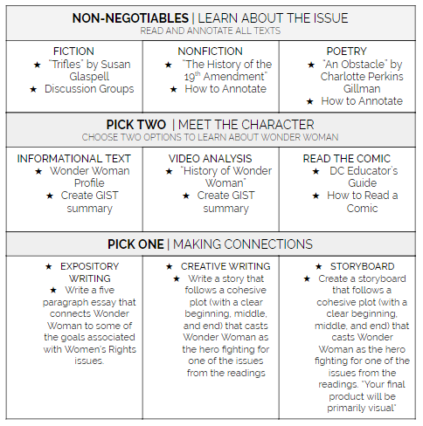

Civil Rights and Black Panther Paired Passages Choice Board

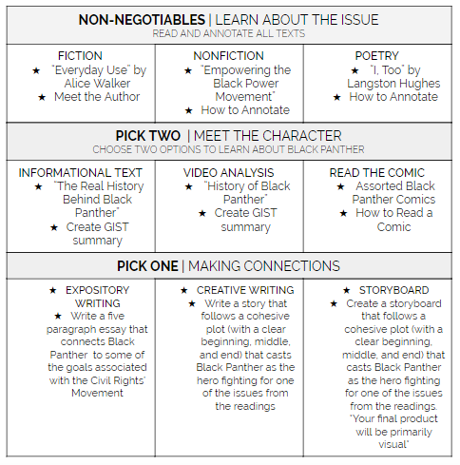

Poetry Annotation

Directions: To understand poetry, sometimes it helps to put it in our own words. Copy and paste the original poem into the left column. Next to each line, or stanza, re-word the poem in language that you understand. After you have finished, compare the two. Use your literal interpretation of the poem to help you better understand its literary and abstract meaning.

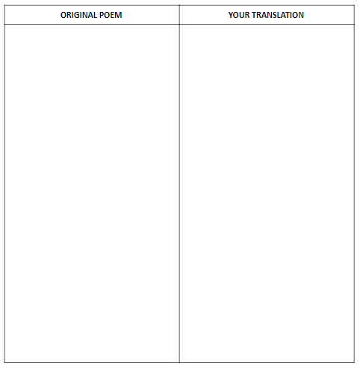

Nonfiction Annotation

Directions: Use this document to outline the main idea and key points of the article while you read.

Name of article:

Header/Bold subject:
  - Main idea:
    - Key facts/points:
- Header/Bold subject:
  - Main idea:
    - Key facts/points:
- Header/Bold subject:
  - Main idea:
    - Key facts/points:
- Header/Bold subject:
  - Main idea:
    - Key facts/points:
- Header/Bold subject:
  - Main idea:
    - Key facts/points:

Expository Writing Rubric

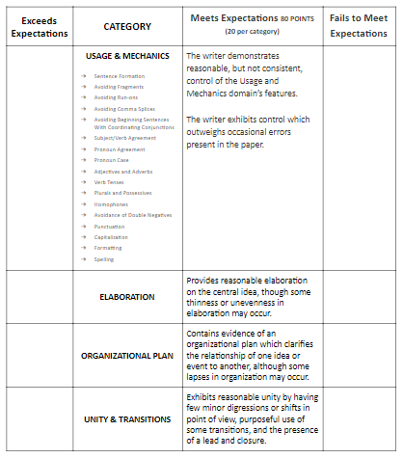

Creative Writing Rubric

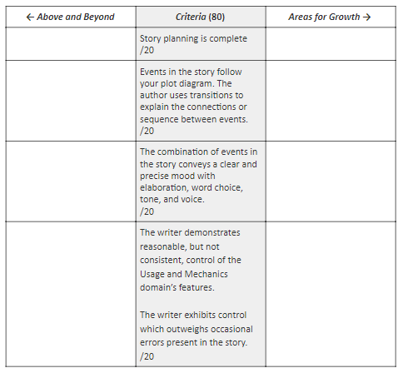

Storyboard Rubric and Story Planning

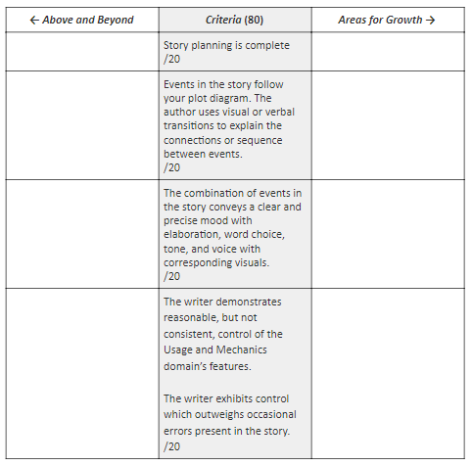

(STEP 1) What are some possible conflicts (problems in the story) that you could have? Make a list here, then highlight your favorite!

(STEP 2) Read and review the resources on setting and characters before you start drafting your story.

(STEP 3) Now that you know the conflict for your story, you will create a plot diagram. Remember--the conflict is what drives the plot! You can be as creative as you like, but make sure your plot connects to the character and issues presented in the readings. *You may change the shape of the plot diagram depending on the shape of your story. Label the plot diagram.

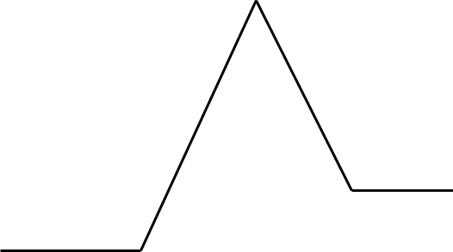

Establishing Setting

A good story doesn’t just tell the reader about the setting, it shows them. Rather than telling the reader, for example, that the story begins with the two main characters on the beach in the winter, a writer can use descriptive details and sensory words to give the reader clues about the setting. Remember, you want to make your reader feel like they are there and that they can imagine the setting in their mind.

Poor Example → Martha and Jim are at the beach. It is cold because it is December. Martha and Jim are throwing shells into the water. The wind is chilly so the two kids decide to walk back to their parents’ beach house. On their way back, they find a bottle with a note inside.

Good Example → The frigid December wind whips past Martha and Jim as they laugh and play with excitement. The smell of salt lingers in the air. Their shoes sinking into the dark brown sand, the children wonder why their parents have brought them on vacation at such an odd time. Finding broken remnants of once beautifully ornate seashells the two teens decide to throw the jagged pieces into the ocean, watching the shells skip as they hit the glassy surface of the water. With the cool air hitting their faces the two look at one another, faces bright pink from the wind. “Let’s go back,” mumbles Martha, her teeth beginning to chatter. Their feet shuffling in the sand, Martha and Jim discover something odd sticking out of the sand as they reach the dunes. Kneeling, Jim begins to dig furiously at the sand, and to his astonishment he discovers an old, stained bottle with a burnt cork on the top. Picking the bottle up, the glass is cold in his hands. Rubbing off the grainy sand, Jim lets out a small scream. There was a note inside!

Establishing Characters

Similar to setting, a good story doesn’t just tell the reader about the characters, instead it shows them. Rather than bombarding your reader with facts about your characters, try revealing physical descriptions and personality traits slowly to them so that they can see and hear the character in their mind. Look below at a poor example and a good example of characterization.

Poor Example → Jonathan Whitefield gets out of bed and turns off his alarm. He has brown hair. He is fourteen. He loves rock music, especially ACDC. Getting out of bed, Jonathan gets dressed and goes downstairs. Even though he hates going to school, he continues to go through the motions of getting ready for his day while his mom packs lunches in the kitchen. His mom always worries about him, which makes Jonathan angry. Jonathan goes to Green Valley Middle School with his best friend, Kyle, who lives next door. When there is a knock on the door, Jonathan sees that it is Kyle and so saying goodbye to his mom he heads out for another day at middle school. Or, so he thought.

Good Example → The jarring ringing pierces his ears as Jonathan wakes with a jump. Reality. Hitting the alarm with his fist, Jonathan silently wishes for ten more minutes. Five more minutes. Anything to mean he could delay going to school. Getting out of bed, Jonathan feels the cold air hit him as he rummages his floor for a clean pair of jeans and his favorite ACDC tee shirt. Once dressed, the teen brushes his brown moppish hair out of his eyes as he sleepily heads down the stairs. ‘6:00 am is way too early’ thinks the fourteen-year-old as he reaches the bottom of the steps.
“Good morning honey!” exclaims the bright pink bathrobe that is Mrs. Whitefield. “Better get a move on, or you’ll be late. I don’t want you making Missy late again.”
Missy. Meaning Mrs. Drummond. Even though Monday morning means another dreaded day at Green Valley Middle, it is also the day he rides to school with his best friend Kyle and his mom.
At the table, Pop Tarts in hand, the teen sits in a daze. Wishing he were back in bed, Jonathan snaps to attention when he sees the familiar face of Kyle peeking in through the front door window.
Grabbing his tattered book bag, the teen mumbles something to his mom and heads out into the cold autumn air.
“Ready for another day at the happiest place on Earth?” sarcastically questions Kyle as he squeezes into the minivan.
Another day. Sure. Only little did Kyle know that today would not be like any other day. For this was the day when everything changed.

