English Instructional Plan – Exploring Concepts Across Cultures
Primary Strand: 10.4 Reading
Integrated Strand/s: 10.1 Communication and Multimodal Literacy
Essential Understanding:
- Understand the relationship between references made from fictional texts and the conclusions they draw as a result.
- Understand that stories from all cultures explore similar themes but might have different interpretations of those themes based on their value system.
- Understand how authors use character development, theme, conflict, and archetypes to impact the meaning of stories.
- Understand the intent behind informational documents and the way we should engage with them as a result.
Essential Knowledge, Skills, and Processes:
- Identify, evaluate, and be able to make effective references.
- Identify, evaluate, and be able to draw effective conclusions from references.
- The different elements that define a culture and how those elements might shape the literature it produces.
- Recognizing similarities and differences between cultures and how those factors might lead to varying interpretations of the same thematic concepts.
- Identify and analyze the literary elements. Critique how authors use them to convey deeper meaning.
- Identify and analyze the intent of informational documents.

Primary SOL: 10.4a, 10.4b, 10.4f
- Using references from text to draw conclusions in fiction
- Analysis of literature across cultures
- Critique how authors use literary elements to contribute to meaning
Reinforced (Related Standard) SOL: 10.6g
- Clearly state and defend a position using reasons and sufficient evidence from credible sources as support.

Academic Background/Language:
- Reference
- Conclusion
- Infer
- Analyze
- Synthesize
- Critique
- Compare/contrast

Materials
- Non-Fiction text to establish background knowledge.
  - Suggestion: “I Got Myself Arrested So I could Look Inside the Justice System” by Bobby Constantino
- Empathy Map Graphic Organizer (attached)
- Two short stories from different cultures exploring similar themes
  - Suggestions: “Cell One” by Ngozi Adichie and “God Sees the Truth But Waits” by Leo Tolstoy
- Story Map Graphic Organizer (attached)
- Venn-Diagram Graphic Organizers
- Post-It Notes
- Butcher Paper or Whiteboard
- Pens, pencils, and/or markers

Student/Teacher Actions: (3 class periods for completion)
- Teacher provides students with non-fiction text that will help provide background knowledge for the short stories to be provided.
- Students read and annotate non-fiction text using their own methodology or suggestions supplied in Read-Write-Think’s “Making Annotations: A User’s Guide” (http://www.readwritethink.org/files/resources/lesson_images/lesson1132/AnnotationGuide.pdf)
- Teacher completes an empathy map graphic organizer to discuss the author’s perspective based on information present in the texts and annotations made by students.
- Teacher facilitates a discussion about the author’s intent based on conclusions drawn from the empathy map activity
- Students write a paragraph where they make a claim about what they believe the author’s intent was and defend it using evidence from the text.
- Teacher passes out “Short Story 1” to half the class and “Short Story 2” to the other half of the class
- Students read and annotate their respective story, with a specific focus on the ways that the author uses conflict and characters to create meaning within the text, while teacher walks around the room and offers support and answers questions.
- Students complete story map graphic organizer individually.
- Teacher puts students into groups of four comprised of two students who have read “Short Story 1” and two students who have read “Short Story 2” and provides butcher paper. Teacher writes one overarching question on the board about the deeper meaning of both texts and another question about how the author used literary elements to convey that meaning.
  - Example #1: What is the relationship between justice, freedom, and systems?
  - Example #2: How do both authors use literary elements to explore this question?
- Students draw a Y chart on butcher paper and discuss the similar and different ways their text explores the overarching question. They then complete the “Y Chart.”
- Teacher hangs the “Y Charts” up around the room to help prompt discussion.
- Students form a Socratic circle where they are asked to discuss the overarching question as explored through the two different texts
- Teacher facilitates discussion and ensures students can articulate the similarities and differences between how different cultures view similar ideas. To cover the previously explored non-fiction text, the teacher also asks how a culture’s stories may inform the way it writes non-fiction texts like articles, op-eds, etc.
Assessment (Diagnostic, Formative, Summative)
- Students annotated texts (Diagnostic)
- Persuasive paragraph (Formative)
- Group “Y Charts” (Formative)
- Socratic Seminar (Summative)
Writing Connections:
- Students are asked to compose a persuasive paragraph where they must make a claim about what they believe an author’s perspective is and defend their claim with evidence from the text.

Extensions and Connections (for all students)
- Challenge students to add further nuance to their understanding of how different cultures explore similar ideas by introducing them to new texts from other cultures
- Challenge students to add further nuance to their understanding of how different cultures explore similar ideas by presenting them with stories portrayed across various modes (documentaries, TED Talks, spoken word poems, etc.)
Strategies for Differentiation
- Articles and short stories pulled from commonlit.org have both read aloud and translate features.
- Empathy maps and Y Charts allow students to visually and spatially orient information to lessen cognitive load.
- Consider selecting texts that allow your students to connect the text to personal experience or interests. This is a great opportunity to facilitate a conversation about the cultural similarities and differences of students in your own room in a context that can build empathy and allow students to leverage knowledge they already have.

Note: The following pages are intended for classroom use for students as a visual aid to learning.

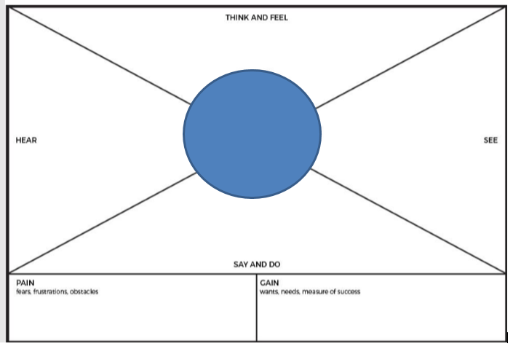

Story Map Graphic Organizer
Setting: Time: Place:
Characters:
Problem
Plot/Events:
Resolution

