English Instructional Plan Making Inferences 6-8

Primary Strand: Reading 6.5, 7.5 and 8.5

Integrated Strand/s: Writing 6.7, 7.7, 8.7 Communication and Multimodal Literacies 6.1, 7.1, 8.1

Essential Understanding:
- Understand that the author uses images to craft a message and create characters.

Essential Knowledge, Skills, and Processes:
- Use evidence from the text(s) for support when drawing conclusions or making inferences.

Primary SOL: 6.5f – Draw conclusions and make inferences using the text for support. 7.5i - Make inferences and draw conclusions based on the text. 8.5e Make inferences and draw conclusions based on explicit and implied information using references to the text for support.

Reinforced (Related Standard) SOL:
- 6.7- The student will write in a variety of forms to include narrative, expository, persuasive, and reflective with an emphasis on narrative and reflective writing.
- 7.7 - The student will write in a variety of forms to include narrative, expository, persuasive, and reflective with an emphasis on expository and persuasive writing.
- 8.7 – The student will write in a variety of forms to include narrative, expository, persuasive, and reflective with an emphasis on expository and persuasive writing.

Academic Background/Language:
- Review any key or academic vocabulary that students may have difficulty understanding.

Materials
- Multiple Visual Resources to be used for making inferences (artwork, photos, picture books, objects)
- Sentences or brief passages to model how to make inferences (samples attached)
- It Says/Shows - I Say - So Graphic Organizer (Attached)
- Alternate graphic organizer (T-Chart)
- Short Stories or Novel that may be paired with nonfiction
- New York Times: What’s Going On in This Picture? website

Student/Teacher Actions: What should students be doing? What should teachers be doing?
- Before using any text, gather visual resources and display throughout the class. Share your thoughts on two of the resources. Explain what you think each of the visuals represent (if you are using objects, you may share ideas about the person who might have owned the objects). Explain what clues you used to make your inferences.
- Have students complete a gallery walk doing the same thing.
- Have students explain how they came up with their inferences.
- Say “Today we are going to learn to make inferences. Making inferences involves using what you know from personal experience or background knowledge, along with the information presented from the text to make assumptions about what is not clearly stated or written. We will look at the evidence in the text we are reading to come up with our own inferences.”
- Model for students the concept of making inferences using sentences or short passages.
  - For example: Give the students this sentence: It’s late, and I am really hungry!
  - Ask students: What do you think the speaker will do next? (accept all plausible answers).
  - Ask them what they knew already that helped them answer your question. If they don’t answer independently, prompt them with scaffolding questions like,
    - What do you usually do when you are hungry?
    - Where do you go?
    - What do your parents do when you are hungry?
    - What do you know about the person who is speaking? Have they just eaten a big meal?
  - Once you have several answers, show them how they can use what they know to make plausible, realistic, or believable inferences.
- Complete a section of the graphic organizer with the whole group. Explain any misconceptions students may have when making inferences.
- Introduce the text to be read. Explain any aspect of the text that students may have limited knowledge about.
- Read the first section of the text (or entire text). While you are reading, have the students listen as you highlight any idea (I SAY) that comes together and what you can infer from it. Complete the graphic organizer as you are modeling. Include the detail (IT SAYS) that helped you make your inference (SO) in the chart.
- Guide the students to re-read the section you have modeled, along with the rest of the text, and with a partner, have them record any other details as they go, stopping to make inferences and complete the chart throughout the text.
- Once students have completed the re-reading, have them discuss the details they have filled out in their charts.
- Clarify any misconceptions and be sure students have recorded relevant details to support their inferences.
- Once students finish reading the last paragraph of their text, have them note any important details from the text that enabled them to make inferences. This will serve as a reminder that their inferences should be directly connected to the text.
- Lead a whole group discussion to summarize what students have learned about making inferences using textual evidence.

Assessment (Diagnostic, Formative, Summative)
- Students complete the graphic organizers as a formative assessment.

Writing Connections:
- Using the New York Times “What’s Going On in This Picture?”, students will write short stories about the pictures based on the inferences they make.

Extensions and Connections (for all students)
- Students read The Cask of Amontillado by Edgar Allan Poe. Students make inferences about the events in the story, as well as analyze the faulty inferences being made by the character Fortunato.
  - Students then watch the Ted Ed video “In On a Secret? That’s Dramatic Irony” to identify the dramatic irony in Poe’s story.
  - Students discuss how Fortunato’s faulty inferences contribute to the dramatic irony.

Strategies for Differentiation
- Teacher may preselect appropriate sentences from a short story or picture book for the students to practice making inferences.
- Limit the number of required inferences to three.
- Students with accommodations use available technology to allow them to access audio recordings of the stories.
- Students with accommodations have the option to choose shorter stories with a lower Lexile level.
- Allow English Learners to work in small groups to help develop language, learn the content, and hear other students’ thinking.
- For English Learners, find stories representative of their culture and language backgrounds.
- Provide ELs with sentence frames/starters to help get the conversation started when they are in their small groups. For example, “At first I thought ____ but now I think____ because ____. I like how this article uses ____ to show ____. This word/phrase stands out to me because ____.”
- Provide ELs an alternate graphic organizer (T-Chart) to help aid comprehension.

Sample sentences for making inferences:
- When I woke up, there were branches and leaves all over the yard. What can you infer? What details support your answer?
- I forgot to set my alarm clock. What can you infer? What details support your answer?
- Three students leave the room without permission. What can you infer? What details support your answer?
- I stuffed my ticket in my pocket before I bought popcorn. What can you infer? What details support your answer?
- Cheri forgot to grab her raincoat and her umbrella. What can you infer? What details support your answer?
- Raul always carried his flute with him. What can you infer from this statement? What details support your answer?
- After Denise broke her trophy, her mother turned and walked away without saying anything. What can you infer about Denise’s mother? What details support your answer?

Note: The following pages are intended for classroom use for students as a visual aid to learning.

It Says/Shows – I Say – So Graphic Organizer

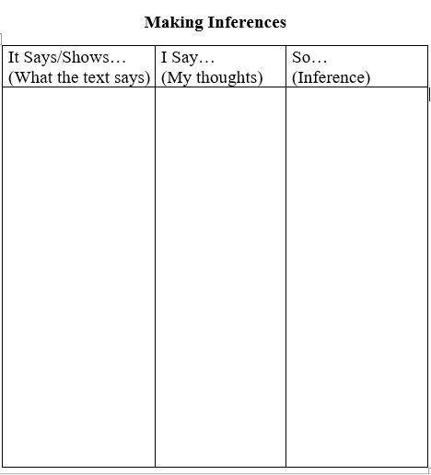

Making Inferences T-Chart

