English Instructional Plan Direct and Indirect Characterization 6-8

Primary Strand: Reading 6.5, 7.5, and 8.5

Integrated Strand/s: Communication and Multimodal Literacies 6.1, 7.1, 8.1

Essential Understanding:
- Understand that the author uses images to craft a message and create characters

Essential Knowledge, Skills, and Processes:
- Identify characterization as the way an author presents a character and reveals character traits by
  - what a character says
  - what a character thinks
  - what a character does
  - how others respond to the character

Primary SOL: 6.5a The student will identify the elements of narrative structure, including setting, character, plot, conflict, and theme. 7.5a - The student will describe the elements of narrative structure including setting, character development, plot, theme, and conflict and how they influence each other. 8.5a The students will analyze how authors’ development of characters, conflict, point of view, voice, and tone convey meaning.

Reinforced (Related Standard) SOL:
- 6.1a The student will listen actively and speak using appropriate discussion rules with awareness of verbal and nonverbal cues.
- 7.1 - The student will participate in and contribute to conversations, group discussions, and oral presentations.
- 8.1f The student will use a variety of strategies to listen actively and speak using appropriate discussion rules with awareness of verbal and nonverbal cues.

Academic Background/Language:
- Introduce any text the class will read to the students, highlighting any critical vocabulary from the text.

Materials:
- Text selections containing good character development – short stories or novels
- COMMONLIT: The War of the Wall
- Lists of short animated films that depict varying characters
  - Bao
  - Sanjay’s Super Team
  - Inside Out
  - Sing!
- Copies of Characterization Chart (attached)
- Copies of the STEAL Indirect Characterization Chart (attached)
- TV clips from various shows or commercials
- List of character traits from ReadWriteThink
- Sentences that include direct and indirect characterization (examples included)

Student/Teacher Actions: What should students be doing? What should teachers be doing?
- Before beginning this lesson, review the various definitions of the word character, and list them on the board for students to record. Give students a list of character traits to reference for the lesson.
- Explain that an author may use direct or indirect ways to develop a character.
- Say “For example, with direct characterization, the author tells the reader directly about a character.”
- Display these sentences:
  - Direct characterization:
    - Jim was a short man who loved ham sandwiches.
    - Natasha was jealous of Naomi’s success in the clothing business, and she vowed to get revenge.
- Say “With indirect characterization, the reader must infer how the author is describing the character based on what the character says, does, thinks, or on what other characters say about that character.”
  - Display these sentences:
    - Indirect characterization:
    - After Jim stepped down from the stool in front of the refrigerator, he carefully placed 15 ham sandwiches in his lunch box; just enough for him to have a light snack and some lunch.
    - Natasha angrily burst into Naomi’s Clothing Design store, and began to set every piece of clothing on fire.
- Say “Today we are going to learn how an author presents a character and reveals his or her character traits while viewing short animated films.”
- Distribute copies of the Characterization Chart and model for the students how to fill in the chart using one of the short films from the list. Be sure they understand what is being asked in each category.
- Set the task for students, letting them know that they are to first look at the film for understanding. They may use the “Character Traits” sheet for the third column.
- Have students turn and talk to each other, debriefing on what they noticed in the film.
- Show the film again, this time focusing on gathering information about the characters in the film.
- Allow the students to turn and talk again and discuss their findings on the characters.
- Complete the Characterization Chart based on the classroom discussion and your observations.
- Show students another film(s) of your choice. Be sure the film is short because you will want them to view it multiple times.
- Have students complete the Characterization Chart with a partner and discuss whole group.
- Say “We are now going to read the short story The War of the Wall.”
- Using the same Characterization Chart graphic organizer, model for students how to fill in the chart while reading a portion of the text.
- Be sure to conduct multiple reads for the section to model for students how they should read a text.
- Have students continue to fill out the chart as they read again, working with a partner for the second portion of the text.
- For gradual release, have students complete the final portion of the text on their own.
- After students are finished, lead the class in listing the character traits that have been revealed in the text.
- You may want to give students an alternative lesson using a different graphic organizer.
- Say “Character traits can be revealed indirectly by what a character says, does, and thinks, particularly when responding to other characters. Character traits are also revealed by what is directly said about the character. Remember indirect characterization shows the reader (or viewer) character traits.”
- Distribute copies of STEAL charts.
- Go over the components of the STEAL chart and model for the students, using the appropriate STEAL characteristics, how to fill in that chart with two indirect characterization sentences. Make students aware that not all of the aspects of the STEAL chart may be used for a text.
- Say “You will be watching a portion of a TV show in order to observe and analyze a particular character.”
- Assign half of the class to observe one character and the other half to observe another character. Instruct students to watch carefully and write down in each of the STEAL columns any trait that is observed from their respective characters. If necessary, stop after a few minutes to model filling out an example for each character to ensure that students understand the task.
- When the video is over, put students in groups of three or four so that each group is dedicated to one of the two characters observed. Have students in each group compare their STEAL charts and confirm or add examples as necessary.
- Hold a class discussion on the character traits of the two focus characters, asking students to share what they put in the Explanation column.
- Remind students that their job as readers and viewers is to notice a character’s actions and words. Then use that information to figure out a character’s traits and how they impact a text.
- Through a Socratic Seminar, utilize the discussion questions from The War of the Wall.

Assessment (Diagnostic, Formative, Summative)
- Students write a reflection on how they use an author’s words to identify a character’s traits.
- Students complete a self-assessment or exit ticket about the process of identifying character traits to help them comprehend a text better.

Writing Connections:
- Reverse the Characterization: Using either characters from the video or the indirect characterization sentences, have students write sentences that directly state what the author is saying about the character.
  - Example: Indirect: Melanie bit her pencil and began shaking right before a big test. Direct: Melanie is an extremely nervous student when she has to take a test.

Extensions and Connections (for all students)
- Through a Socratic Seminar, utilize the discussion questions from The War of the Wall.
- Provide multiple texts for students to identify characterization.

Strategies for Differentiation
  - Allow for groups of six instead of three so students may partner read and collaborate to create the note to a friend and text message.
  - Students with accommodations use available technology to allow them to access an audio recordings of the text.
  - Students with accommodations have the option to choose a shorter text with a lower Lexile level.
  - Scaffold the activity by providing a Characterization Chart with some of the boxes already completed.
  - For English Learners, find stories representative of their culture and language backgrounds.
  - Provide ELs with sentence frames/starters to help get the conversation started when they are in their small groups. For example, “At first I thought ____ but now I think____ because ____. I like how this article uses ____ to show ____. This word/phrase stands out to me because ____.”

Note: The following pages are intended for classroom use for students as a visual aid to learning.

Characterization Chart

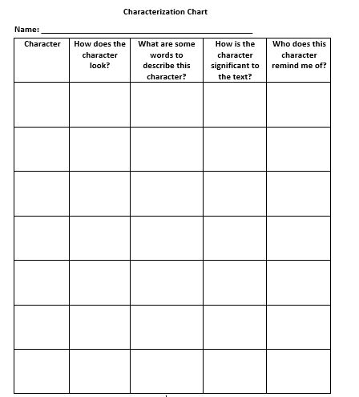

Indirect Characterization Chart

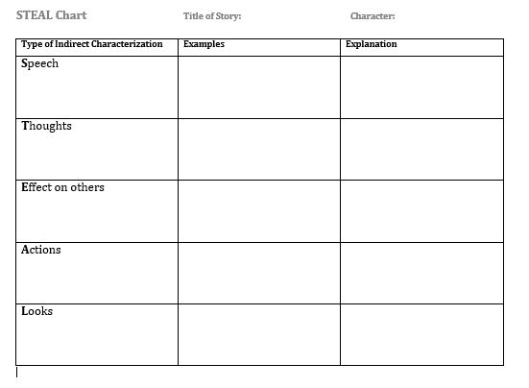
From NCTE’s ReadWriteThink.org
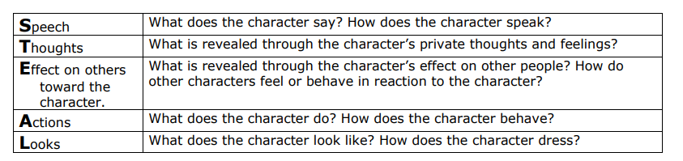

Sample Direct and Indirect Characterization Sentences

SAMPLE DIRECT CHARACTERIZATION SENTENCES
- Joel is often distracted, but one thing he stays focused on is girls.
- Karen is bright, energetic, and helpful.
- Devon was motivated by money. He had no use for love or family.
- James was a kind man and an obedient husband.
- Jasmine is an extremely nervous student.

SAMPLE INDIRECT CHARACTERIZATION SENTENCES
- Melanie bit her pencil and began to shake right before a big test.
- As Mr. Byrd walked by families, mothers pulled their children close to their side.
- Elyssa cried when my puppy passed away.
- When Kylie’s name was called, she slowly walked up to the stage, staring straight at the ground.
- Clarence happily strolled through town, waving at everyone, including strangers.

