English Instructional Plan- Characters Impact on Plot 8-9

Primary Strand: Reading 8.5 and 9.4

Integrated Strand/s: Writing 8.7, 9.6, Communication and Multimodal Literacies 8.1, 9.1

Essential Understanding:
- understand that analysis of a text should be based on text references, not personal opinion
- understand a character’s development throughout a text

Essential Knowledge, Skills, and Processes:
- read paired passages/read across texts to examine author’s word choice, theme development, point of view, etc.
- explain the relationships among the elements of literature, including, but not limited to,
  - protagonist/antagonist and other characters
  - plot
  - setting
  - tone
  - point of view (e.g., first person, third-person limited, third-person omniscient)
  - theme
  - speaker and narrator
- analyze the techniques used by an author to convey information about a character
- analyze character types, including dynamic/round character, static/flat character, and stereotype
- analyze how authors create multilayered characters through the use of literary devices
  - indirect and direct methods of characterization
  - character’s actions
  - interactions with other characters
  - dialogue
  - physical appearance
  - thoughts
- analyze how characters with multiple or conflicting motivations develop over the course of a text and advance the plot or develop theme
- use evidence from the text(s) for support when drawing conclusions, making inferences
- analyze how an individual, event, or idea is introduced, illustrated, and elaborated in a text (e.g., through examples or anecdotes)

Primary SOL: 8.5a Analyze how authors’ development of characters, conflict, point of view, voice, and tone convey meaning. 9.4b - Explain the relationships between and among elements of literature: characters, plot, setting, tone, point of view, and theme.

Reinforced (Related Standard) SOL:
- 8.5b Identify cause and effect relationships and their impact on plot
- 8.7 Write in a variety of forms.
- 9.6 Write in a variety of forms.

Academic Background/Language:
- Prior to the lesson, students should be able to identify direct and indirect characterization and understand the features of each. Students should also know the difference between a protagonist and antagonist.

Materials
- 1 copy of the Video Observation Guide per student
- Teacher copy of the traditional nursery rhyme “Humpty Dumpty”
- Access to YouTube video “Humpty Dumpty: Fixed Fairy Tales” by HISHE Kids
- 2 copies of the Character Impact Graphic Organizer for each student and one teacher copy
- Scanned copy of a familiar short story or excerpt from a novel and additional copy for students

Student/Teacher Actions: What should students be doing? What should teachers be doing?
- Teacher will introduce the lesson by asking students what they know about nursery rhymes.
- Teacher will read the traditional nursery rhyme “Humpty Dumpty” aloud.
- Next, the teacher will tell students they will watch a video clip of the same nursery rhyme that offers a humorous twist on the traditional ending.
- Teacher will play the YouTube video “Humpty Dumpty: Fixed Fairy Tales” by HISHE Kids.
- Teacher will pass out the video observation guide and explain that students will watch the video a second time and compare the two versions of the stories by charting the actions and personality traits of the characters.
- After watching the video, students will share their observations of the two different outcomes and explain what feeling and actions caused the outcome to be different in the second version of the nursery rhyme.
- Teacher will ask students to share which version they found more interesting and explain why.
- Teacher will explain the role of characterization in fiction and how authors use a character’s motivation, actions, and interactions with other characters in the development of plot.
- Teacher will use the video to explain how a change in the personality or action of one character affects, or impacts, not only other characters, but also the plot.
- Teacher will explain that when a reader analyzes how characters impact the plot, they can understand how the story elements fit together and gather clues to the author’s theme.
- Next, the teacher will display on the board a scanned copy of a previously read short story or excerpt from a novel.
- Teacher will model how to complete the graphic organizer by reading the first few paragraphs of the text, doing a think aloud, and recording examples of the feelings, traits, actions and dialogue of the protagonist and antagonist presented by the author during the exposition.
- Teacher will then read aloud a few more paragraphs, and at the next plot point, elicit responses from students, guiding them through the process of doing a think aloud and recording examples of the feelings, traits, actions and dialogue of the protagonist and antagonist on the graphic organizer.
- Students will read the rest of the text on their own and complete the graphic organizer. Teacher will then engage students in a discussion about what impact the characters had on the development of the plot by providing evidence from their graphic organizers.
- During the second part of the lesson, teacher will have students work in small groups to read a new text from the curriculum.
- Students will work together to complete the attached graphic organizer, comparing the feelings/character traits, actions, and dialogue of the protagonist and antagonist.
- Close the lesson by having the students participate in a Think, Pair, Share. Students should discuss the four bulleted questions at the bottom of the Character Impact Graphic Organizer to draw conclusions on how the characters impacted the events in the plot.

Assessment (Diagnostic, Formative, Summative)
- Teacher will perform frequent checks for understanding throughout the lesson.
- Students will use their graphic organizer to complete the “After Reading” questions independently.

Writing Connections:
- Students complete a well-written expository paragraph how the characters’ motivations, actions, and interactions lead to the resolution of the conflict.
- Using two different passages, students compare and contrast how the authors advanced the plot through the actions and behaviors of the characters.

Extensions and Connections (for all students)
- Students can choose an important event from a previously read text and rewrite the outcome by changing the feelings and actions of the characters.
- Using another nursery rhyme or fairytale and changing the outcome, students can create a video, presentation, or story book with the different ending.

Strategies for Differentiation
- Students with accommodations use available technology to allow them to access audio recordings of the stories.
- Students with accommodations have the option to choose shorter stories with a lower Lexile level.
- Scaffold the activity by completing a portion of the graphic organizer.
- For English Learners, find stories and nursery rhymes representative of their culture and language backgrounds.
- Provide ELs with sentence frames/starters to help get the conversation started when they are in their small groups. For example, “At first I thought ____ but now I think____ because ____. I like how this article uses ____ to show ____. This word/phrase stands out to me because ____.”

Note: The following pages are intended for classroom use for students as a visual aid to learning.

Video Observation Guide

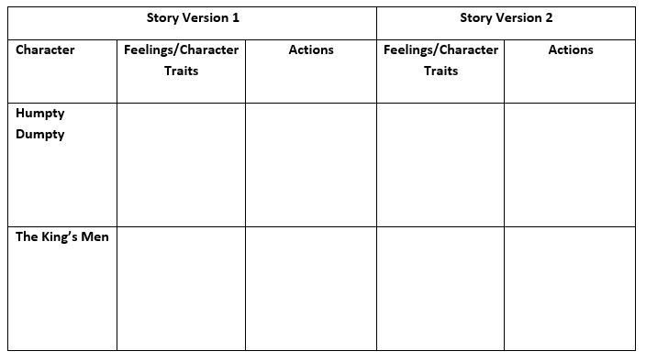

Character Impact Graphic Organizer

While reading, keep track of how the characters feel and what actions drive their behavior throughout the plot points listed below. Include an example of dialogue from the text that shows this behavior and action.

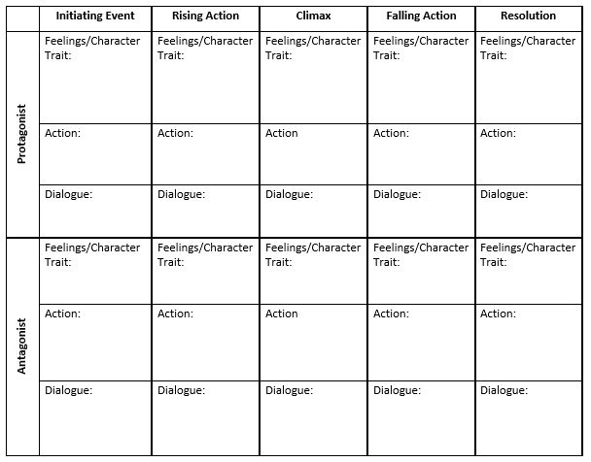

After Reading: Analyze the characters from the chart.
- What was the protagonist like in the beginning of the story? At the end?
- What event(s) caused the protagonist to change?
- What was the antagonist like in the beginning of the story? At the end?
- What event(s) caused the antagonist to change?

