English Instructional Plan Differentiate Between Formal and Informal Language 8

Primary Strand: Communication and Multimodal Literacies 8.2

Integrated Strand/s: Writing 8.7

Essential Understanding:
- understand how audience, topic, and purpose impact language and style
- understand the elements of an effective presentation, including language and nonverbal communication appropriate to purpose and audience
- understand that using more than one communication mode creates a more effective presentation.

Essential Knowledge, Skills, and Processes:
- articulate the purpose of the presentation
- select vocabulary, tone, and style with audience and purpose in mind
- create a presentation that uses two or more communication modes to make meaning
- select and narrow the topic with attention to time limits and audience
- answer questions and respond to comments with relevant evidence, observations, and ideas
- work effectively with diverse groups, exercise flexibility, and work as a constructive team member to accomplish a common goal or reach consensus

Primary SOL: 8.2f – Differentiate between Standard English and informal language.

Reinforced (Related Standard) SOL:
- 8.2b - Choose vocabulary and tone appropriate to the audience, topic, and purpose
- 8.2c - Use effective verbal and nonverbal communication skills to deliver multimodal presentations.
- 8.7 Write in a variety of forms to include narrative, expository, persuasive, and reflective

Academic Background/Language:
- The students need to differentiate between formal and informal language, know the meaning of tone, and understand author’s purpose.

Materials
- Copies of the words to three formally written speeches, songs, or documents that students are familiar with (e.g., The Pledge of Allegiance, The Gettysburg Address, The National Anthem, The Preamble). Provide 10 copies of each document, or enough copies so that when students work in groups of three, each student in the group is working with a different document.
- Note to a Friend/Text Message sheet
- Standard English Formal and Informal Language Evaluation
- Reflection Document

Student/Teacher Actions: What should students be doing? What should teachers be doing?
- Review characteristics of formal language and informal language. Ask students to discuss when to use formal language. Remind them to consider audience and purpose.
- Tell students they are going to be “rewriting history” by changing formal text into informal language they would use with friends.
- Give each student a copy of The Preamble. Project a copy onto a screen. Display a copy of the note to a friend. Model through a think aloud, revising the formal language in The Preamble to informal language as you compose a note to a friend. Point out the similarities and differences.
- Project a copy of the text message form. Repeat the modeling process by simplifying the note to a friend as you compose a text message or blog post. Point out similarities and differences.
- Organize students in groups of three. Students should work with their backs to each other so they are not able to see what others in the group are writing. Give each student in the group a different document.
- Students use the original document they receive to write a note to a friend (template attached), conveying the message using informal language. They should not directly reveal the document by using the title. Specify that the note may not use any text message abbreviations. After about ten minutes, have students pass notes to their right.
- Each student should have an informal document based on a formal document. Challenge each student to take the note to a friend and condense it to a text message or post they would consider making on a social media network (template provided).
- Have students pass the text message to the right. When the students receive their text message, they should try to guess the formal basis for the text, and write their guess on the message.
- Have students reposition their desks so they can now face each other and discuss their findings. Review and discuss the original documents, notes to a friend, and text messages.

Assessment (Diagnostic, Formative, Summative)
- Students complete the Standard and Informal English Evaluation Form as a formative assessment.
- Students complete the Reflection document as a formative assessment.

Writing Connections:
- Students edit and revise their Reflections to include correct grammar, spelling, sentence structure.

Extensions and Connections (for all students)
- Students create presentations, podcasts, or videos based on another formal document of their choice by rewriting it using informal language. Have their classmates try to guess the original documents.
- Using a thesaurus, students rewrite picture books using formal language with a higher vocabulary.
- Find video footage of different people reciting the same story, speech, etc. but using different tone or body language. Allow students to discuss the effectiveness of these differences.

Strategies for Differentiation
  - Allow for groups of six instead of three so students may partner read and collaborate to create the note to a friend and text message.
  - Allow students to use available technology to type a note to a friend and a text message.
  - For selected students, model the completion of the Standard and Informal English Reflection Form using the versions that were modeled for the class.
  - For selected students use available technology to allow them to access audio and/or video recordings of the historical documents.
  - Give English Learners a model of expectation by providing a completed Note to a Friend, Text Message, and Standard English and Informal Language Evaluation Chart based on one of the documents used in class.
  - Provide ELs with videos of the songs, speeches, and documents being recited as a way to help them understand the texts.

Note: The following pages are intended for classroom use for students as a visual aid to learning.

Note to a Friend
Using the space below, transpose the original document into language you would use to retell the information to a friend. Do not reveal the title of the document when you transpose the contents.

Text Message
Rewrite the information from the letter to a friend into a text message below.

When you receive this message, guess what the original document is.

I think this message is based on

Standard English and Informal Language Evaluation

The message was based on:

I was able to correctly guess the origin when I received my message. Yes, or No?

How many members of your group correctly identified the original source of their message?

Review the original documents, notes to a friend, and text messages with your group members.
Fill in a chart for the three works you evaluated:

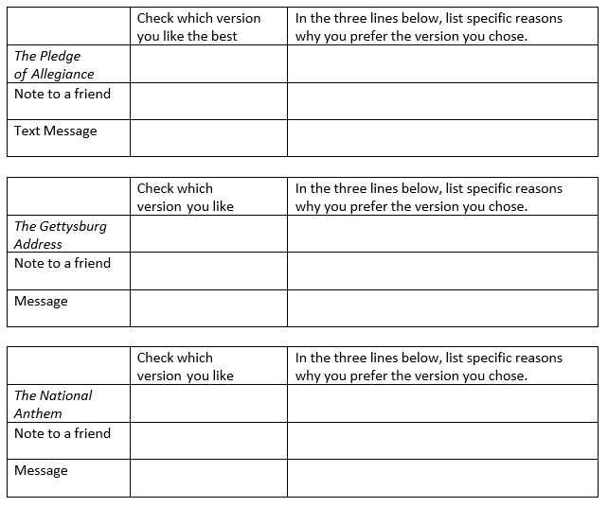

Reflection

There are strengths and benefits of formal and informal language. Use formal language to write a paragraph in the space below reflecting on what you learned.

