**2016 Mathematics Standards of Learning**

**Algebra Readiness Formative Assessment**

# **7.3**

1. **A scale drawing of a rectangular field is shown, with a scale of 15 yards = 1 inch.**

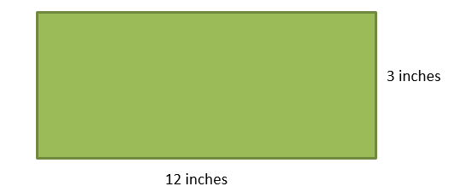

**Find the actual lengths of the sides of the field**

1. **The ratio of boys to girls in the schools’ math team is six to seven. Which combinations of boys and girls could the team have?**

**Select the statements that correctly match this ratio.**

| Twelve Boys  Fourteen Girls | Twelve Boys  Twenty-one Girls | Eighteen Boys  Twenty-one Girls |
| --- | --- | --- |
| Eighteen Boys  Fourteen Girls | Twenty-four Boys  Twenty-eight Girls | Twenty-four Boys  Twenty-one Girls |

1. **Travis is making a scale model of his home. The actual home is 45 feet long and 35 feet wide. Travis wants his model to be 15 inches in length. Which could be used to find the width of his model if he uses the same ratio?**
   1. 
   2. 
   3. 
   4. 
2. **The regular price of a burger meal at a certain restaurant is $8.70. It is on sale for a 20% discount. What is the sale price of the hamburger meal?**
   1. $1.74
   2. $6.96
   3. $7.83
   4. $10.44

Virginia Department of Education 2018