**2016 Mathematics Standards of Learning**

**Algebra Readiness Formative Assessment**

# **6.6a – NO CALCULATOR**

1. **Ricardo is solving a math problem. He knows the model (see below) but does not know the numbers. Find integers that would solve this problem**



1. **Identify each true statement**

|  |  |  |  |
| --- | --- | --- | --- |
|  |  |  |  |

1. **Which of the following equations is NOT true**
   1. – 2 – ( -6) = -4
   2. -6 – (-7) = 1
   3. 2 – ( -6) = 8
   4. 6 – 7 = -1
2. **If *p* is a negative integer, which of these expressions represents the largest number**
3. 5*p*
4. 
5. 5 – *p*
6. 5 + *p*

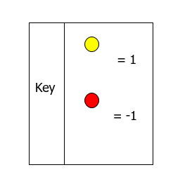

1. Which equation does this model represent?

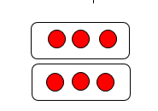

1. 3 ( -2) = -6
2. 2 (-3) = -6
3. -2 (-3) = -6
4. -2 ( 3) = 6
5. Which equation does this model represent?



1. -2 + 3 = 1
2. -2 + -3 = -5
3. -3 + 2 = -1
4. 3 + -5 = -2

Virginia Department of Education 2018