**2016 Mathematics Standards of Learning**

**Algebra Readiness Formative Assessment**

# **5.6b**

1. **Matthew runs  mile during warm up before soccer practice. If he runs for 8 days, how many miles will he run during warm up?**
2. **William scored 4 goals, this soccer season. Which of the following could represent the fraction of games that he scored goals in?**

| of 12 games | of 10 games |
| --- | --- |
| of 8 games | of 6 games |

1. **Wayne had 8 donuts.**

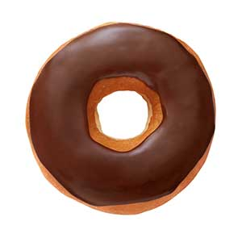

**He ate of the donuts for breakfast for dessert. How many donuts did he eat?**

1. **Dana baked 12 cupcakes and sprinkled icing on of them. Which model correctly shows the number of cupcakes with icing?**







