2016 Mathematics Standards of Learning

Algebra Readiness Formative Assessment

1A.8

- A car can drive 600 miles on 18 gallons of gasoline. How many miles can a car drive on 15 gallons of gasoline?

- A point is an element of direct variation at the location (2, 4).
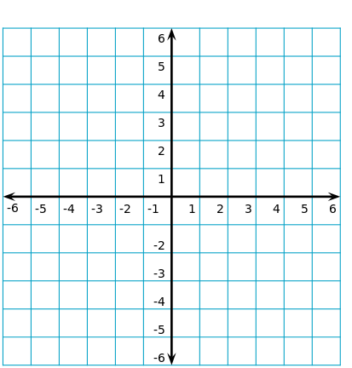

Select all points that are elements of this variation
(0,0) | (4,2) | (1,1) | (1,2) | (3,6) | (6,3)

Which of the following equations represents direct variation?
  - y=3x+4
  - xy=6
  - 3x-6y=0
  - x+y=6

- $1,000 will be split up equally between workers on a job. If the number of workers on the job increases, the amount each worker is paid decreases. What type of variation exists between the money paid and the number of workers?
  - Direct Variation
  - Inverse Variation
  - Neither
  - Not enough information

Virginia Department of Education 2018

