2016 Mathematics Standards of Learning

Algebra Readiness Formative Assessment

# 1A.2abc

1. Write a polynomial product which shows the area of the original rectangle before being divided into 4 smaller rectangles. Then simplify the polynomial product.

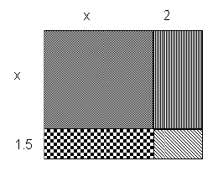

1. Given  and , find the sum, difference, product and quotient of these polynomials.
2. If , $y≠0$, and , then



* 1. 
  2. 
  3. 
  4. 

1.  is equivalent to –
   1. 
   2. 
   3. 
   4. 
2. Which of the following is NOT a factor of?
   1. 4
   2. 
   3. 
   4. 
3. Factor the expression 
   1. 
   2. 
   3. 
   4. 

Virginia Department of Education 2018