2016 Mathematics Standards of Learning

Algebra Readiness Formative Assessment

# 8.17

1. The perimeter of the fenced area shown is 260 meters. What is the measure of the side that is labeled *x* in the figure shown? Explain your reasoning.

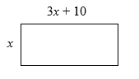

1. The figure below shows the heights of Rebecca and her brother Daniel.

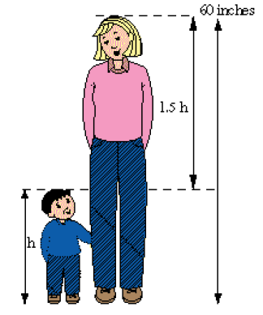

What is Daniel’s height (h)?

1. Using the given key, write a multistep linear equation to represent the model. Then solve and confirm your algebraic solution.

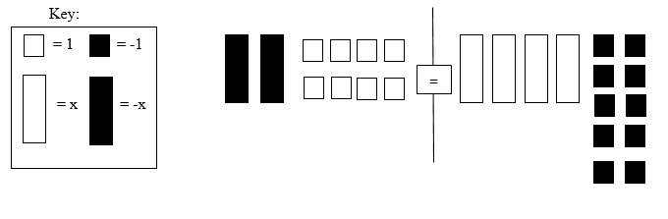

1. Mrs. Singh wrote this equation on the board.



What is the solution to the equation?

* 1. *n* = 17
  2. *n* = 19
  3. *n* = 34
  4. *n* = 68

1. Solve the equation below for *p*.



* 1. 3
  2. 4
  3. 7
  4. 10

1. What value for *x* makes this equation true?



* 1. 16
  2. 28
  3. 37
  4. 55

1. Provide the algebraic sentence that would represent the verbal sentence, “ten less than two-thirds of a number results in 15”.

Answer: __________________________________________

1. Provide the verbal expression that would represent the algebraic expression,

.

Answer: __________________________________________

Virginia Department of Education 2018