2016 Mathematics Standards of Learning

Algebra Readiness Formative Assessment

# 8.16e

1. Josie is saving money to purchase a new pair of shoes. She has already saved $5 and will earn $0.50 for each chore she completes. Graph the relationship between number of chores Josie completes and the total amount she will have saved.

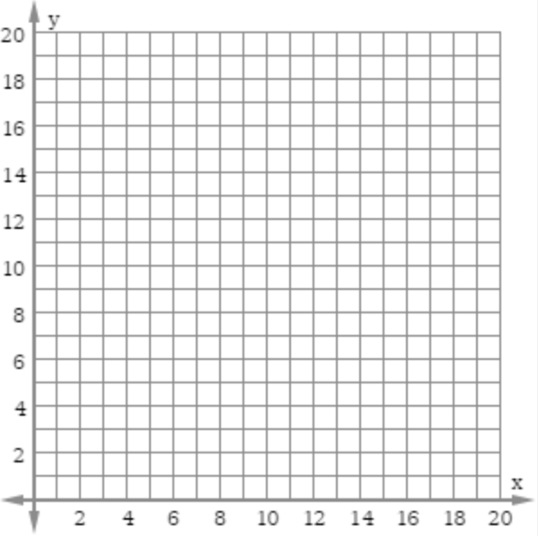

What part of Josie’s scenario represents the slope of the line you graphed?

What part of Josie’s scenario represents the *y*-intercept of the line you graphed?

1. A linear function has a slope of 4 and a y-intercept of 3.
   1. Write an equation to represent this function
   2. Create a scenario to represent this function.
   3. Make a table of values with at least 3 ordered pairs that represents this function.
   4. Graph this function on a coordinate plane.

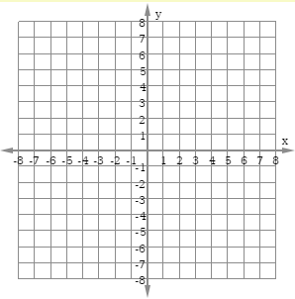

1. Which graph represents the same linear relationship shown in the table below?

| *x* | *y* |
| --- | --- |
| -1 | -5 |
| 1 | -1 |
| 2 | 1 |
| 4 | 5 |

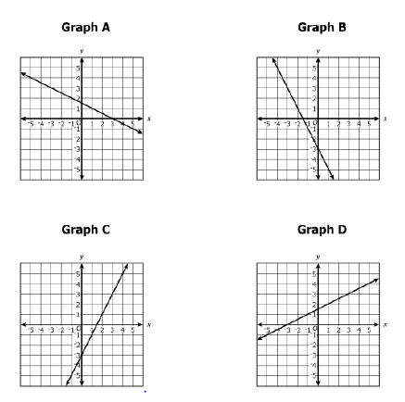

1. Which equation represents the same linear function in the table below?

| *x* | *y* |
| --- | --- |
| 1 | 7 |
| 3 | 15 |
| 5 | 23 |

* 1. 
  2. 
  3. 
  4. 

1. Which table of values is represented by ?

| *x* | *y* |
| --- | --- |
| 1 | 1 |
| 2 | -1 |
| 3 | -3 |



| *x* | *y* |
| --- | --- |
| 1 | 1 |
| 2 | 4 |
| 3 | 7 |



| *x* | *y* |
| --- | --- |
| 4 | 10 |
| 6 | 7 |
| 8 | 4 |



| *x* | *y* |
| --- | --- |
| 4 | 10 |
| 6 | 12 |
| 8 | 14 |

1. The graph represents the same relationship as which table of ordered pairs?

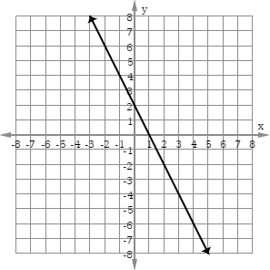



| *x* | *y* |
| --- | --- |
| 8 | 14 |
| 9 | 16 |
| 10 | 18 |



| *x* | *y* |
| --- | --- |
| 8 | -18 |
| 9 | -20 |
| 10 | -22 |



| *x* | *y* |
| --- | --- |
| -10 | 18 |
| -9 | 16 |
| -8 | 14 |



| *x* | *y* |
| --- | --- |
| -10 | 22 |
| -9 | 20 |
| -8 | 18 |

Virginia Department of Education 2018