2016 Mathematics Standards of Learning

Algebra Readiness Formative Assessment

# 8.16d

1. Graph the equation .

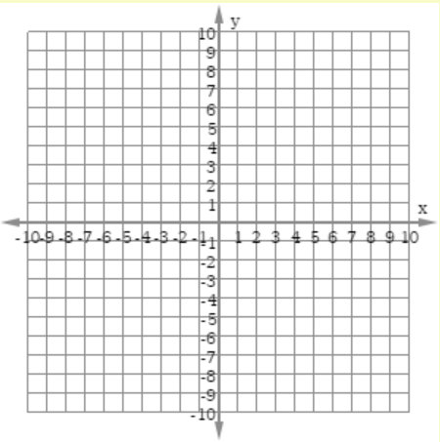

1. Plot three points that lie on the line .



1. What is the equation for the line graphed below?

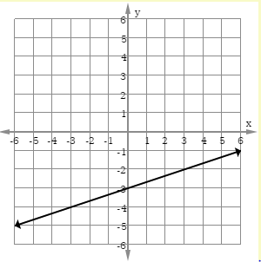

1. Which graph corresponds to ?

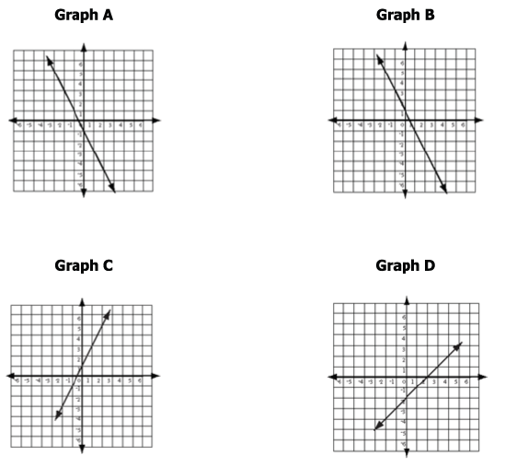

1. Which linear equation best represents the graph below?

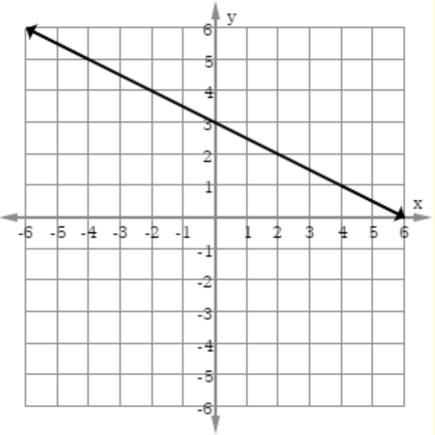

* 1. 
  2. 
  3. 
  4. 

1. Which linear equation represents the same relationship shown in the graph below?

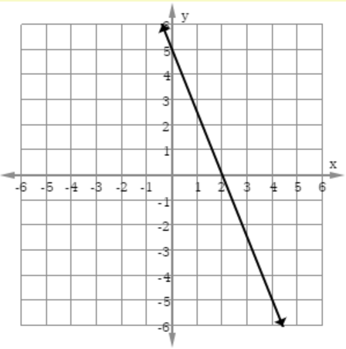

* 1. 
  2. 
  3. 
  4. 

Virginia Department of Education 2018