2016 Mathematics Standards of Learning

Algebra Readiness Formative Assessment

# 8.16b

1. The table of values below represents a linear relationship.

| ***x*** | ***y*** |
| --- | --- |
| -4 | 6 |
| 0 | 3 |
| 4 | 0 |

What is the slope and *y*-intercept for this line?

slope ____________ *y*-intercept ________________

1. The equation  represents a linear relationship.

What is the slope and *y*-intercept for this line?

slope ____________ *y*-intercept ________________

1. Choose two true statements about the slope and y-intercept of the linear function shown.

| The slope is . |
| --- |
| The slope is . |
| The slope is . |
| The slope is . |

| The *y*-intercept is 2. |
| --- |
| The *y*-intercept is 3. |
| The *y*-intercept is -2. |
| The *y*-intercept is -3. |

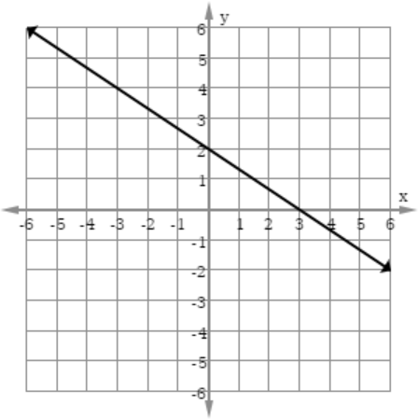

1. Which is an equation for a line with a slope of -4 and a y-intercept of 5?
   1. 
   2. 
   3. 
   4. 
2. Which table of values represents a line with a slope of -1 and a y-intercept of 4?

| *x* | *y* |
| --- | --- |
| -1 | -5 |
| 0 | -1 |
| 1 | -3 |



| *x* | *y* |
| --- | --- |
| -4 | 8 |
| 0 | 4 |
| 4 | 0 |



| *x* | *y* |
| --- | --- |
| -1 | 0 |
| 0 | -4 |
| 1 | -8 |



| *x* | *y* |
| --- | --- |
| -4 | 0 |
| 0 | 4 |
| 4 | 8 |

Virginia Department of Education 2018