2016 Mathematics Standards of Learning
Algebra Readiness Formative Assessment

8.16a

- Draw a sketch of a line that has a slope of zero and describe how you know the slope is zero.
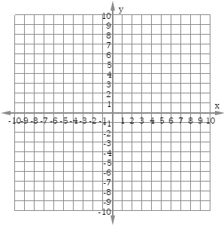

- Select the two graphs with a negative slope.
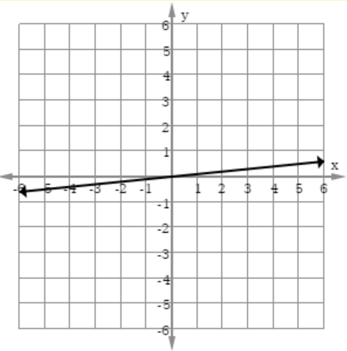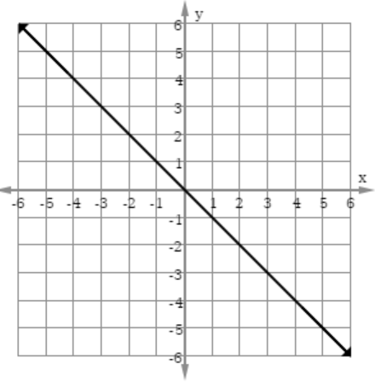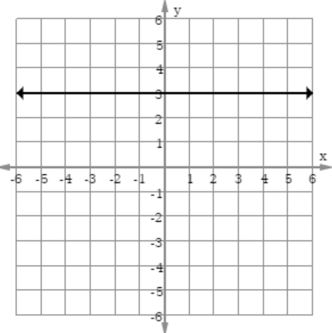
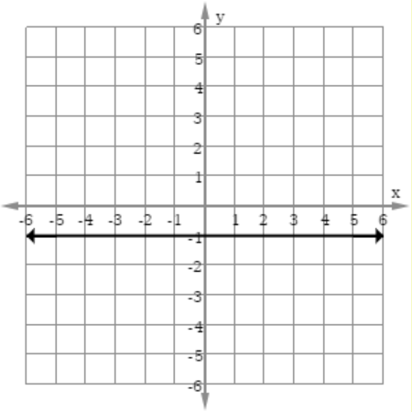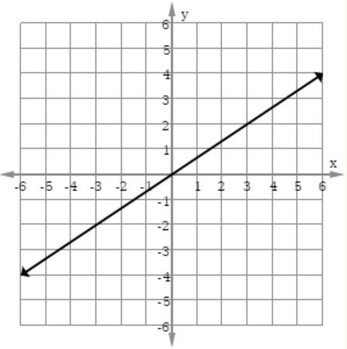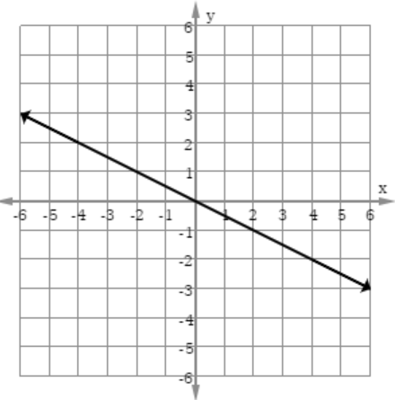

- What is true about the equation for the graph shown?
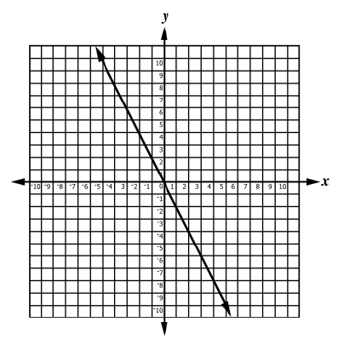
- It has a slope of -2.
- It has a slope of -1.
- It has a slope of 0.
- It has a slope of 2.

- What is true about the slope of the line graphed?
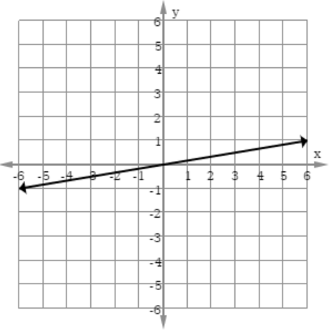
- The slope is positive.
- The slope is negative
- The slope is zero.
- The slope cannot be determined.

- Which of the following statements is true about the line graphed below?
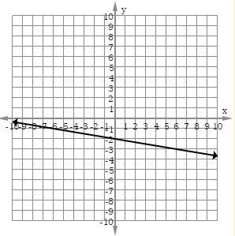
  - The slope of the line is positive because the line is increasing from left to right.
  - The slope of the line is positive because the line is decreasing from left to right.
  - The slope of the line is negative because the line is increasing from left to right.
  - The slope of the line is negative because the line is decreasing from left to right.

Virginia Department of Education 2018

