2016 Mathematics Standards of Learning

Algebra Readiness Formative Assessment

8.15ab

1. Identify all of the true statements.

All relations are functions, but not all functions are relations.

All functions are relations, but not all relations are functions.

A function is a relation between a set of inputs and a set of outputs with the property that each input is related to exactly one output

In any set of ordered pairs, the second coordinate is called the domain.

1. The table defines a function.

| Changes in Joshua’s Height Per Year | | | | |
| --- | --- | --- | --- | --- |
| Year | 2002 | 2003 | 2004 | 2005 |
| Change in height (inches) | 2.5 | 2.25 | 1.5 | 0.75 |

What is the domain of the function?

1. Complete the function table below. Then, list all of the domain and range values.



| x | y |
| --- | --- |
| -1 |  |
|  | 1 |
| 2 |  |
|  | 10 |

Domain: ___________________________

Range: _____________________________

1. Does the following relation represent a function?



YES NO (circle one)

Explain your reasoning. ____________________________________________________ ________________________________________________________________________________________________________________________________________________

1. Does the following relation represent a function?

| x | y |
| --- | --- |
| -2 | -5 |
| 0 | 1 |
| 5 | -5 |
| 9 | 6 |

YES NO (circle one)

Explain your reasoning. ____________________________________________________ ________________________________________________________________________________________________________________________________________________

1. Does the graph below represent a function? YES NO (circle one)

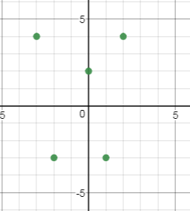

Explain your reasoning for your answer. _______________________________________  
________________________________________________________________________

1. Marissa used the set of ordered pairs below to graph a relation.



What is the domain of the relation?

1. 
2. 
3. 
4. 
5. In the linear equation shown, which variable would represent the output (range) values?



1. 
2. 
3. 
4. 
5. Alex created a table to represent the function. What is the range for this table of values?

| *x* | *y* |
| --- | --- |
| -2 | 0 |
| 0 | 4 |
| 2 | 8 |
| 4 | 12 |

1. Which of the following does NOT represent a function?

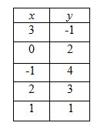 A. 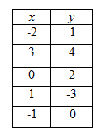 B.

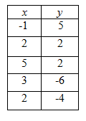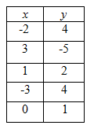 C. D.

Virginia Department of Education 2018