2016 Mathematics Standards of Learning

Algebra Readiness Formative Assessment

7.13

1. Solve the following two-step inequality.

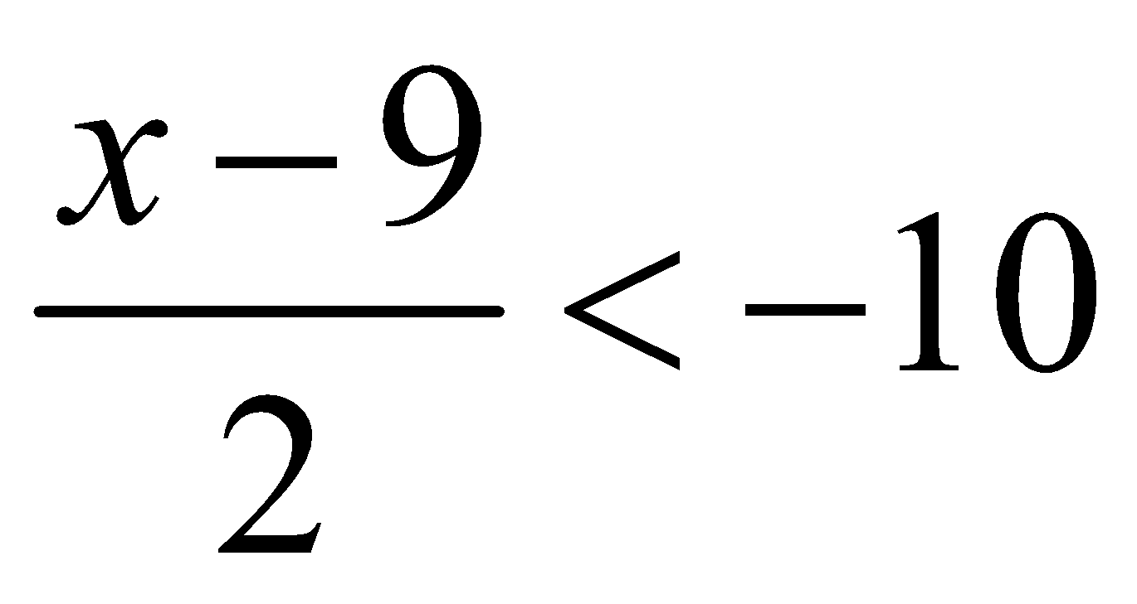

1. Look at the number line below.The number line represents the graph of which inequality?

Number line from -5 to 5; intervals of 1

1. 
2. 
3. 
4. 
5. Select the statement that correctly represents the inequality below.

“Twice a number increased by 14 is at least the opposite of 10”

1. 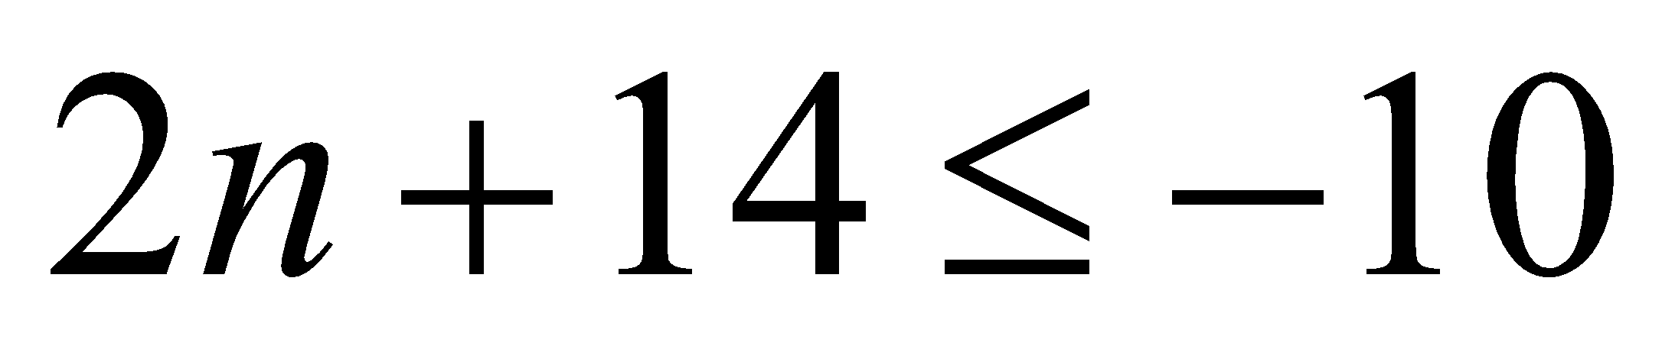
2. 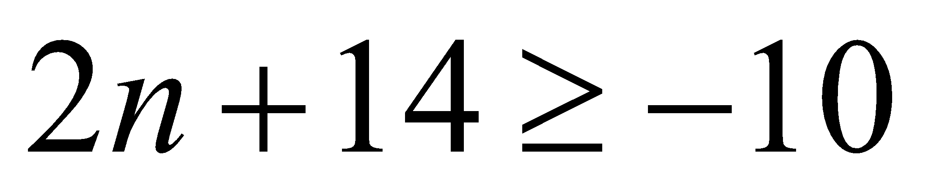
3. 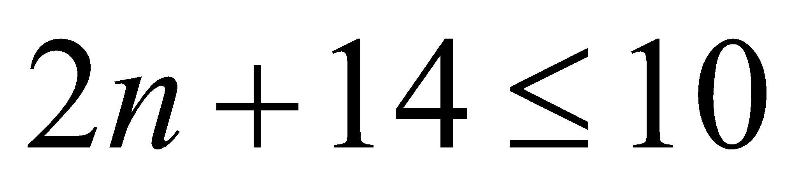
4. 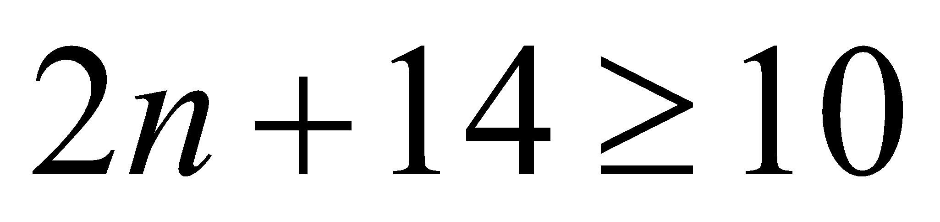
5. A truck can carry a maximum of 1,350 pounds of weight. How many 250-pound scoops (d) of dirt can the truck carry?
6. 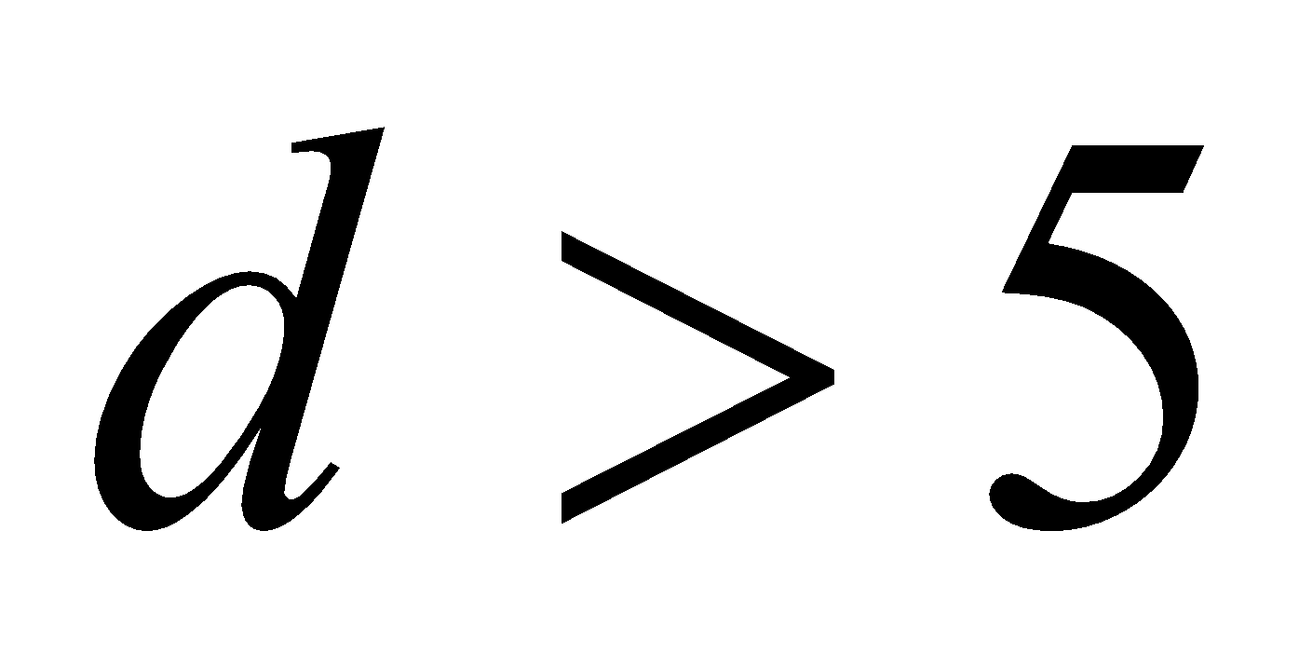
7. 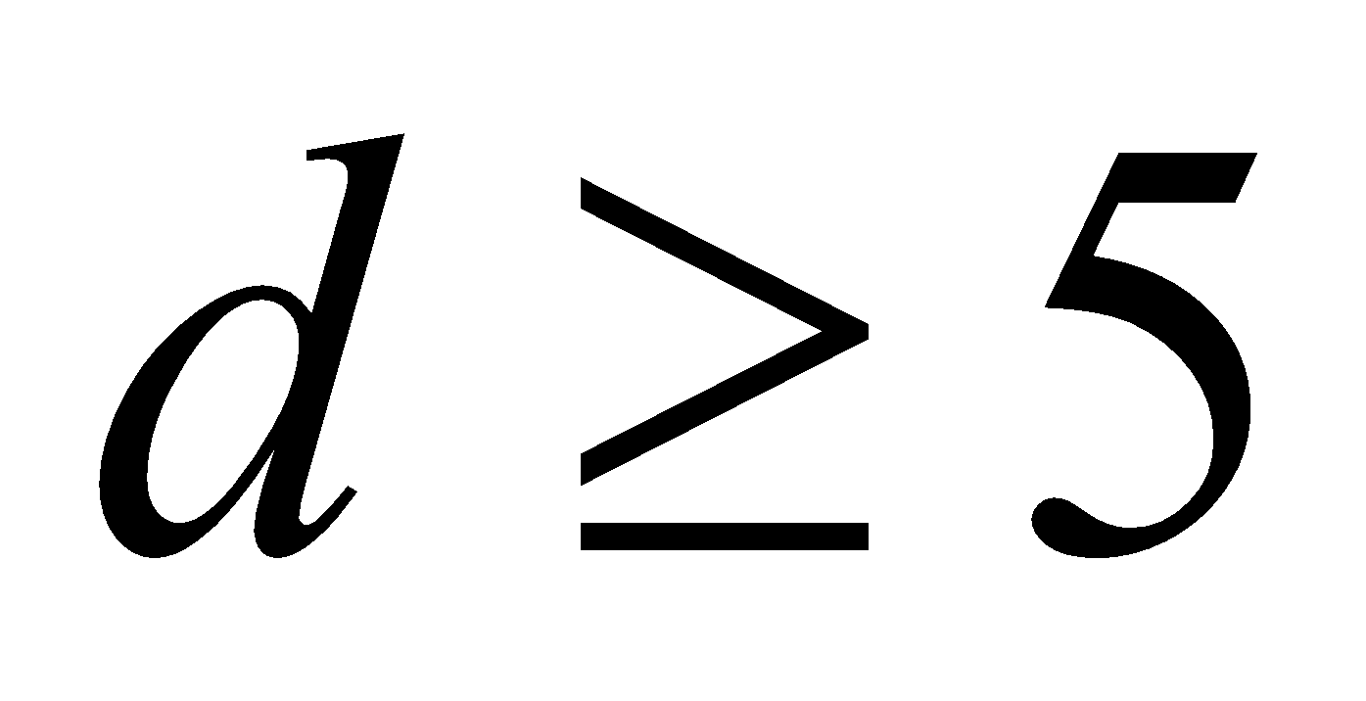
8. 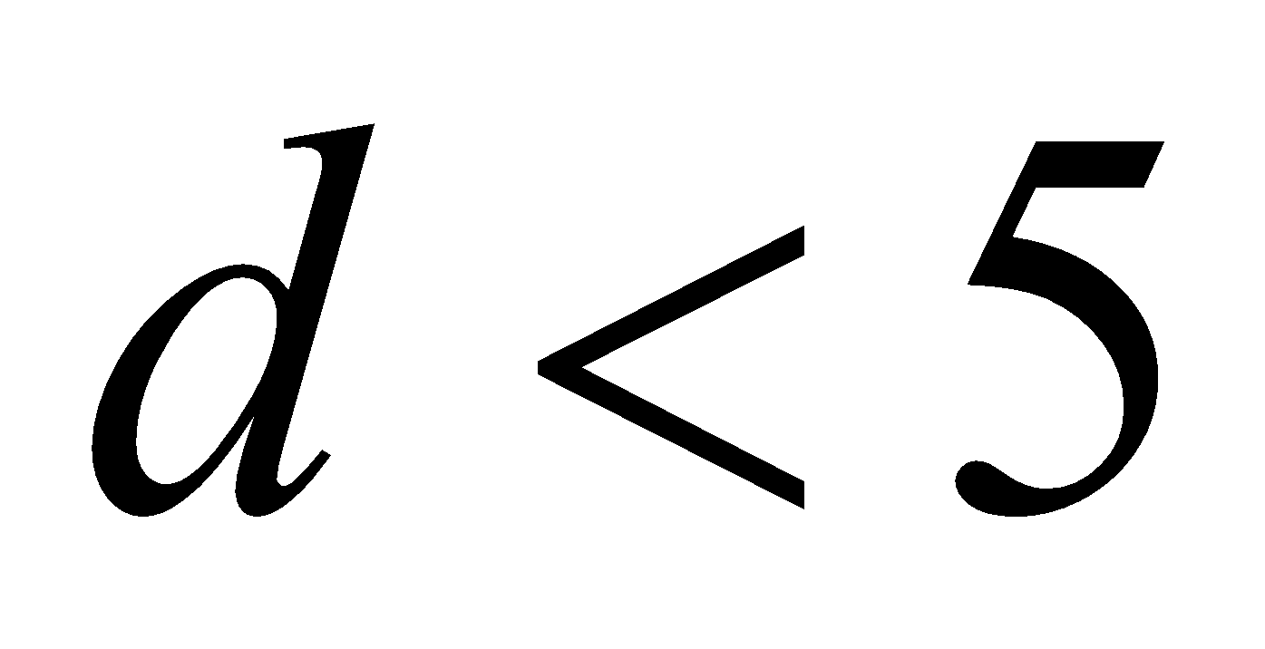
9. 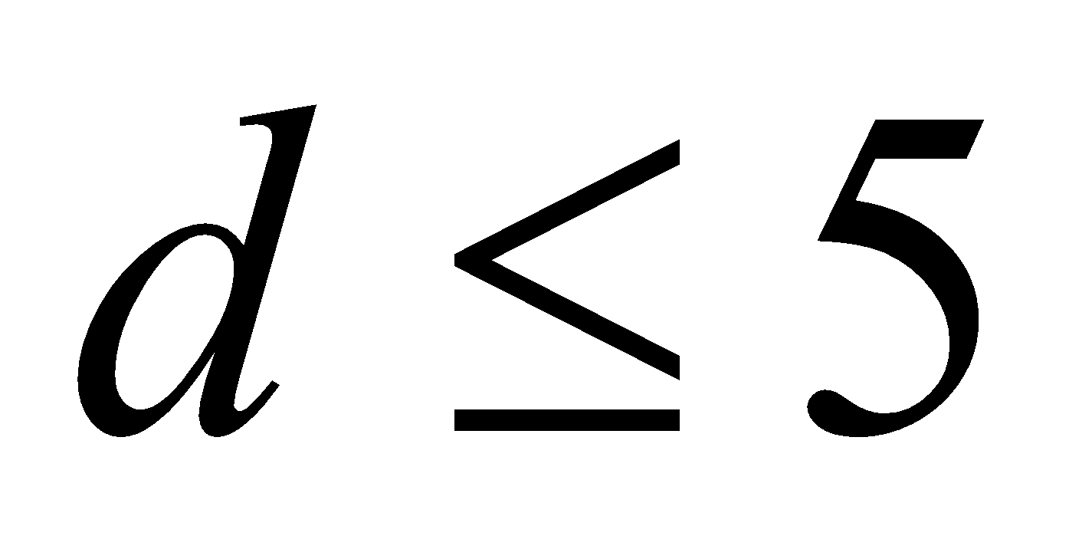
10. James solved the inequality  and got. What did he do wrong?
11. Identify all numerical values that are part of the solution set for the following inequality.



| -4 | 4.5 | -5.5 |
| --- | --- | --- |
| 4 | -3.5 | -4.5 |

1. What values for *w* make the following inequality true? 
2. 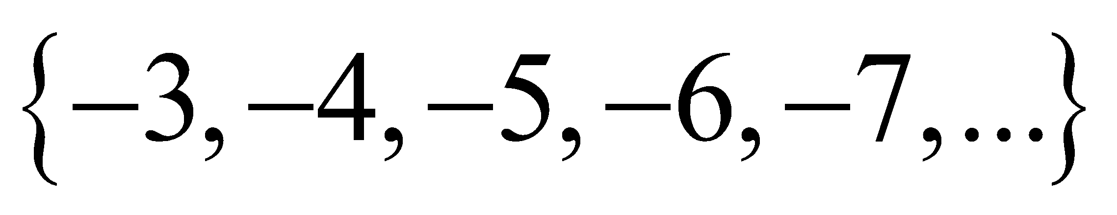
3. 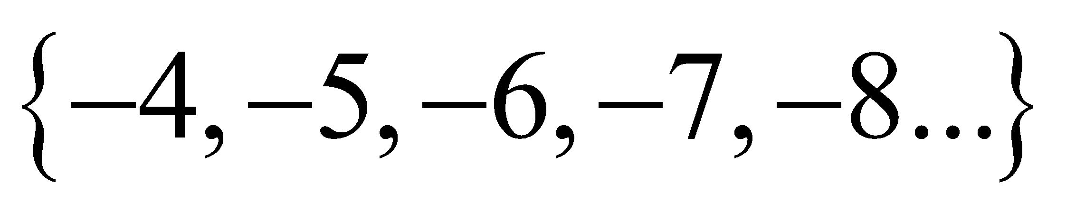
4. 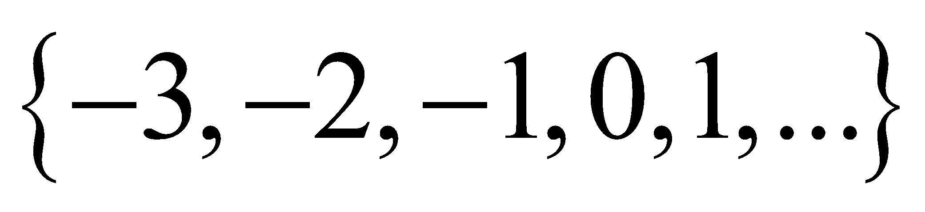
5. 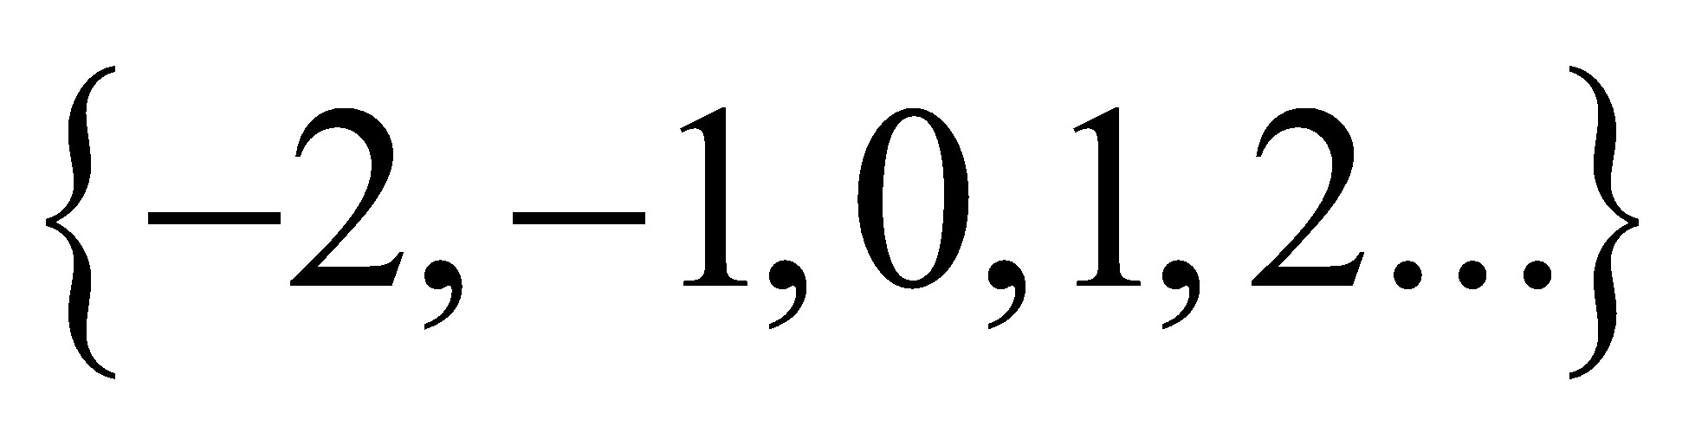
6. What is the solution to?
7. 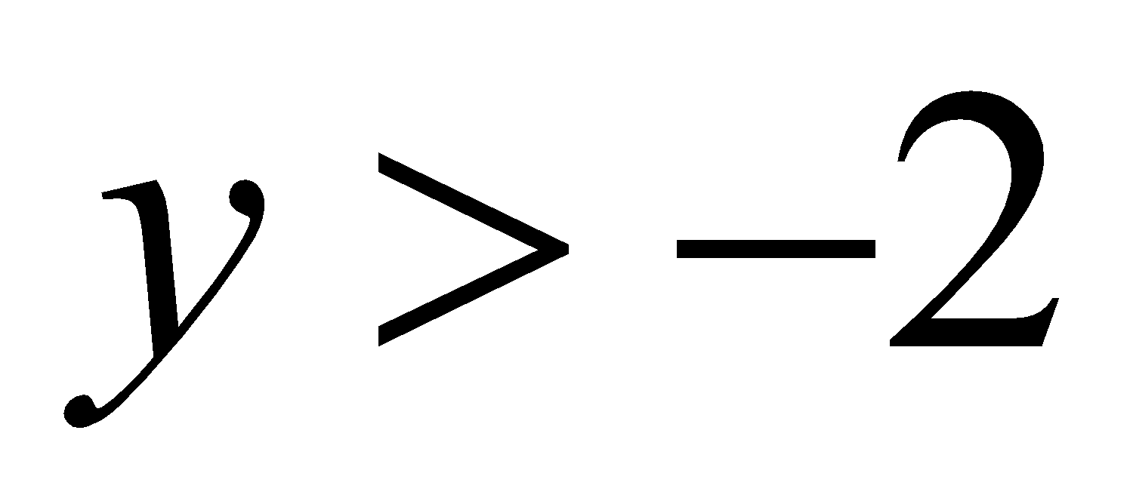
8. 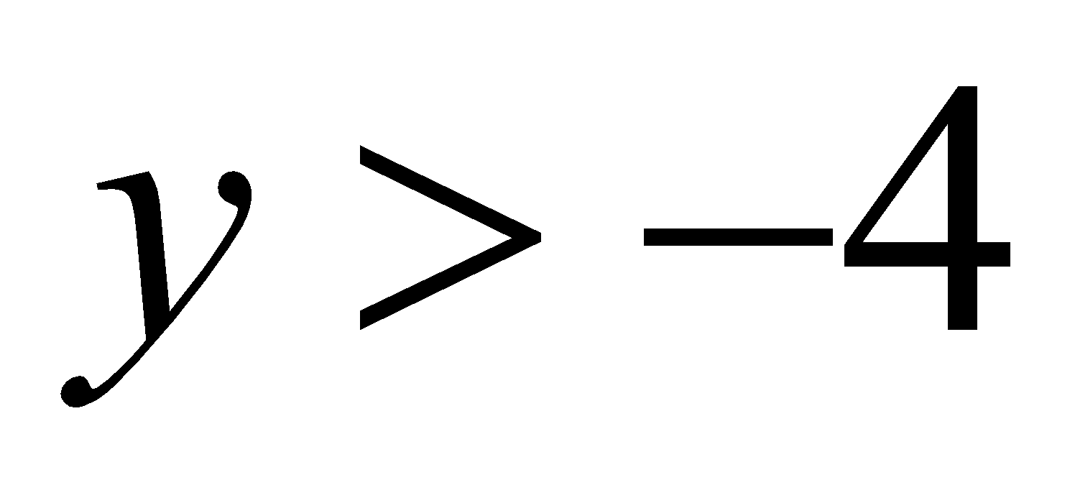
9. 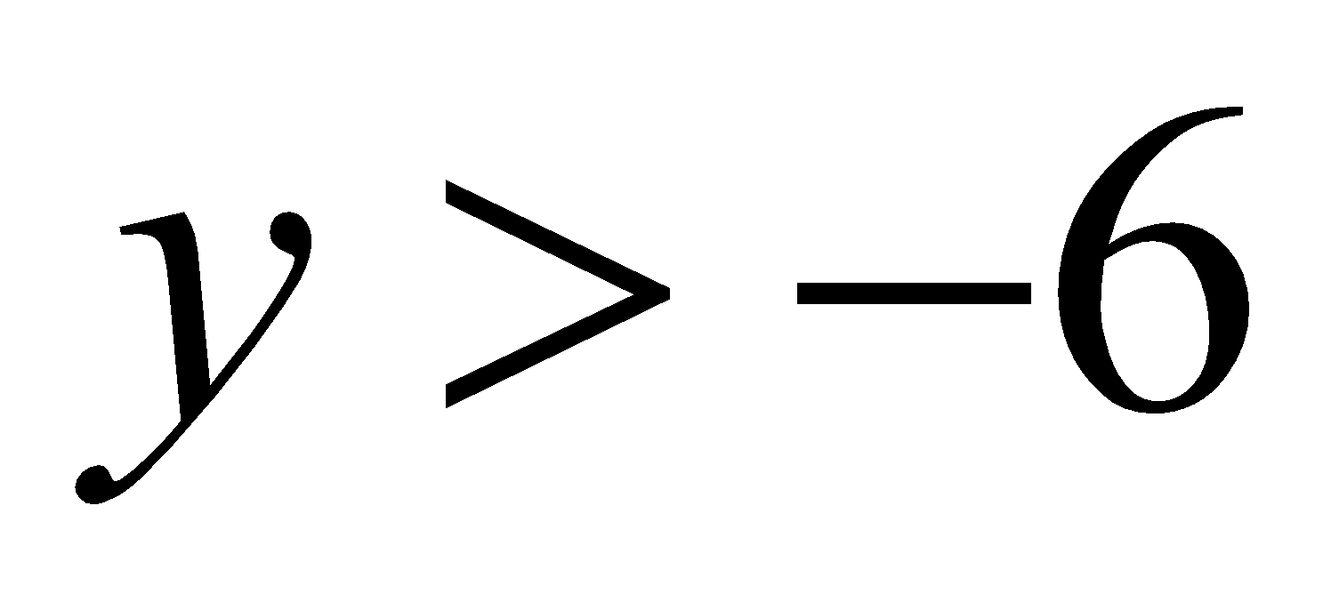
10. 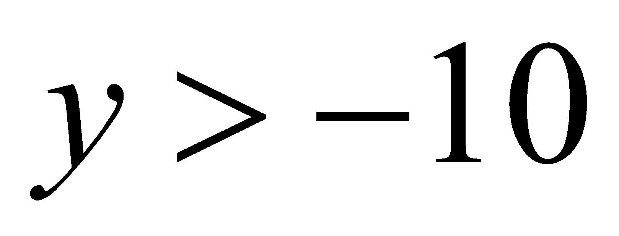

Virginia Department of Education 2018