# 2016 Mathematics Standards of Learning

# Algebra Readiness Formative Assessment

## 7.12

1. Patti wants to solve for *x* in the equation.



What steps should she take to solve the equation for x?

1. Look at the following algebraic expression.



Write at least two different verbal expressions that represent the given algebraic expression.

1. Using the given key and equation mat, represent and solve the following linear equation algebraically. Then, confirm your solution.

10 = 4 – 3x

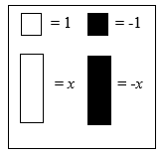 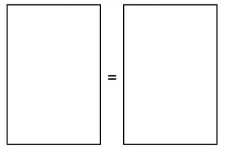 Key: Equation Mat

1. What is the solution to



* 1. *x* = 21
  2. *x* = 19
  3. *x* = 11
  4. *x* = 9

1. Aubrey’s scarf is 4 inches more than half the length of Tyrone’s scarf. Aubrey’s scarf is 34 inches long. How long is Tyrone’s scarf?

* 1. 15 inches
  2. 60 inches
  3. 112 inches
  4. 128 inches

1. Which equation means “a number increased by the product of 7 and 12 is 93”?
   1. 
   2. 
   3. 
   4. 

Virginia Department of Education 2018