2016 Mathematics Standards of Learning

Algebra Readiness Formative Assessment

# 7.11

1. What is the area of the trapezoid shown below if , , and ?

Area = 

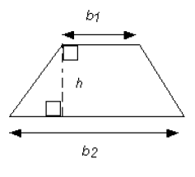

1. What is the value of  if *x* = -2 and *y* = 3?
2. What is the value of  if *x* = 4, *y* = -3, and *z* = 2?
   1. 2
   2. 10
   3. 22
   4. 26
3. What is the value of  if *x* = 15?
   1. 62
   2. 77
   3. 272
   4. 276
4. The outside temperature is 10 degrees Celsius. Using the formula, what is that temperature in degrees Fahrenheit?
   1. 17.8 degrees Fahrenheit
   2. 33.8 degrees Fahrenheit
   3. 50.0 degrees Fahrenheit
   4. 57.6 degrees Fahrenheit

Virginia Department of Education 2018