2016 Mathematics Standards of Learning
Algebra Readiness Formative Assessment

7.10e

- Steven went to play video games in Games Galore arcade. Games Galore charges $1.50 for each game played. Represent the relationship between total cost, y, and number of games played, x using a table, graph and equation. Is this relationship a proportional or additive relationship? Explain.

- Sam went to play video games in Video Game Central arcade. Video Game Central charges $10 to get into the arcade and then $1 per game played. Represent the relationship between total cost, y, and number of games played, x using a table, graph and equation. Is this relationship a proportional or additive relationship? Explain.

- The graph represents which table of ordered pairs?
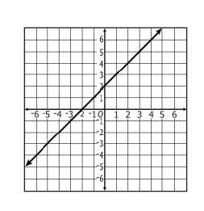

- B.
x | y
-3 | -5
-1 | -3
2 | 0
4 | 2
x | y
2 | -2
4 | 0
-1 | -3
-3 | 5

x | y
-2 | -4
0 | -2
3 | 1
5 | 5
x | y
-4 | -2
-2 | 0
1 | 3
3 | 5
- D.

- Which graph best corresponds to this table of ordered pairs?

x | y
-2 | -2
-1 | -1
1 | 1
2 | 2

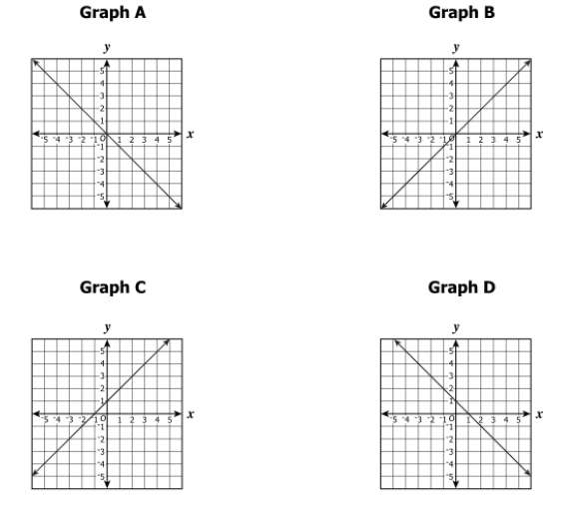

- Which of the following graph represents the same relationship as “y is four more than x”?

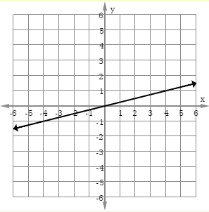

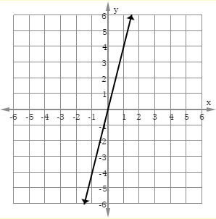

- 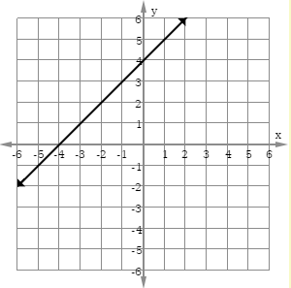

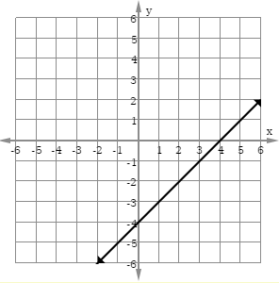

Virginia Department of Education 2018

