2016 Mathematics Standards of Learning

Algebra Readiness Formative Assessment

# 7.10d

1. Graph the line that passes through the point (3, -1) and has a *y*-intercept of -4.

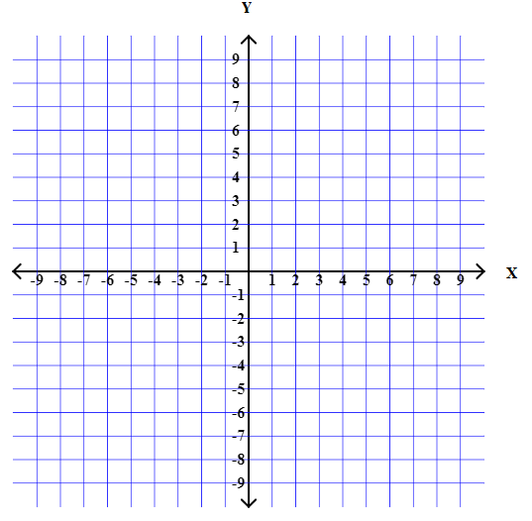

1. Graph the line 



Graph of a line


Which equation represents the same relationship shown in the graph?

1. 
2. 
3. 
4. 

4. Which of the following graphs represents ?

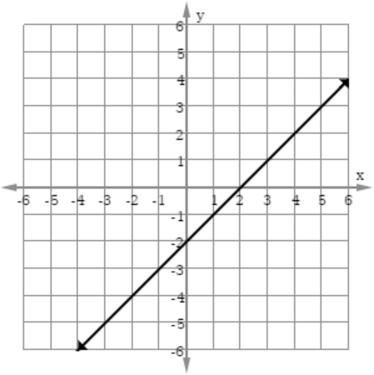A. B.

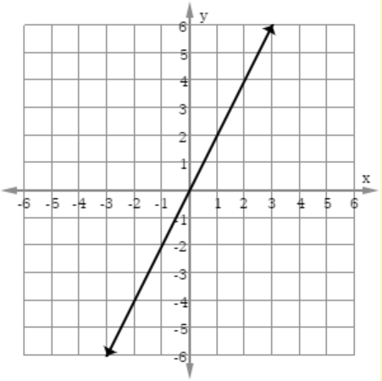

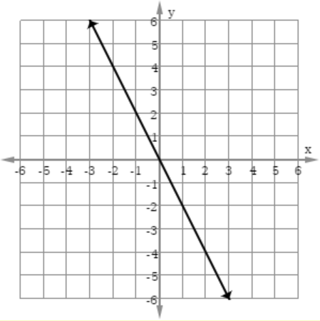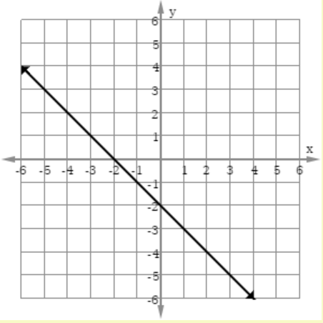C. D.

Virginia Department of Education 2018