2016 Mathematics Standards of Learning

Algebra Readiness Formative Assessment

# 7.10b

1. A line passes through (5, 3) with a slope of . Plot at least 3 points on this line.

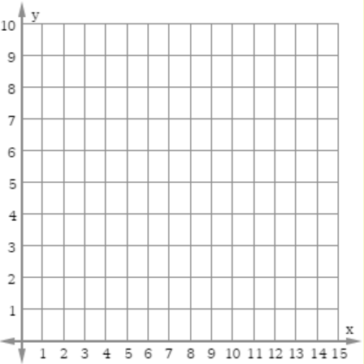

1. Select three points that lie on the graph of the line .

| (0, 0) | (1, 2) | (3, 6) |
| --- | --- | --- |
| (4, 2) | (10, 5) | (4, 8) |

1. Which of the following equations represents the same proportional relationship shown in the graph?

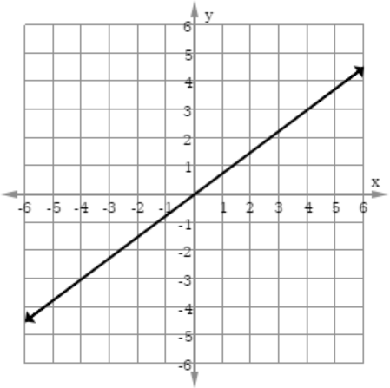

* 1. 
  2. 
  3. 
  4. 

1. Which of the following graphs represents ?

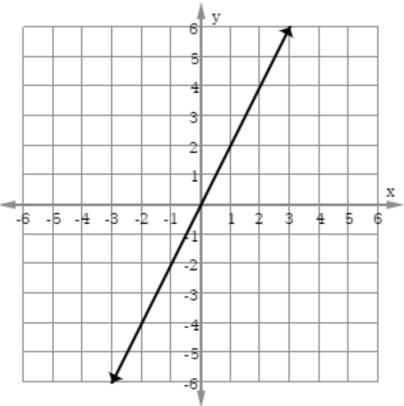



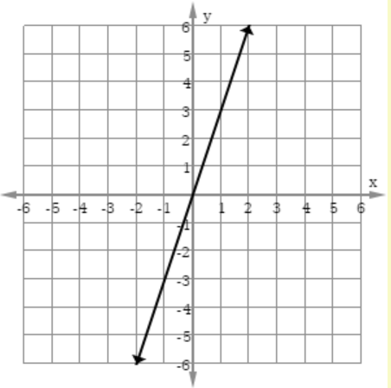



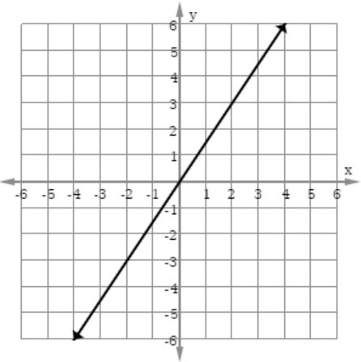



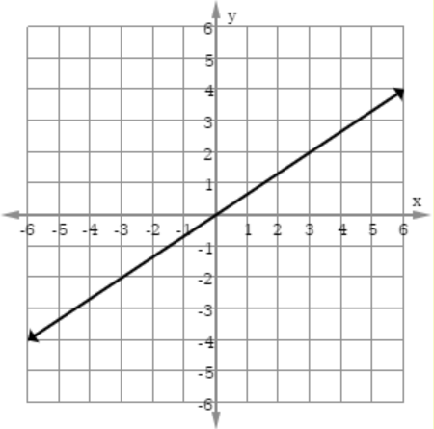

Virginia Department of Education 2018