2016 Mathematics Standards of Learning

Algebra Readiness Formative Assessment

6.14

1. Joey is a member of the football team. He works out at least 4 hours each week to stay in

shape. Write an inequality to represent this situation and graph the solution.

Algebraic Inequality: __________________________

blank number line

2. Solve the one-step linear inequality.

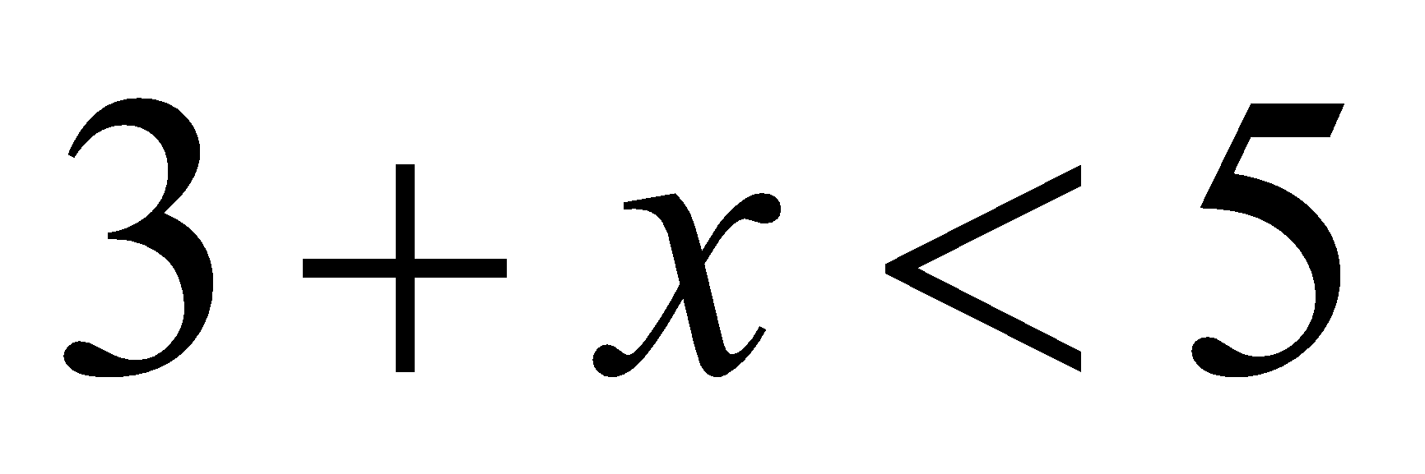

A. 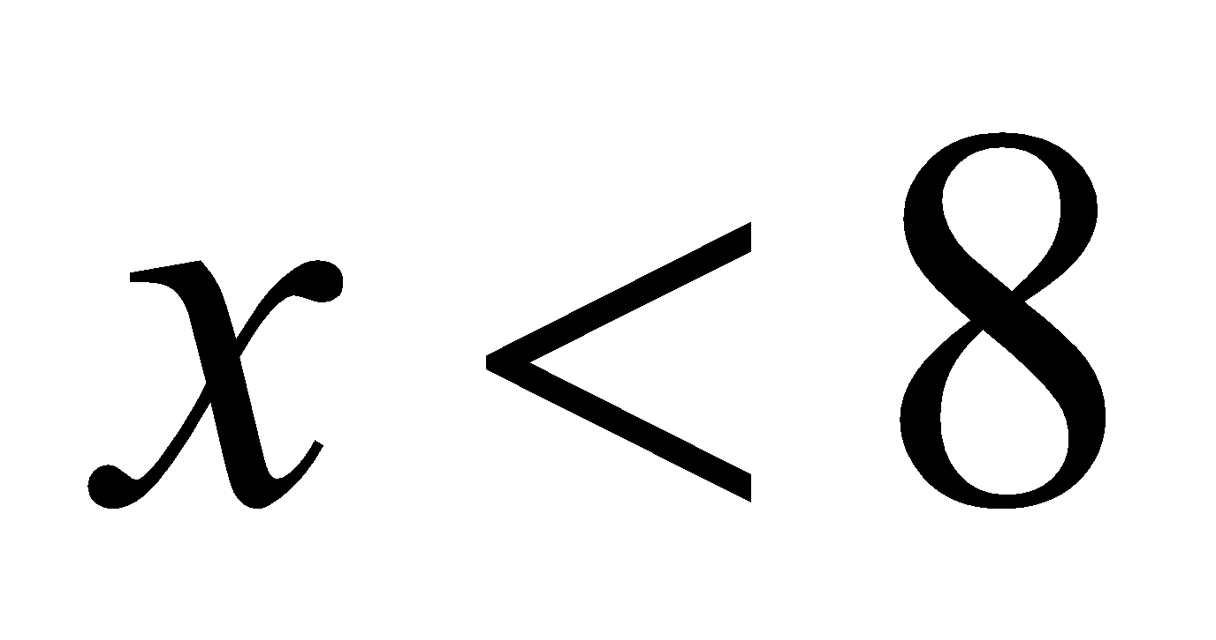

B. 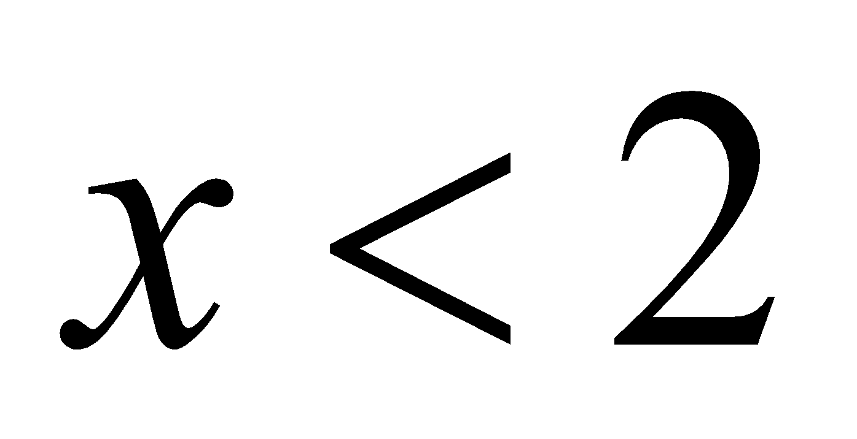

C. 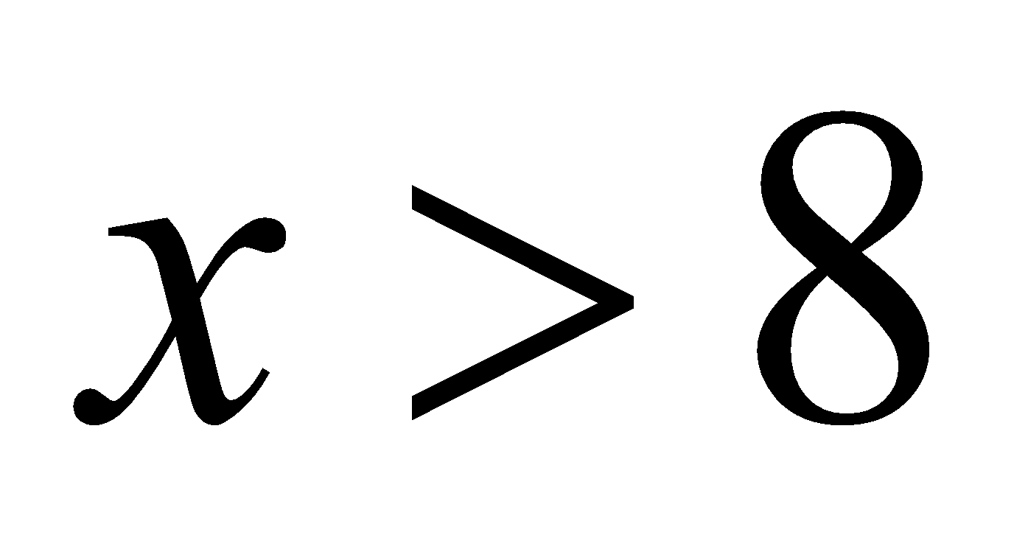

D. 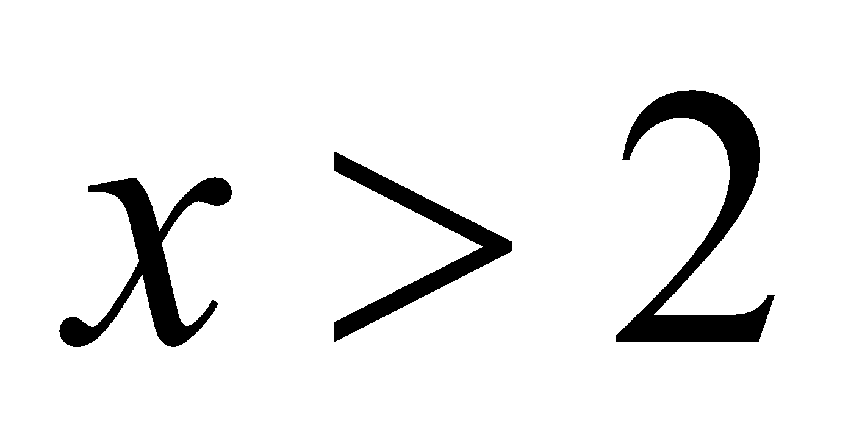

3. Identify two inequality statements that represent the graph below.

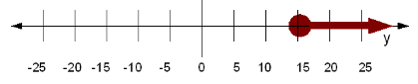

|  |  |  |  |
| --- | --- | --- | --- |
|  |  |  |  |

4. Select all of the numerical values that would make the inequality statement true.



| 4 | -3 | -7 |
| --- | --- | --- |
| -5 | 0 | -4 |

5. What is the solution to ?

A. 

B. 

C. 

D. 

5. Which number line represents all solutions to the inequality 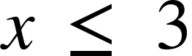?

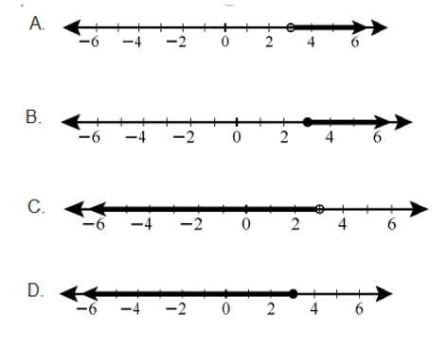

Virginia Department of Education 2018